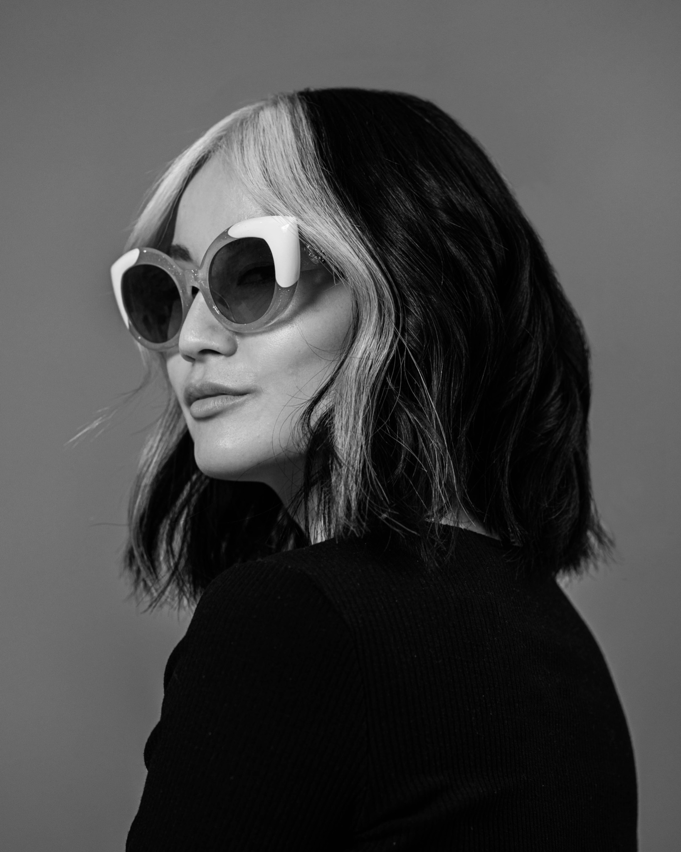

**Cutler**

OUR MISSION IS TO BE IMPECCABLE IN THOUGHTS, WORDS, AND DEEDS.

WELCOME TO CUTLER

Congratulations on your decision to join our team. Our training program is designed to measure your abilities and challenge you in ways you might never think possible. Our goal is that you be the best that you can be. Remember that your unique talents and abilities will complement our team, unlike anyone else.

You will discover our philosophies on success and our thoughts on various issues, from fashion, style, creativity, and individuality to the importance of being socially aware (a cornerstone of professional and personal success is the ability to build relationships). You will learn to coffee a high level of customer service, from greeting through saying goodbye.

We believe that a strong foundation in styling hair is essential, regardless of the specialty you pursue. You will learn to create seamless, timeless work that will truly suit each client.

You control your future. Your attitude and enthusiasm combined with professionalism and a genuine interest in learning will have an enormous influence on where this path ultimately leads you.

Our values are the most important things to us in creating a positive foundation and transferring the spirit of ownership of our culture to our staff. Unlike our personal goals and visions which may change from year to year or moment to moment, these values do not! We must believe in them and embody them to the best of our ability to create a positive work environment, positive client retention, and a positive quality of life in and out of the salon.

**TEAMWORK**

Work together to grow together.

**COMMUNICATION**

Be effective listeners to understand each others’ needs (clients and co-workers), and be open to the exchange of ideas.

**INTEGRITY**

Be true to yourself and others. Always treat everyone with honesty and respect.

**CUSTOMER SERVICE**

Without customers, we have no business. Treat all clients tactfully and consistently. Go above and beyond to provide the best experience possible. Maintain cleanliness and professionalism at all times.

**STARTING THE DAY**

Everyone in this company performs a vital role, and that of the salon assistant is no exception. It is important that you arrive at work 15 minutes before you are scheduled to start work so that you can settle in and prepare for the day. Please sign each morning when you arrive.

**BREAKS**

Head Assistants for the color and cutting departments are in charge of running each department as smoothly and efficiently as possible. In order to accomplish this, they need to approve the timing of all breaks and lunches. Please see them before signing out, as there may be times you’ll need to postpone a break to ensure adequate coverage on the floor. A reminder: smoking breaks are included in your break time, and eating breakfast after you are scheduled to work is not acceptable. You are entitled to one 15-minute break and one 45-minute lunch break each day.

**APPEARANCE**

There is no dress code, it is important for you to present a professional appearance at work. You should appear polished.

**CLASS FORMAT**

Arrive at least 15-20 minutes early. Have cutting and styling tools prepared.

Bring this book to every class. Have the Model Release form ready for the model to read and sign.

Have proper references.

Model Policy

To get the most out of your education we ask that you bring a proper model with suitable hair for what you may be working on. We ask that when you use the same model you wait at least 8 weeks in between sessions and that you try something completely different each time. We suggest having models stop by the salon before sessions to determine their suitability

Consultation

For the first 30 seconds, don't touch your client’s hair.

Make eye contact and simply listen.

Start by asking:

What color are you looking for?

Tell me what you have done to your hair in the past 2 years.

What would you like to do today?

What do you like about your hair>

What do you not like about your hair?

How often do you get your hair done?

Key points:

Make sure you 100% understand what they are looking for.

Make sure the color they are looking for compliments skin tone/eye color.

Look at natural color root and assess what level they are and how much grey they have if covering grey.

Look at mid-length and ends; assess the level, and if the previous color is on hair

Explain color maintenance and how to keep color from fading or going brassy.

**SHAMPOO**

*Adjust water pressure/temperature and check against wrist/fingers.*

*Wet hair thoroughly, protecting the client’s face and ears.*

*Use 1-3 pumps of shampoo (as needed) and distribute.*

*Use pads of fingers to scrub the scalp.*

*Divide head into three zones: front (hairline), middle (crown), back (nape).*

*Keeps hands moving, with at least one hand on the client at all times.*

*Maintain a rhythm (beginning, middle, and end).*

*Rinse thoroughly.*

**CONDITIONER**

*Use the same principles as shampooing*

*Apply conditioner Beginning at hair ends and work toward scalp.*

*Massage scalp using the three zones.*

*Rinse thoroughly.*

*Towel dry.*

*Use a wide toothed comb to detangle, and clip hair up.*

**TRADITIONAL LEVEL SYSTEM**

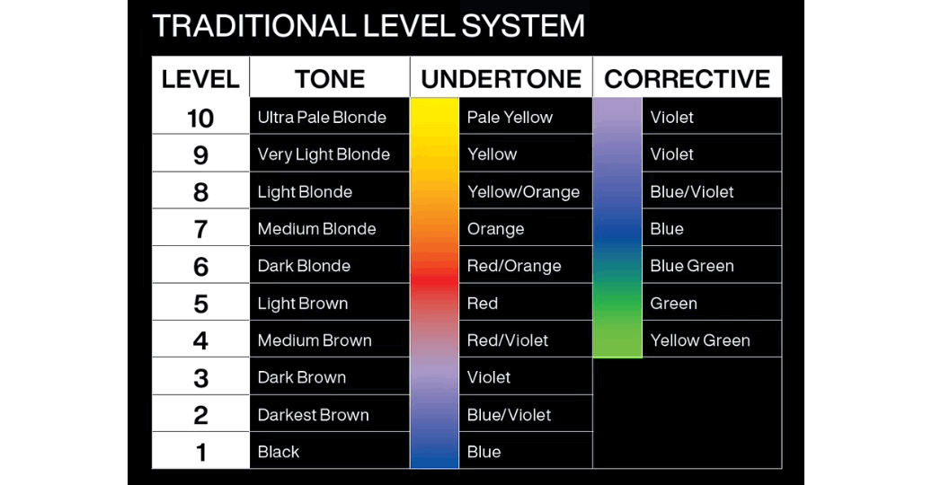

**PRIMARY COLORS SECONDARY COLORS COMPLEMENTARY COLORS**

The building blocks of all colors: 2 Primary Colors mixed: Opposite each other on the color wheel:

Red, Blue, and Yellow Green = Blue + Yellow Red / Green

Orange = Red + Yellow Yellow / Violet

Violet = Red + Blue Blue / Orange

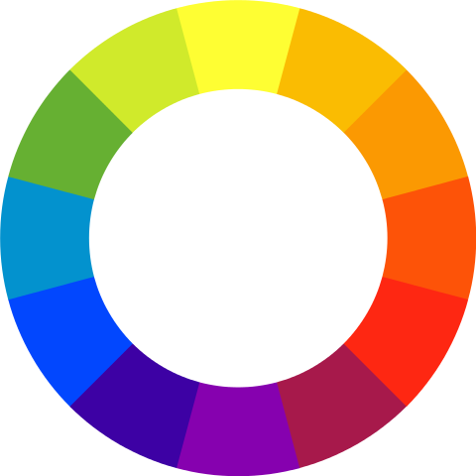

Type of Hair Color

**TEMPORARY**

This is more of a physical change than a chemical change.

It is designed to coat the cuticle, with no penetration due to the large size of the color molecules.

This allows the color to last from shampoo to shampoo.

Dry hair types absorb color more readily because the cuticles are open and color will last longer.

*Examples: Manic Panic*

*Action: Coats the cuticle*

**SEMI-PERMANENT**

This is more gentle than permanent but stronger than temporary.

It can be used to tone pre-lightened hair (great for hair that can't take any more peroxide).

It can also be used to refresh and enhance natural tones.

*Examples: L’Oreal Richesse, Matrix Prizms, and Schwarzkopf Igora Personality*

*Action: Some color enters the cortex and some coats the cuticle*

**DEMI-PERMANENT**

This type is somewhere between semi and permanent color, with a very low form of peroxide and/or conditioning agent such as MEA or AMP. When applied, it gently swells and opens the cuticle layer and pushes the color molecules into the cortex. Due to low peroxide, natural hair color/melanin is not lifted for a more graceful line of demarcation.

*Examples: Redken Shades EQ/Shades Cream/Shades Cover Plus, and Wella Color Touch*

*Action: Completely penetrates the cortex.*

**PERMANENT**

This type lightens, darkens, or changes tone all in one step. It can penetrate the cuticle and enter the cortical layer. Mix with an oxidizing agent such as hydrogen peroxide to start the oxidation process. These pass all the way through the cortex and develop.

*Examples: Redken Fusion/Colorgels/Chromatics and Wella Koleston Perfect*

*Action: Penetrates completely into the cortex and develops*

**NON-OXIDATIVE PERMANENT DYES**

These types of colors are formed from all sorts of metals, herbs, flowers and salts. They fall into 4 categories: vegetable, metallic, compound and oxidative. The most popular non-oxidative dye is henna, which creates a thickness underneath the cuticle and is nearly impossible to remove. If heavily layered, not even the conditioner can penetrate.

*Examples: Henna*

*Action: Sits directly underneath the cuticle*

Color Curriculum

**1**

**Single Process**

Blonde, Brown, and Red

Gray Coverage

Lowlights

Single Process w/ Foil

**2**

**Highlighting/Lowlighting**

Classic Section Highlighting / Lowlighting

Half Head

Full Head

Herringbone Highlighting / Lowlighting

Half Head

Full Head

Hair Painting

Half Head

Full Head

**3**

**Advanced**

Hair Painting

Color Correction

Double Process/ Double Virgin Application

Virgin Application, Re-touch Application

Creative Color

**Cutler COLOR EDUCATION**

**1**

**SINGLE PROCESS**

BLONDE / BROWN / RED

Cool Tones/ Warm Tones

Lighter |2 Levels or more|

Gray Coverage

Tailored Pieces |Creating Dimension|

**MEN’S CAMO**

**FORMULATION NOTES / MODEL INFORMATION**

**FORMULATION NOTES / MODEL INFORMATION**

**Cutler COLOR EDUCATION**

**2**

**HIGHLIGHTS/LOWLIGHTS**

CLASSIC SECTION HIGHLIGHTING

Classic Half Head

Classic Full Head

End Light/ Low Light

HERRINGBONE HIGHLIGHTING

Half Head

Full Head

End light/ Low light

HAIR PAINTING

Half Head

Full Head

End Light

Low Light

MEN HIGHLIGHTS

**CLASSIC FOILING:**

1. Standing behind the client, start at the occipital using horizontal sectioning to the top of the crown.
2. Standing on the right side, take the horizontal section from the hairline to the crown.
3. Foil hairline and 2 more behind it.
4. Section horizontally working your way up through the section.
5. Part center on top, to the crown, foil hairline 3-4 foils behind.
6. Section horizontally, following the previous side section, working your way up to the center part.
7. For the left side, repeat sectioning from the previous side.

**FORMULATION NOTES / MODEL INFORMATION**

**FORMULATION NOTES / MODEL INFORMATION**

**FORMULATION NOTES / MODEL INFORMATION**

**CLASSIC 1 SECTIONING**

1. Start by sectioning from high recession to high recession. *Guide*: Where the eyebrow starts to arch. Bring this parting back to where the head starts to round. Comb and clip this section away.
2. Use section 1 as a guide carrying it about 2-3 inches below the natural whorl. Pay close attention to where the graduation starts to avoid distinct lines. *Guide*: To ensure proper blend, take a piece from the longest graduation to find where section 2 should end
3. From the bottom corners of section 2, take a diagonal forward slice to the back of the ear on each side. This will give sections 3 and 4

**CLASSIC 2 SECTIONING**

1. Start by sectioning from high recession to high recession. *Guide*: Where the eyebrow starts to arch. Bring this parting back to where the head starts to round. Comb and clip this section away.
2. Use section 1 as a guide, carrying it about 2-3 inches below the natural whorl. Pay close attention to where the graduation starts to avoid distinct lines. *Guide:* To ensure proper blending, take a piece from the longest graduation and find where section 2 should end.
3. From the bottom corners of section 2, take a diagonal forward slice to the back of the ear on each side. This will give you sections 3 and 4. *Note*: The partings for classic 1 and classic 2 are the same, but the foiling will vary when you reach parting 1.

**HERRINGBONE PATTERN**

1. For the first section, make a parting from the recession two inches back into the hairline. Then make a diagonal forward parting to the top of the ear. Weave subsections following the natural hairline. Make sure to fill in the hairline using softer colors below the recession.
2. Begin the next section by parting from the middle of the last foil in section 1 to the back of the head.

Be sure to stay below the natural whorl.

*Optional Sectioning*: Place horizontal subsections below the natural whorl if layers require more color to fall over the back of the head.

1. Divide the top of the head with a center part beginning at the front hairline continuing back below the natural whorl.
2. Weaving subsections begin on the same side of the head as the first section beginning at the front.

Be careful to follow the natural hairline.

Make diagonal back partings, paying close attention to the angle of the subsection.

1. Placement is determined by the natural texture and amount of contrast desired. Make certain to stand directly in front of the section to begin highlighting to ensure proper placement.
2. Continue working toward the back of the head until a small triangular shape remains. A foil may then be placed perpendicular to the last foil to complete the section.
3. Continue on the opposite side using the same technique.

**Cutler COLOR EDUCATION**

**3**

**Advanced**

HAIR PAINTING

DOUBLE PROCESS/ DOUBLE VIRGIN APPLICATION

Virgin Application

Re-Touch Application

COLOR CORRECTION

Decolorizing- (removing unwanted color on previous color hair)

Tint Back- (bringing someone back to their natural or darker color from having previous highlights)

Hair Painting

CREATIVE COLOR

**FORMULATION NOTES / MODEL INFORMATION**

**FORMULATION NOTES / MODEL INFORMATION**

**FORMULATION NOTES / MODEL INFORMATION**