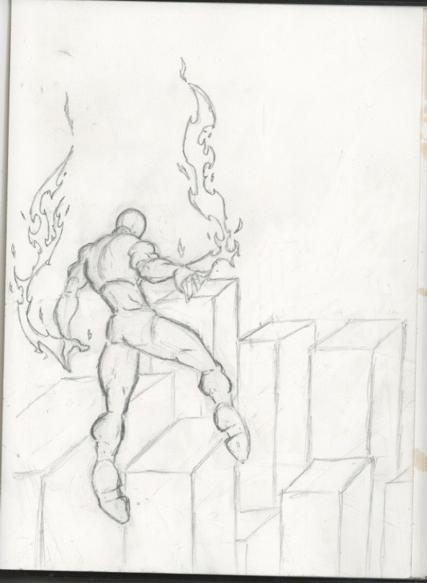The Lines and the color appear dull. These pencil marks appear softer making it lighter. 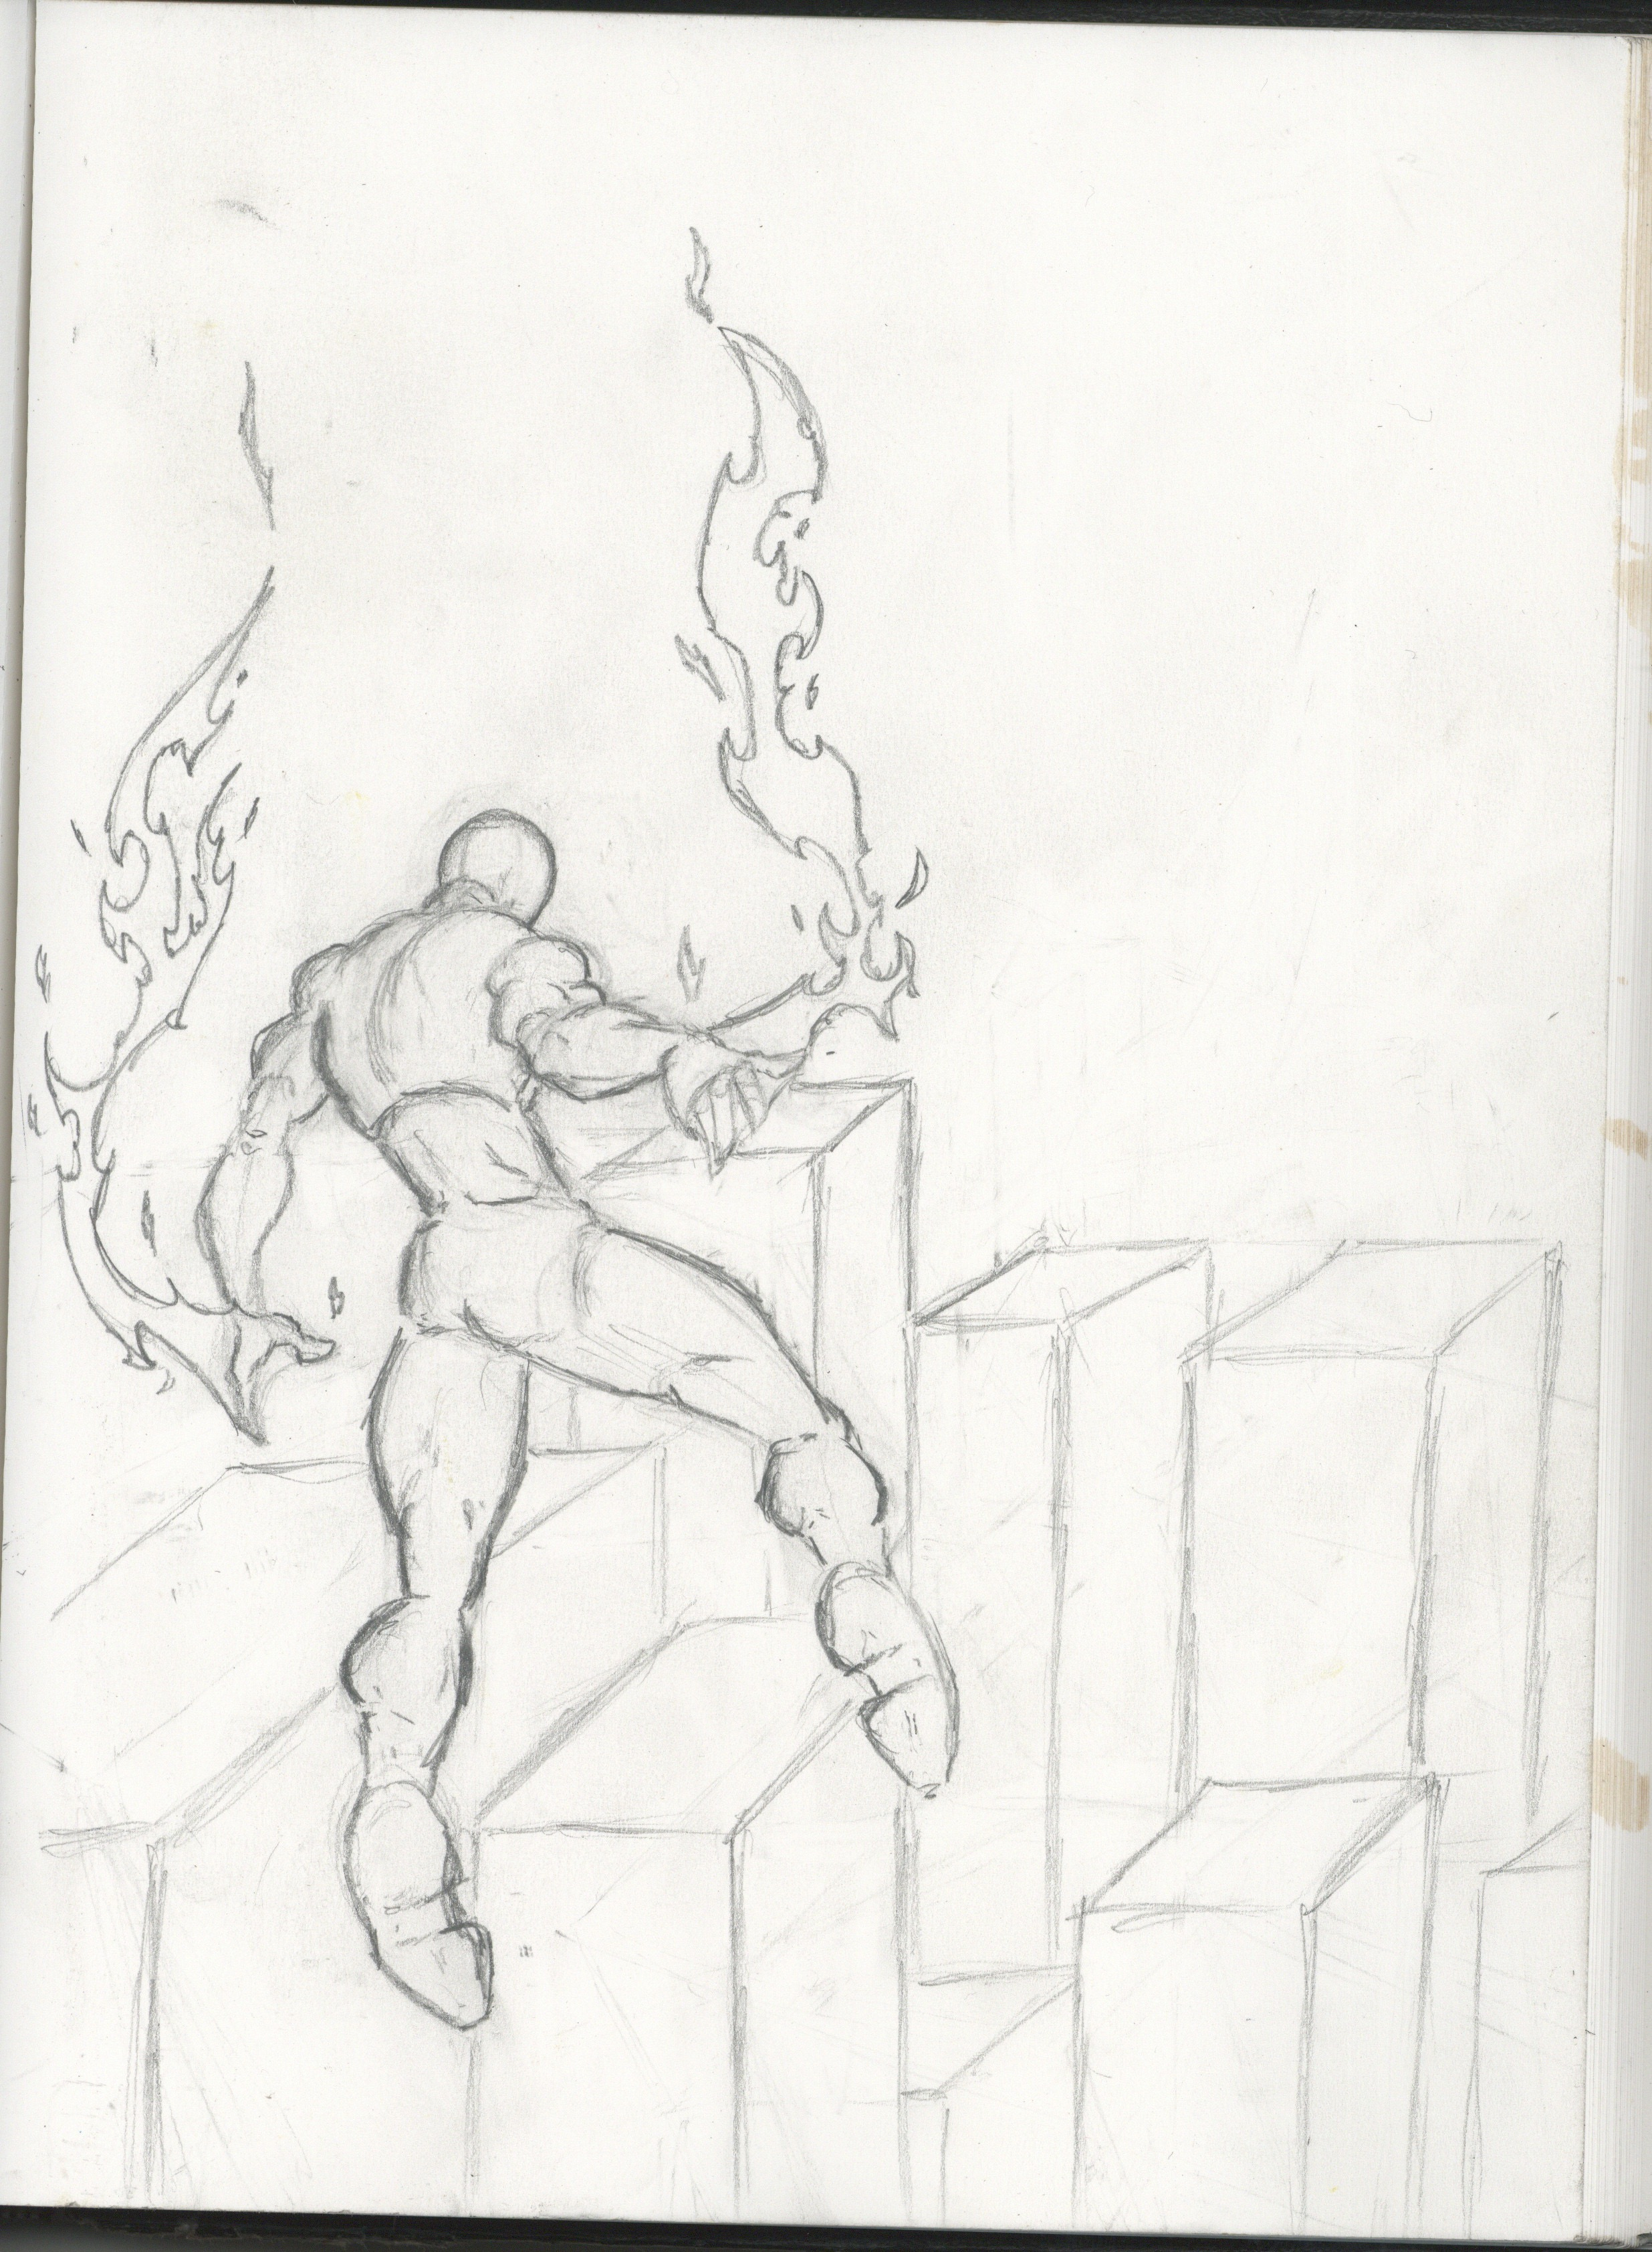These Lines are bolder, making the figure pop out more. The picture is more defined making the pencil marks and sketching more visible to the eye.

