KNOWING YOUR BODY
Lucy Hur
April, 2020

Anatomy & Physiology II
BIO 2312 D057
Wednesdays 2:30 PM – 5:00 PM
Professor Niloufar Haque
Introduction
Our planet is highly-populated, with over 7.5 billion Homo sapiens currently residing on earth. Despite the vast numbers of humans in the population, not many tend to truly be aware of themselves. How many of us genuinely know who we are from the inside out? Identification and character development is an obvious method of self-awareness, but this is mostly done for spiritual and mental growth. Mental awareness is surely important but physical awareness is just as necessary. One must understand the physical mechanism and science of their body for an accurate and complete self-comprehension.
Knowing the body parts and its structure is not enough for physical body awareness. Familiarity in the functions of the body’s different systems along with its’ comprising organs are required to understand how our body works. The study of the body parts and its structure is called anatomy, while the study of the body structure’s functions is called physiology. Human anatomy and physiology courses are subdivided into Anatomy and Physiology I (A&P I) and Anatomy and Physiology II (A&P II). A&P II is a continuation of A&P I, therefore the systems not previously discussed in A&P I will be heavily focused in A&P II. The body systems that have been covered in our A&P II thus far include the cardiovascular system, circulatory system, lymphatic system, respiratory system, digestive system, and urinary system. The remaining reproductive system and endocrine system will be introduced later in the course.
The main objective of this project was to expand our knowledge on how our own body operates, and to use that knowledge to visualize the impacts our daily activities have on our body. Since our personal data is required to accomplish the assignment’s goal, it would be practical to briefly introduce who I am. For starters, I am a Korean-American woman born and raised in New York City. I recently celebrated my 26th birthday last month in quarantine. I consider myself to be relatively healthy, coming from a family with no known underlying health issues. Weighing approximately 48 kg and standing 158 cm tall, my BMI of 19.2 is considered to be in the normal range (“Calculate Your BMI – Standard BMI Calculator”). Series of experiments were conducted to get a deeper understanding of our bodies. Aside from dissecting a fetal-pig for anatomical overview, in-laboratory exercises included measuring our pulse, taking our blood pressures, and conducting an EKG. Additionally, one week’s worth of sleep analysis and dietary recordings were evaluated at home.
Materials and Methods
Our first lab experiment was to measure our pulse in order to check our heart rate. A timer was required to ensure that our data was most accurate. Our heart rate is determined by the number of times our heart beat in one minute. The total pulse counted during the timed minute would be our result. Our pulses were measured twice under differing conditions. The first measurement was taken at the start of the class, when our body was relaxed and at rest. Our second pulse measurement was taken towards the end of class, when our mind and body was put under more levels of stress.
Another experiment conducted in class was checking our blood pressure. The pressure formed by the force of blood on our blood vessels is our blood pressure. Our lab partners used a sphygmomanometer and a stethoscope to check our blood pressure. Just like when we measured our pulse, our blood pressure was taken at rest and under stress. We first checked our blood pressure at rest. The cuff was wrapped around our bare upper arm and the head of the stethoscope was placed under the cuff, over our brachial artery. The sphygmomanometer was closely observed as the cuff was inflated to 180 mmHg. Listening carefully with the stethoscope, air was then slowly released to hear the sound of blood flow. The first sound heard was the systolic measure, while the second sound was the diastolic measure. This was repeated twice in order to find our average blood pressure at rest. These same steps are followed to check our blood pressure under stress. The only difference was the addition of cardio. Prior to checking our blood pressure, we were instructed to run up and down flights of stairs. Our blood pressure was taken immediately after.
Electrocardiography was performed to record our heart’s electrical activity, otherwise known as an ECG/EKG. An ECG can determine our heart rate and detect heart conditions. This activity was conducted under a substitute professor’s supervision. Unfortunately, we were unable to record our individual ECG. Instead, the class was divided into 2 groups, and only 1 student from each group had their ECG recorded. An electrocardiograph (ECG machine) and electrodes were used for this activity. My group’s subject was Kevin Watch, a male in his early 30s. Kevin lay flat on the table after removing all of his jewelry and shirt. Electrodes were then attached to the corresponding areas on his body. Kevin was instructed not to speak or move during the recording in order to prevent any artifacts from interfering with the reading. Once the process was complete, the recorded ECG was printed out. Observing the bottom lead II of the rhythmic strip, large boxes between the two R waves were counted. Kevin’s heart rate was then calculated by dividing 300 by the box count.
At-home experiments were conducted as well. A week’s worth of sleep analysis and dietary log were recorded. A planner/journal and an app called Pillow were used for this experiment. The time and menu of every meal were recorded daily in the planner, while the hours slept were tracked by using the Pillow app at night. Not much differed during the week-long experiment, aside from one particular day. Although it was an unhealthy approach, I deprived my body of nutrients and sleep by fasting and staying up all night. Only water was consumed throughout that day.
Data and Results
Figure 1: EKG Recording
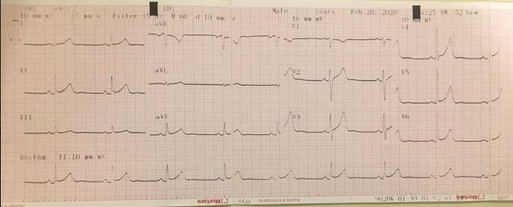
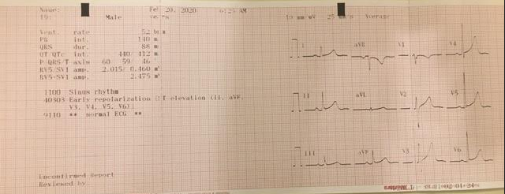
EKG of Kevin Watch recorded on 2/19/2020. We observed the rhythmic strip, lead II in order to calculate his heart rate. There were 5.5 large boxes between the two R waves. Kevin’s heart rate was calculated by 300 ÷ 5.5= 54.55 BPM.
Table 1: Pulse Measurements Under Differing Conditions
Pulse Measurement at Rest (BPM) | Pulse Measurement Under Stress (BPM)
62 BPM | 73 BPM
The results indicate that the levels of stress on our body affect our pulse/heart rate. Although pulse rate increased under stress, both measurements are considered to be in the normal range.
Table 2: Blood Pressure Under Differing Conditions
Blood Pressure  at Rest #1  (Systolic/Diastolic mmHg) | Blood Pressure  at Rest #2  (Systolic/Diastolic mmHg) | Average Blood Pressure at Rest  (Systolic/Diastolic mmHg) | Blood Pressure Under Stress  (Systolic/Diastolic mmHg)
107/80 mmHg | 106/72 mmHg | 106.5/76 mmHg | 110/82 mmHg
The results indicate that the levels of stress on our body affect our blood pressure. Both measurements were within the normal range of 120/80 mmHg.
Table 3: Dietary and Sleep Log
 | WAKE | MEAL TIMES, MENU & DESCRIPTION | SLEPT
4/13/2020 | 11:00 am | 3:30 PM – fried rice  8:45 PM – lechon, thin noodles, rice, ginger ale | 12:30 am
4/14/2020 | 8:00 am | NO MEALS, ONLY WATER | NO SLEEP
4/15/2020 | XXXX | 4:30 PM – McDonald’s hamburger and chicken nuggets | 11:00 pm
4/16/2020 | 1:30 pm | 3:30 PM – 2 slices of pizza  8:45 PM – fried calamari and shrimp with marinara sauce | 2:00 am
4/17/2020 | 10:30 am | 6:00 PM – Chick-fil-A’s spicy chicken sandwich meal | 2:30 am
4/18/2020 | 11:00 am | 2:30 PM – homemade BBQ wings and hot wings  10:30 PM – ramen | 1:30 am
4/19/2020 | 11:00 am | 3:00 PM – Chipotle chicken burrito bowl | 1:45 am
One week’s recording of dietary and sleep log. Note that on 4/14/2020, a.) no meals were consumed, and b). I did not get any hours of sleep. The following day, I was mentally drained and physically exhausted. My skin broke out in acne as well.

Conclusion
The human body is so complex, yet so uniformed. Although they all have different functions, the body’s 11 different systems rely on each other and work together in unison. A malfunction of any one of the systems can put our entire body at risk of danger. The experiments conducted in this project demonstrated how our daily activities affect our body and its systems. Exercise and stress are examples of factors that affect the heart rate and blood pressure. Our body requires nutrients and rest in order to function properly. The collection of my personal data suggests that my overall health will decline later down the road if I continue living this way. In order to improve my body’s health, changes must be incorporated to my daily routine such as a consistent sleeping schedule, nutritional diet, and regular exercise. Continued practice of good habits hopefully will ensure a healthy life as we grow older.

Reference
“Calculate Your BMI - Standard BMI Calculator.” National Heart Lung and Blood Institute, U.S. Department of Health and Human Services, www.nhlbi.nih.gov/health/educational/lose_wt/BMI/bmicalc.htm.

