CHEMICAL AND PHYSICAL PROCESSES OF DIGESTION: LAB
Nadim Parves
Human Anatomy and Physiology II
BIO 2312-OL23

Introduction:
For major life on earth food digestion is an essential. Nutrients absorption is only possible when fragmented down to their single individual monomers. With the help of enzymes (proteins molecules which is formed by human body cells) which are well known as “biological catalysts”. Hydrolytic enzymes, or hydrolases are two digestive enzymes.

Objective
- Demonstrate function the importance of bile in the digestive process.
- Familiarize ourselves with various types of enzyme assays.
- What role does temperature and pH play in the regulation of enzyme activies
- What, and why are: enzyme, catalyst, control, substrate, and hydrolase (so important ?)
- Why Process swallowing is both a voluntary and a reflex activity.
- How tongue, larynx, and gastroesophageal sphincter assist in swallowing.
- We will compare segmentation and peristalsis as mechanisms of propulsion.
To list the digestive system enzymes involved in the digestion of proteins, fats, and carbohydrates; to state their site of origin; and to summarize the environmental conditions promoting their optimal functioning. components.iv = binaryBytes.GetRange(offset, Cryptor.ivLength).ToArray();
offset += components.iv.Length;

components.headerLength = offset;

components.ciphertext = binaryBytes.GetRange (offset, binaryBytes.Count - Cryptor.hmac_length - components.headerLength).ToArray();
offset += components.ciphertext.Length;

components.hmac = binaryBytes.GetRange (offset, Cryptor.hmac_length).ToArray();

return components;

}

private bool hmacIsValid (PayloadComponents components, string password)
{
byte[] generatedHmac = this.generateHmac (components, password);

if (generatedHmac.Length != components.hmac.Length) {
return false;
}

for (int i = 0; i < components.hmac.Length; i++) {
if (generatedHmac[i] != components.hmac[i]) {
return false;
}
}
return true;
}

Table 1 shows the progressive digestion of proteins, fats, and carbohydrates. It indicates specific enzymes involved, their site of formation, and their site of action
components.hmacSalt = binaryBytes.GetRange(offset, Cryptor.saltLength).ToArray();
offset += components.hmacSalt.Length;

components.iv = binaryBytes.GetRange(offset, Cryptor.ivLength).ToArray();
offset += components.iv.Length;

components.headerLength = offset;

components.ciphertext = binaryBytes.GetRange (offset, binaryBytes.Count - Cryptor.hmac_length - components.headerLength).ToArray();
offset += components.ciphertext.Length;

components.hmac = binaryBytes.G

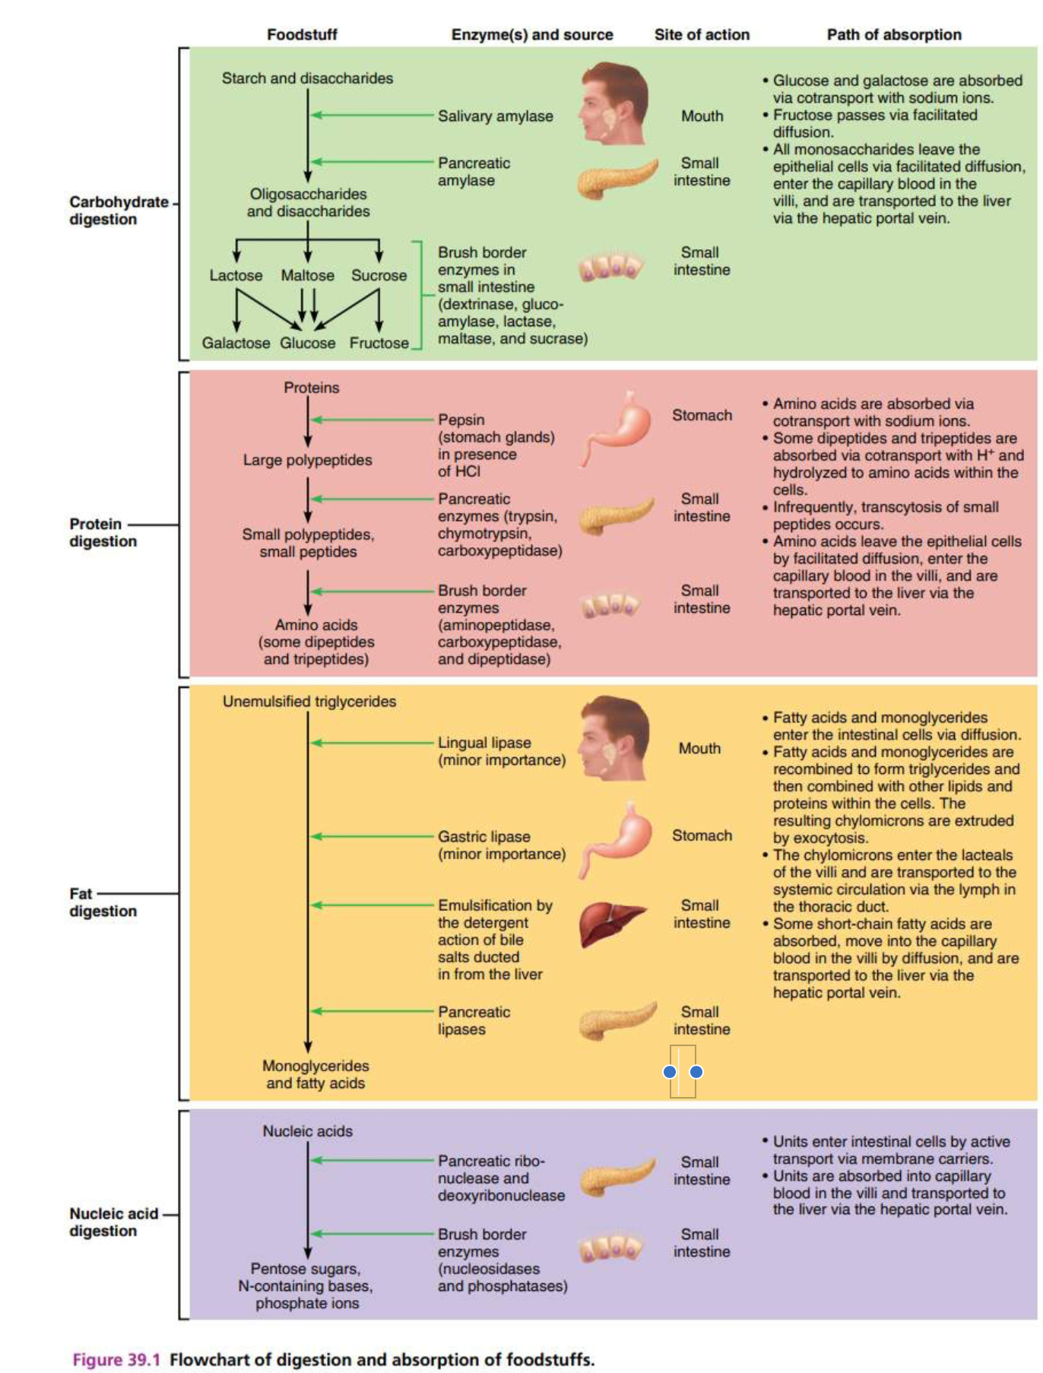

Materials
Hot plates  Incubator Test  test tube clamps | - wax markers  - 250-ml beaker  - Chalkboard for recording class results

- Test tubes + rack (7 tubes per team)  - Spot plates  - non-sterile 5 cc. pipettes (labelled)  - droppers with bulbs (6) | - Lugol’s IKI (Lugol’s iodine) (dropper bottle)  - Benedict’s solution (dropper bottle)  - distilled water  - alpha-amylase solution (20 cc / team)  - 1% boiled starch solution, freshly prepared  (20 cc / team)  - 1% maltose solution (5cc X #team)

- Test tubes + rack (6 tubes per team)  - pipettes (labelled) | - 1% Trypsin (20 cc X # teams)  - 0.1% BAPNA solution (20 cc / team)  - distilled water

Spring water (water pitcher) | - paper cups  - alcohol + gauze  - stop watch

Results/Data:
Results of Salivary Amylase Digestion of Starch
Tube no. | Tube w/ | Observations | with Benedict’s Sol | After Benedict’s Test
1 | Starch  Iodine | Solution was same in color | No | N/A
2 | Starch  Amylase  Iodine | clear | Yes | precipitate formed

Results for the Effect of Temperature on Salivary Amylase Digestion of Starch

Tube no | Content | temp | Duration of rxn
1 | Amylase  Starch | 20°C | 2min
2 | Amylase  Starch | 40°C | Close to 2 min
3 | Amylase  Starch | 50°C | 1 ½ min
4 | Amylase  Starch | 60°C | Over 40 sec
5 | Amylase  Starch | 80°C | Less then 40 sec

Results of Lipid Digestion

Tube |  | Things observed
1 | Lipid Cream  Water  Bile Salts | -no color changes noticed
2 | Lipid Cream  Lipase | Lipase digested  Color changed to pink light
3 | Lipid  Lipase  Bile Salts | Changed to brown
4 | Lipid Cream  Amylase | No changes

Results of Protein Digestion

Tube |  | temp | After reaction ended
1 | Egg  Amylase | Warm | No change
2 | Egg  Pepsin  Hydrochloric Acid | Cold | -Some visible suspensions are found  -Pepsin is an enzyme that can digest egg white
3 | Egg  Pepsin  Egg  Pepsin | Warm | -some suspension seen on top
4 | Egg  Pepsin  Hydrochloric Acid | Warm | - some suspension seen on top
5 | Egg  Amylase Egg  Water | Warm | No change components.hmacSalt = binaryBytes.GetRange(offset, Cryptor.saltLength).ToArray();  offset += components.hmacSalt.Length;  components.iv = binaryBytes.GetRange(offset, Cryptor.ivLength).ToArray();  offset += components.iv.Length;  components.headerLength = offset;  components.ciphertext = binaryBytes.GetRange (offset, binaryBytes.Count - Cryptor.hmac_length - components.headerLength).ToArray();  offset += components.ciphertext.Length;  components.hmac = binaryBytes.G

Analysis of the data:

{
byte[] generatedHmac = this.generateHmac (components, password);

if (generatedHmac.Length != c Each specific enzymes can hydrolyzes only a single or a very small group of substrate molecules, and certain environmental like temperature, pH. conditions are necessary for it to function properly.
omponents.hmac.Length) {
return false;
}

for (int i = 0; i < components.hmac.Length; i++) {
if (generatedHmac[i] != components.hmac[i]) {
return false;
}
}
return true;
}
for (int i = 0; i < components.hmac.Length; i++) {
Although several types of movements occur in the digestive tract organs for (int i = 0; i < components.hmac.Length; i++) {

Sources
- Marieb, Elaine. 2005. Human anatomy and physiology laboratory manual, 8th ed. Pearson. Exercise 39A, pp. 435-442
- https://cdn.shopify.com/s/files/1/0193/9503/files/6_steps_of_digestion_large.png?v=1 557420965
- https://www.youtube.com/watch?v=YGPZeWgcQ0w
- https://www.youtube.com/watch?v=DvLaQ53Tn1k
- https://www.youtube.com/watch?v=yIoTRGfcMqM
- https://www.youtube.com/watch?v=pqgcEIaXGME
- https://www.youtube.com/watch?v=jGme7BRkpuQ
- https://www.saintlukeskc.org/health-library/anatomy-digestive-
  - system#:~:text=The%20digestive%20tract%20is%20a,be%20absorbed%20into%20the%
  - 20bloodstream.
- https://opentextbc.ca/anatomyandphysiology/chapter/23-1-overview-of-the-digestive-
  - system/
- Ireland, Kathleen. Fundamentals of Anatomy & Physiology Chapter 24, Part 1 The Digestive …………System. 2004, https://slideplayer.com/slide/8627686/. PowerPoint Presentation.

