Urinalysis Lab Report

Nadim Parves

Human Anatomy and Physiology II

BIO 2312-OL23

Introduction

Many individuals will have to give an urine sample for testing at one point in there life. The sample given may evaluated using several methods. These tests assist doctors to treat ongoing diseases and or disorder a individual may have or simply check on progress.

#mainpage #mainContainer {
min-height: 650px;
height: 100%;
min-width: 700px;
position: relative;
}
#mainContainer {
position: relative;
min-height: 100%;
overflow: hidden;
}
*, ::after, ::before {
-webkit-box-sizing: border-box;
-moz-box-sizing: border-box;
box-sizing: border-box;
}
body, html {
font-family: Arial, Sans-Serif;
font-size: 13px;
}
body {
line-height: 1.428571429;
color: #333;
}
html {
font-size: 62.5%;
}
html {
font-family: sans-serif;
-webkit-text-size-adjust: 100%;
}
position
margin
border
padding
1440×650
1440×650
relative
box-sizing
border-box
display
block
float
none
line-height
18.5667px
position
relative
offsetbody#body
z-index
auto
Objective

The purpose of this lab session was to examine and match urine samples and
conclude if there are abnormalities in them.

Materials

- Urine samples
- multistix strips
- pH meter
- Microscope
- Urinometer
- Timer

Methods

#mainpage #mainContainer {
min-height: 650px;
height: 100%;
min-width: 700px;
position: relative;
}
#mainContainer {
position: relative;
min-height: 100%;
overflow: hidden;
}
*, ::after, ::before {
-webkit-box-sizing: border-box;
-moz-box-sizing: border-box;
box-sizing: border-box;
}
body, html {
font-family: Arial, Sans-Serif;
font-size: 13px;
}
body {
line-height: 1.428571429;
color: #333;
}
html {
font-size: 62.5%;
}
html {
font-family: sans-serif;
-webkit-text-size-adjust: 100%;
}
position
margin
border
padding
1440×650
1440×650
relative
box-sizing
border-box
display
block
float
none
line-height
18.5667px
position
relative
offsetbody#body
z-index
auto

Results/Data
Sample Type | Leukocyte | Urobilinogen | Protein | Nitrite | Glucose | Specific gravity | Bilirubin (BIL) | Blood | Ketones (KET)
Abnormal Urine-2 Artificial sample | Negative | 0.2mg/dL | 2000 or more  ++++ | Negative | 1000mg/dL | 1.000 | Negative | ?? | Trace 5mg/dL
Abnormal Urine-1 Artificial sample | Negative | 1mg/dL | 300  +++ | Negative | 2 or more (mg/dL)  2000 or more(mg/dL) | 1.000 | Negative | Negative | 100mg/dL
Normal Urine Artificial sample | Negative | 0.2mg/dL | Negative | Negative | Negative | 1.02o | Negative | Negative | Trace 5mg/dL

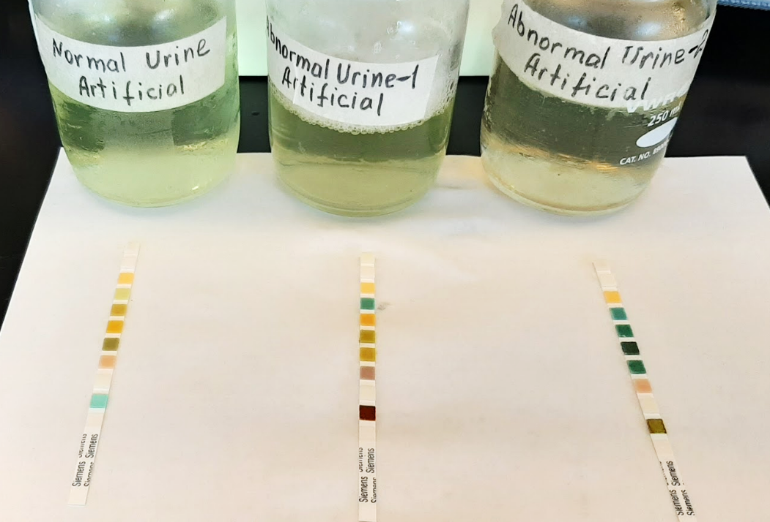
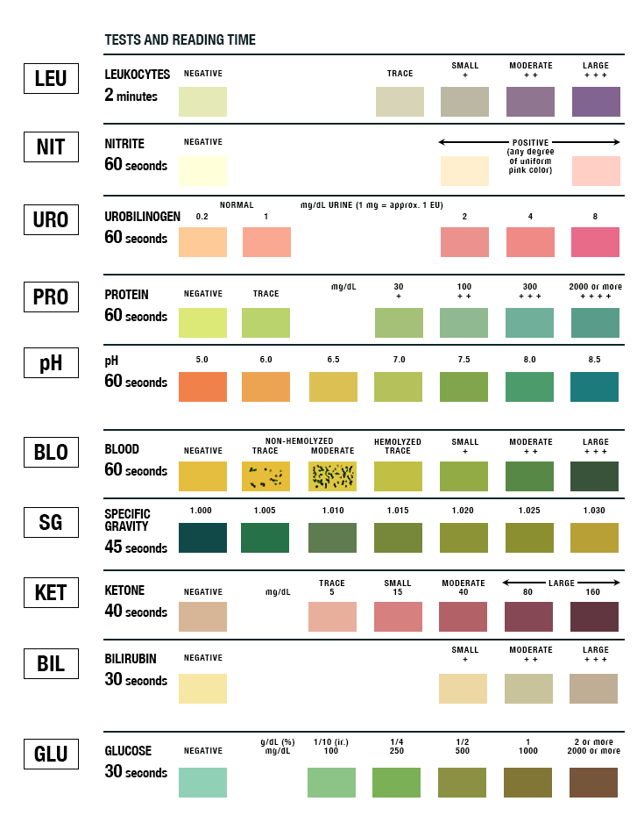
Discussion/Conclusion#mainpage #mainContainer {
min-height: 650px;
height: 100%;
min-width: 700px;
position: relative;
}
#mainContainer {
position: relative;
min-height: 100%;
overflow: hidden;
}
*, ::after, ::before {
-webkit-box-sizing: border-box;
-moz-box-sizing: border-box;
box-sizing: border-box;
}
body, html {
font-family: Arial, Sans-Serif;
font-size: 13px;
}
body {
line-height: 1.428571429;
color: #333;
}
html {
font-size: 62.5%;
}
html {
font-family: sans-serif;
-webkit-text-size-adjust: 100%;
}
position
margin
border
padding
1440×650
1440×650
relative
box-sizing
border-box
display
block
float
none
line-height
18.5667px
position
relative
offsetbody#body
z-index
auto

References

Martini, Frederic, et al. Fundamentals of Anatomy & Physiology. Pearson Education, Inc., 2018.

