Daniel Espinoza
ENG 1121
Professor Rebekah Coleman
3/2/2020
Word Count: 1124
More Than A Sport: The NBA

The NBA, what is it? The National Basketball Association is full of pride and glory for players to win and become an NBA champion. Some would say it isn’t a Discourse Community because it is too broad of a community. That’s not true, the NBA is specific enough compared to a Lakers community which is also a Discourse Community, but the NBA is as well. The NBA is one of the largest communities in the world.
Communication is key to express how we feel and feel about anything that happens in the NBA. Our community can communicate with: Twitter, Instagram, Facebook, Discord, or almost any social media app. One of our best ways to communicate is using memes that everyone finds funny and can make people understand the topic being discussed a bit better. A very well-known meme is the crying Michael Jordan meme that is used commonly due to the humor of Jordan’s face, it’s priceless.
Our goals are very simple to understand: to entertain, debate, appreciate greatness, and enjoying the sport. Famous athletes like Lebron James, Kawhi Leonard, Giannis Antetokounmpo, James Harden are who make our community alive and great. To join our community, you must: have a favorite team and or player, have basic knowledge of the NBA, and be able to defend yourself in a tough debate. Members of the community always love these statistics in the game such as field percentage, points, steals, rebounds, blocks, etc. all are important to us. Of course, there is a famous debate about whether a number/statistic should define what kind of player you are.
Our way of speaking can be in almost every language as our Discourse Community is very diverse. Also, a common way in which we speak is using internet slang such as: lol, simp, u, and so much more. Special NBA terms we use are “brick” which means the NBA player missed the shot or like “Dub” which is used to indicate whether someone won in a debate or an NBA game. These words or terms are encouraging and motivating for members to participate in debates and comedy, especially the word “Dub” is the best term in the NBA community.
Everyone has a unique identity kit in our community, some people may be the funniest and the best at making memes, and some might be smart with knowing statistics in a second during a debate. If you spot anyone with some NBA clothes or a hat, you’ll know that they are part of the NBA community.
Before explaining the depths of the NBA Discourse Community, discussing the environment is important. Members of the NBA Discourse Community must be aware that the social media environment can be rough sometimes. Generally, debates turn into arguments that make members use foul language. Members must have a strong mentality, meaning to have the ability to take a joke and not easily take offense to something. Nothing is personal in this Discourse Community; everyone appreciates each other company.
Many of the members in the NBA Discourse Community love the famous ESPN which is a sports channel. ESPN has great shows throughout the day such as First Take, Get Up, The Jump, and so much more. These videos inform the Discourse Community about the NBA in case anybody missed games or inform them about the big news that is required for the Discourse Community to know. Information that can be important is the NBA Draft, NBA Playoffs, injuries, drama, etc. Great television personalities such as Stephan A. Smith, Max Kellerman, Jay Williams, and so much more is what makes these shows so great. They are great debaters in sports in how they gather statistics, personal opinions, intelligent debating, and analyzing data in all parts of ESPN.
Memes are what make our Discourse Community whole and fluid throughout. Memes help members express their humorous self and help other members understand what topic is being discussed by simply looking at the memes. Everyone in the community loves to communicate with memes, it’s our greatest benefits! For example, the meme below is very symbolic and has a whole lot of meaning. This meme was created in the week of the All-Star Dunk Contest in Chicago 2020. Dwayne Wade gave Aaron Gordan a 9/10 controversial rating, and he made this face. Aaron Gordan dunked on 7 feet 5 inches Tacko Fall which didn’t even earn him a 10/10 according to Dwayne. This meme is a GIF where he makes a face filled with confusion. The meme is only growing and has become very popular in the Discourse Community. This is commonly used when someone in our Discourse Community says something stupid even if they are joking around. It symbolizes the stupidity of someone or something that is simply stupid and or confusing.
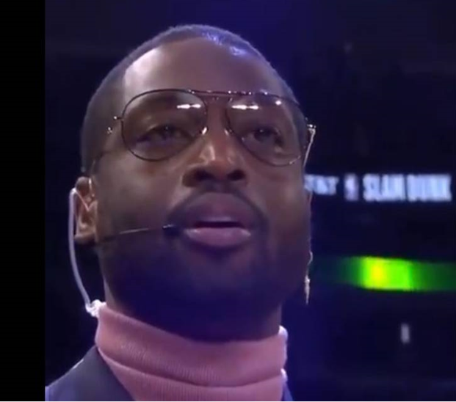

Videos are another thing our community loves to watch. They could come from any social media platforms like Instagram, Twitter, and YouTube. These videos can be made for various reasons to entertain, inform, and persuade. An example of one of the videos is on YouTube by ESPN on First Take below this paragraph with personalities: Stephen A. Smith, Max Kellerman, and Molly Qerim. This video can be considered an interview because they were talking one of the greats in Kevin Durant. Kevin Durant suffered from an Achilles injury during the 2019 NBA Finals which is one of the most career-ending injuries in all the sports. To this day he is still recovering but the ask questions about his career and drama that was going on in his previous team in the Golden State Warriors. He left the Warriors to join the Brooklyn Nets teaming up with Kyrie Irving. This video is important in our Discourse Community because KD is one the greats and everyone questioned his health, which team he was going to, his reasons for leaving the Warriors are all answered in this video.
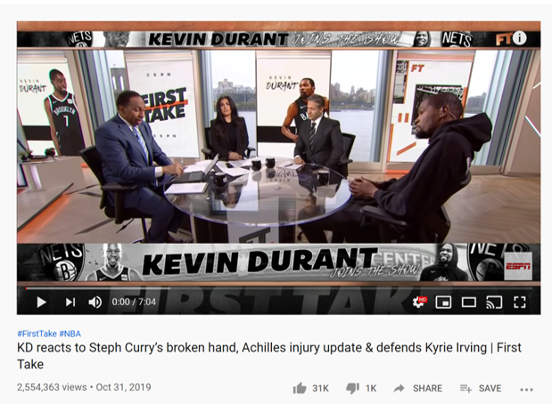

The NBA Discourse Community is one of its kind. The NBA is only growing even more like the younger generation love and enjoys this sport. Everyone has their unique identity kit by wearing unique clothing like a Lakers Jersey, hat, shoes are all the little pieces that make our Discourse Community great. Accommodated with humorous memes and jokes like Dwayne Wade, crying Michael Jordan, or Stephen A. Smith is essential in the Discourse Community. Appreciating Kawhi winning a championship or when Lebron won with the Cavs is great for our community even if the members don’t support it, it’s all about appreciating greatness. Overall, the NBA Discourse Community is filled with love for the NBA, caring for each other, entertain everyone, inform everyone, and appreciate greatness.

