Learning Places Fall 2016
Chin/Swift

SITE REPORT [part II: performer/spectator]
name of site report

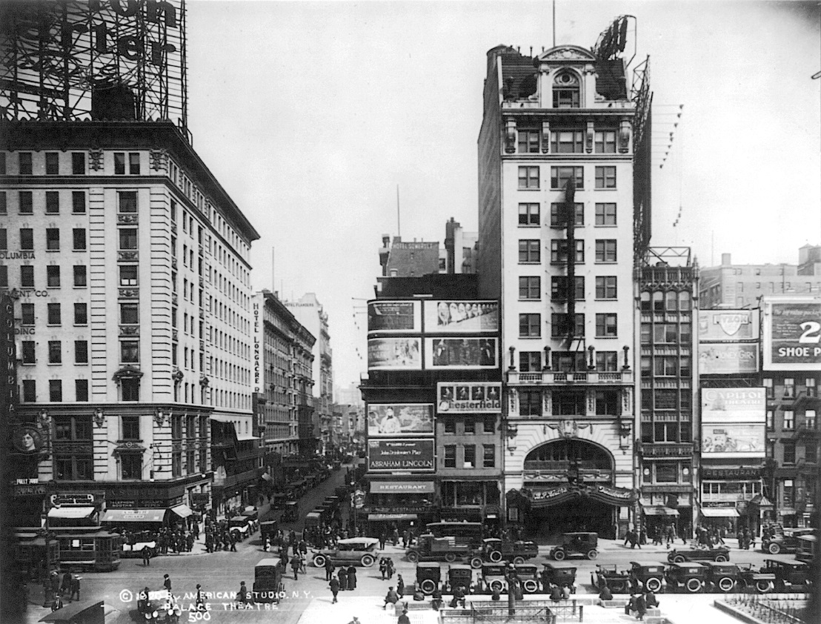

STUDENT NAME
Leslie Fuller

INTRODUCTION
This site report is about the history of Broadway Theater. The excitement of bring people together magnificent show that people can come enjoy. The theater is located on 1564 Broadway at 47th street. The palace opened it doors i

SITE DOCUMENTATION (photos/sketches)

This is the history of theater back turn of the century. Before the atomobiles people brought their horses and buggies to the show and it was slower pace back in the days in the late 1800's.

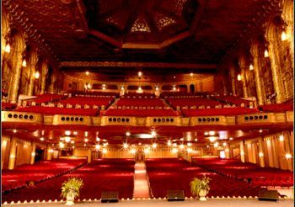

Write description of sketch or photo here, explaining why it is important and what it shows
The theater has two floor seats and it divided into groups, the more you pay the more you see the performance.

Write description of sketch or photo here, explaining why it is important and what it shows Write description of sketch or photo here, explaining why it is important and what it shows Write description of sketch or photo here, explaining why it is important and what it shows Write description of sketch or photo here, explaining why it is important and what it shows Write description of sketch or photo here, explaining why it is important and what it shows

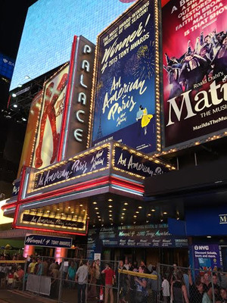

Write description of sketch or photo here, explaining why it is important and what it shows

QUALITATIVE SITE OBSERVATIONS
The Wall Street Journal describes how Mr. Wheeldon gives a great performance. They take extra care of the costumes and it takes months to prepare for the play. The songs that they sing in the play “I Got Rhyme”, “Love Here to Stay”, “The S Wonderful”.

- Description of performance limits (ground, walls, barricades, streets, buildings)

The performance is the star of the show.

- Description of audience (static, moving, direction of attention)

The audience is there is to see and get out of the performance.

- Description of audience (socio-economic, community identity)

The audience pays for the show, and they expect to a performance

- Description of performer/spectator dynamics (engagement, morphology)

The performance and spectators brings the theater to life with the applude

- Other Observations
When I go see the show I want to see live action.

QUANTITATIVE DATA for Area of Study
Subject | Data
Size of performance space | 1,748
Size of spectator space | 1,743
Range of dynamic change | Different people from all over the world comes see this show.
# of points of focus | The people exacally wants to see the performance.
Number of spectators (range) | The spectators comes in thousands
Time period of performance | It takes place during the day and night
# of repetitions | The show have different times during the days of the week.
Cost of performance (if any) | The cost of performance is $47.00 and up.
Other data

QUESTIONS TO RESEARCH FURTHER
QUESTIONS:
- Lorem ipsum dolor sit amet?
- Consectetuer adipiscing elit?
- Sed diam nonummy nibh euismod?
RESEARCH METHOD/SOURCE FOR EACH QUESTION ABOVE:
- Question 1
  - xx
  - xx
  - xx
- Question 2
  - xx
  - xx
  - xx
- Question 3
  - xx
  - xx
  - xx

SUMMARY / POST VISIT REFLECTION
Lorem ipsum dolor sit amet, consectetuer adipiscing elit, sed diam nonummy nibh euismod tincidunt ut laoreet dolore magna aliquam erat volutpat. Ut wisi enim ad minim veniam, quis nostrud exerci tation ullamcorper suscipit lobortis nisl ut aliquip ex ea commodo consequat. Lorem ipsum dolor sit amet, consectetuer adipiscing elit, sed diam nonummy nibh euismod tincidunt ut laoreet dolore magna aliquam erat volutpat. Ut wisi enim ad minim veniam, quis nostrud exerci tation ullamcorper suscipit lobortis nisl ut aliquip ex ea commodo consequat.

