Learning Places Fall 2018
SITE REPORT #1A
Zuccotti Park / The Subway (The Oculus)
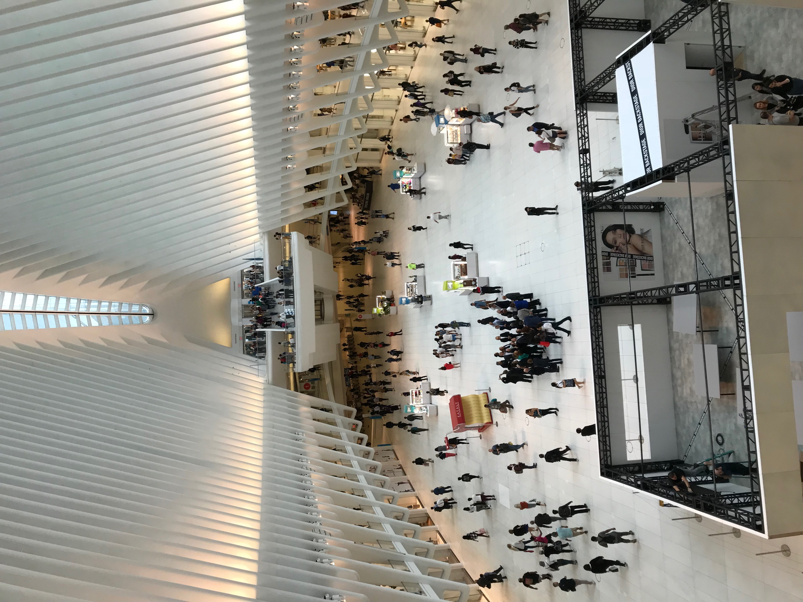
Cover Image: Modernization of Public Space
This image represents the modernity of public gathering space, the open ceiling allows freedom within the space. The all white façade evokes feelings of, newness, purity, welcoming, and futuristic attributes.

STUDENT NAME: Danielle Ali

INTRODUCTION
What were your expectations of the place, before arriving? Did your experience of the place match your expectations? How did it, or did it not, live up to your expectations? What did you notice about the place that you didn’t already know from reading or previous visits?
Zuccotti Park: Prior to arriving to Zuccotti Park, I presumed that I would be walking into a traditional park. Which would have included wooden benches, more landscaping, an enclosed space that was gated, as well as a significantly larger area. My experience did not match my expectations, and I felt that the name Zuccotti Park was not fitting for the space because it did not represent a ‘park’ at all. To me it was more like a ‘common area’, or a ‘community space’. Zuccotti Park is a great space for people who are touring the area, or individuals who work near to come to lounge around. I noticed that the space was a place that many people came to rest or have lunch. It seems like a space that not many people would pay attention too. From the readings I wouldn’t have known how actively used the space is. I work near Zuccotti Park, and have passed this park several times and never knew it was wear the Occupy Wall Street protests took place, I never thought much of the park. I also noticed that the sign that marks ‘Zuccotti Park’ is not very visible. Since this is a very important space due to the events that has took placed here, I feel that the park’s name should be more visible to people walking by. [THIS IS VERY WELL WRITTEN. GREAT OBSERVATIONS]
Subway (The Oculus): I have been to The Oculus several times, as a tourist, a shopper, and as a commuter. Before arriving, I didn’t expect it to be so busy. The Oculus is truly a gem, and each time I go there I feel as if I’ve learned or noticed something new. When I arrived to The Oculus, I felt a bit overwhelmed because of how many people were there, as well as the bright white lights. As I began to walk around I noticed how clean the space was kept. I noticed large groups of people who seemed to be have a meeting in the middle of the lower level, which seemed unordinary. [GOOD OBSERVATIONS] I also saw several cops posted all throughout The Oculus. The new World Trade Subway Station was absolutely mesmerizing [REALLY? THIS SEEMS HYPERBOLIC]. I didn’t expect it to be so meaningful and designed with such conscious effort of what it truly represents. [I DON’T UNDERSTAND THIS] I was surprised to see cleaning crews wiping down the turnstiles. I felt that my expectations were surpassed by the different details I noticed. From previous visits, I didn’t know that NYPD cops surveilled the area. I also didn’t know how many people come to The Oculus to do various things like casually talk with one another, business meetings, and just lounging around.

SITE OBSERVATIONS
Insert 3 photographs and provide a title for each image. The title should be a a word or short phrase that sums up the subject matter of the photo or a visual theme present in the photo.
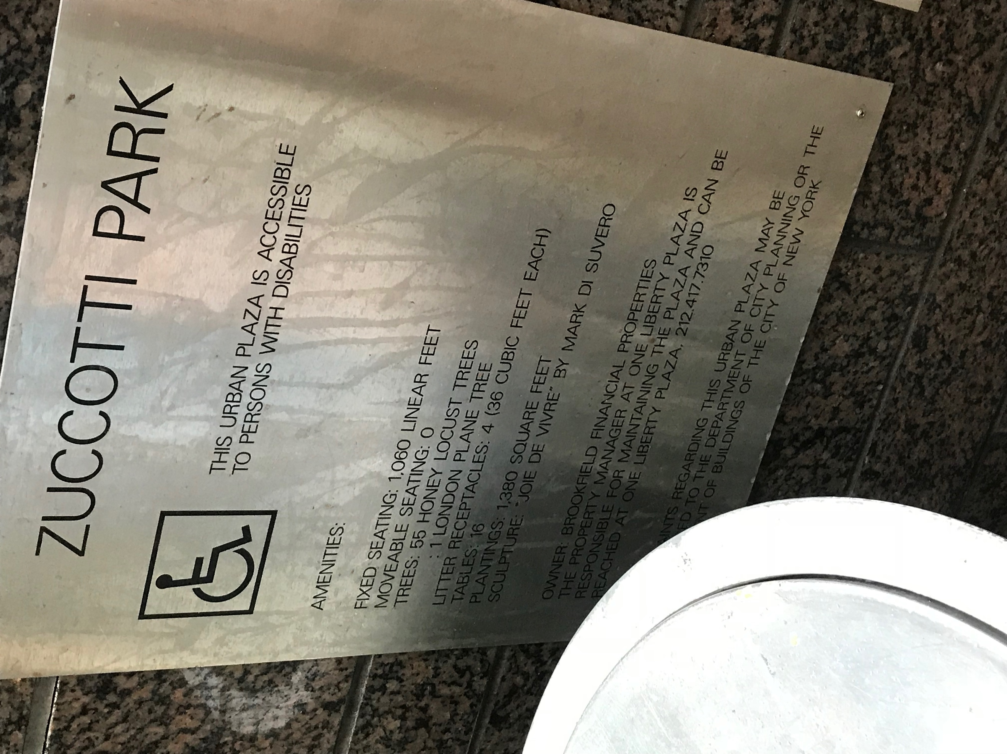
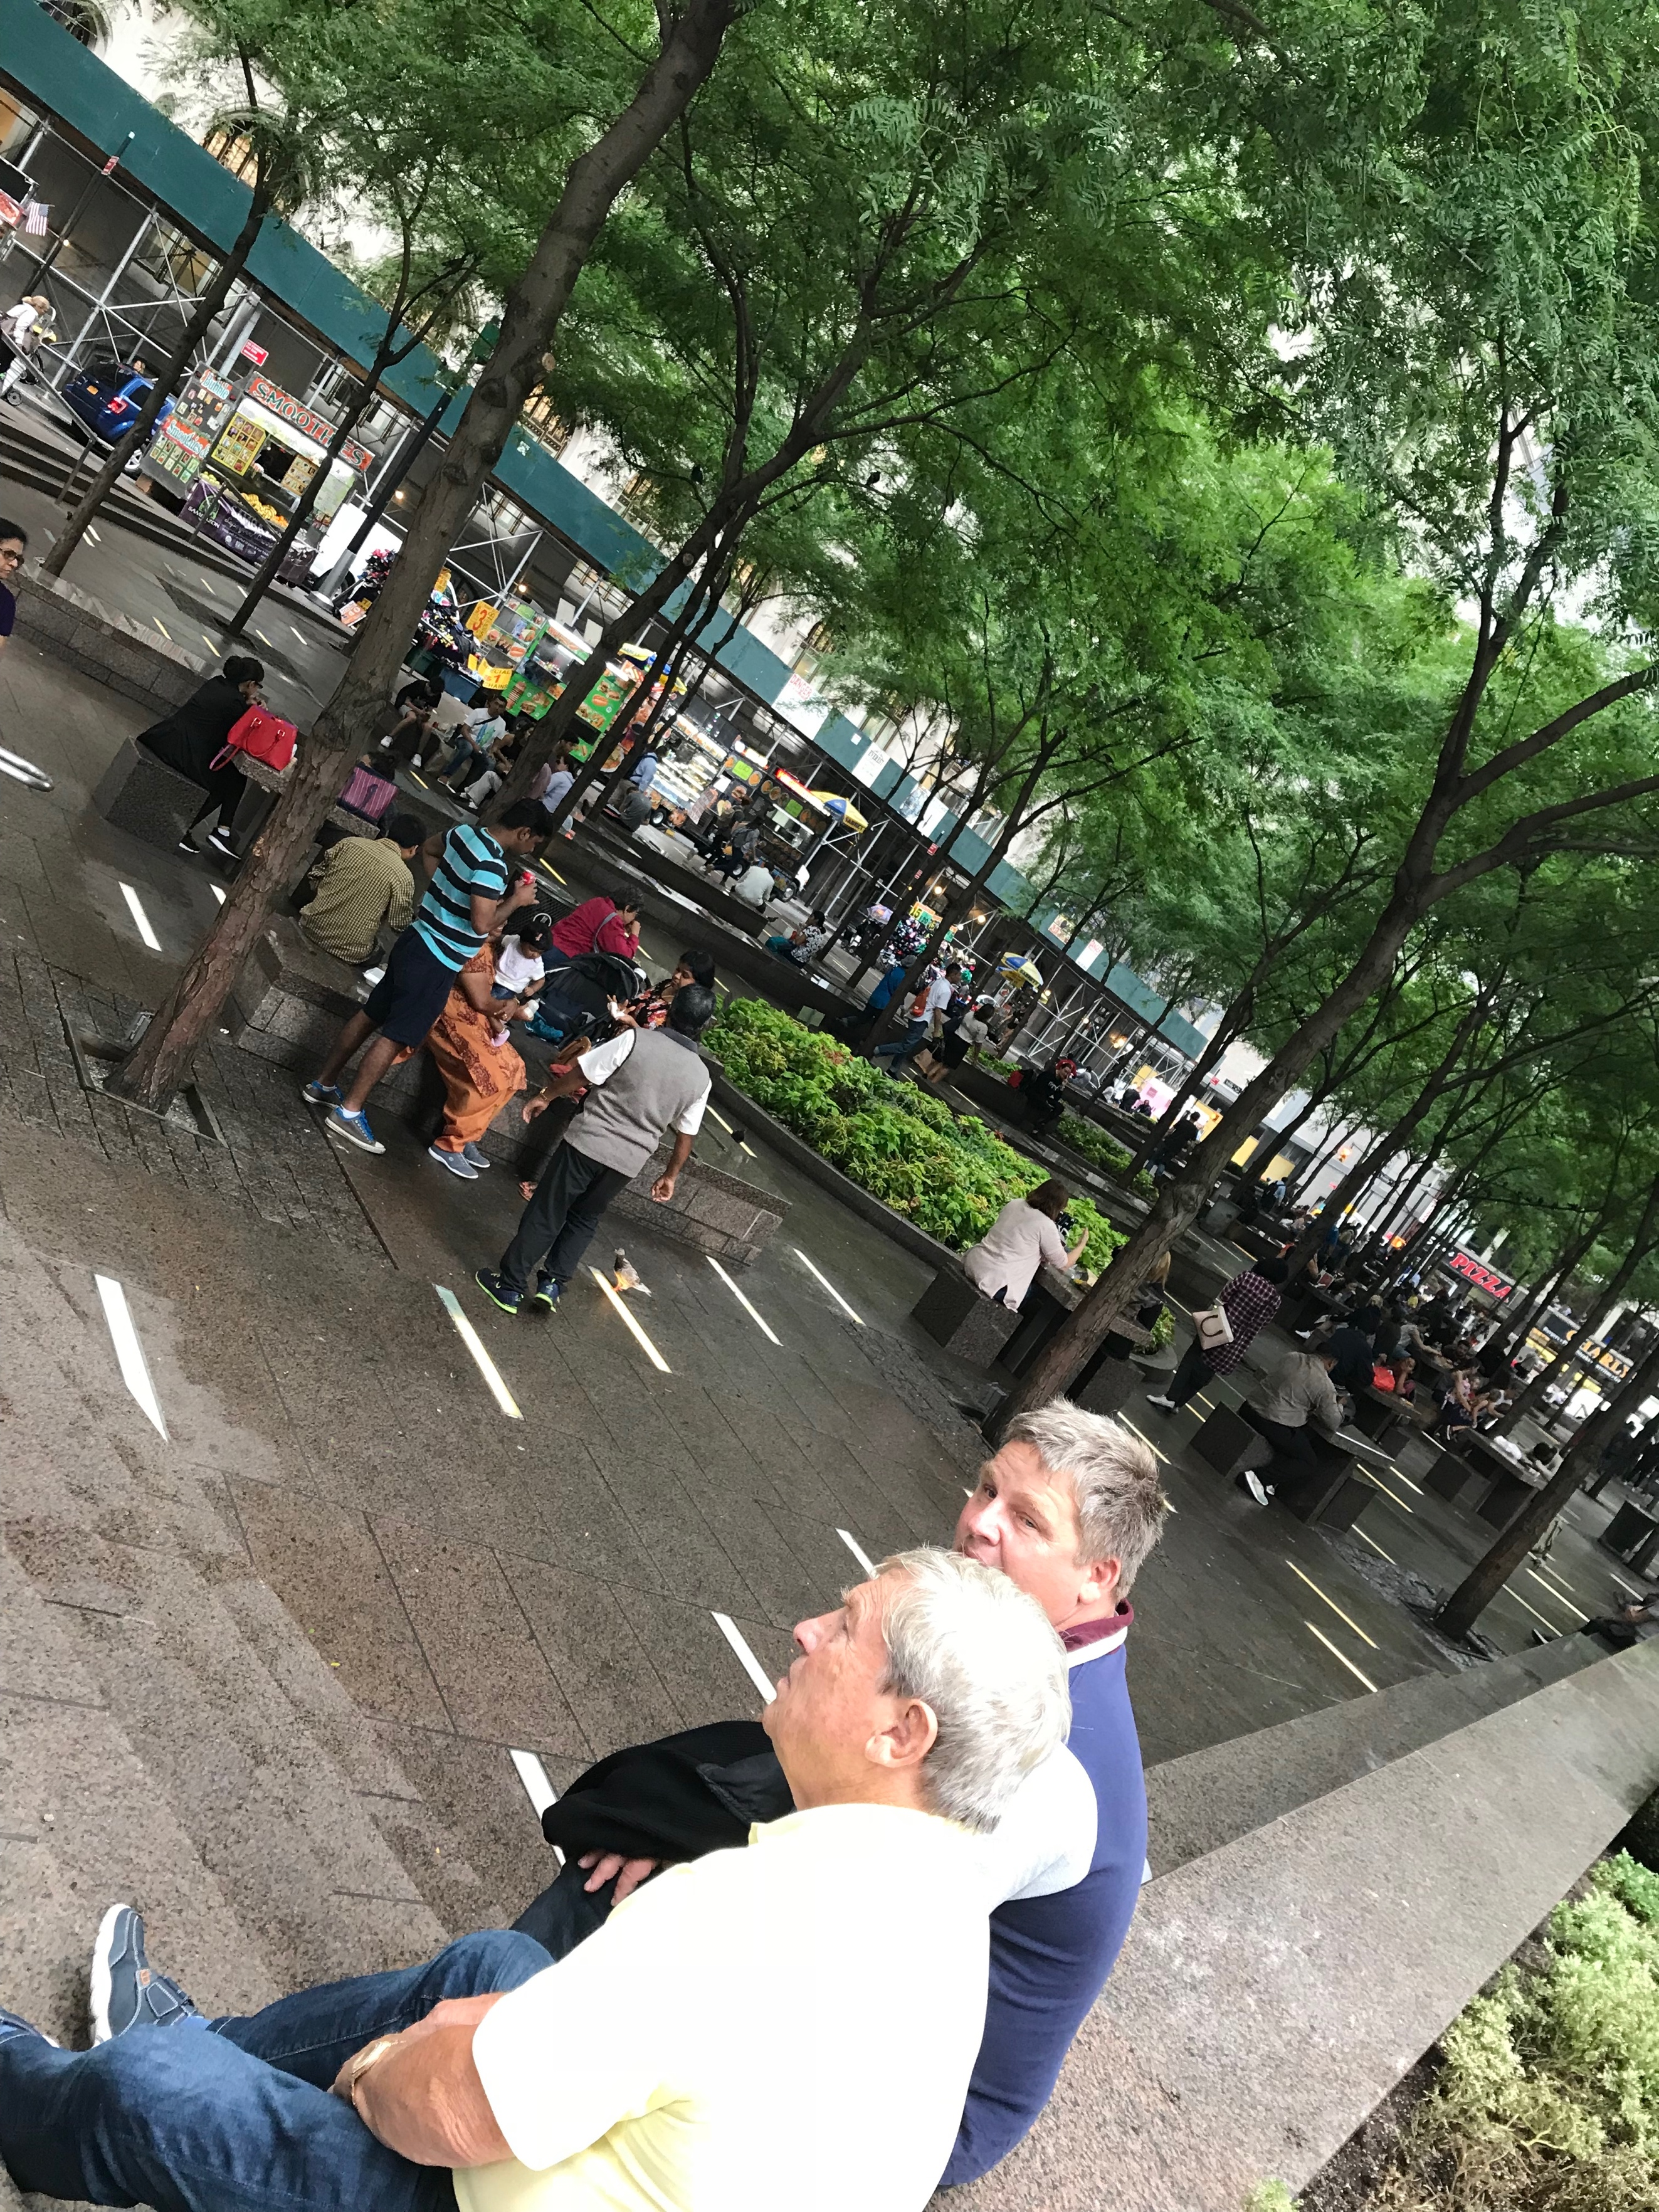
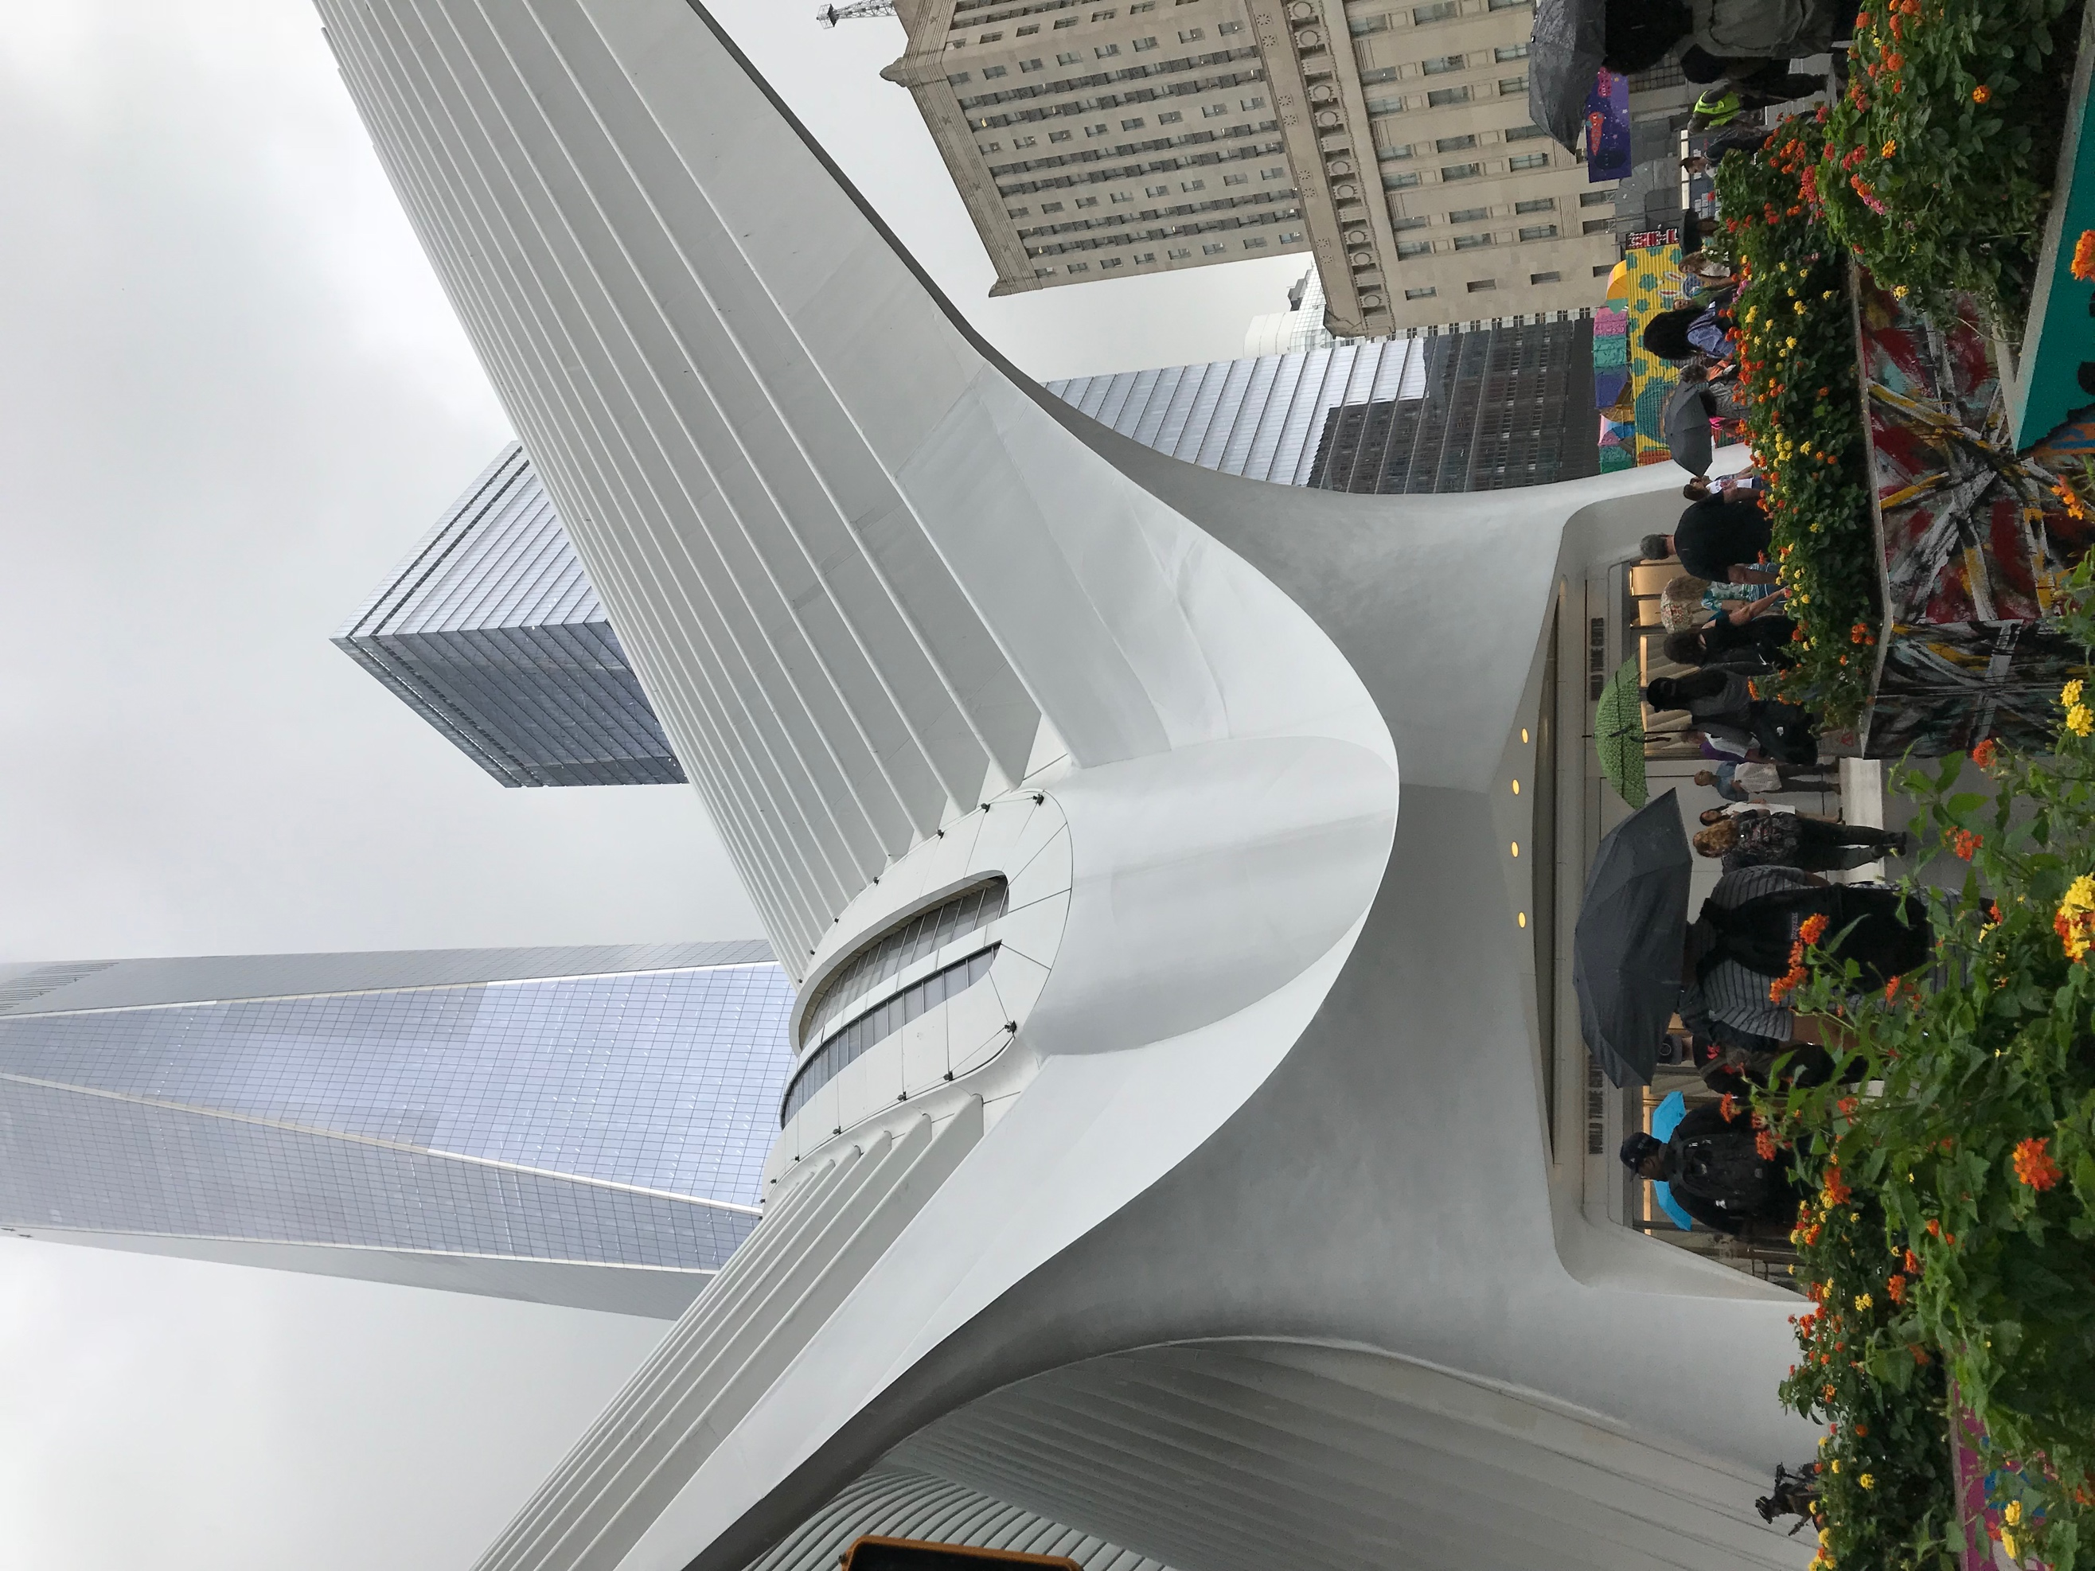
Urban Plaza Resting Space Building with Wings
Why did you choose these images? Do they summarize a feeling you have for the place? Do they focus on prominent objects or features of the place? Explain.
Urban Plaza (Zuccotti Park): This picture of the information panel, describes Zuccotti Park as an urban plaza which is formfitting for this park. Also, the panel describe that although this is a public park it is privately own which is an incredibly interesting concept [WHY? Explain.]. This photo focuses on some of the amenities and information of the park. This photo gives me a better understanding about the park’s data.
Resting Space (Zuccotti Park): What many people come to Zuccotti Park to do is to rest, sit and relax. It shows the many people gathering as if it is a ‘pit-spot’ to finalize any plans, or a quick convenient area to eat lunch, or to even gather thoughts. This photograph perfectly grasps [WRONG WORD] the idea of what this space is used for. It makes me feel that there is a modernization to parks, and urban plaza, where it doesn’t have to contain swings and benches, or landscape for people to utilize it, which is why I chose this image. I feel like there is a reason why benches aren’t in the park, because it isn’t made for comfort, more so convenience, to be in and out of the area. [GOOD!]
Building with Wings (The Oculus): This photo is a fascinating photo [COMPLIMENTING YOUR OWN WORK?], that captures the architectural beauty of The Oculus Structure. I chose this image because it shows how innovative, modern, and enchanting this building is, and the message it sends to the world. The building seems to be soaring, like a bird. [RIGHT] Also, this photo represents the structures uniqueness, it is unlike any other building in the city. This photo makes me feel hopeful and inspired, because of its cutting-edge design and memories attached to this location.
Describe the sizes and shapes of buildings in this area. Is there general uniformity or heterogeneity among structures?
The Buildings in this area are a mixture of general uniformity and heterogeneity [THIS DOESN”T MAKE SENSE]. Some of the structures are regular [WHAT ARE REGULAR SKYSCRAPERS? I DON”T THINK THERE IS A SINGLE NORM] large sky scrapers with reflective glass facades, and then you have unique structures like the Oculus smack down in the middle of the area. All of the buildings are unique in its own way. [BUT EARLIER YOU WROTE THAT THERE WAS UNIFORMITY AMONG THE BUILDINGS] The architecture in this area to me symbolize immense wealth and power. These structures are overwhelmingly intimidating and contains numerous of multi-billion-dollar companies. Most buildings in this area are convex polyhedrons [NO THEY ARE NOT… WHY DID YOU USE THIS TERM?] besides the Oculus which resembles a dove taking flight.

Describe the patterns, textures, colors, and ornamental features of the surfaces of the buildings and structures in and around the place.
The structures around this area can be considered art-deco with modernized French Gothic detailing [REALLY? WHERE? WHICH BUILDING IS ART DECO? TRY NOT TO MAKE STATEMENTS YOU CAN’T BACK UP]. Some of the buildings are steel-clad buildings that reflect off one another. A very interesting building that definitely stands out is One Liberty Plaza, it is a black steel building. It is unlike any of the buildings in the area because of its grim color and symbolic resonance. [SYMBOLIC OF WHAT?] Many of the buildings in the area features white Georgia marble and stone balustrades. In Zuccotti Park there is a large red sculpture by the beginning of the stairs. This sculpture is incredibly unique and resembles a bow compass. It brings a pop of color and modernization to the area. [GOOD!] The Oculus is a large structure that allows plenty of the outside light into the building. The surface of this building is white marble which stands out in the city.

How is the natural world integrated into the built environment? Were trees, plants, lawns, and bodies of water established around existing architectures, or were the buildings and walkways built to observe preexisting “wild” areas? Describe patterns and methods of integration.
Zuccotti Park: The natural world was definitely integrated into the built environment of this park. It includes many trees for shade. It has approximately 55 honey locust trees established around and inside of the plaza. It also has several circles of plants with do not feed birds signs. There are also small hedges along the upper perimeter of the plaza. The park houses many trees because of the many people who come to use the park, it is unlike the rest of the area because it a space for people to gather and interact. [GOOD DETAIL]
Subway (The Oculus): Outside of The Oculus there are some aspects of the natural world integrated into the built environment. For instance, in the entrance/walk way of The Oculus there are a series of colorful flowers, and some surrounding trees. This integration of nature in the walk way help create an aesthetic to The Oculus. There aren’t any plants inside the Oculus maybe because of the type of structure it is, it isn’t a mall, more of a transit hub with luxury stores. [AND SUNLIGHT… LOTS OF IT]

Other than buildings, what are the functions of the designed / built structures (walkways, seating, etc)?
In both Zuccotti Park and Subway (The Oculus) contain non-traditional functions. The seating arrangement in both are very different than what is usually used in a park or transit hub. The seating in Zuccotti was large flat granite slabs with dividers, with no back rest, unlike a traditional bench or chair. [GOOD POINT] In The Oculus there were barley any seating through the floors. More so by the subway there were large white marble figures to sit on which was extremely uncomfortable and didn’t really present itself as a seat. Zuccotti park had some tables and seats to sit on for anyone who maybe having lunch. There were not many resting or lounging areas. In both locations I noticed an increase police presence, along with barricades around Zuccotti Park.

What public amenities are offered to users of the space (water fountains, wheelchair access and other supports for the disabled, public telephones, phone charging stations, WiFi, subway and bus stations, etc.)?
Zuccotti Park: There were not many public amenities offered in the park besides seating. It also contained a ramp for handicap access. There was a public telephone booth but no telephone actually inside. There were no water fountains like a traditional park, but vendors selling food and drinks. The subway and busses are nearby and easy accessible. The users can freely sit and have lunch or chat at this park. No laying down seems to be allowed.
Subway (The Oculus): There were many amenities offered in this location, like seating, public washroom, Wi-Fi and electrical outlets. In The Oculus it had elevator banks for anyone who couldn’t take stairs, as well as escalators. The Oculus serves as a mass transit hub, connecting various of train stations, and railway accessibilities. There is also a circulation desk to help get any information, and staff walking around to help with any directions or assistance.

How have the planners and architectects communicated the purpose of the place, via signage or design elements?
In Zuccotti Park the intended use of the park is stated at the entrance by information panels stating that it is open to the public, designs for handicap access. It also describes the number of trees, tables and trash receptacles in the park. The owner of the park and contact information is also on the signage. Since an event like Occupy Wall Street occurred in this plaza it can be seen to the public as a place to gather and protest. In The Oculus it isn’t obviously communicated about the purpose of the building. There are many signs with directions, and nearby amenities. The architect communicated the purpose of The Oculus by its massive size and ambience the structure gives off. [THE AMBIENCE CONVEYS “TRANSIT”? I DON”T UNDERSTAND]

Are there any restrictions or rules (either explicit or implied) about how to use the space or interact with other people? Do you see anyone using the space in a manner that exceeds or violates the intentional design? Describe.
Zuccotti Park: There are no explicit rules put on display for users to follow. It is implied that you do not litter in the park, because there are several trash cans, and cleaning people employed by the park’s owner. It is also implied that laying down is not permitted in the seating area, by the dividers on the granite slab. Unlike a traditional park there is no opening and closing hours. I didn’t notice anyone using the plaza inappropriately. Maybe in the later hours of the night, people do street performance and lay down in the space.
Subway (The Oculus): I didn’t notice any rules or restrictions displayed in The Oculus. There were many police officers, security guards, and staff all over the floors. This maybe a subtle way to imply rules, like no disorderly conduct, no littering, and no smoking inside, etc. No behavior in The Oculus seemed to violate the intentional design. People know to conduct themselves in a cordial manner, mainly because of the type of structure it is, the type of stores, and the amount of guards watching around show you that there is a certain way you carry yourself in this sort of space.

How do people generally interact with the environment? Is this place crowded? Walkable? Easy to navigate? Comfortable?
In both Zuccotti Park and The Oculus people generally interact with the environment by walking and observing around the area. People also lounge around, and people watch [GOOD]. In Zuccotti Park it was not over crowded but had people dispersed all throughout the plaza. It seems that during lunchtime, the park will have the most people. It is easy to walk through the park and extremely easy to navigate. It isn’t most comfortable park in my opinion. In The Oculus it was crowded because it is a transit hub, as well as a shopping and eating area. It is walkable from the train, and easy to navigate with all the signs and staff. It isn’t that comfortable to me, because of the immense white bright lights and lack of seating areas.

What is your personal experience of the place? Think about sound/smell/touch, your body’s movement, contact with the ground and physical comfort. How does the place make you feel?
Zuccotti Park: I feel that Zuccotti Park is exactly an ‘Urban Plaza’. [YEP] It is a great place to gather and have lunch and enjoy the city. The air is filled with scents of the food vendors, it is also loud from people’s voices, cars, bikes, and near-by construction. [NICE DESCRIPTION] I was not physically comfortable in the park because of the seating and there was a lot of bird droppings all over the seats. Zuccotti Park made me feel content.
Subway (The Oculus): The Oculus is always an extravagant place to visit. It always feels very luxurious and futuristic. It is not very loud because of how large the structure is. It feels very clean, and rich. I always feel very light and airy when I visit The Oculus. The only thing that makes me uncomfortable at The Oculus is the white bright lights and paints.

ANALYSIS/DISCOVERIES
Use this section to reflect on your observations. Remember to refer to your observations when drawing general conclusions.
Thinking about the neighborhood in which the place is embedded, who is this space designed for and for what general purpose?
Since both locations are in the same neighborhood I feel that this space is designed for several groups of people, which are the following:
-Working class New Yorkers
- Upper Class citizens [WORKERS? RESIDENTS?]
-Tourist
-College Students
I do feel anyone is allowed to visit these areas, but the general types of people who visit and utilize these spaces are the above listed. These groups of people are near by the area because they work near of live in the area. Tourist always visit the landmarks in the area. There are also many school in lower Manhattan. The general purpose of this area is for gathering, socializing, and lounging. It can be utilized for other things like protest and spreading awareness to things due to how heavily populated it is. [GOOD POINT… INSTANT AUDIENCE!] In all the photographs of both locations, it is visible of how many people visit and utilize the area, and the numerous activities going on nearby.

More specifically, what kinds of social interactions does the place encourage or support? How do noise and light affect social interaction? What about the proximity of design elements (walkways, benches, etc.)? Mention specific design elements in your answer.
I feel that both of these spaces encourage any sort of social interaction that doesn’t disturb the public or threaten anyone’s lives. It is encouraged to meet new people in these areas and communicate with one another. It is a bit noisy in both locations due to cars, [GOOD – WE ARE LOOKING FOR CONCRETE EVIDENCE FOR SPECIFIC WAYS THE SPACE INHIBITS OR ENCOURAGES INTERACTION] and other people talking which may make it difficult to be alert and hear things. Both areas are filled with bright natural lights and it is easy to see everything going on. Noise and light affect social interactions because if it isn’t present than people may not utilize the area as much. [GOOD OBSERVATION!] Both Zuccotti Park, and The Oculus are welcoming areas, their design elements make it known that it is for public use. Mainly due to is vastness, and open region. Both areas are designed with high end material like marble and granite which depicts a wealthy background. [I DON”T THINK THE OCULUS IS MARBLE…] There was handicap accessibility in both locations. Zuccotti Park and The Oculus are both very modern types of architecture and spaces. It is by no means traditional and creates its own style of design.
How might you use the space in a creative way that exceeds the intended use of the designers? Think about behavior, physical movement and organization, numbers of people, etc.
Zuccotti Park: This urban plaza has already been used in a creative way, with The Occupy Wall Street protests and gatherings. This space can be used in so many creative ways other than its intended use of designs. Some examples are public shows, dances, singing, and music can be showcased in this park. Also it can still be a place where people gather to raise awareness and speak about their rights and beliefs. [BE MORE SPECIFIC – HOW WOULD THE SPACE AND STRUCTURES SUPPORT DANCE OR MUSIC? WHERE WOULD THE AUDIENCE SIT AND WHERE WOULD THE STAGE GO?]
Subway (The Oculus): This space doesn’t seem to be a place where creativity can be practiced. Mainly because there are so many authoritative figures guarding it. I don’t believe that public entertainment can be practiced here, or any sorts of protests. I think that the intended use of the space isn’t to be changed and is not allowed to change [I THINK YOU’RE RIGHT!]

QUESTIONS for FURTHER RESEARCH. Write down questions that require further research to answer.

These should follow directly from your analysis section and be complex and specific enough to serve as the basis of a research project; do not include questions you can answer with a quick google search.
- What is the urban identity of Zuccotti Park? [THIS WOULD BE DIFFICULT TO RESEARCH SINCE IT’S MORE SUBJECTIVE] Who sets the context for the park, is there a history as to the use of this park?
- Why do private entities own/invest in public spaces? Does Zuccotti Park make any profit, and if so from who? [INTERSTING QUESTIONS! PERHAPS NOT “PROFIT” – BUT LOOK AT WHAT THE OWNERS GET IN RETURN FOR PROVIDING THIS PUBLIC/PRIVATE SPACE TO THE CITY]
- Why is The Oculus used as commercial retail space, opposed to any other kind of space? Why wasn’t it used as a memorial for 9/11?

SITE REPORT #1B

FURTHER RESEARCH
Choose and revise one of your questions for further research from part 1A of this report.
Revised Research Question:

Find a book, government document, or newspaper article that could help you answer your question.
MLA Citation for Book, Government Document, or new article:

Why did you select this source? How does it address all or part of your research question?

Describe the process you used to find this source including any keywords and the search engine or tool you used to search.

What other sources or further information would you need to answer your question? Where would you look for them?

