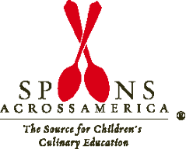
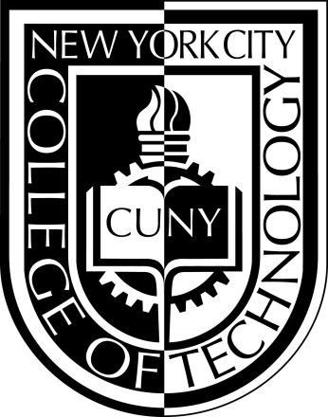

SPOONS ACROSS AMERICA CLUB
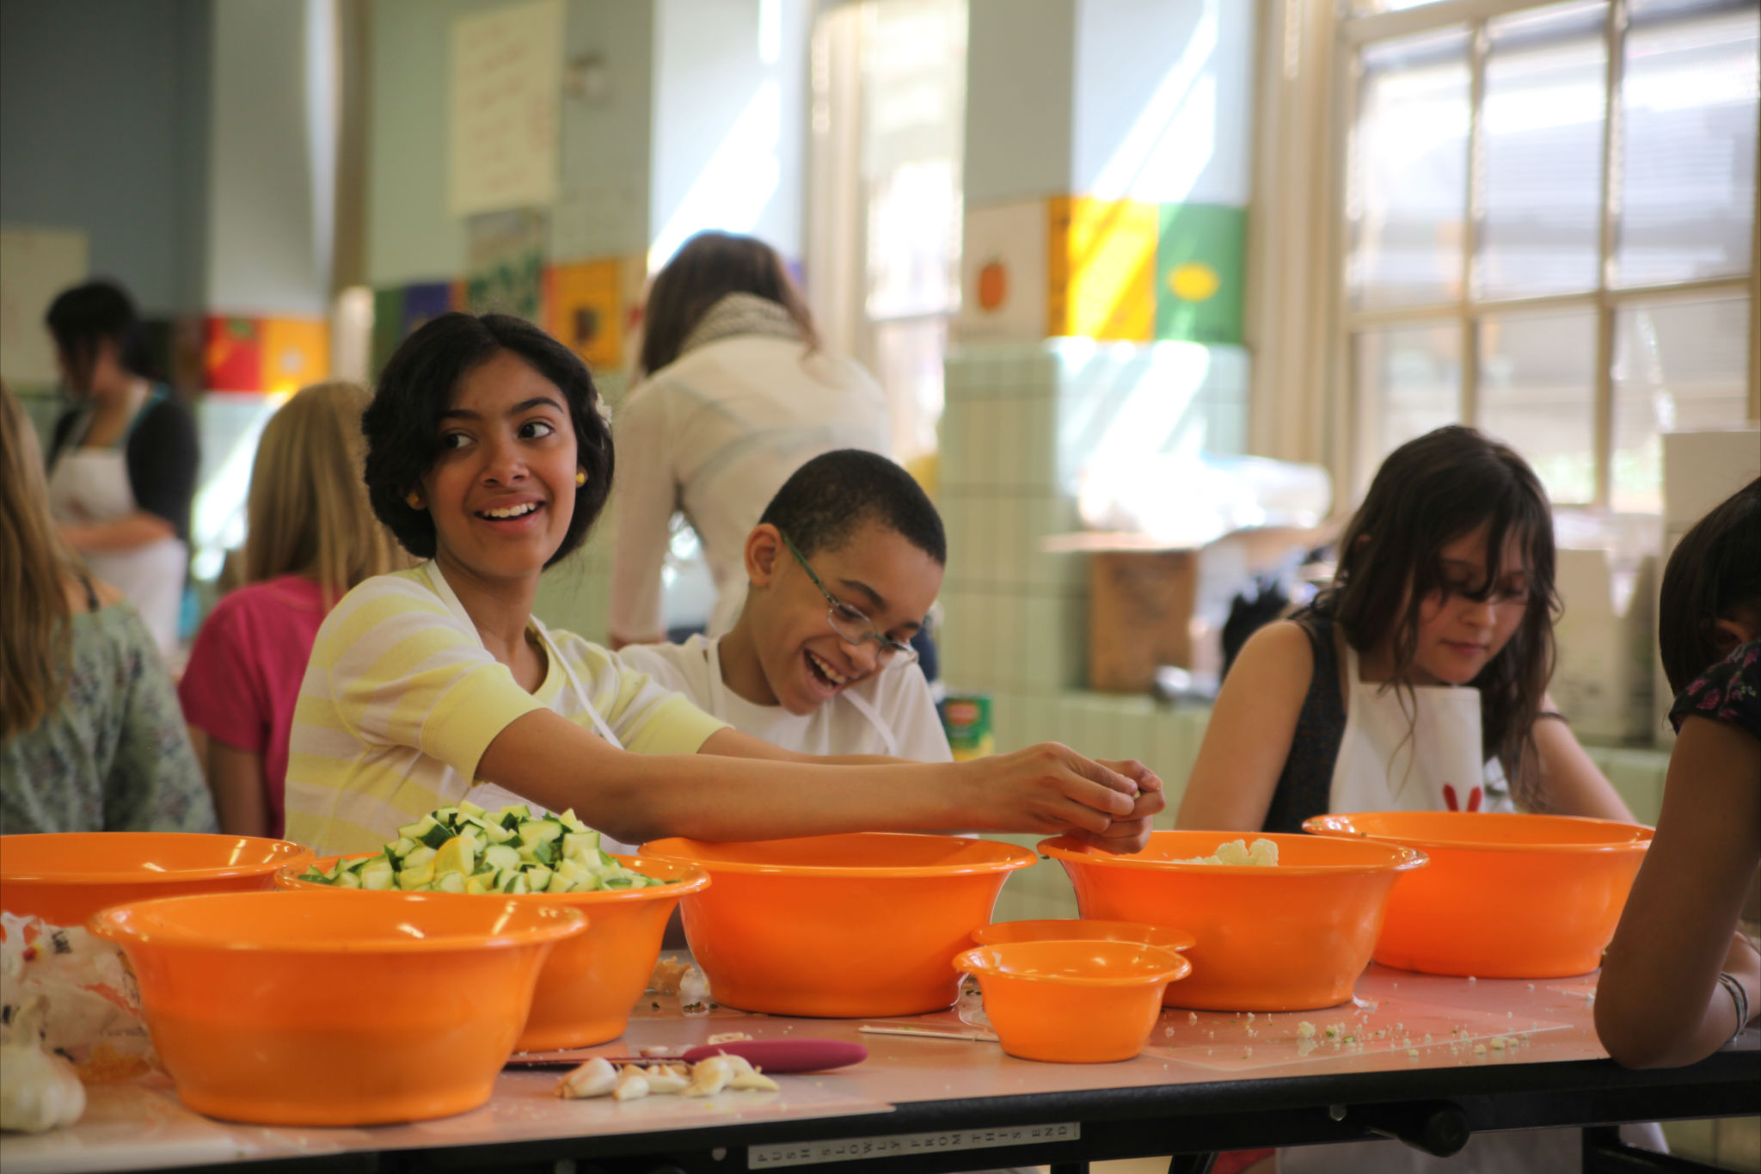
PLEASE JOIN US FOR OUR FIRST MEETING!

Learn about how you can make a difference in our community

September 27, 2012
12:45 PM-1:45pm
NAMM 206
All Are Welcome!

