Chapter 1

|  |  |
| --- | --- |
| 1. | *The speed limit on some interstate highways is roughly 100 km/h. (a) What is this in meters per second? (b) How many miles per hour is this?* |
| Solution | (a)  (b) |
| 17. | State how many significant figures are proper in the results of the following calculations: (a)  (b) (c) . |
| Solution | (a) 3 (limited by 98.2 and 1.01)  (b) 3 (limited by 18.7)  (c) 3 (limited by 1.60) |

Chapter 2

|  |  |
| --- | --- |
| 3. | *Find the following for path C in Figure 2.59: (a) The distance traveled. (b) The magnitude of the displacement from start to finish. (c) The displacement from start to finish.* |
| Solution | (a)  (b)  (c) |
| 12. | The speed of propagation of the action potential (an electrical signal) in a nerve cell depends (inversely) on the diameter of the axon (nerve fiber). If the nerve cell connecting the spinal cord to your feet is 1.1 m long, and the nerve impulse speed is 18 m/s, how long does it take for the nerve signal to travel this distance? |
| Solution |  |
| 18. | A commuter backs her car out of her garage with an acceleration of . (a) How long does it take her to reach a speed of 2.00 m/s? (b) If she then brakes to a stop in 0.800 s, what is her deceleration? |
| Solution | (a)  (b) |
| 23. | (a) A light-rail commuter train accelerates at a rate of . How long does it take to reach its top speed of 80.0 km/h, starting from rest? (b) The same train ordinarily decelerates at a rate of . How long does it take to come to a stop from its top speed? (c) In emergencies the train can decelerate more rapidly, coming to rest from 80.0 km/h in 8.30 s. What is its emergency deceleration in ? |
| Solution | (a)  (b)  (c) |
| 44. | A rescue helicopter is hovering over a person whose boat has sunk. One of the rescuers throws a life preserver straight down to the victim with an initial velocity of 1.40 m/s and observes that it takes 1.8 s to reach the water. (a) List the knowns in this problem. (b) How high above the water was the preserver released? Note that the downdraft of the helicopter reduces the effects of air resistance on the falling life preserver, so that an acceleration equal to that of gravity is reasonable. |
| Solution | (a) Knowns:  (b) |
| 46. | A swimmer bounces straight up from a diving board and falls feet first into a pool. She starts with a velocity of 4.00 m/s, and her takeoff point is 1.80 m above the pool. (a) How long are her feet in the air? (b) What is her highest point above the board? (c) What is her velocity when her feet hit the water? |
| Solution | (a) Knowns: , so we use the equation . Rearranging,    (b)  (c)  and rearranging    Since the diver must be moving in the negative direction, |

66.

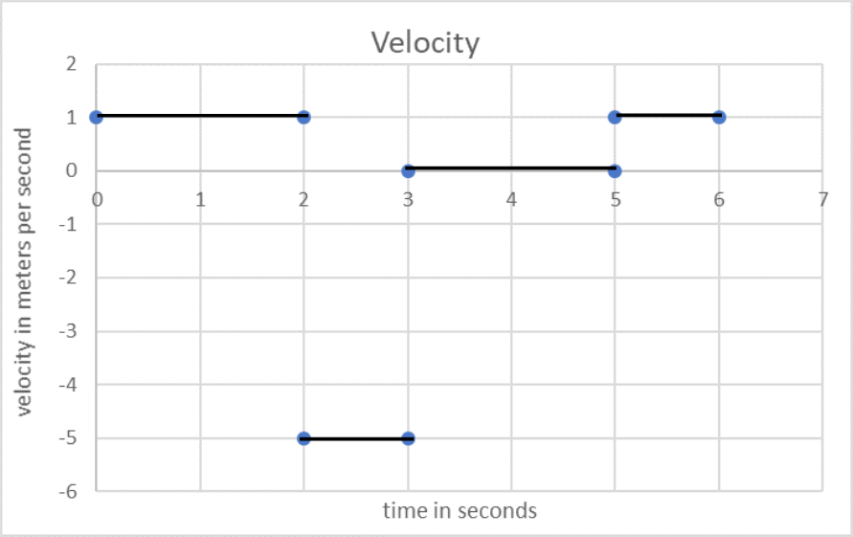

Note that the velocity is discontinuous, it jumps in value instantly. Indeed, the value of the velocity is not well defined at exactly 2s, 3s, 5s. Of course, this is impossible. This should be thought of as an approximation.

The acceleration is 0 where the velocity is constant, inside the time intervals 0-2s; 2-3s; 3-5s; and 5-6s. Since the velocity changes instantly, the acceleration would have to be infinite at exactly 2s, 3s, 5s. Again, we should think off this as an approximation. The acceleration is very large and negative at 2s, and very large and positive at 3s and 5s.