Klebsiella pneumoniae
Hi my name is Klebsiella pneumoniae and I will be telling you a few interesting things about myself and I would like to make friends with some of you. I am a gram negative rod bacterium which means that I have a thin peptidoglycan and I am surrounded by outer lipid containing layers. Since I am gram negative I will stain pink in a gram stain, this is why in this document you will see me highlighted in pink.
Below is what my gram stain looks like.
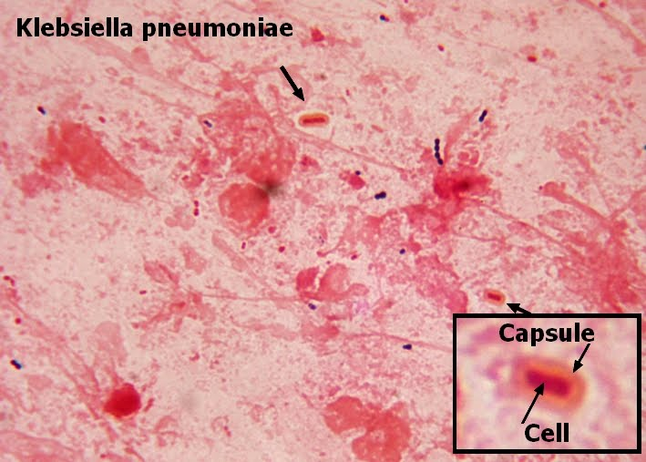
I am positive that you know some microorganisms are capable of utilizing oxygen for cellular respiration while others are not, but I am known as a facultative anaerobe. This means that I am able to exhibit both aerobic and anaerobic growth, in other words I can make ATP in the presence of oxygen and I can also carry out fermentation.
Now I must say I possess a unique property which is I am capable of reducing atmospheric nitrogen gas to ammonia and amino acids.
I, Klebsiella pneumoniae is normally found in the intestines of humans but apart from humans I also like to live in animals, sewage, polluted waters and soils.
I am occasionally pathogenic and I affect the liver, urinary tract and lung. It is important to mention I have virulence factors, below is brief explanation of how this relates to me;
“First, the presence of cell wall receptors enables K. pneumoniae to attach to the host cell, thereby altering the bacterial surface so that phagocytosis by polymorphonuclear leukocytes and macrophages is impaired and invasion of the non-phagocytic host cell is facilitated. Second, invasion of the host cell is also facilitated by the large polysaccharide capsule surrounding the bacterial cell; in addition this capsule acts as a barrier and protects the bacteria from phagocytosis. Third, K. pneumoniae produces an endotoxin that appears to be independent of factors that determine receptors and capsular characteristics” (Highsmith. AK, Jarvis. WR-Pubmed).
My genus is Klebsiella and my family members include; Klebsiella ozaenae, Klebsiella terrigena, Klebsiella rhinoscleromatis, Klebsiella oxytoca, Klebsiella planticola, and Klebsiella ornithinolytica.
I am classified under Gammaproteobacteria because I am an enterobacteriaceae.
Below is a Mackonkey agar culture of myself:
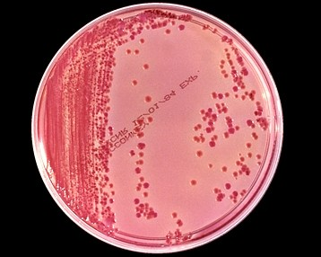

Last summer I was known as the ‘Superbug.’
Below is the article by Brian Vastag taken from the Washington Post;
“As a deadly infection, untreatable by nearly every antibiotic, spread through the National Institutes of Health’s Clinical Center last year, the staff resorted to extreme measures. They built a wall to isolate patients, gassed rooms with vaporized disinfectant and even ripped out plumbing. They eventually used rectal swabs to test every patient in the 234-bed hospital.
Still, for six months, as physicians fought to save the infected, the bacteria spread, eventually reaching 17 gravely ill patients. Eleven died, six from bloodstream superbug infections.
The outbreak of the antibiotic-resistant bacteria known as Klebsiella pneumoniae was not made public until Wednesday, when NIH researchers published a scientific paper describing the advanced genetic technology they deployed to trace the outbreak.
This was “the proverbial superbug that we’ve all worried about for a long time,” said Tara Palmore, an infection control specialist at the Bethesda hospital.
With some 99,000 U.S. deaths attributed to hospital-borne infections annually, the NIH outbreak provides a stark case study of the dangers of the latest wave of hospital-bred bacteria and the extreme measures hospitals must adopt to stem the rising superbug tide.
The NIH Clinical Center now screens every patient transferring from another facility for superbugs, tests every patient in the intensive care unit twice a week and screens every patient monthly.
“This was our introduction to [antibiotic-resistant] Klebsiella,” Palmore said. “We hoped we would never see it.”
Clinical Center spokeswoman Maggie McGuire said the hospital did not alert the public earlier because Klebsiella infections do not trigger mandated reports to the Centers for Disease Control and Prevention like other infectious diseases do, such as HIV. She also downplayed such outbreaks as too common to be newsworthy.
“There are . . . hospital-acquired infections in almost every hospital in the country,” she said. “It’s happening everywhere.”
Nationwide, about 6 percent of hospitals are battling outbreaks of the class of superbugs known as carbapenem-resistant bacteria, which includes Klebsiella, said Alexander Kallen of the CDC. These bacteria usually live harmlessly in our intestinal tracts, and they pose little or no threat to patients with healthy immune systems. But in patients with compromised immune systems, the bacteria can turn dangerous, gaining an enzyme that defeats even the most powerful antibiotics. That’s what happened at NIH.
The six patients who died of bloodstream Klebsiella infections had immune systems weakened by cancer, anti-rejection drugs given after organ transplants, and genetic disorders.
The CDC detected this type of antibiotic-resistant bacteria in 2000. “Since then, we’ve seen it spread across the country,” Kallen said, to 41 states.
Later this year, the CDC is launching a program in 10 cities, including Baltimore, to watch for hospital-borne outbreaks of Klebsiella and related superbugs. CDC staff will review hospital records, Kallen said, and hospital labs will be asked to report any antibiotic-resistant bacteria to the CDC” Vastag, Brian (08/22/2012).
The article examined a major outbreak of myself and illustrates how life threatening I can be.

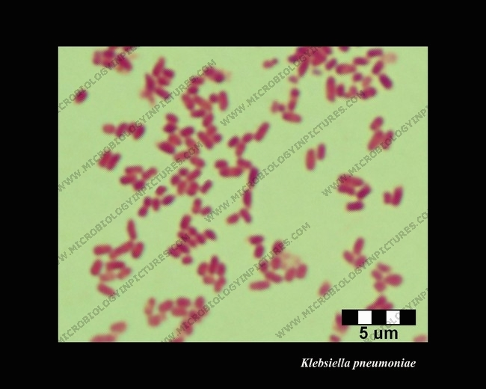
Gram stain of Klebsiella pneumoniae at 1000 magnification

Below is a pretty picture of Klebsiella pneumoniae
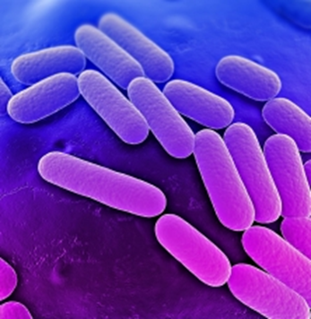
Reference
- http://en.wikipedia.org/wiki/Klebsiella_pneumoniae
- http://4.bp.blogspot.com/_od5PmBTqqUM/TGIMCl3BLzI/AAAAAAAAGN8/DzJgdHLVP8o/s1600/Klebsiella+Capsule+1.jpg
- http://microbewiki.kenyon.edu/index.php/Klebsiella_pneumoniae
- http://www.ncbi.nlm.nih.gov/pubmed/3882590
- http://www.ncbi.nlm.nih.gov/pubmed/2857687
- http://en.wikipedia.org/wiki/Klebsiella_pneumoniae
- http://articles.washingtonpost.com/2012-08-22/national/35493591_1_superbug-antibiotic-resistant-hospital-borne-infections
- http://www.bioquell.com/technology/microbiology/klebsiella-pneumoniae/
- http://www.microbiologyinpictures.com/bacteria%20photos/klebsiella%20pneumoniae%20photos/KLPN37.html
- http://www.cdc.gov/HAI/organisms/klebsiella/klebsiella.html

