Porsha Miller 4/27/14
ALABAMA
ALABAMA CODE § 43 -8-40 –Section 43-8-40 INTESTATE GENERALLY
STATUTE- Any part of the estate of a decedent not effectively disposed of by his will passes to his heirs as prescribed in the following sections of this chapter (Acts 1982, No. 82-399, § 2-101.)
I. The intestate share of the surviving spouse is as follows:
(a) If a decedent was to die survived by a spouse and no issue in Alabama all of the estate goes to the surviving spouse.
§ 43-8-40(1) If there is no surviving Issue the entire intestate estate.
(b) If a decedent was to die and is survived by no spouse and no issue in the state of Alabama the estate is divided amongst the parents of the issue by representation.
§ 43-8-41(3) If there is no surviving issue or parent, to the issue of the parents or either of them by representation.
II. This statute governs holographic and/or nuncupative wills in the state of Alabama
ALABAMA § 43-8-130
Holographic Wills - A Written Will.
In the state of Alabama you must be 18 years or older, you must be of sound mind and memory. The will must be signed by at least TWO witnesses who must also witness the signing ceremony or the acknowledgement of the Testator’s signature.
Nuncupative Wills - An Oral Will.
Nuncupative Wills are NOT being recognized in the state of Alabama. Alabama enforces the statutory requirement that any hand-written WILL must be witnessed and attested for by TWO people minimum; Therefore, Nuncupative Wills does not fall in the category of a will that is written.
The statute that governs holographic and/or nuncupative wills in the state of New York is Estates, Powers & Trusts §§3-1.1
In the State of New York you must also be 18 years or older, you must be of sound mind and memory. Testator must sign at the end of the WILL or be confirmed in the presence of at least THREE attesting witnesses who must also attest to Testator’s Signature within 30 days and with Testator’s request witnesses must also sign their names and address of residence at the end of the WILL, while, Nuncupative Wills are valid only for members of the armed forces, persons who serves with or accompanies an armed force engagement and mariners at sea while on active duty in military or naval service.

Tallapoosa County, Alabama has the second largest Population of 76,000. Mostly Hispanics

Law firm that specializes in probate/estate planning (aka “trusts and estates”) in Tallpoosa County Alabama is Probate & Estate Planning - Akridge & Balch, P.C.
www.akridgebalch.com/Practice-Areas/Probate-Estate-Planning.shtml

Akridge & Balch, P.C. or www.estateattorneyhome.com

www.akridgebalch.com. Business and Real Estate Law; Land use and development; Debt relief and ... Business & Real Estate Law · Bankruptcy Law · Probate & Estate Planning · Litigation ... Lanett, Lee County, Chambers County, Tallapoosa County, Russell County

A Real Estate Appraisers in Tallapoosa County, Alabama

Tallapoosa County - Mapping and Appraisal Department
www.tallaco.com/content

Address of a Probate court.

Tallapoosa County Probate Judge
100 Court Sq
Alexander City, AL 35010 (256) 234-5328

- Alabama Association of Paralegals | Membership & Regions
alabamaparalegals.net/membershipAndRegions.php‎
Region I encompasses the following counties in Alabama: Bibb, Blount, Calhoun, Lee, Lowndes, Macon, Montgomery, Perry, Pike, Russell, Tallapoosa. ... (2) Any individual who holds a bachelor's or associate's degree in Paralegal Studies from ... standing in any university, college, junior college or other post-secondary.

Birmingham Museum of Art, Alabama
www.artsbma.org/
This is the “Miss Nina." sculpture dates from the 1450s.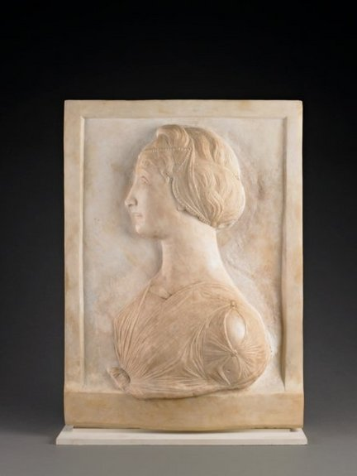
A bequest of $1 million from the late Nina Miglionico. 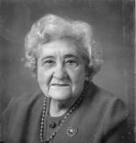

The marble Sculpture above was a surprise bequest to the museum. It is quite an awesome and fine piece of art.

