Game Design Document
Zhongxu Su ENT4499
Framed

Concept:
Main character (you) Play as agent “Slip” 2.5D action combat game, as he tries to escape the mafia that discover him in their hideout. Is then framed for something he did not do. The user will be taking control of Agent slip in real time to punch, kick and jump escape the mafia. And letting people know why your codename is Slip. Player must run across town (Cityscape), through the city and through the subway MTA, and traverses many obstacles, all while fighting enemies and must avoid getting caught at all cost. 2.5D Runner game with perpetual run, Jumping, Sliding, Hitting, Vaulting, Throwing, *Crouching (Optional),

Mechanic: Platformer, 2.5D,

Mechanics
- 2.5D
- Runner without perpetual run
- Jumping
- Sliding
- Hitting
- Vaulting
- Throwing
*Crouching (Optional)
- Fighting enemies

The Level Design: 2 Levels
The Obstacle/ The Solution
- Cityscape,
  - Cops = Donuts
  - Swarms Pigeons = Bacon Egg and Cheese
General Obstacles
- Jump = On Cars In Traffic
- Slide = Under Garbage Truck
- Misc. = Rooftop Parkour

- MTA Subway Station,
  - Enemies = Change
  - MTA Turnstile = MetroCard
  - Delay = Just Wait
  - Massive Rat = Discarded Pizza
  - Roaches = Concentrated Bug-Spray

Optional Ideas
Museum,
c. Tourists = Map
d. Knights = Jar of Black Plague
e. Dinosaurs = Call in Meteor Strike
General Obstacles
- Jump = Tour Groups
- Slide = Exhibits
- Misc = Museum Guard

Asset List
- Cityscape,
  - Cops
  - Donuts
  - Swarms Pigeons
  - Bacon Egg and Cheese
  - Buildings
  - Trash Cans
  - Garbage
  - Light Post
  - Fire Hydrant
  - Traffic Lights
  - Streets
  - Cars
  - Mailboxes (Blue/Green)
  - Trees
  - Windows
  - Fire Escape
  - Streetlights
  - Parking Meters
  - Stop Sign
  - Clothing Lines
  - Vents
  - Satellite Dishes
  - WaterTower’s
  - AC
  - Powerlines
  - Torch
General Obstacles
- Jump = On Cars In Traffic
- Slide = Under Garbage Truck
- Misc. = Rooftop Parkour

- MTA Subway Station,
  - Change
  - MTA Turnstile
  - MetroCard
  - Massive Rat
  - Discarded Pizza
  - Roaches
  - Concentrated Bug spray
  - Platform Benches
  - Lights
  - Conductors Board
  - Train Traffic Lights
  - Advertisements
  - Map
  - Pillars
  - Platform
  - Tracks
  - Train

UI/UX
- Enemy Health Bar
- Number of Deaths
- Symbols for all Interactions
  - Donut
  - Change
  - Metro Card
  - Discarded Pizza
  - Concentrated Bug-spray
  - Lead Pipe
  - Hot Chocolate
- Load Menu (Start)
  - Logo
  - Title Screen
  - Start
  - Settings
  - Scoreboard
  - Timer
  - Credits
  - Exit
Audio
- City street
- Ocean side
- Crowd of people
- Cars
- Trains
- Turnstile sound
- Train track sound
- Jump sound
- Punch sound
- Run sound
- Birds
- Police/ambulance sounds

EX of prototype Progress Pics:

Levels: city/Subway
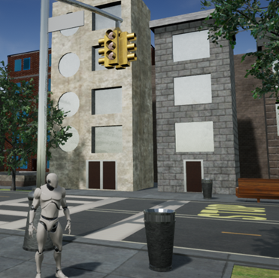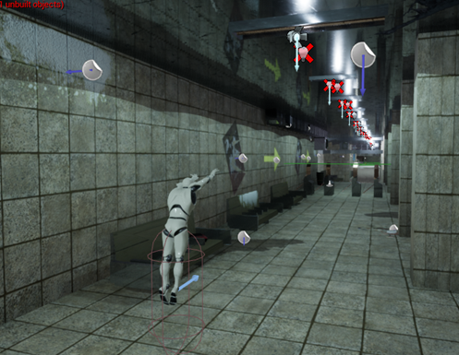

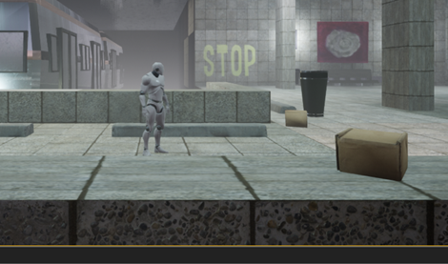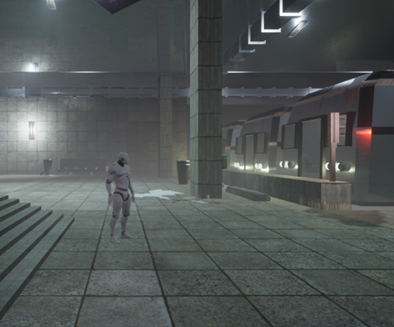

Dark Tunnel Level
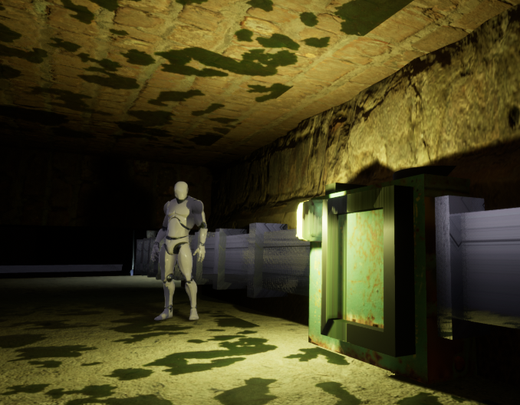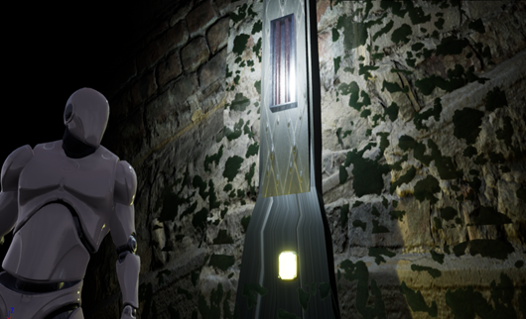

Movement/Jumping
