Ent 4499-Culmination Project

Project Description
Play as agent “Slip” 2.5D action combat game, as he tries to escape the mafia that discover him in their hideout.The user will be taking control of Agent slip in real time to punch,kick and jump escape the mafia.and letting people know why your codename is Slip.

Methods
Using the unreal engine 4 in 3d model i build a sidescroller game allowing the fine game engine to process my game and bring Agent “slip” to the action, with it strong blueprint it allow me to map the key press and animation of Agent “slip”.
Maya well be used for building the model and rigging the bones.
quixel megascans for it detail images and uv maps and as well as bridge to put them in to ue4.
(I have been working with all the software tool over the summer have an understanding of them)
Story is being rework rest have not change!

Project deliverables
A simple action combat game as player plays as Agent Slip
-materials is nothing more the a working pc and that able to run few software.

Schedule
As you read this the prototype is being built as we well have moven done by the September background lay of the 3d world will take a month to build for a few levels.
AI well be simple AI aas it attacking the player as they enter the range.
And over all the player should be able to fight and run away from the AI as well. THis well be done in month as well end at november.
All should be done by november as working game and last month of the class well be used to polishing the remain or catch to the part that fall behind from mouth back.

Required Resources
Unreal engine 4
Maya
Quixal
Strong PC
Udemy

Budget
Quixal-$40 per month
Maya-free(student)
Unreal engine shop-flex $0-300
udemy-100(learning)
And with extra 300 for any Flex or solve problem
EX of prototype:
Movement/Jumping
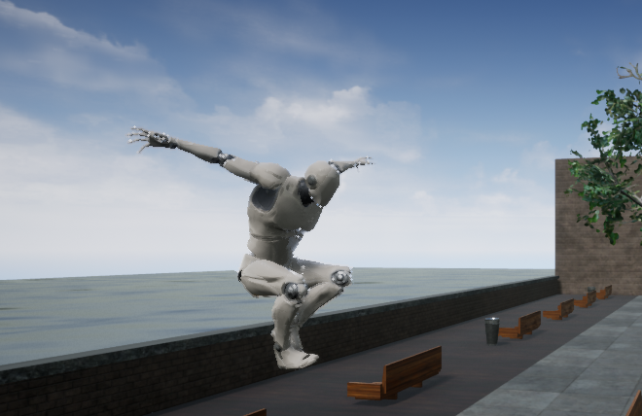
Levels:city/Subway
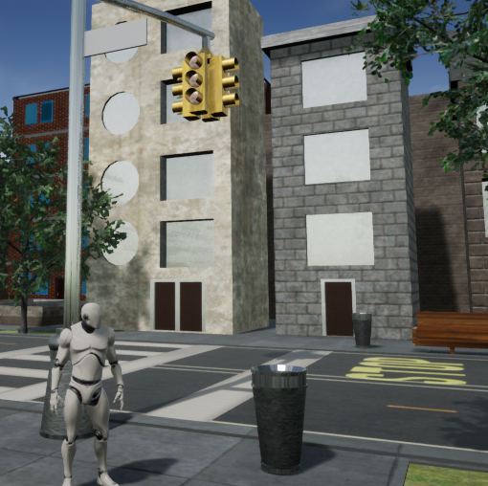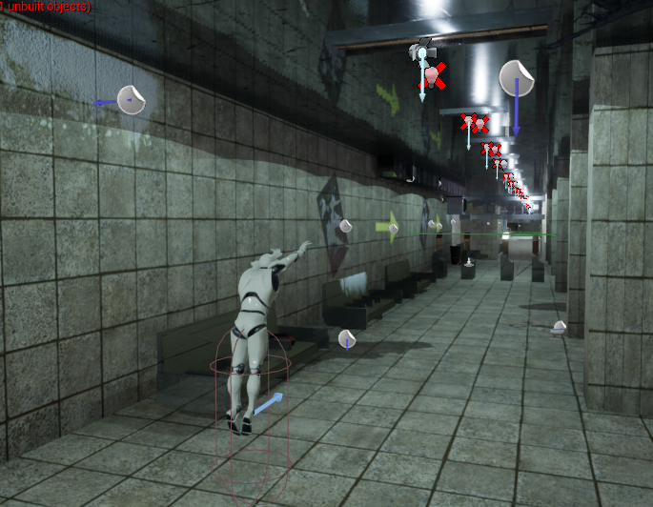
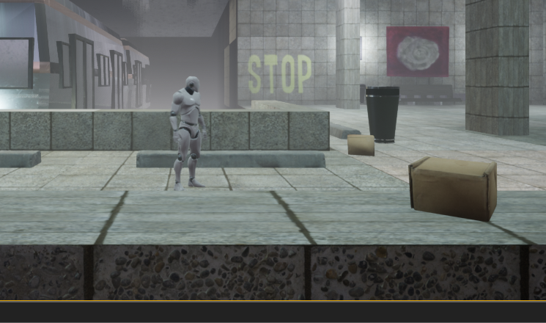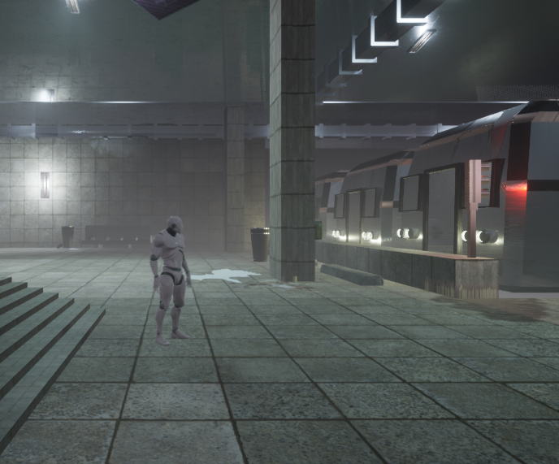

Dark Tunnel Level
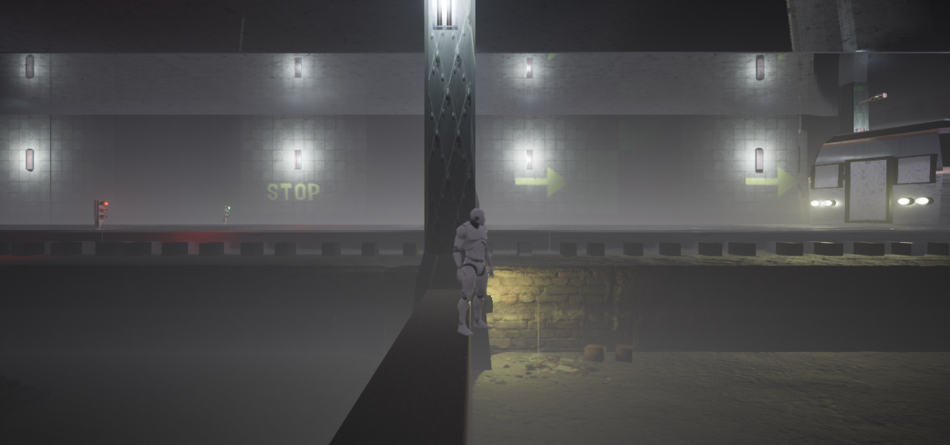
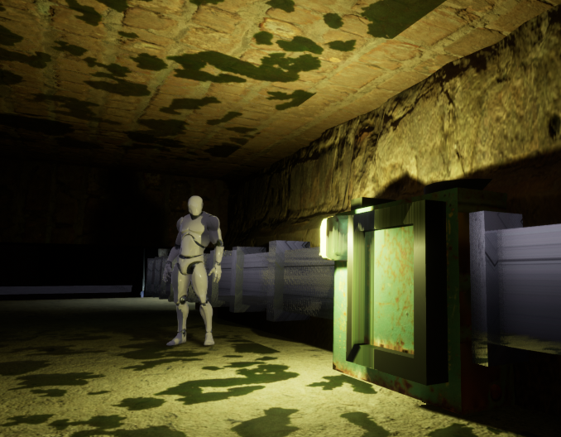
High Detail Meash and sound :
