Zakareia Masboob
Culmination Prompt

The project we are going to be able to do is a short film that will be about dealing with loss in a family and the struggles that come with it. We are going to use a Canon EOS 5D Mark IV, also we are going to need different types of lights like a led video lighting kit, soft boxes and other types of lighting. When it comes to editing software, we are going to use either avid or adobe premiere, it’s up to preference of the editor. For the location we are going to get the New York streets and we are going to use an Airbnb with the owner’s permission to film.
For the short film we want the viewer to be immersed in the story. The short film is going to have meaning and a strong theme to it. Its always going to stay on the major theme and not go off the point. The theme is going to be about mental struggles with loss. We also want our scenes to carry some sort of subliminal message behind them
with the specific shots we decide to take. We see the main character Sam dealing with loss and the struggles that come with it. The film is also going to have minimal dialogue, and its going to show what’s around Sam and what she is looking at as we go on in the film.

Our main challenges are finding the right actor. I never scouted for an actor before, so I do not know where to start. I can start to look at different acting schools around New York, but then comes the difficult decision on who we pick for the role. Actors also need to be compensated for their work. I would feel bad if we got someone and we didn’t get to compensate them for their work. We can get a friend or family member that could be the actor but depending on their experience it can make the film go down in quality. Another big problem is getting the lighting correct. Usually with short films or low budget films the lighting is hard to get down. It is usually way too over saturated, or the movie ends up being dark and we cannot see anything. Also, lighting can also affect the color of the movie and mess it up. Us as a group would have to figure out the perfect way to light the movie during production.
I have directed other videos in the past specifically in the first video class and in advanced video editing, but those videos were short and around 3 minutes long. This project is going to be around 8-10 minutes fully exploring the main characters and there struggles with loss in a family. This would challenge me immensely because I want to write a screenplay that is very serious in tone, and it deals with very serious subject matter. This will help my future career because it would show that I understand how direct and or write certain screenplays.
As the director I should work with the Aaron the editor throughout the whole movie. I always love to edit movies since its like a puzzle, figuring out what pieces go where. It is crucial that we set the tone of the movie through editing, whether it be through music or color correction. Editing is also challenging because me and the editor get to decide how long do, we want to stay on a shot before cutting to a different shot. If we stay on a shot for too long it might ruin the pacing of the movie, but if we cut every time to a new shot, it can get annoying for the viewer, so its very crucial to find an in between.
Filming was always an inspiration of mine. Watching how directors do their thing while on a movie set, I loved how each one of them had their style while directing. I want to show my style of directing to other people when I get to film. I decided to want to direct the short film because I have a bunch of ideas that I want to show, and I also want to interact with the actor and make sure they know what they are doing and importantly having a good time with the project. It’s going to be a fun time to see what me and my group members come up with.

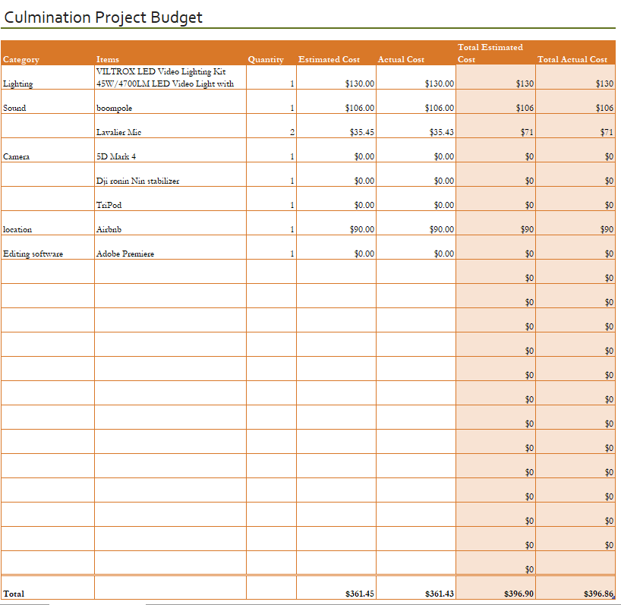
As you see here is the budget for the film. We are going to need a led lighting kit, as for sound we need a boom pole and a lavalier mic just in case. Since one of our group mates has a camera and a stabilizer, we don’t need to pay for that. Lastly, we are going to rent an Airbnb for 2 days and we are going to ask permission if we can film in their house.

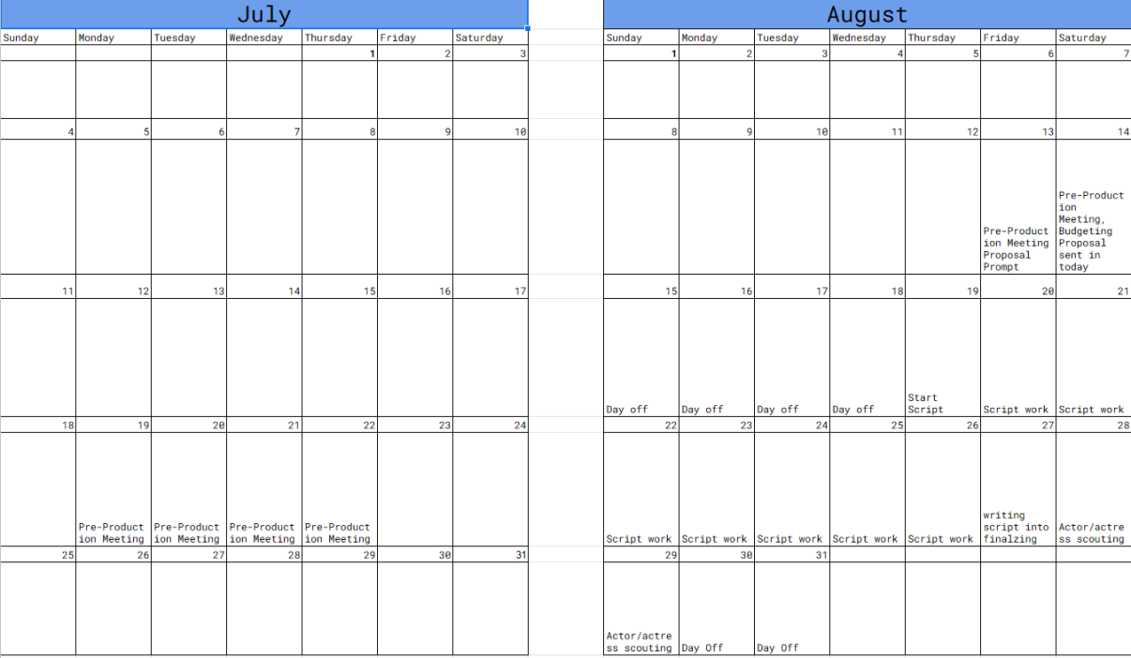
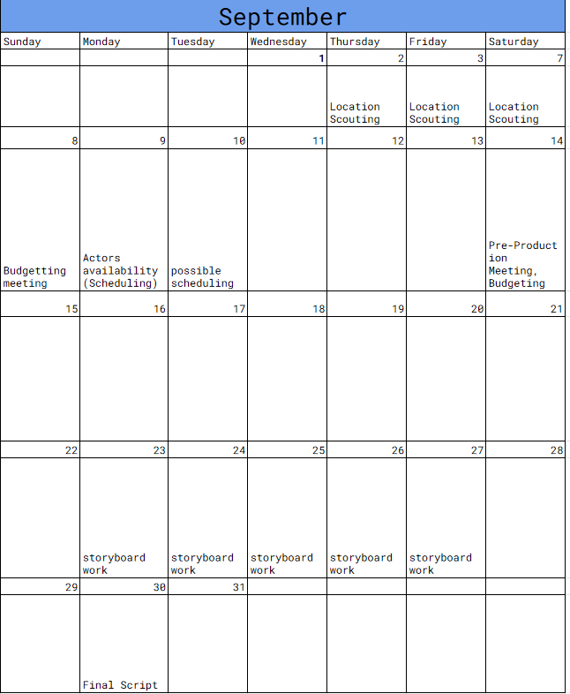
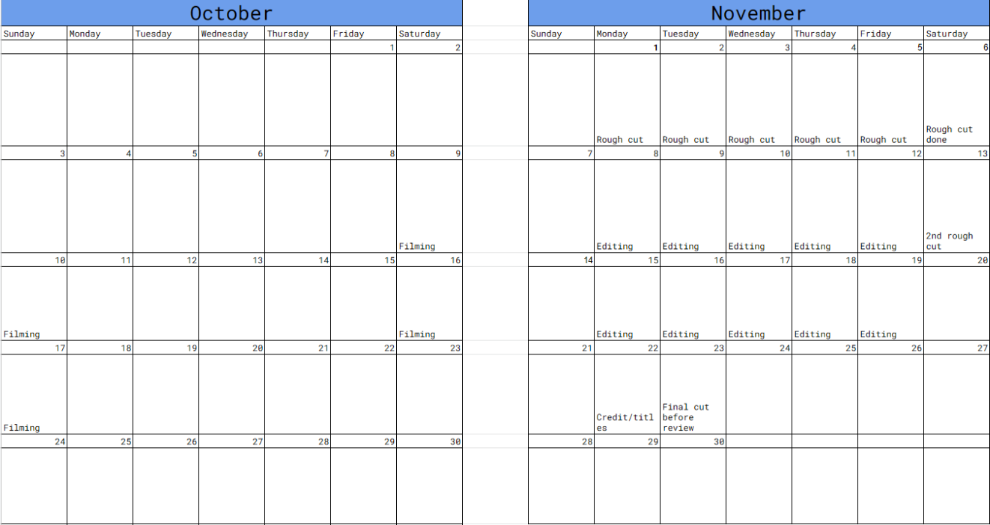
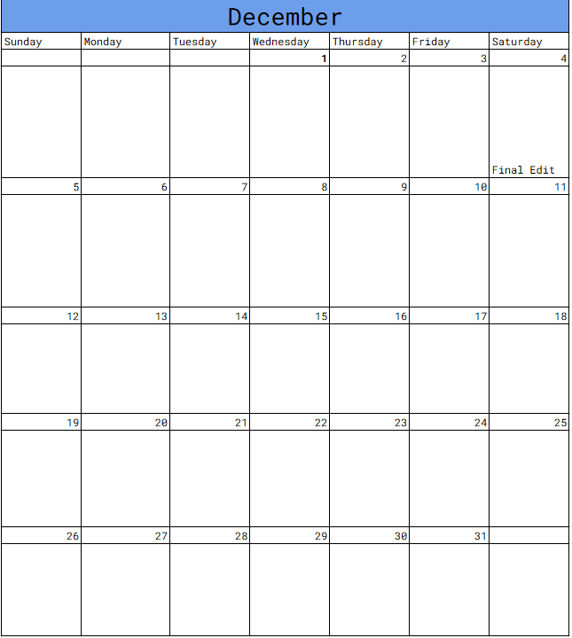
As you see above here is the calendar. Obviously, all this is subject to change because something wrong can happen and or someone can get sick, so its good for us to be prepared for a scenario when the time comes. We should start filming around October and it should take us a couple of weeks to film. We should have a lot a time for filming just in case we don’t get everything we wanted. In November we have multiple weeks where we are going to edit. I feel like this is a good choice because a lot of decisions are made during editing, and we have to see if it fits well with our short film.

