

Wilkins, E. M. (2017). *Clinical practice of the dental hygienist* (12th ed.). Philadelphia, PA: Wolters Kluwer.

## References:

# Knowledge is power…

### By Rana Almontesar

### Ladasha Gaytanviechweg

### Zoar Hai

### MyDuyen Nguyen

### Ariana Potestio

### Saudia Talip

### March, 2018

🙞 🙜



Oral Implications for Older Patients with Dementia / Alzheimer’s Disease

🙞 🙜

Taking care of our teeth and gums is a critical part of our overall health. This is especially true for our senior citizens. The condition of an older patient’s oral health can impact more than just their smile. It significantly impacts their ability to eat and speak.

Poor oral health can lead to many things, some of which include tooth decay and gum diseases. Untreated gum disease and dental infections may also affect the other areas of the patient’s health, such as arthritis and heart disease.

#### Tooth loss increases with age, but is not due to the process of aging.

# Alzheimer’s Disease & the Effects on the Oral Cavity in Elder Patients

Dementia is a category of brain disease, defined as extreme impairment of cognitive abilities, especially in the areas of thinking, memory, and judgment. Alzheimer’s disease is an irreversible form of dementia that most commonly affects people over 65 years of age. Patients in this population may have difficulty achieving optimal oral health, posing some dental concerns.

Dental Considerations:

**Xerostomia** is common in older patients, which is also known as dry mouth. It may be caused by salivary hypofunction and an adverse effect of certain medications taken.

**Dental caries**, which is known as dental decay,in the older population is commonly associated with gingival recession, salivary hypofunction, medications that are xerostomic, poor oral hygiene, and diet consisting of fermentable carbohydrates. This may be found on the roots or crowns of the teeth.

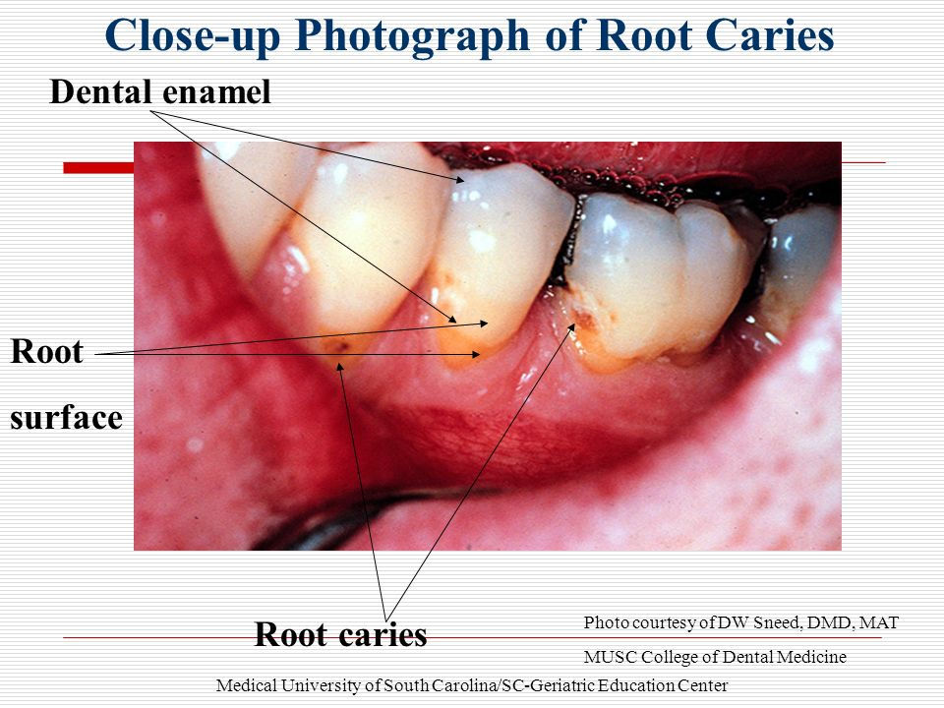

**Periodontal Disease** is the result of longstanding, untreated, neglected chronic dental infection that affects the gums, ligaments, and bone. This may lead to tooth loss.

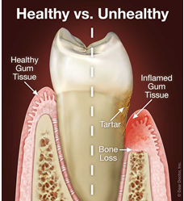

## How caregivers can help establish dental health

***Address Xerostomia***

Since dry mouth may be a common issue, it is important to keep the hydrate the oral cavity. You can help minimize this by:

-Keeping the patient hydrated.

-Allowing the patient to chew on sugar-free gum or sugar-free candies to help with salivary flow.

-Avoid mouth rinses that contain alcohol.

***Address dental* caries**

Since decay may contribute to tooth loss, it is important to prevent or control the disease. You can help by:

-Using fluoride toothpaste and/or mouth rinses.

-Allowing patient to drink fluoridated water.

-Deplaquing the patient’s teeth with toothbrush and interdental tools (i.e. proxybrush) two times daily.

-Be mindful of their diet.

***Address Periodontal disease***

Encourage regular dental visits.