Final Practical

Submitted by: Zeeshan Ahmad
Submitted To: Prof. Viviana Vladutescu
EET-3132 Remote Sensing
Date: - 05/24/2016

Final Remote Sensing Hands on (MATLAB)

Q1: - (A) Look up the orbits for the nine planets and plot the period vs. the semi-major axis. Do they obey Kepler’s third law? This is best done by using a log-log plot.
(A) Following are the Orbital Data for planets and dwarf planets where we plot the period vs the semi-major axis.
Figure-1 Orbital Data for the Planets & Dwarf Planets
ANS: - In figure-1, Orbital period of all the planets are per year. Our goal is to calculate the semi major axis of planets vs orbital period in hours. So, we have to convert periodic year of each planet into hours. We know that 1 year = 8760 hours, so by multiplying each period with 8760, we’ll get period in hours. We’ll get the following results: Mercury (2109.408hours), Venus (5389.152), Earth (8760), Mars (16476.684), Jupiter (103911.12), Saturn (258052.08), Uranus (735927.6), Neptune (1443560.4) and Pluto (2177210.4).
Yes, it follows Kepler’s 3rd law which states that “The Square of the orbital period of a planet is directly proportional to the cube of the semi-major axis of its orbit. This captures the relationship between the distance of planets from the Sun, and their orbital periods”.

MATLAB Program using Loglog function for graph
Result Figure-2
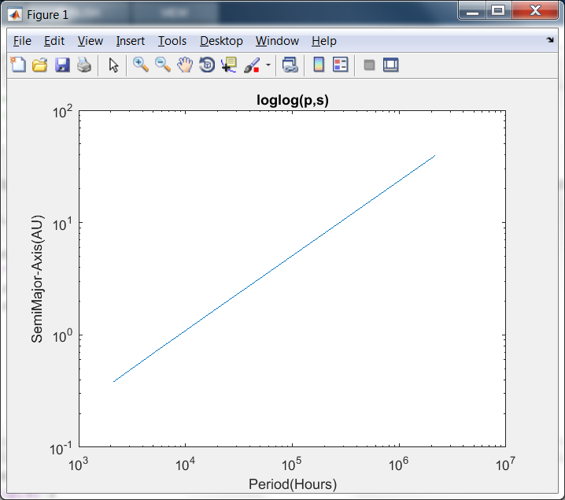
Figure-2 is showing the loglog plot of Semi Major Axis vs Orbital Period in hours for 9 planets

MATLAB Program using Plot function for graph

Result Figuer-3
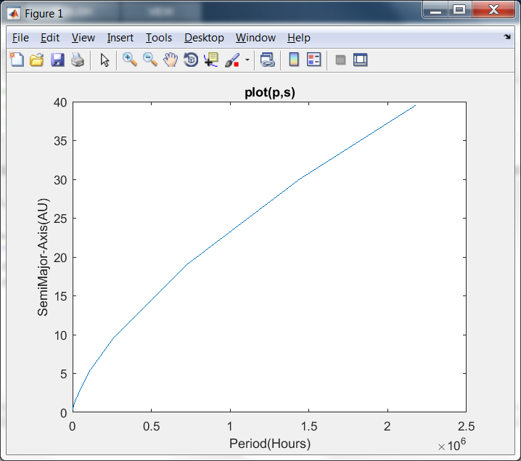
Figure-3 is showing the plot of Semi Major Axis vs Orbital Period in hours for 9 planets
(B) Plot the two-thirds root of the period vs. the semi-major axis (or mean radius).
ANS: - We need the two-thirds root of the period of all planet in order to get two-thirds root of the period vs the semi-major axis. We use the same MATLAB function for two-third root and got the following graph. Figure-4
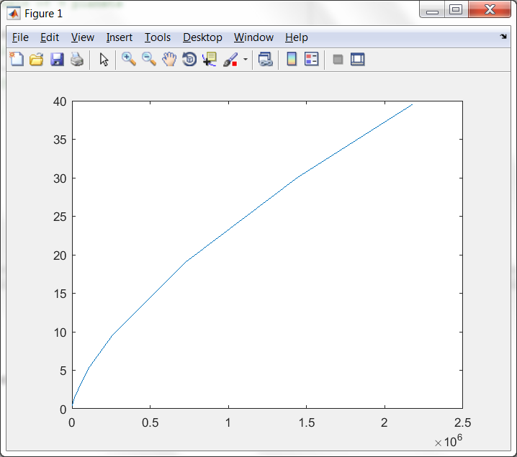
Figure-4 is the plot of two-thirds root of the period in hours of all planets vs semi major axis.

Q2: - For a scene with 4 pixels, calculate the correlation between the pixels, and the covariance.
Pixel # | Red (DN) | Green (DN) | Blue (DN)
1 | 40 | 50 | 60
2 | 20 | 25 | 28
3 | 30 | 30 | 30
4 | 15 | 16 | 14
ANS: -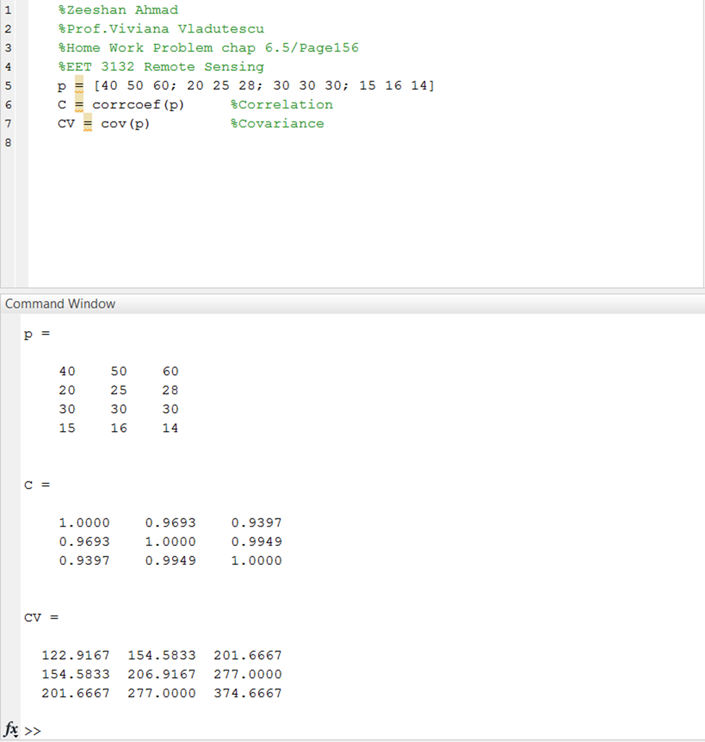

Q3: - Plot 72 hours HYSPLIT backward trajectories starting at NYCCT or CCNY at 500m, 1500m, 3000m on May 15th, 2016 (4 pm UTC time). (10 points)]
Figure-5
Figure- 5, 72 hours Backward Trajectories at CCNY at 500m, 1500m and 3000m on May 15, 2016

We got the following result after we requested the backward trajectory for 72 hours starting at CCNY at 500m, 1500m, and 3000m on May 15th, 2016 (4 pm UTC time).
Figuer-6
Figure- 6 is clearly showing that Altitude 3000m is much farther than 500m, because higher the altitude faster will be the air and longer will be the distance. It means that the backward trajectory for 3000m is coming from farther distance than 500m.

Q4: - Download a MODIS file for the month of May 2016 over NYC area and plot an image of the LWP or Cloud fraction available in the .hdf file. Make sure you use the HDF Viewer to open the file much easier. (10 points)
ANS: -

Figuer-7
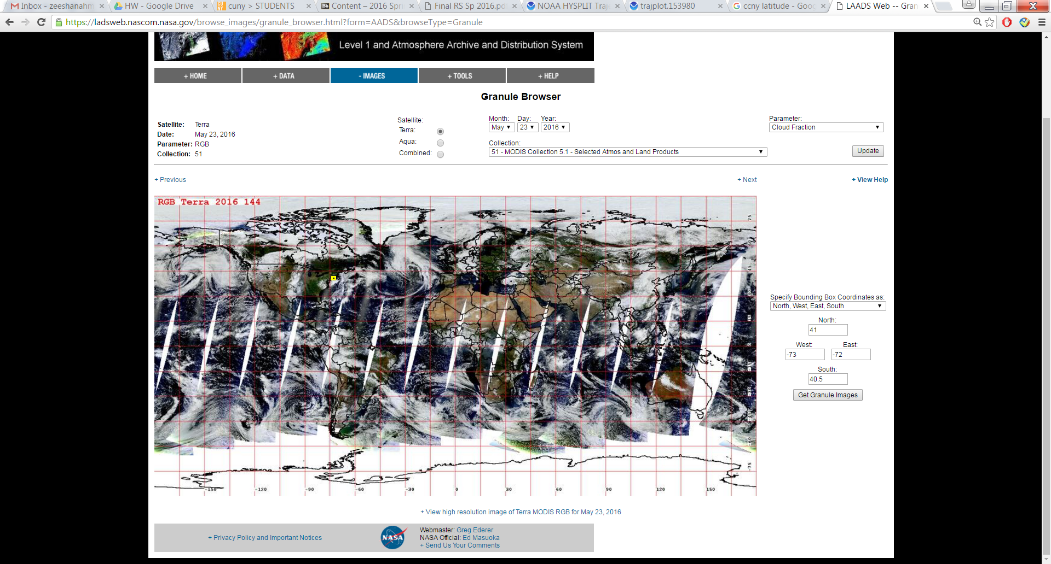

Figure- 7 is showing the granule Browser after we selected New York City using terra satellite collection from 51-MODIS collection 5-1 and parameter Cloud Fraction.
Following result we got after getting Granule images, May 23, 2016 at 2:25

Figuer-8
Figure-8 is showing the particular Granule Browser details image of cloud fraction taken by satellite Tera, collection from MODIS for Cloud Fraction.
After downloading the product, I opened the file in HDF Viewer. From there, I went to data and selected the cloud fraction and import the data into txt and got the cloud fraction through MATLAB by using imagesc and histogram function. MATLAB program and results are as follow:

Results Figure-9
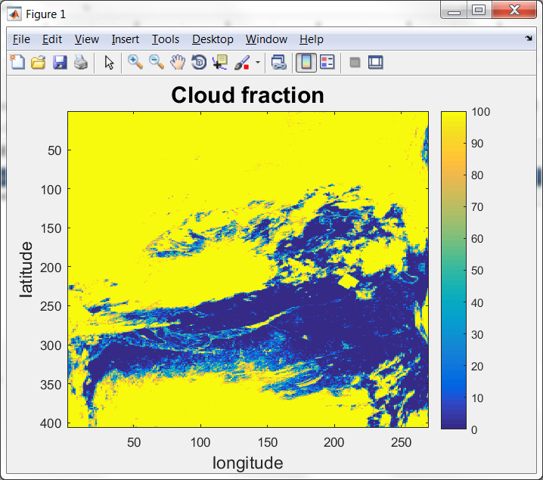
Figure-9 is showing cloud fraction on May 23, 2016. If we look at the graph, we can see that there is a lot of cloud fraction by looking at all the yellow part which means that there is 100% cloud fraction. The dark blue part is showing that there is no cloud fraction. And, the light blue part is showing that there is some cloud fraction.
Figure-10
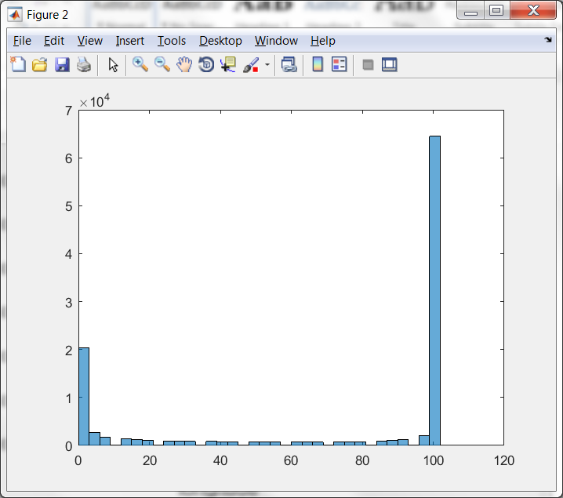
Figure-10 is showing the graph of Digital number and their quantity. X-axis is showing all the digital numbers starting from zero to 100. Zero is no cloud fraction and 100 is cloud fraction. On Y-axis, we only have the quantity of each Digital Number multiply by 10 power 4.

