NEW YORK City College of Technology

Electrical and Telecommunication Engineering Technology Department
Lab # 4 WHEATSTONE BRIDGE AND ITS APPLICATIONS
EET 3120 Sensors and Instruments
Submitted To: Prof. Viviana Vladutescu
Submitted By: Zeeshan Ahmad
ID: 23390657
Group Members: ZEESHAN AHMAD
BUSAYO DARAMOLA
MICHAELANGELO BROWN
Semester: Spring 2015
Date: 05/02/2015

CONTENTS
Introduction ……………………………………………………………………………. 3
Procedure………………………………………………………………………………. 4
Theoretical Approach……………………………………………………………….. 8
Measurement and Analysis …………………………………………………………… 9
Conclusions……………………………………………………………………………. 15
References……………………………………………………………………………… 15

Experiment 4 WHEATSTONE BRIDGE AND ITS APPLICATIONS

INTRODUCTION:-
OBJECTIVES: - In this experiment we’ll trouble shoot a Wheatstone bridge in Multisim, and prototype electrical circuit on NI ELVIS II and will measure the unknown resistance.

Equipment and Devices:-
- Desktop Computer
- Multisim 11.0 Software
- NI ELVIS II Software
- NI ELVIS II Workstation
- 4 1kΩ Resistors
- Electrodes (2 per team member)
- 2 Alligator to Alligator clips

PROCEDURE:-
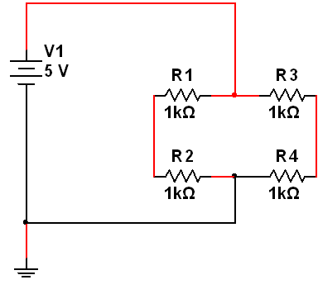
- SIMULATION IN MULTISIM: - First we opened schematic in Multisim and then we draw following electrical circuit Figure.1 using different components. To find a component, just click on place and search for component we need. Like resistors, and voltage source.
Figure -1
After building the circuit diagram, we saved our work and clicked on NI ELVISmx icon to find digital multimeter. We connected the desired ports V and COM to a) R1 and Ground b) R4 and ground c) R2 and R4, and calculated the voltages. We calculated different values which are following.

- R1 to Ground voltage was 5.00V DC
Figure-2
Original Figure 2 taken from Experiment

- R4 to Ground Voltage was 2.50V DC
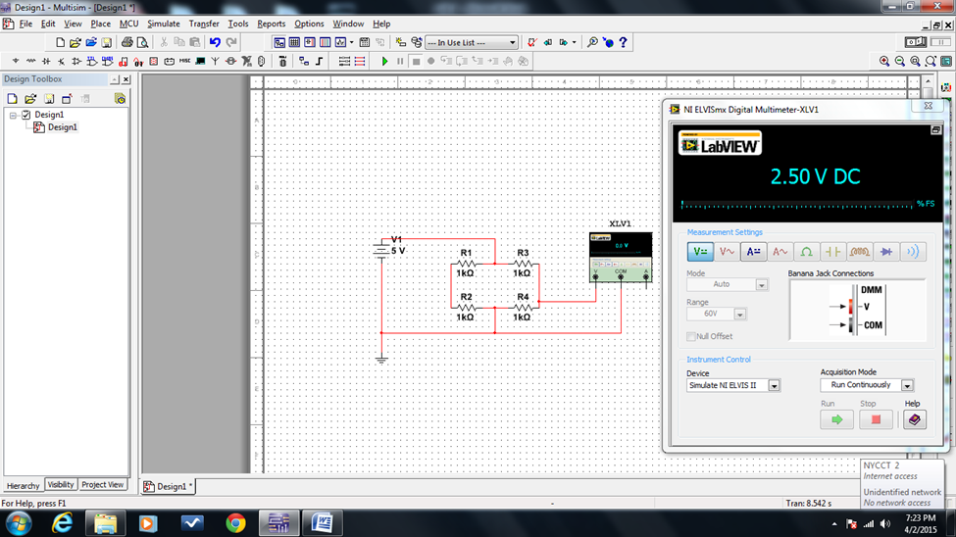
Figure-3
Original Figure 3 taken from Experiment

- R2 to R4 voltage was 224.56 µV DC. This is almost equal to Zero because this circuit was balance and we know that when a circuit of Wheatstone bridge is balanced then the voltage between the arms is almost equal to zero.
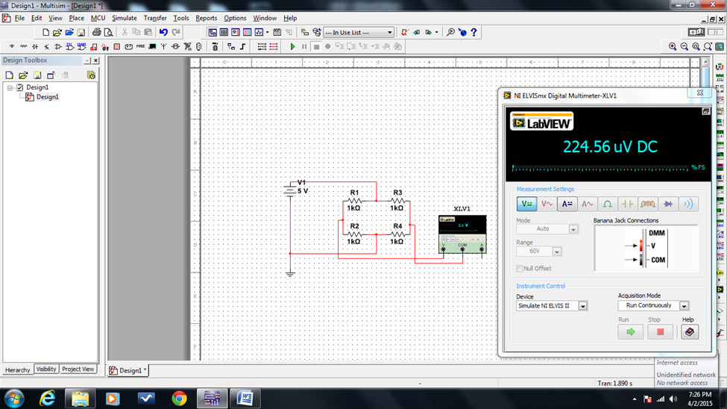
Figure-4
Original Figure 4 taken from Experiment
3. Prototype on NI ELVIS II: - first we build the same circuit on prototype, we stimulated on multisim. We measured the given resistances using NI ELVISmx launcher, but only measured 3 resistors and did not measure the 4th one. First we calculated the 4th resistor using R1/R2 = R3/R4. We have used this equation because our circuit was balanced. Then we find R4 using NI ELVISmx launcher and found that both the values were almost equal.
We then replace R4 with two connecting wire. We then took two electrodes, and put one on wrist and the other on elbow of left hand and calculated all the values from the start which are as follows.
Theoretical Approach: - The standard method of finding the resistance of a circuit is by Ohm Law which is V=I*R or R=V/R. In which we need voltage across the particular resistor and current through that resistor. To find voltage and current, we use Volt Meter which is connected in parallel of that resistor and Ammeter is connected in series. As we are finding the particular resistor through Voltage and Current, there is possibility of errors which can affect resistor actual values. So, it is possible to determine the actual value of resistor with minimum errors we have used Wheatstone bridge. Wheatstone bridge was invented by Samuel Hunter Christie in in 1833 and later improved by Sir Charles Wheatstone in 1843.
Wheatstone bridge is an instrument used to measure unknown resistance. It is an electrical bridge circuit which has 4 different resistors, a battery and a galvanometer. Two resistors are known, 3rd resistor is variable which is used to balance the circuit, and 4th is unknown resistor. Galvanometer is placed between two arms which will indicate the balance circuit. Wheatstone bridge is ideal for finding small resistors.
Wheatstone bridge is also used as transducer. We know the physical phenomena that when there is a change is strain, it causes temperature shift which changes the resistance. In a system a Wheatstone bridge senses the same change in resistance and gives electrical signal which is the property of a transducer. Transducer converts variations in physical quantity into an electrical signal.
Measurement and Analysis:-
First we measured R1, R2 and R3 which are as follows
Figure-5 R1

Figur-6 R2
Figure-7 R3

We calculated R4 using the equation R1/R2 = R3/R4
So, R4 = (R2 * R3)/R1 = (0.9825*0.9857)/0.9906 = 0.9776 kΩ
And our measured R4 = 0.9819 kΩ which is almost equal to the calculated one
Figure-8 R4

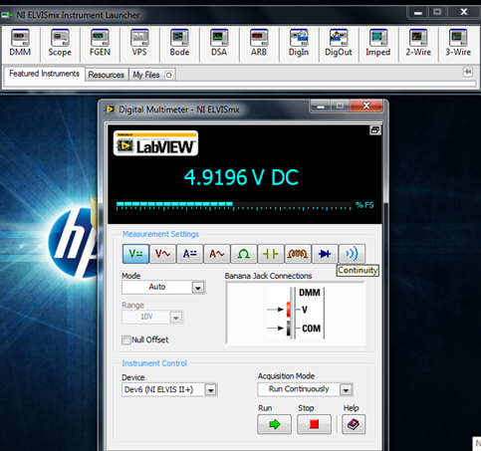
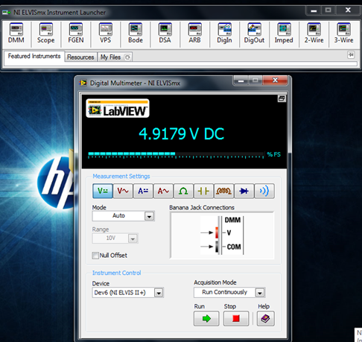
We also calculated the Voltages across R1 to Ground, R4 to Ground, and R2 to R4 and with respect to elbow as well which are as follows.
Figure-9 R1 to Ground Figure-10 R1 to Ground with respect to Elbow
Figure-11 R4 to Ground Figure-12 Elbow to Ground

If we look at the value Elbow to Ground is almost equal to the source voltage, it is because elbow has very high resistance which behave like open circuit. So it has almost total source voltage.
Voltage between R2 and Elbow = 2.4527
Figure-13
In balanced circuit the voltage between R2 and Elbow supposed so to be equal around zero, but here it is 2.4527DC. It’s because the circuit is not balanced. So if the circuit is not balanced then we use unbalance Wheatstone bridge equation to calculate the unknown resistance, and in this case we have Elbow as unknown resistance.

We first calculated the resistance of elbow by using unbalanced Wheatstone bridge equation and then measured the actual elbow resistance using NI ELVISmx launcher and protoboard. The equation is as follow.
$$Velbow=\left(\frac{Rx}{R3+Rx}- \frac{R2}{R1+R2}\right)Vs$$
2.4527$=\left(\frac{Rx}{985.7+Rx}- \frac{982.5}{990.6+982.5}\right)4.9179$
Rx = R elbow = 2.8894MΩ
Figure-14 Actual Elbow resistance

Required table
 | V across R1 to G | V across R4 to G | V across R2 R4 | R1 | R2 | R3 | Calculated R4 | R4 Actual
Circuit | 4.9179v | 2.4537v | 4.557mv | 0.9906kΩ | 0.9825kΩ | 0.9857kΩ | 0.9776kΩ | 0.9819kΩ
Arm | 4.9196v | 4.9014v | 2.452v | 0.9906KΩ | 0.9825kΩ | 0.9857kΩ | 2.8894MΩ | 8.107MΩ

CONCLUSION:-
We got the conclusion that by Wheatstone bridge we are able to find unknown resistance practically. We are able to trouble shoot Wheatstone Bridge in Multisim, and are also able to build a Wheatstone bridge prototype on NI ELVIS II workstation and find unknown resistances.
REFRENCES:-
- Lab Manual EET 3120 – compiled, edited and developed by prof. Viviana Vladutescu
- Book Fundamentals Of Sensors For Engineering And Science by Patrick F Dunn
- NI Educational Laboratory Virtual Instrumentation Suite II Series (NI ELVISTM II Series) User Manual

