**New York City College of Technology – City University of New York**

300 Jay Street, Brooklyn, NY 11201

**Department of Architectural Technology**

186 Jay Street, Brooklyn, NY 11201 718.260.5262 architectech@citytech.cuny.edu

**ARCH 1101 INTRODUCTION TO ARCHITECTURE Fall 2020**

4 Lab hours, 2 credits

**Associate Professor Robert Zagaroli 3rd** [**zagaroli@citytech.cuny.edu**](mailto:zagaroli@citytech.cuny.edu)

Office Hours: Wednesdays 11am – 1pm Via Zoom:

https://us02web.zoom.us/j/7211646223?pwd=eFhvNUd5Q1lyVS8wckl2d1RTSjVaUT09

**Course Description:** The Introduction to Architecture provides a foundation for students entering the BArch / BTech program to develop a “visual literacy” of the built environment. Using New York City as a living laboratory, students explore concepts of design, composition, and construction in the context of the city through their direct experience of buildings. By practicing the basic skills of drafting, sketching, and reading about buildings, and with the opportunity to present their understandings to others through written assignments and verbal presentations, students will develop methods of representing and presenting architecture verbally and graphically.

**Co-requisites:** ENG 1101 (ARCH1112 recommended for Arch Tech/BArch majors)

**Required Text:** Texts will be assigned during class. Where applicable, links will be provided. **Students are not required to buy any textbooks for this course.**

**Suggested Reference:** Francis Ching, Architecture: Form, Space, and Order. Wiley Publishing. This is a good foundation text that students can also use in their design courses.

**Attendance Policy:** Excessive absences will be reflected in the student’s final grade at the discretion of the instructor due to lack of class participation and mastery of course material. For the purposes of record, two late arrivals are considered as one absence.

**Course Goals and Objectives:**

* Observe buildings in their totality and in detail and convey your observations in sketches. Learn to identify the various styles and tectonic elements within the built environment.
* Translate on-site measurements of a building into scaled drawings that relate the plan, section, and elevation of a building following basic graphic standards.
* Understand the basic concepts of composition such as scale, proportion, balance, and symmetry as experienced in the built environment, and be able to express them in drawing, speaking, and writing.
* Read different formats of architectural writing and become familiar with the way architecture is discussed.
* Develop a vocabulary specific to architecture and construction.
* Research case studies of buildings and urban spaces.
* Work together as a team, learning how to divide responsibilities and manage time.
* Present your work to a jury as an individual and with a team.

***It is assumed that students entering this class have no background in architecture and no experience in drawing. Drawing assignments will begin with simple exercises that become more complex as the semester progresses. Students will be evaluated by their determination and improvement during the semester, and on their ability to grasp an understanding and ability to represent the built environment graphically, verbally, and in writing.***

**Course requirements & Grading:**

1. Students will be required to maintain a sketchbook into which they will enter their sketching assignments and record their observations. Sketchbooks can be used for other courses such as Foundations I. Sketchbooks will be reviewed from time to time by the instructor for recommended improvement.
2. Students will be required to write several essays in the course of the semester as homework assignments. Students will print out their papers and turn them in to the professor at the following class.
3. Students will work on drawing projects during lab time. Since students have varying experience, there are no hard deadlines except at the midterm (everything from weeks 1 – 7) and the final (everything from weeks 9 – 15). Students with experience will progress more quickly and can be given the next assignment ahead of schedule or be given an outside bonus assignment as the instructor wishes. Slower students can work past the intended deadline. It is recommended that students keep up in order to avoid having to work on multiple assignments simultaneously.
4. Students are required to participate during pinups and class discussions. While instructors recognize that some students are more comfortable speaking up, all students are encouraged to speak. All students will make two presentations to juries (A team presentation and an individual presentation) where they stand before the jurors with their work pinned on the wall (or projected on a screen in the case of the group project). If a student is not present for their presentation, they will receive no credit for that assignment even if they turn in the work afterwards.
5. Below are the grading values for each assignment.

Project 1 – Mausoleum: 10 Points

Midterm: 30 Points

Project 2 – House Section: 10 Points

Urban Design Project: 20 Points

Final Project: 40 Points

TOTAL 110 Points

In addition, there will be several reading, writing, and drawing assignments during the semester. These will be corrected but not graded. Not turning them in will subtract points from your final point total. Turning them in satisfactorily will not affect your point total. Doing a great job on them will add points to your point total.

**GENERAL NOTES ON GRADING:**

Failures: Students fail this course is by not doing their work. When an assignment is not turned in it gets a zero. If a student doesn’t show up for the final review, they get a zero. **Please do your work.** I accept work at any time, even if it’s late; you will be graded, though it won’t be what you have received if you turned it in on time.

Withdrawals: Students may withdraw officially within the first few weeks, as shown on the City Tech academic calendar. If a student does not withdraw officially, but stops attending class, they will receive a WU or “unofficial withdrawal.” In this case the student will receive no credit for the course which for all intents and purposes is a failure.

Incompletes: If a student has been performing satisfactorily during the semester but fails to submit their final project they may receive an INC. The student is obligated to coordinate with their professor to arrange completing the work and submitting it to the professor. If the professor is satisfied, he/she will submit a change-of grade form with your new grade. If the Incomplete is not made up by the date specified on the academic calendar, it will automatically be recorded as an F. ARCH1101 Introduction to Architecture is a prerequisite for most of the subsequent courses in the program. If you have an incomplete, you will not be able to register for your later classes. If you have already registered but have not gotten a grade change by the date specified in the academic classes, you will be removed from the roster.

***IT IS THE STUDENT’S RESPONSIBILITY TO CONSULT THE ACADEMIC CALENDAR FOR COMPLIANCE. ↓***

**http://www.citytech.cuny.edu/registrar/academic-calendar.aspx**

**Academic Integrity:**

Students and all others who work with information, ideas, texts, images, music, inventions and other intellectual property owe their audience and sources accuracy and honesty in using, crediting and citation of sources. As a community of intellectual and professional workers, the college recognizes its responsibility for providing instruction in information literacy and academic integrity, offering models of good practice, and responding vigilantly and appropriately to infractions of academic integrity. Accordingly, academic dishonesty is prohibited in The City University of New York and is punishable by penalties, including failing grades, suspension and expulsion.

**Course Learning Outcomes:**

Since this is a first-semester introductory course, it does not meet any of the Student Performance Criteria required by NAAB. It’s goal, however, is to give students a broad

* Demonstrate an understanding of the relationship between plan, section, and elevation of a simple building.
* Demonstrate the ability to produce a scaled hand-drafted drawings and models from a set of given dimensions.
* Demonstrate the ability to understand a reading about architecture through writing and speaking.
* Demonstrate an understanding of building proportion, rhythm, symmetry, hierarchy, etc. through sketching.
* Demonstrate an ability to stand before a jury and articulate ideas through drawings, models, writing, and speaking

|  |  |
| --- | --- |
| **General Education Learning Outcomes / Assessment Methods** | |
| **Learning Outcomes** | **Assessment Methods** |
| Upon successful completion of this course the student shall be able to: | To evaluate the students’ achievement of the learning objectives, the professor will do the following: |
| 1. Develop **Knowledge** from the range of architectural disciplinary perspectives presented in the course. | 1. **Review** student observations of site visits and lectures and assess written, graphic and oral reports. |
| 1. Utilize **Skills** and demonstrate knowledge needed to facilitate communication and critical thinking. | 1. **Assess** student research and critical thinking abilities by monitoring weekly progress of lab work and readings. |
| 1. **Integrate** knowledge and work productively to communicate ideas through oral, graphic and written media. | 1. **Assess** the students’ ability to integrate and communicate through peer and juried review of student presentations. |

|  |  |
| --- | --- |
| **Course Intended Learning Outcomes / Assessment Methods** | |
| **Learning Outcomes** | **Assessment Methods** |
| Upon successful completion of this course the student shall be able to: | To evaluate the students’ achievement of the learning objectives, the professor will do the following: |
| 1. **Observe** with a critical eye and engage in discussion on the subject of the course. | 1. **Review** student observationsand **Assess** the quality of critical thinking and contributions to discussions during oral and graphic presentations. |
| 1. **Research** and investigate deeply into a given subject so as to contribute to the growth of knowledge. | 1. **Assess** student research abilities through written and graphic materials. |
| 1. **Synthesize and Apply** what is learned to synthesize understanding and to complete assignments given in the class. | 1. **Assess** the students ability to synthesize apply what is learned from lab work and through the grading of assignments. |
| 1. **Communicate** effectively through presentations to the class using written oral and graphic media. | 1. **Assess** the students’ ability to effectively present and communicate what is learned on a given subject. |
| 1. **Communicate** effectively using a vocabulary developed throughout the course. | 1. **Assess** the students’ use of professional vocabulary during quizzes, oral presentations and written assignments. |

**ARCH 1101: Weekly Course Outline  
Class Schedule**

**WEEK 1 Introduction: The Role of the Architect**

**The Profession of Architecture:** What do architects do? How do I become an architect? What roles do architects play in our society? These are the types of questions investigated in this first class. Students will be introduced to the BArch and BTech curricula of City Tech to understand the various paths they can follow to pursue a career in architecture and related fields. <https://vimeo.com/302735202/203e040818>

**Vitruvian Triad:** Using the framework of the Vitruvian triad as a simple starting point, students will be introduced to fundamental concepts of architecture and to the methods of understanding buildings.

Lab:

1. In-class Writing Exercise: What do you see? Write a one-page description of the building projected on the screen.
2. In-class Video: *Archiculture*: experience architectural studio culture with a visit to Pratt:

<https://www.youtube.com/watch?v=62r3UPrOS9k>

Homework Assignment:

1. Purchase a sketchbook (8”x10” or so), an architect’s scale, drawing pencils, and a triangle.
2. Read: “The Education of the Architect” from Vitruvius, Ten Books of Architecture. Pages 5-11.

https://www.gutenberg.org/files/20239/20239-h/20239-h.htm

**WEEK 2 Introduction to Sketching**

**Modes of Representation**

Drawings: Manually graphic representations of things

Photographs: Mechanical representations of things that exist

Writings: Descriptive representations of things in language

Renderings: Manual or digital representations of things that do not exist

Images: Digital representations of things that do not exist

**Shapes (massing and volume)**

Students will examine simple and moderately complex two- and three-dimensional forms and explore their outlines and internal relationships.

**Foreshortening**

As an aid to building observation and sketching, students will learn the basic concept of foreshortening as it pertains to linear perspective.

**Proportions**

Students will be introduced to proportional systems such as the Fibonacci, golden section, and harmonic (musical) systems

The ability to sketch is an essential skill for the architect. With a sketch the architect can document attributes encountered in the environment or record a fleeting idea that might be incorporated into a design. Sketching allows the architect to “see” a building much more closely than just looking at it. It is said that an “Architect doesn’t see a building until he draws it.” Furthermore, architects record their first ideas as sketches and often explore those ideas in sketch form before turning to the drafting table or computer to work it out.

**Perspective**

To assist their sketching techniques, students will be introduced to the science of linear perspective through demonstration and practice. Students will be introduced to basic sketching techniques for documenting their observations upon which they will build their skills in the course of the semester. Readings will reinforce and build technical vocabulary.

**Class Schedule**

1. Class Writing Discussion: Vitruvius
2. Lab Demonstration:
   * 1. Proportions, rhythm, and module: sketching the elevation of the Villa Savoye
     2. Foreshortening and perspective: sketching the Villa Savoye

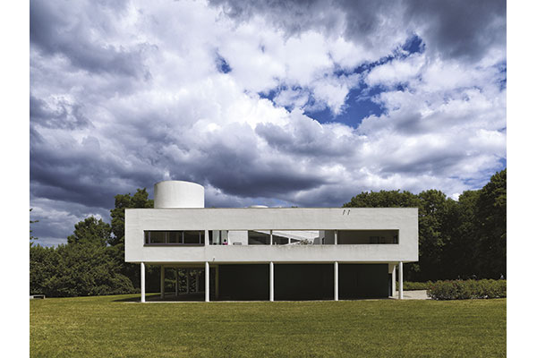 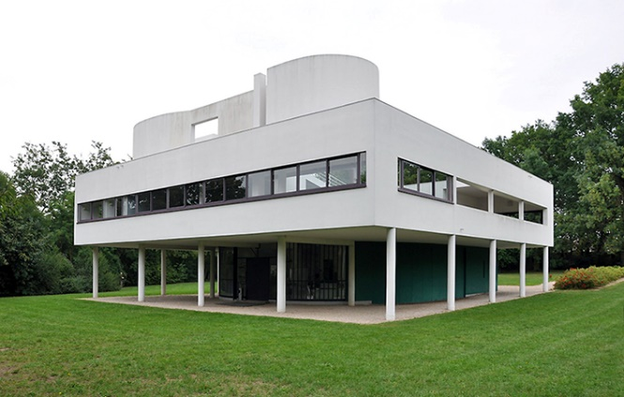

1. Lab:
   * 1. On a photograph of a building in perspective, the students will use a scale or straightedge to find the vanishing points and horizon line.
     2. Sketching:Provide students with copy paper (if they don’t have a sketchbook) and have them practice sketching a simple object (a cup, for example) from multiple points of view.
     3. **Vocabulary:**

Look up the vocabulary words and be prepared to discuss them next class.

Module Bay

Rhythm Repetition

Verticality Horizontality

Frontal Oblique

Foreshortening Colonnade

Fenestration Façade

**Homework Assignments:**

1. **DRAW**: a. In your sketchbook make a drawing from a photograph of a complex rectilinear building (Robie, Fallingwater, Unity Temple, for example).
   1. In the sketchbook, draw a coffee mug, cooking pot, chair, table, or other simple object in your home from multiple points of view (5 sketches).

2) **Read** Vitruvius, Ten Books of Architecture  
 Book I, Chapter 2: The Fundamental Principles of Architecture  
 Book III, Chapter 1: On Symmetry: In Temples and in the Human Body  
 <http://www.gutenberg.org/files/20239/20239-h/20239-h.htm>

3) **Writing** Assignment: In Book III, chapter 1, Vitruvius relates symmetry to the human body. What does Vitruvius mean by symmetry? How is the human body symmetrical? How is a building symmetrical?

Write a 200- to 250-word (long paragraph) and describe what Vitruvius means by symmetry. Your paper should be written in full sentences in paragraph form using 12 point Ariel font on 8 1/2 x 11 inch paper. Place your name, date, course number (ARCH1101), professor’s name (Prof. Zagaroli), and assignment number (Assignment 1) in a column in the upper left-hand corner of the paper.

**WEEK 3 Introduction to Architectural Drawings: Measuring, Drawing, Dimensioning**

Students must develop an awareness and familiarity with drawing types used in the typical architectural practice. Students review and practice the use of drafting strategies introduced in ARCH 1112 and apply these methods to a more complex drawing problem. Concepts covered will include review of orthographic projection drawings, introduction architectural graphic standards and notation. Understand the co-relation between different drawing types. Students will understand and use the architectural scale.

This class presents methods for surveying and documenting measurements. Students will apply the use of the architectural scale to translate an existing building to its orthographic representation as an elevation.

**Class Schedule**

Discussion: Homework assignment: vocabulary words

Lab demonstration: Introduction to drafting.

1. Using the architectural scale: drawing a simple shape at 1/8, ¼, ½ scales. Start with a simple rectangle at full foot dimensions, say 8’x10’; try a couple at different scales. Then teach them how to find inches and give them a couple of rectangles to try.
2. Title block
3. Lettering

Lab:

1. Sketch the elevations of four sides of a chosen object in the classroom. (I use the metal and glass storage case for stone and masonry samples in V305.) Each sketch should resemble its proportions.
2. As a class, measure the object and have the students write the dimensions on your sketches.
3. The class will pick an appropriate scale and you will draw the four elevations, plan, and section.
4. Put in the dimension lines and note label the dimensions.

Assignment:

1. Complete the lab assignment.

2. Write a 200- to 250-word (long paragraph) and discuss the importance of the principles of Order, Arrangement, and Eurythmy as described by Vitruvius.

To Be Discussed

**WEEK 4** **Introduction to Architectural Drawings: Field Trip**

Students investigate the correspondence between the elevation of a building, which they see, and the plan and section of the building, which they don’t. Students will meet at the front entrance to Greenwood Cemetery, 25th Street and Fifth Avenue in **Brooklyn** (yes. Brooklyn. One year several student went to Madison Square Park).

**Sketching**

Immediately inside to the right is the Kohl Mausoleum which I have the students sketch; you are free to choose another. Draw the four orthographic elevations, take pictures, and sketch a perspective from an oblique view of your choice.

**Measuring**

I then ask them to measure it for the hands-on experience. I then ask them to think about the footprint: what is the perimeter outline of the building? Their dimensioned drawings will become the basis of their drafted elevations

**Exploring**

Time permitting, walk deeper into the cemetery and discuss the many styles of architecture; the classical orders, Gothic, Egyptian, etc. I provide a handout of the Classical orders; they are easy to find on Google Images.

**Class Schedule**

Discussion: Historic styles

Lab: Sketching, measuring, and recording

Assignment:

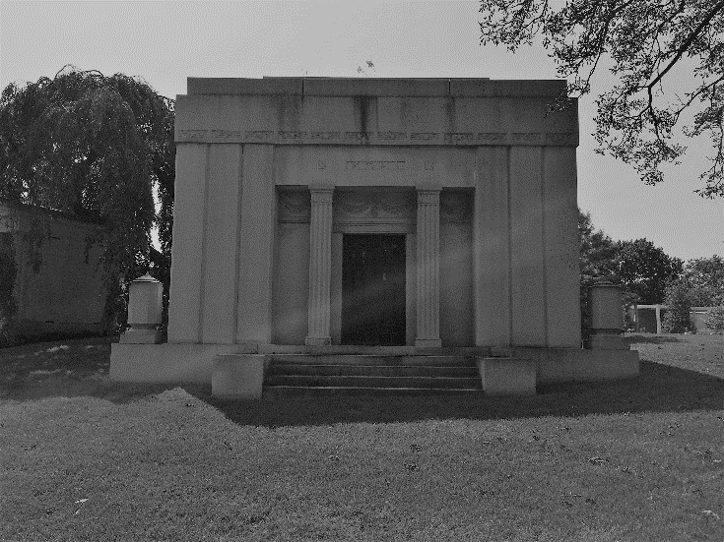 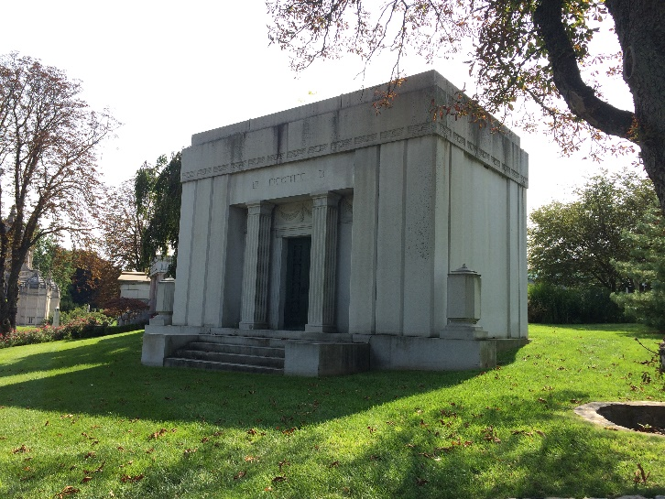

**Kohl Mausoleum, Greenwood Cemetery, Brooklyn**

**WEEK 5 Introduction to Architectural Drawings: Elevations**

After measuring the four sides of a building and noting the openings, projections, bays, etc., students will draft the four elevations to scale at ¼”=1’-0”. Students continue to develop familiarity with drawing types used in the typical architectural practice. This week focuses on drafting elevations.

In the long term, students review and practice the use of drafting strategies introduced in ARCH 1112 and apply these methods to a more complex problem of drawing a building. Concepts covered will include review of orthographic projection drawings, introduction to architectural graphic standards and notation, and understanding the interrelation between different drawing types.

**Class Schedule**

Discussion: Class pin-up of elevation sketches for comparison of dimensions

Lab: Students will set up the drawing sheets with a title block and start their drawings. Two elevations should fit on a 11x17 sheet. Professors can specify how they want the students to format their sheets.

Professors will spend the class time conferencing from student to student helping them advance their drawings and answering any question.

**WEEK 6 Introduction to Architectural Drawings: Plans and Sections**

Lab Demonstration: How to derive a plan of a building?

During the trip to Greenwood Cemetery students were asked to sketch the footprint of the perimeter of building based on their “best guess” by what they observed from the outside. They will then “go inside” and in a separate drawing sketch the plan. In separate drawings they will sketch sections of the interior space.

Students will continue to develop familiarity with drawing types used in the typical architectural practice. This week will focus on deriving a plan. Students review and practice the use of drafting strategies introduced in ARCH 1112 and apply these methods to a more complex drawing problem. Concepts covered will include review of orthographic projection drawings, introduction architectural graphic standards and notation. Understand the co-relation between different drawing types.

**Introduction to differentiating construction vs. design drawings**

Students are introduced to concepts of graphic representation in relation to intention and desired communication. Students observe, analyze, and discuss the difference between construction drawings and design drawings.

**Class Schedule**

Discussion: class pin-up of elevations.

Lecture: How to derive a section from a plan and elevations

Lab: Taking your scaled elevation drawings of a mausoleum, derive a longitudinal and transverse section based on the information provided. You will accurately draft a scaled a scaled plan that conforms to the dimensions given.

Each student is provided with dimensioned sketches of the interior elevations of the mausoleum. Taking your scaled elevation drawings of the exterior, derive the plan based on the information you have. You will accurately draft a scaled plan that conforms to the dimensions given.

**WEEK 7: Introduction to Architectural Drawings: Plans and Sections**

Having constructed a plan, section, and elevation of your building, you will now learn how to bring this knowledge together to construct a three-dimensional representation of in an axonometric projection.

**WEEK 8: Midterm**

**WEEK 9:** **A Section and Elevation of a Two-story House**

Building sections are important when describing the construction of buildings. They show the floor-to-floor height differences, floor construction, and stair configurations. Given a plan of a simple house, students will investigate how to interpret the information given and translate it into a section and an elevation.

**Class Schedule**

Demonstration: From plan to section

Lab: Begin to construct the section and elevation

**WEEK 10: A Section and Elevation of a Two-story House (continued)**

Building sections are important when describing the construction of buildings. They show the floor-to-floor height differences, floor construction, and stair configurations. Given a plan of a simple house, students will investigate how to interpret the information given and translate it into a section and an elevation.

**Class Schedule**

Demonstration: From plan to section

Lab: Continue to construct the section and elevation

**WEEK 11: Urban Design and Planning**

Develop awareness of the practice of urban design and site planning though team activity and presentation. Concepts covered will include site observation, site inventory and analysis, principles of climate and the process of selecting the best location for a given use. Discover the relationship of buildings and the space and contexts that surround them, how places are made, and how programs interrelate across and urban setting.

**Class Schedule**

To Be Discussed

Lecture: Chicago Plan & Rockefeller Center

Lab: visit Metrotech (To Be Discussed related to COVID )

 

**WEEK 12:** **Principles of Composition**

**Proportions:** Students will learn the principles of proportional systems through demonstrations supported by assigned readings. Building examples using harmonic proportions, the golden section, or the Fibonacci spiral will illustrate how these systems were used.

**Symmetry and Balance:** Concepts of symmetry will be explored in historical examples and in actual buildings in downtown Brooklyn. Readings discussing the principles of classical symmetry will be assigned and discussed, followed by a discussion of the Renaissance church, villa, and palazzo.

**Hierarchy:** Many buildings are organized as an assembly of several masses, each of which exhibits its own symmetry and proportion. Such assemblies may be symmetrical or asymmetrical. Students will be introduced to examples where buildings of complex mass are balanced and discover how the connections between the masses are visually resolved. Buildings, both simple and complex, exhibit visual hierarchy. Students will be introduced to examples of ways in which buildings exhibit hierarchy and deploy elements to reinforce that hierarchy.

**Modules, Bays, Rhythms**

This lesson will ask students to grasp concepts of organizational structures such as grids and repetitions through readings, demonstrations, and sketching assignments. Students will investigate building elements such as colonnades, bays, and loggias. Through the exploration of building facades students will learn how building surfaces are opened for windows and doors and how edges and corners are defined. Students will learn technical terms associated with facades such as fenestration, soffit, cornice, string course, column, etc. by sketching them and labeling their sketches. Students will learn to hierarchically break down the building in a drawing, beginning with its profile, its organization, and its primary elements.

**Class Schedule**

Lab: Students will work with their group on their urban design presentations

**WEEK 13: Personal Space**

This week begins a three-week exercise in which students are asked to develop a concept for a non-programmed space, namely a personal space, and express it in words, and in coordinated plan, sections, elevation, and cutaway axonometrics. In the final class they will present their project to a jury. The purpose of this exercise is to give the students a chance to present a concept that is expressed in architectural drawings. They should not be evaluated by how well their concept corresponds to their design; this they will do in design studio. Rather the evaluation should focus on the completeness of the drawings, and how well they are coordinated.

**Class Schedule**

Discussion:

What is a concept? How do architects organize their thoughts into a single concept that can be expressed architecturally?

Lab:

1. The professor should provide the students with a plan showing a 20’ x 20’ square space with window and door positions dimensionally indicated. A window and door schedule should be provided enumerating sill and head heights. The plan should be at a smaller scale than the deliverables so the students will have to scale it up. Students have the option to change window sizes and locations, but the quantity of windows and doors must remain the same
2. Think about the kind of personal experience you want to capture in your space. Make a list of bullet points of the key feelings you have and ways you might want to accommodate them
3. Draw a floor plan sketch on tracing paper to represent your concept. Be adventurous.
4. Pin-up the list and the plan for in-class discussion. In this discussion, we will select a “concept” for your personal space, and we will discuss how this “concept” might be interpreted architecturally.

Homework Assignment:

1. Each personal space must be 20’ wide x 20’ deep x12’ high (18’ x18’ interior). Variations are allowable with permission of the professor.
2. Compose a one-paragraph description of your concept from your bullet points.
3. Using hardline drafting (not freehand) draw the plan and 4 interior elevations of the walls of the space (at ¾”=1’-0” scale).
4. Draw the interior elements you are adding to the space on the plan
5. Place trace paper over each elevation and sketch in the interior elements as they would appear in elevation. Assume you are standing in the center of the room and looking in each direction.
6. On the sketches, use notations to identify the major elements.

**WEEK 14: Personal Space - Development**

This week continues the three-week exercise in which students are asked to develop a concept for a non-programmed space, namely a personal space, and express it in words, in plan, section, and elevation, and in a model. In the final class they will present their project to a jury.

**Class Schedule**

Lab:

1. Review your plan and elevations with your professor.
2. Draw 2 cutaway axonometric drawings (plan plus two walls) from opposite corners of the room.

Homework Assignment:

Requirements for the final assignment are:

1. (1) Plan, (4) interior section/elevations and (2) cut away axonometric drawings on 11 x 17 vellum drawn at 3/4”=1’-0”. You will be graded on the quality of the drawings and the completeness of the drawings.
2. Concept statement. You must write 2-3 paragraphs that describe your personal space with all of the concepts that are being represented in the drawings. You will be graded on the clarity of your written statement, and your ability to clearly communicate your architectural concept. This must be computer printed, and must be pinned up along with the drawings for review. Include any inspirational imagery, or any other diagrams that you used in reaching your final design.

**WEEK 15 Personal Space – Presentation**

You will present your Personal Space to a jury of faculty members, similar to what you might expect in your Foundations or Studio classes.

**NOTE: Weekly lesson sequence could be reversed depending on the season. As shown, the outdoor lab lessons are at the end of the semester (ideal for the spring semester), but could be reversed (or interchanged) in the fall to permit the outdoor labs to occur in September and October.**