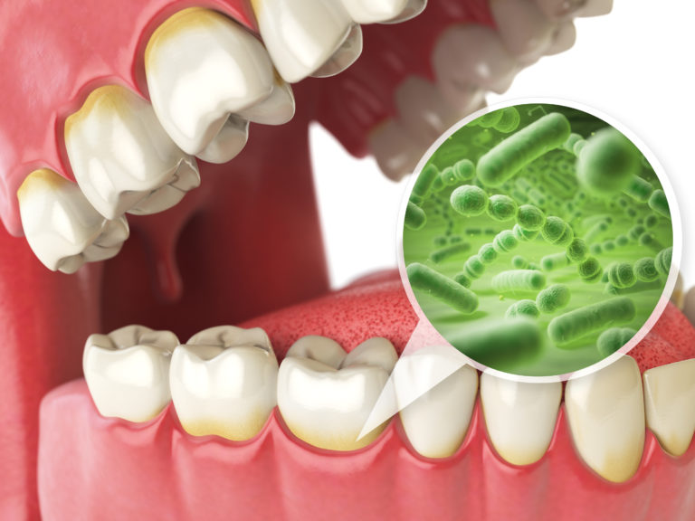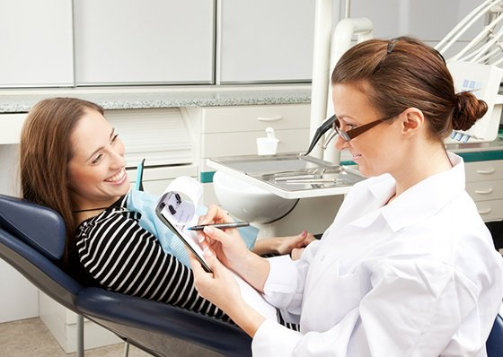

## **References:**

* Mahantesha, T. R. (2015). Comparative Study of Probiotic Ice Cream and Probiotic Drink on Salivary Streptococcus mutans Levels in 6-12 Years Age Group Children. Journal of International Oral Health : JIOH, Vol.7(9), pp.47-50.
* Nadkerny, P., Ravishankar, P., Pramod, V., Agarwal, L., & Bhandari, S. (2015). A comparative evaluation of the efficacy of probiotic and chlorhexidine mouthrinses on clinical inflammatory parameters of gingivitis: A randomized controlled clinical study. Journal of Indian Society of Periodontology, 19(6), 633. doi:10.4103/0972-124x.168491
* Weinberg, M. A., Theile, C. M., Froum, S. J., Palat, M., & Schoor, R. (2014). Comprehensive periodontics for the dental hygienist. Upper Saddle River: Prentice Hall.
* Gao, L., Xu, T., Huang, G., Jiang, S., Gu, Y., & Chen, F. (2018). Oral microbiomes: More and more importance in oral cavity and whole body. Protein & Cell, 9(5), 488-500. doi:10.1007/s13238-018-0548-1
* Lin, S., Lin, S., & Lin, S. (n.d.). Probiotics and Your Oral Microbiome by Dr Steven Lin. Retrieved from https://www.drstevenlin.com/probiotics-oral-microbiome/
* Granier, D. (2010). Probiotics and Oral Health. JCDA. Retrieved from https://www.cda-adc.ca/jcda/vol-75/issue-8/585.pdf.
* Mary Jane Brown. (2016). 8 Health benefits of probiotics. Retrieved from https://www.healthline.com/nutrition/8-health-benefits-of-probiotics
* Srinivasan, S., Nandlal, B., & Rao, M. S. (2017). Assessment of plaque regrowth with a probiotic toothpaste containing Lactobacillus paracasei: A spectrophotometric study. *Journal of Indian Society of Pedodontics and Preventive Dentistry,35*(4), 307. doi:10.4103/jisppd.jisppd_323_16
* Neel Dugga. (2017). 5 Way Oral Probiotics Can Keep Your Mouth Healthy. Retrieved from https://www.healthline.com/health/oral-probiotics#foods-and-supplements

Presented by:

Jashlie Sanchez

Jenny Lau

Yahya Salim

**Role of the dental hygienist:**

2019 © New York City College of Technology   
718-260-5000     
300 Jay St, Brooklyn, NY 11201

**Probiotics and the Oral Microbiome**

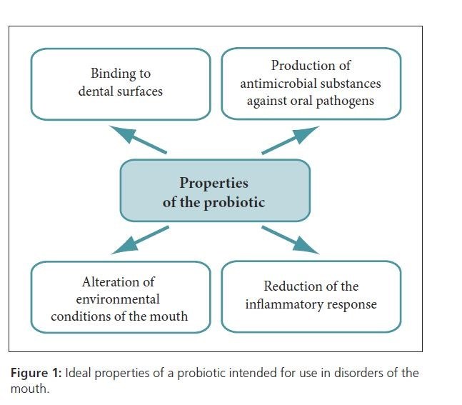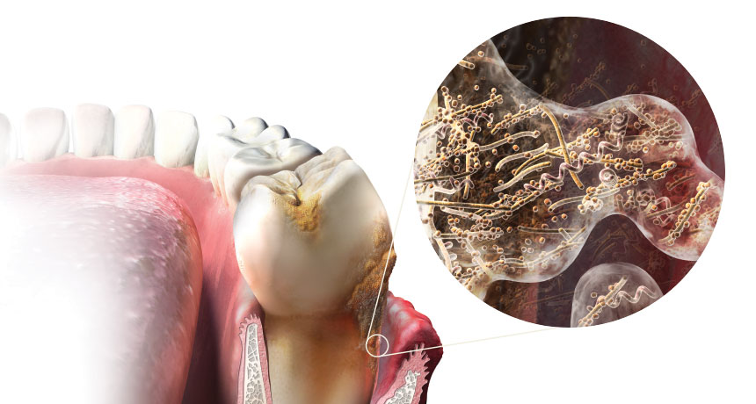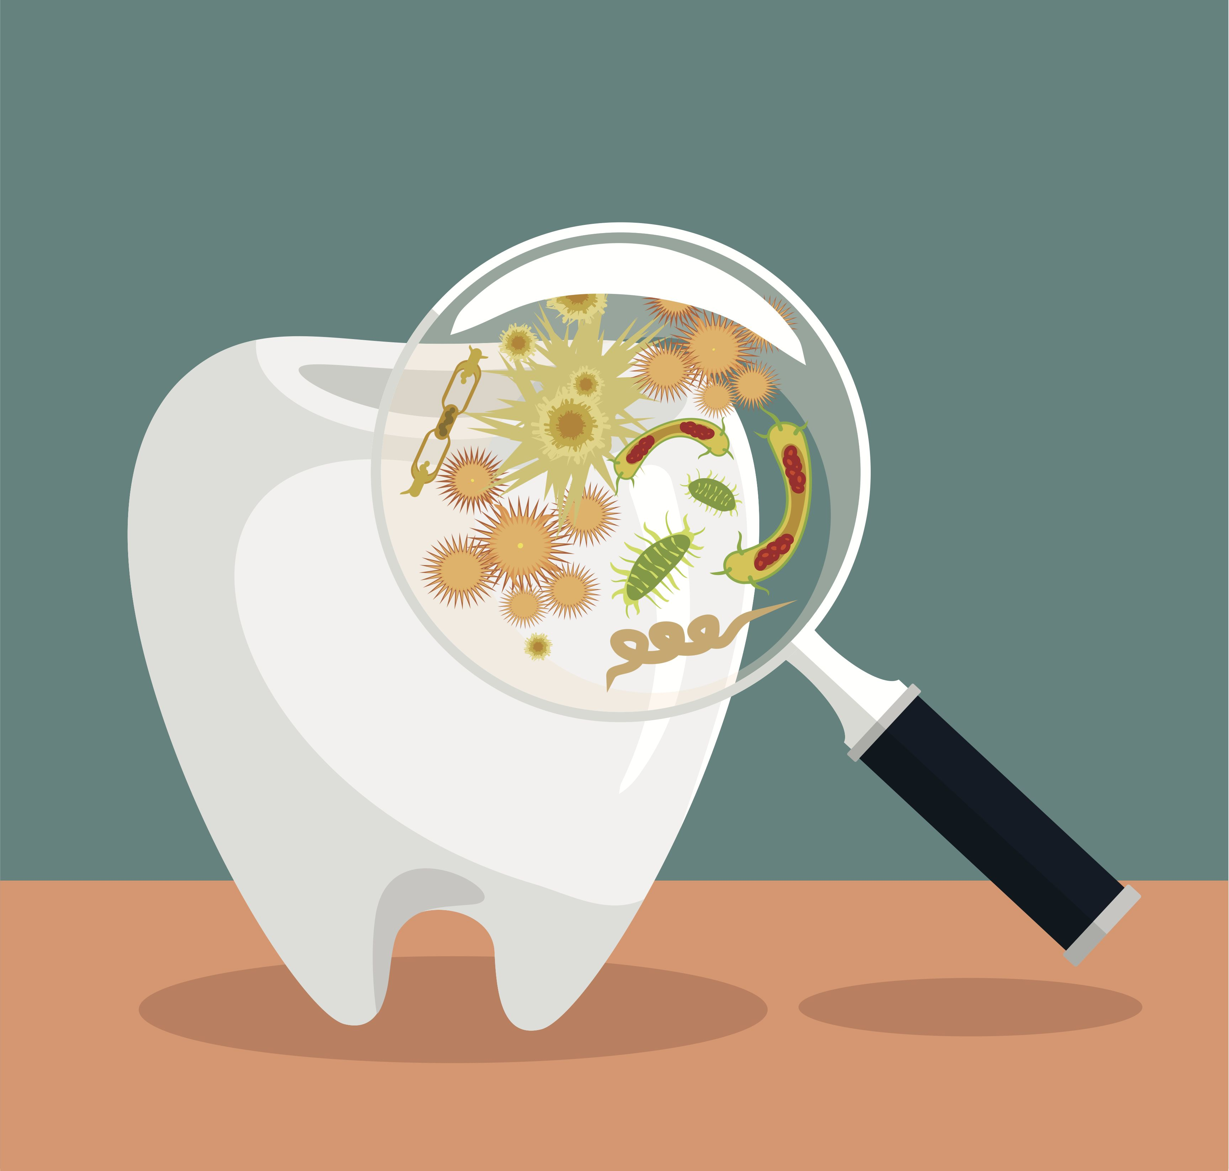

* Thorough medical and dental history check
* Periodontal assessments such as Plaque, Calculus, or Gingival index scores.
* Patient education services
* Prevention and therapeutic service and maintenance
* Dietary assessment
* Nutritional counseling and diet log
* Public health education
* Evidence based practice

Dental Hygiene Department

Wellness Fair 2019

**Probiotics** are known as good friendly bacteria that when consumed in adequate amounts can provide a list of health benefits, primary in your gut flora. Probiotics can be found in the foods we eat or in supplements. Within the past decade, researchers have studied probiotics as a potential oral health. **Oral probiotics** are specific beneficial bacteria used to maintain oral health as a defense against bacteria known to be harmful to teeth and gums. Oral probiotics can be found in the form of toothpaste, chewable tablets or mouth rinse. Probiotics in oral health is a new area of research and only a few clinical studies have been conducted.

***Bacteria in the oral cavity***

Early stages of gum disease can indicate in increase/imbalance amount of bacterial population, primarily due to poor oral hygiene. Some examples are:

* *Streptococcus mutants* - bacterium that has been linked to caries formation 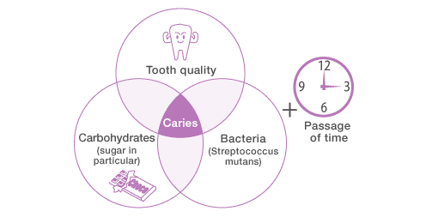
* *T. denticola*- releases toxins that can cause gum inflammation and can also cause bad breath
* P. Gingivalis- can destroy tissues that support the tooth.

***Benefits of Oral Probiotics***

* Prevents Plaque build up
* Fights bad breath
* Manage symptoms of gingivitis
* Decreases inflammation from gum disease

# ***What are Probiotics?***

***Oral Probiotics in Dentistry***

Studies have shown:

* Oral probiotic rinses are efficient as chlorhexadine in the reduction of gum inflammation
* Probiotic toothpaste containing Lactobacillus paracasei disrupts the formation of plaque
* Probiotic ice cream lowered levels of S.mutants (caries causing bacteria) for over 1 months consumption
* There are also specific probiotics know to prevent and heal gum disease.

Although there is still much research going on about oral probiotics, more research is still needed to evaluate the long-term effect of probiotics and the role of specific strains. In the meantime, it is important to maintain a diet with probiotic containing foods to get the benefits of a balanced micro biome.

***How to incorporate probiotics***

* Diet- food that is rich in probiotics; yogurts, milk, pickles, and etc.
* Supplements
* Breast feeding- research shows healthy microbes in breast milk, which is essential for a newborns gut health.

***Oral Microbiome***

***Did you know that our mouth contains over 700 species of bacteria?***

Microbes are a part of our everyday life. Our body contains both good and bad bacteria.

***“Your mouth, the gateway to your body”***

Studies have shown how our oral micro biome can be linked to our general systemic health and it is important to keep a balance of microbes for our general health benefit.

### ***Bacteria: Relationship to gum disease & caries***

* ***Biofilm*** is a surface of film that contains microorganisms and other biological substance.
* ***Plaque*** is more visible, increased structural amount of biofilm.
* **Microbial biofilm** plays a major role in the initiation and progression of both dental caries and periodontal infection.

***Gingivitis*** and gum disease begins with the presence of plaque biofilm, bacterial invasion, and the body’s inflammatory response.