TCET 2202
Transmission Lines
By Prof. Viviana Vladutescu

Project # 1

Date: 05/24/2013

Group Members:
Esnan Ambeau
Rupan Hossain
Yevgeniy Morozov

Question 1

A source with 50 Ω source impedance drives a 50 Ω T-Line that is 1/8 of a wavelength long, terminated in a load Z_{L}=50-j25 Ω. Calculate and use the Smith Chart to find:
a)Γ_{L}; b)VSWR; c)Z_{in} seen by the source.

ANSWER:

a) 0.245 ← 74º

b) 1.66

c) Z_{in} = 31 - j5

Utilizing the Smith Chart:

a) We first locate the normalized load impedance Z_{L(normalized)} = (50 – j25) / 50 = 1 – j0.5

Now, we draw a line from the center through Z_{L} towards the angle of reflection coefficient. The angle is -74º.
OP1 is the distance from the center to Z_{L(normalized)} . OP2 is the distance from the Center toward the angle coefficient of reflection.

Γ_{L} = OP2/OP1 = 2.45 at an angle of -74º

b) For VSWR, we drew the gamma circle and took the real value where it intersected the real axis, and therefore VSWR = 1.66

c) For the Z_{in} , Z_{L} is at 0.353λ, so 0.353λ + 0.125λ = 0.478λ towards the generator from the load. At this distance, the Z_{in(normalized)} is 0.62 – j0.1, so the actual input impedance is
Z_{in} = (0.62 – j0.1) * 50 Ω = 31 – j5 Ω

Smith Chart can be seen on the next page
Smith Chart

Question 2

A 1m long T-line has the following distributed parameters: R’=0.10 Ω/m, L’=1.0 µH/m, G’=10.0 µS/m, and C=10nF/m. If the line is terminated in a 25 Ω resistor in series with a 1.0nH inductor, calculate at 200MHz, Γ_{L} and Z_{in.}

ANSWER:

We figured the best way to organize a solution to this problem was to implement Matlab, because there are so many constants, and we also thought it would be useful to experiment with the Smith Chart function within Matlab.

First we calculated our

Z_{L} = 25 + jwC = 25 + j * (2*pi*f) * C = 25 + j * (2 * 3.1428 * 200 * 10⁶ * (10⁻⁹) = 25 + j1.257 Ω

Now we can utilize Matlab to find our values with the following code:

clc
clear
clf

R=0.1;
L=1.0e-6;
G=10e-6;
C=1.0e-9;
f=200e6;
w=2*pi*f;
l=1; %Just to clarify, length is in meters
Zl=25+j*1.257;

A=R+j*w*L;
B=G+j*w*C;
gamma=sqrt(A*B)
Zo=sqrt(A/B)
gammaL=z2gamma(Zl,Zo) %the z2gamma function we use instead of writing the full equation
Zin=Zo*((Zl+Zo*(tanh(gamma*l)))/(Zo+Zl*(tanh(gamma*l))))

gammareal=real(gammaL); %I defined this real value to be used in a toolbox later
gammaimag=imag(gammaL); %I defined this imaginary value to be used in the same toolbox

Our output values are:

gamma =

0.0017 +39.7384i

Zo =

31.6228 - 0.0011i

gammaL =

-0.1164 + 0.0248i

Zin =

34.0192 – 7.4618i

Now we utilize the Smith Chart function in Matlab to plot our values, and we used a very helpful toolbox created by an individual by the name of “Mohammad Ashfaq,” which can be found here:

http://www.mathworks.com/matlabcentral/fileexchange/324

Here is the additional code, that we used after the previous:

scDraw %This is one of the toolbox functions
scArc([gammareal gammaimag],'c') %This is also one of the toolbox functions
scRay([gammareal gammaimag],'r') %This is also one of the toolbox functions

The values are based on our gamma that we found originally, and produces the plot below, which the corresponding Ray that goes through the gamma = 0.0017 + 39.7384i point is shown in red, and the gamma circle itself is shown in cyan.

Smith Chart can be seen on the next page

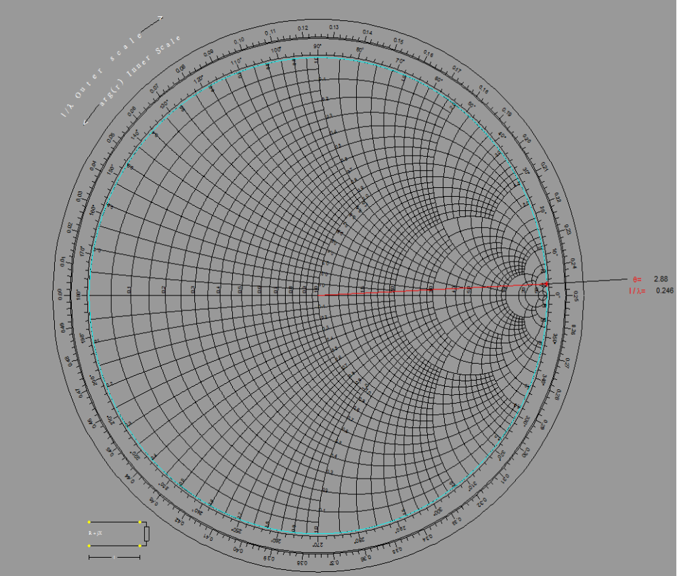
Smith Chart

Question 3

The input impedance for a 30cm length of lossless 100 Ω impedance T-line operating at 2.0 GHz is Z_{in}=92.3-j67.5 Ω. The propagation velocity is 0.7c. Determine the load impedance.

ANSWER:

Velocity v = 0.7 * c = 0.7*3*10⁻⁸ = 0.21 * 10⁻⁸ m/s

When we use our base equations of Z_{in} = Z_{o} ((Z_{L} + Z_{o}tan(β*l))/(Z_{o} + Z_{l}tan(β*l)))
When we multiply both sides by the denominator, and then rearrange it in terms of our load impedance Z_{L}, we get the equation Z_{L} = Z_{o} ((Z_{in} - Z_{o}tan(β*l))/(Z_{o} – Z_{in}tan(β*l)))

β = w / v = (2*3.1428*2*10⁹) / (0.21 * 10⁻⁸) = 59.8 rad / m

tan(β*l) = -1.254

We use the following Matlab code to help with the calculations:

clear
clc
clf

Zo=100;
Zin=92.3 - j*67.5;
Zload = Zo*((Zin - j*(Zo*(-1.254)))/(Zo - j*(Zin*(-1.254))))

Our Z_{L} came out to be Z_{L =} 49.998 + j*0.0163.

Utilizing the toolbox we used for the previous problem, we can see the Smith Chart with the Z_{L} ray plotted in cyan.

We added the following code to the previous code:

Zloadreal=real(Zload);
Zloadimag=imag(Zload);

scDraw
scRay([Zloadreal Zloadimag],'r')

Smith Chart can be seen on the next page

Smith Chart

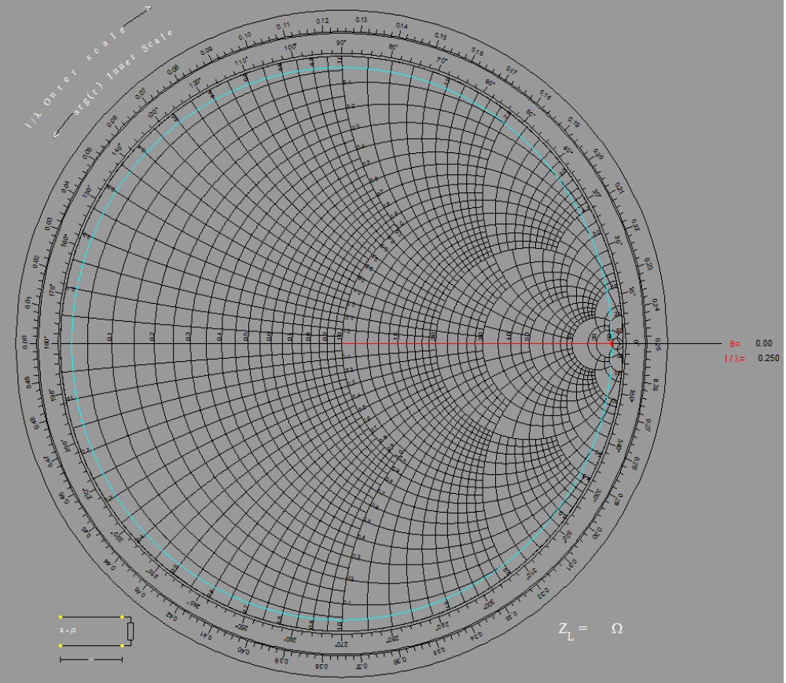

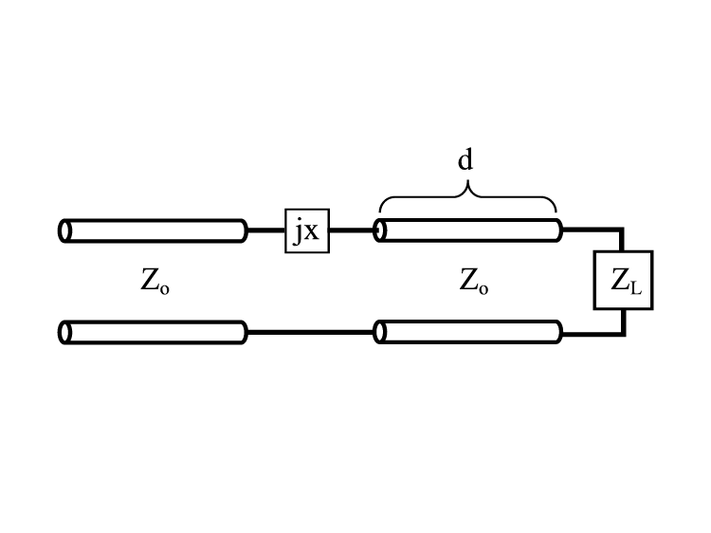
Question 4

A matching network, using a reactive element in series with a length d of T-Line, is to be used to match a 35 – j50 Ω load to a 100 Ω T-Line. Find the through line length d and the value of the reactive element if (a) a series capacitor is used, and (b) a series inductor is used.

ANSWER:
a) Z_{L(normalized)} = (35 – j50 Ω) / (100 Ω) = 0.35 – j0.5 Ω.

We draw the ray through the point of Z_{L(normalized)} and also draw a circle, centering around the origin where the normalized point lies.

We look for the intersection point of the r = 1 circle, and it appears to be on the + j1.4 and the -j1.4. Using the +j1.4 value (for reactive), the capacitive element would be
C = 1 / (2*3.1428*(1*10⁹)*(100)*(1.4) = 1.14 * 10⁻⁹ F.

Our distance would be 0.5 λ + 0.173 λ (as can be seen from the Smith chart on the next page) – 0.419 λ (also on the Smith Chart) = 0.254 λ .

b) Now we go to the bottom of the chart for the inductive element, and there we use the -j1.4 which yields the 0.327 λ measurement.
D = 0.5 λ + 0.327 λ – 0.419 λ = 0.408 λ .
Our inductance would be L = (1.4) * (100) / ((2 * 3.1428) * (10⁹)) = 22.3 * 10⁻¹² H

Smith Chart can be seen on the next page

Smith Chart

Question 5

You would like to match a 170 Ω load to a 50 Ω T-Line. (a) Determine the characteristic impedance required for a quarter-wave transformer. (b) What through-line length and stub length are required for a shorted shunt stub matching network?

ANSWER:
a) Z_{characteristic} = (Z_{o}R_{L})^{1/2} = 91.195 Ω

b) Z_{L(normalized)} = 170 / 50 = 3.4 + j0
Y_{L(normalized)} = 3.4 - j0

On the next page there is a Smith chart with all the plots required. Both Y_{L(normalized)} and Z_{L(normalized)} are on the vertical axis.

We drew the r circle, and the gamma circle, and the matching points were on 1+1.3j and 1-1.3j, which we then extended out into rays, both colored green, and had a distance difference of the bottom point of 0.354 λ. We subtracted our quarter-wave length of 0.25 λ and got 0.104 λ for our final answer for l.

l = 0.104 λ

We used Matlab for the Smith Chart using the same Toolbox as before, but we had to slightly modify it because one of the functions was printing r circles on the higher values. Here is the code we utilized:

clear
clc
clf

Zload = 3.4 + j*0
Yload = 3.4 - j*0

Zloadreal=real(Zload);
Zloadimag=imag(Zload);

scDraw
scRay([Zloadreal Zloadimag],'r')
scArc([Zloadreal Zloadimag],'r')
set(gcf,'color',[0.6 0.6 0.6])
modifiedscMatchCirc('c')
modifiedscRay([1 1.3],'g') %1st ray above horizontal axis
modifiedscRay([1 -1.3], 'g') %2nd ray below horizontal axis

We had to modify another Toolbox function “scRay” which draws rays from the origin, because it was unable to take the -j value from our Y_{L}. We simply redefined the radian boundaries so it would allow for -j values to print.

Here is the shunt-stub:
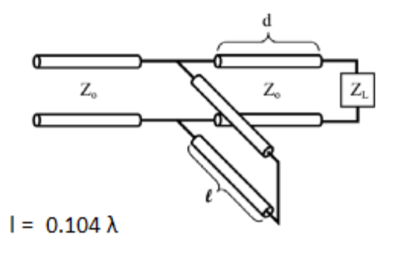

Smith Chart can be seen on the next page
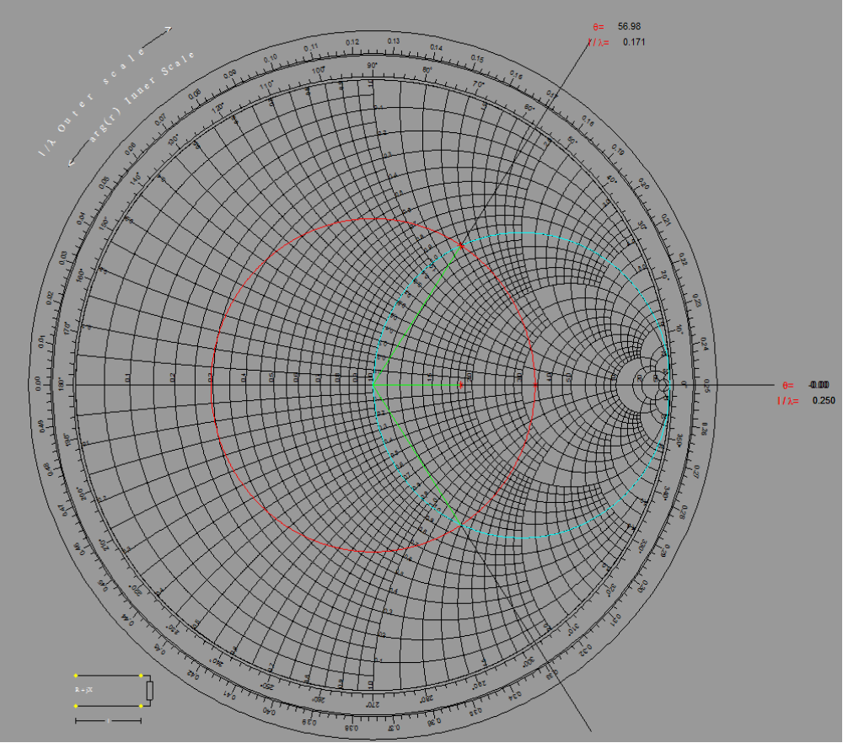
Smith Chart

Question 6

Consider the circuit in the figure with the following values: V_{s} = 10 V, Z_{s} = 30 Ω, Z_{o} = 50 Ω, u_{p} = 0.666c, Z_{L} = 150 Ω, l = 10 cm for a 10 V pulse of duration 0.4 ns. Plot, out to 2 ns, (a) the voltage at the source end, (b) the voltage at the middle, and (c) the voltage at the load end of the T-Line.

ANSWER:

Let us find our speed first.

u_{p} = 0.666* 3* 10⁸ = 2*10⁸ m/s

Then we find our time it takes to travel one length which is

t_{initial} = l / u_{p} = 10*10⁻² / (2*10⁸) = 0.5 ns.

This means we will have 4 bounces in our measurements (t_{plot}/t_{initial} = 4)

Our Γ_{L} = (Z_{L} – Z_{O})/(Z_{L} + Z_{O}) = (150 – 50)/(150+50)

Γ_{L} = 0.5

Our Γ_{S} = (Z_{S} – Z_{O})/(Z_{S} + Z_{O}) = (30 – 50)/(30 + 50)

Γ_{S} = -0.25

We did the calculations based on the two gammas and the results are included in the bounce chart below.

First wave travels at 10V

Second wave reflects back at 5V

Third wave reflects back at -1.25V

Fourth wave reflects back at -0.625V
Bounce Chart

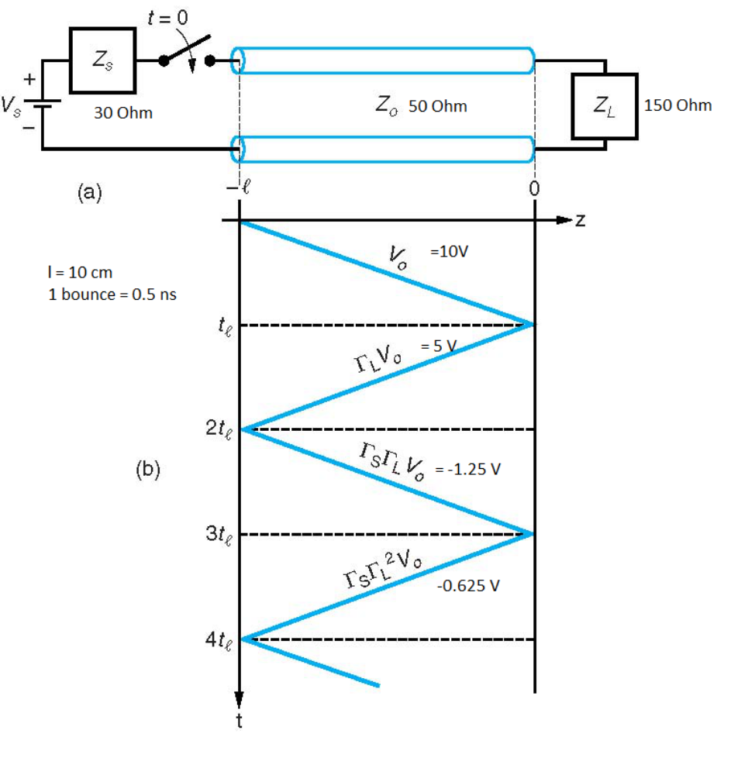

On the next page, you can find the Voltage Diagrams for the Source, Middle, and End of the T-Line

Voltage Diagrams



