$E_{3μm}=\frac{hc}{λ}=\frac{\left(4.136*{10}^{-15}ev*s\right)\left(3*{10}^{8}\frac{m}{s}\right)}{3*{10}^{-6}m}=0.4136eV$

$E_{5μm}=\frac{hc}{λ}=\frac{\left(4.136*{10}^{-15}ev*s\right)\left(3*{10}^{8}\frac{m}{s}\right)}{5*{10}^{-6}m}=0.248eV$

$E=hf=\frac{hc}{λ}=\frac{\left(4.136*{10}^{-15}ev*s\right)\left(3*{10}^{8}\frac{m}{s}\right)}{1*{10}^{-6}m}=1.24eV$

1. X band radar

Wavelength: 2.4cm-3.8cm

Frequency: 12.5GHz-8.0GHz

$E_{n}=Z^{2}*\frac{E1}{n^{2}} , E1=-13.58eV$

$E_{He+}=2^{2}*-\frac{13.48eV}{1^{2}}=-54.32eV$

$E4=Z_{4}^{2}*\frac{E1}{n_{4}^{2}}=1^{2}* -\frac{13.45eV}{4^{2}}=-0.84875eV$

$E2=Z_{2}^{2}*\frac{E1}{n_{2}^{2}}=1^{2}* -\frac{13.45eV}{2^{2}}=-3.395eV$

$λ=\frac{hc}{E}=\frac{1.24*{10}^{-6\left(eV*m\right)}}{0.84875eV-(-3.395eV)}=486*{10}^{-9}m$

$f=\frac{c}{λ}=\frac{3*{10}^{8}\frac{m}{s}}{486*{10}^{-9}m}=6.16*{10}^{14}Hz$

1. `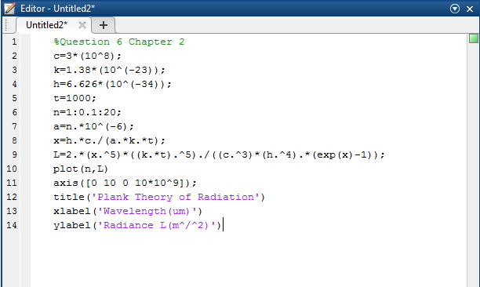

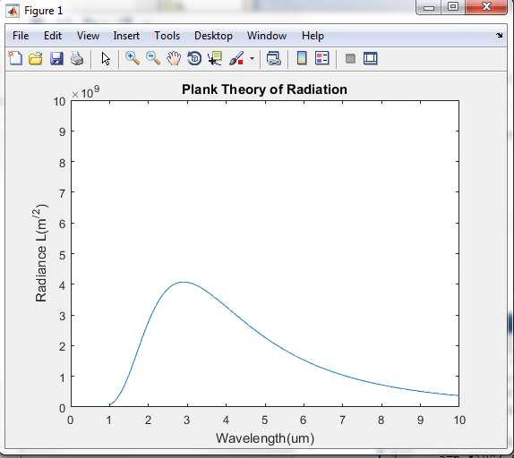

$$L_{10μm}=\frac{2*\left(6.626*{10}^{-34} J*s\right)*\left(3*{10}^{8}\frac{m}{s}\right)}{{\left(10*{10}^{-6}m\right)}^{5}}*\frac{1}{e^{\frac{\left(6.626*{10}^{-34}j*s\right)*\left(3*\frac{{10}^{8}m}{s}\right)}{10*{10}^{-6}m*\left(1.38*\frac{{10}^{-23}J}{K}\right)*\left(1000K\right)}}-1}=3.7011*{10}^{8}\frac{w}{m^{2}}$$

$L_{20μm}=\frac{2*\left(6.626*{10}^{-34} J*s\right)*\left(3*{10}^{8}\frac{m}{s}\right)}{{\left(20*{10}^{-6}m\right)}^{5}}*\frac{1}{e^{\frac{\left(6.626*{10}^{-34}j*s\right)*\left(3*\frac{{10}^{8}m}{s}\right)}{20*{10}^{-6}m*\left(1.38*\frac{{10}^{-23}J}{K}\right)*\left(1000K\right)}}-1} =3.5332*{10}^{7}\frac{w}{m^{2}}$

$L_{30μm}=\frac{2*\left(6.626*{10}^{-34} J*s\right)*\left(3*{10}^{8}\frac{m}{s}\right)}{{\left(3*{10}^{-6}m\right)}^{5}}*\frac{1}{e^{\frac{\left(6.626*{10}^{-34}j*s\right)*\left(3*\frac{{10}^{8}m}{s}\right)}{3*{10}^{-6}m*\left(1.38*\frac{{10}^{-23}J}{K}\right)*\left(1000K\right)}}-1}=4.0669*{10}^{9}\frac{w}{m^{2}}$

7. $λ_{max}=\frac{a}{T} \left(a=2.898*{10}^{-3} m*K\right)$

${ λ}_{\max{ 297}K}=\frac{a}{T}=\frac{2.898*{10}^{-3} m*K}{297 K}=9.7575*{10}^{-6}m=9.7575μm=9757.5nm$

$λ_{\max{ 1000}K}=\frac{a}{T}=\frac{2.898*{10}^{-3} m*K}{1000 K}=2.898*{10}^{-6}m=2.898μm=2898nm$

$λ_{\max{ 297}K}=\frac{a}{T}=\frac{2.898*{10}^{-3} m*K}{5800 K}=0.49965*{10}^{-6}m=0.49965μm=499.65nm$

8. $R=σεT^{4} \left(σ=5.67*{10}^{-8}\frac{W}{m^{2}k^{4} }\right)$

$$R=σεT^{4}=\left(5.67*{10}^{-8}\frac{W}{m^{2}k^{4} }\right)*\left(1\right)*\left(297K\right)=441.2 \frac{W}{m^{2} }$$

$$P=R*Area=441.2 \frac{W}{m^{2} }*2 m^{2}=882.4 W$$

9.

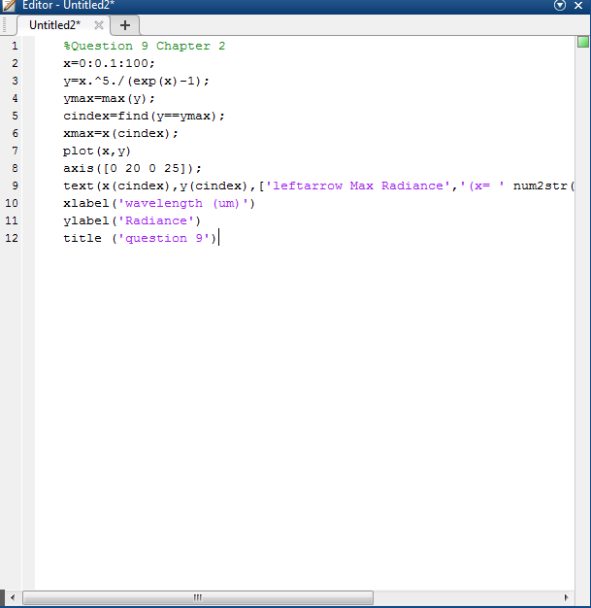

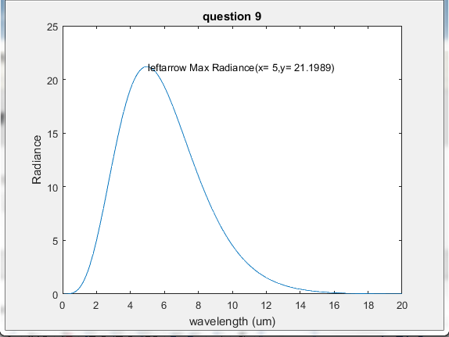

10. $n_{1} sinθ_{1}=n_{2} sinθ_{2}$

$\left(1\right)sin{30}^{°}=\left(1.33\right)sinθ_{2}=\sin_{θ2}=\frac{\sin\left({30}^{°}\right)}{1.33}=0.375939$

$$θ_{2}=\sin^{-1}\left(0.375939\right)={22.08}^{°}$$

$$n=\frac{c}{v}=v=\frac{c}{n}=\frac{3*{10}^{8} m/s}{1.33}=2.255*{10}^{8} m$$

$$θ_{reflected}=θ_{1}=30°$$

11. $R={\left(\frac{n_{1}-n_{2}}{n_{1}+n_{2}}\right)}^{2}={\left(\frac{1-1.5}{1+1.5}\right)}^{2}=0.04$