Yanling Feng
Den 2315 Pharmacology
Fall, 2019
Horse Chestnut
Horse chestnut trees are native to Balkan Peninsula, which includes such countries as Albania, Bulgaria, Greece, Romania, and Servia. They have grown worldwide because of its excellent resistance to environmental conditions. Common names are called Aesculaforce, Buckeye, California buckeye, Castanea equine, Chestnut, Essaven, Horse chestnut, Japanese horse chestnut, Ohio buckeye, Semen hippocastani. Scientific names are called A. California Nutt. (California buckeye)., A. glabra Willd. (Ohio buckeye), A. turbinata Blume., Aesculus hippocastanum L. (horse chestnut). People use oral horse chestnut seed extract as a dietary supplement. The generic name this supplement is called Horse chestnut, the brand name is called Venastat.
The principal proposed uses are to treat short-term treatment of mild to moderate chronic venous insufficiency (CVI). Based on a 2012 systematic review of 17 studies published between 1976 and 2002, it suggested the horse chestnut seed extract can improve leg pain, swelling, and itching in people with CVI. It also suggested it may be as effective as wearing compression stockings. Other proposed uses are for hemorrhoids and swelling after surgery. The main active component in horse chestnut extract is Aescin. Most commonly, Aescin 20 to 120 mg taken orally has been used for venous insufficiency and is available in tablet form. Oral tinctures and topical gels containing 2% Aescin are also available. Horse chestnut may have interactions with other drugs like aspirin, clopidogrel (Plavix), ticlopidine (Ticlid), pentoxifylline (Trental), anticoagulant drugs such as warfarin or heparin. The most common adverse reactions include nausea and stomach discomfort. Other mild and infrequent complaints include headache, dizziness, and pruritus. Horse chestnut has been classified by the FDA as an unsafe herb. It’s contraindications for pregnancy or lactation. There are no oral manifestations.
The most common treatment for CVI is the compression therapy of stocking, which can increase blood flow to your legs. However, Compression treatment for CVI is a conservative therapy, it also often causes discomfort and has been associated with poor compliance. Therefore, oral drug treatment is an attractive option for consumers. However, people with chronic venous insufficient who want to take the horse chestnut oral supplement should always consult with a healthcare provider first before they start the medication. They may know this product through advisement and any of the online websites. Therefore, they may have misleading information or may only know insufficient information about the product.
As a health educator, we should know well about this product including the therapeutic function, direction, dosage, drug/food interaction, adverse effect, contraindication and so all. We should obtain product information from a drug book, a government website or a reliable website. To know well about the product, it will prepare us to discuss the product with the patient and convey the valid information to them regarding possible associated risks. Also, it will facilitate us to develop and implement a precise treatment plan for a patient who is taking this natural supplement. As mentioned before, horse chestnut has interactions with other drugs; it may cause adverse effects, and it’s contraindications for pregnancy or lactation. When discussing a treatment plan with a patient, we should always education them with valid information and tell patient that it is necessary to consult with a medical doctor before taking Horse chestnut supplements.

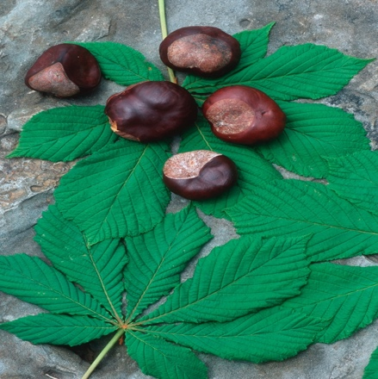
Product Image: appears in nature
https://nccih.nih.gov/health/horsechestnut

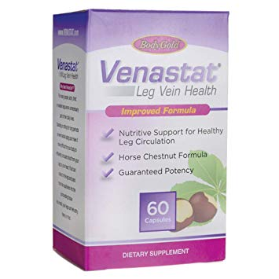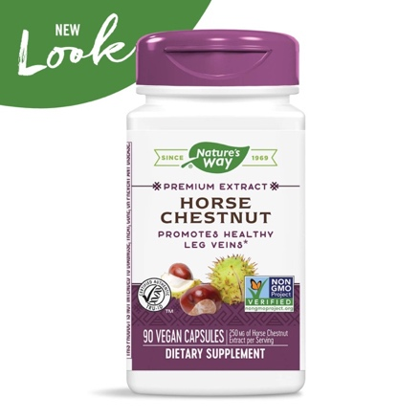
Product image: as packaged for consumer use
https://www.amazon.com/Venastat-Vein-Health-Bonus-Capsules/dp/B00009N8R1
https://www.amazon.com/Natures-Way-Standardized-Certified-Vegetarian/dp/B0002MSSGE

References
Drug Information Handbook for Dentistry. Lexi-Comp Inc, 2016.
“Horse Chestnut.” Winchester Hospital, 2015, www.winchesterhospital.org/health-library/article?id=21758.
“Horse Chestnut.” National Center for Complementary and Integrative Health, U.S. Department of Health and Human Services, 30 Nov. 2016, nccih.nih.gov/health/horsechestnut.
Pittler MH, Ernst E. Horse chestnut seed extract for chronic venous insufficiency. Cochrane Database of Systematic Reviews 2012, Issue 11. Art. No.: CD003230. DOI: 10.1002/14651858.CD003230.pub4.
Sudheendra, Deepak. “Venous Insufficiency: MedlinePlus Medical Encyclopedia.” MedlinePlus, U.S. National Library of Medicine, 10 June 2018, medlineplus.gov/ency/article/000203.htm.

