Wilawan Wunjina
DEN 2315 Pharmacology
Fall, 2016
Feverfew
Product information
Feverfew or Tanacetum parthenium is a flowering plant with green-yellow leaves and a yellow flower resembling chamomile. Feverfew is native to southeastern Europe and Australia. It has been used for centuries as an analgesic in the treatment of fever, headache and arthritis; however, for the past two decades, feverfew has been predominantly used as a treatment for migraine headaches. Feverfew is rich in a compound known as parthenolide, which is found in a portion of the leaf and is believed to be responsible for anti-migraine activity. Studies show parthenolide in feverfew has anti-platelet, anti-histamine and anti-inflammatory properties, and also improves blood vessel tone. It is also believed to stop cancer cells from progressing.
Feverfew leaf is used for medicinal preparations. Feverfew products may contain dried leaves or extracts, and are available in tablets, tea, dried leaf powder, or liquid extracts. Side effects of feverfew may include upset stomach, heartburn, diarrhea, constipation, bloating, flatulence, nausea, vomiting, nervousness, dizziness, headache, joint stiffness, tiredness, menstrual changes and rash. Feverfew is not recommended for use by pregnant and nursing women, children under two, and people with bleeding disorders. Possible interactions may include the risk of bleeding if taken with blood-thinning medications such as warfarin or aspirin. Feverfew can interact with many medications that are broken down by the liver. When chewing unprocessed feverfew leaves, it can cause oral ulceration, swelling of the mouth, tongue, lips, and loss of taste.

Impact on the dental hygienist
The pharmaceutical effects of feverfew for the relief of migraine headaches can be compared to other analgesic medications such as Aspirin, ibuprofen (Advil, Motrin IB), Acetaminophen (Tylenol), Excedrin Migraine, and Triptans.
Feverfew products may be attractive to consumers as a natural alternative drug for pain relief. Many studies have shown the effectiveness of feverfew in the prevention of migraine headaches. Because it is a natural herb, people may believe feverfew is safer and has fewer side effects than synthetic drugs. Also, based on manufacturer’s claims, people may believe they will benefit from other effects of the product such as anti-inflammatory effects or decreased risk of cancer. The product is available without a prescription, making it easy for consumers to purchase it in drug stores, supplement stores, supermarkets or online.
As a healthcare educator, I believe it is important to be knowledgeable about natural products in the market place today because they are so popular and people often may not be aware of the potential side effects associated with them. Also, it is important for us to be aware of the herb’s possible interactions with other medications, especially in the dental setting. Some natural products may not be found in a drug handbook, so in order to verify information about the products, I would look for scientific literature and studies about the particular products and their possible side effects and interactions.
I have a high level of confidence in reviewing medical information about feverfew. I would be comfortable discussing feverfew’s possible side effects, potential risks, oral manifestations and the interactions with other drugs in the dental setting.
In order to account for the potential interactions of this product in a treatment plan, I would
discuss the possible interactions of the product with the patient. For example, if a patient were using blood thinner medications with feverfew, I would ask for the INR value from the patient before implementing a dental treatment.

Feverfew plants Feverfew powder Feverfew tablets
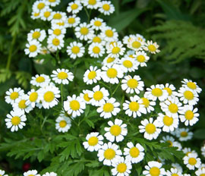Image: www.koipen.com | 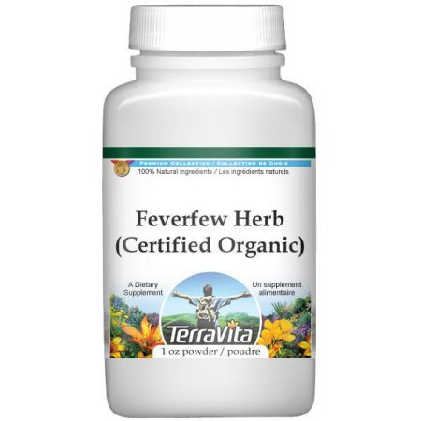Image: www.sear.com | 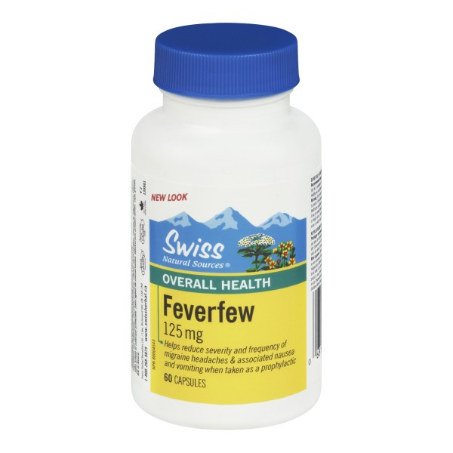Image: swissnatural.com
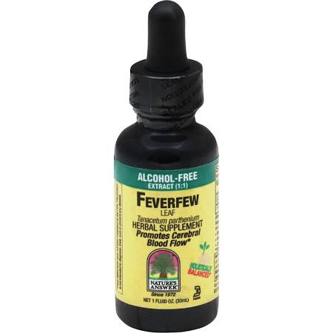Image: www.vitacost.com | 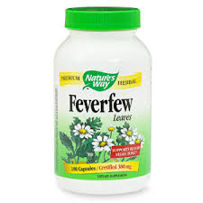Image: www.drugstore.com | 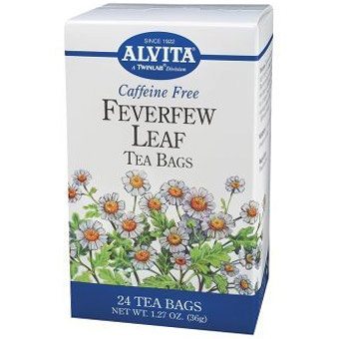Image: www.greentagmerchants.com
Feverfew extract Feverfew capsules Feverfew tea

References
Pareek, Anil et al. “Feverfew (Tanacetum Parthenium L.): A Systematic Review.” Pharmacognosy Reviews 5.9 (2011): 103–110. PMC. Web. 20 Nov. 2016.

Ehrlich, Steven. “Feverfew”. http://umm.edu/health/medical/altmed/herb/feverfew.Web. Nov. 20, 2016.

Mayo Clinic staff. Migraine. http://www.mayoclinic.org/diseases-conditions/migraine-headache/diagnosis-treatment/treatment/txc-20202474. Web. Nov. 20, 2016

Hendrix, Curt. "Dietary supplement for supporting cerebrovascular tone and treating migraine headaches." U.S. Patent No. 6,068,999. 30 May 2000. Web. Nov. 18, 2016.

