The Creative Classroom:
Strategies & Resources

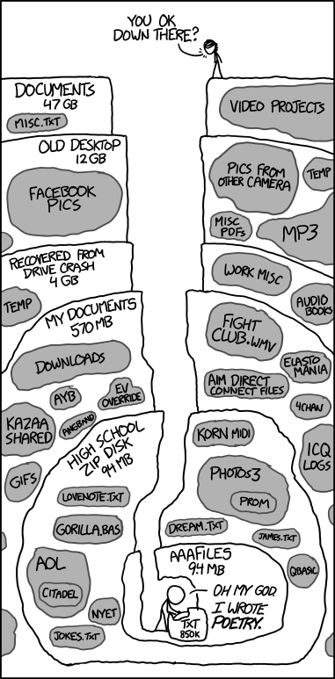
http://xkcd.com/1360/

Writing Across the Curriculum (WAC) Program
New York City College of Technology
Laura Malhotra and Christina Quintana
March 21, 2019

Active Learning
“Active learning is generally defined as any instructional method that engages students in the learning process. In short, active learning requires students to do meaningful learning activities and think about what they are doing. While this definition could include traditional activities such as homework, in practice active learning refers to activities that are introduced into the classroom. The core elements of active learning are student activity and engagement in the learning process. Active learning is often contrasted to the traditional lecture where students passively receive information from the instructor.” (Prince 2004)

No-Tech Strategies
Brainstorming:
Question-generating: “Carefully observe this [poem, graph, statistical table, painting, advertisement]. What aspects of it puzzle you or intrigue you? As a group, pose three good questions that emerge from your observation of the item.” (Bean 2011)
Debate:
Goal: To help students learn to evaluate the relative strength of competing arguments/ideas
- “We have read about four different approaches to the design of a digital data-recording device for Company X’s portable heart defibrillator. Your group will advocate for approach #n. Begin by summarizing the approach, then come up with at least three pros AND three cons. Finally, imagine you have to pitch your approach to Company X alongside the other three approaches. Be prepared to promote your approach and argue its merits against others.”
Goal: To teach students to defend or refute an argument regardless of their own position on it
- “The eighty-three-year-old stroke victim described in the case study should be informed of her daughter’s diagnosis of terminal cancer.”
Real-world Problems:
Using the following graph of the amount of carbon dioxide in the atmosphere as measured by the National Oceanographic and Atmospheric Administration’s Mauna Loa Observatory from 1958 to 2008, model the data (find an equation that connects the horizontal axis and the vertical axis). Then, use your model to extrapolate (predict) what the carbon dioxide level will be in a few decades. Explain your math in a 2-page report you will deliver to the EPA .
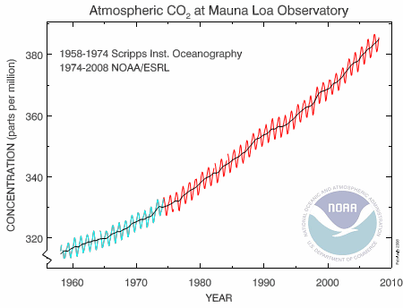
Image source: National Oceanic & Atmospheric Administration
(adapted from Murray Bourne’s Earth Killer: composite trigonometry co2 graph)

Peer Review:
Sample Peer Review Questions – Supporting Evidence

In groups of 4-5, read the draft. Then, as a group, discuss the answers to the following questions (20min). Then, as a group, write down the responses you can all agree on, and return the drafts and worksheet to the original writer.

1. Underline the sentences on the draft that you think use supporting evidence.

2. List below the pieces of evidence the author uses to support her/his argument and label each by type (e.g. data, secondary source, logic, anecdote, etc.).

3. Which piece of evidence is the strongest? Why?

4. Which piece of evidence is the weakest? Why?

Sample Assignment:
Frankenstein BINGO! (kindly provided by Rebecca Devers)
Instructions:
Step One: You’ve already produced the BINGO cards for the game. The moderator holds 60 quotations from Mary Shelley’s Frankenstein.
Step Two: Assemble into teams. Make sure you all have the same BINGO cards. Name your team.
Step Three: When the moderator reads a quotation, work with your team to determine if you can use it to help you fill your bingo card. Determine if it represents a theme that appears across the top row of your card. If so, then determine which other element of fiction it represents. For example, a quotation that describes the appearance of M. Krempe and the ways in which that appearance led Victor to judge him would describe the theme of APPEARANCE and the element of CHARACTERIZATION. This constitutes a “match.”
Step Four: If you have a “match,” write the number of the quotation in the box where the appropriate column and row meet. Get all of one column, all of one row, or an entire diagonal in either direction, and YOU’VE GOT A BINGO! Call it out!
Step Five: Defend your readings of the quotations to the rest of the class. If they don’t agree that quotation 11A falls into the categories you’ve assigned it, your team will have to start over from scratch. If they do agree with your readings, YOUR ENTIRE TEAM EARNS 10 EXTRA CREDIT POINTS.

Themes  CARD A | What it means to be human | Companionship | Storytelling | Technology, Science, and Responsibility | Appearance
Characterization

Style

POV |  |  | BINGO!
Plot

Setting

Sample Scaffolding for Thesis Statements
Topic: Use of cell phones while driving.
Assignment: You are to write a paper that argues a strong case on the topic of cell phones while driving. Your paper should be between 500-1000 words with a clear thesis statement. You should use at least two outside written sources, one of which should be from a major newspaper (online is fine), and cite these using MLA style. The paper should be addressed to a general audience of college-educated, non-specialists.
This assignment will have several steps. If you miss any of these, your final paper grade will automatically lose half a letter grade (e.g. from A- to B+) for every missed step in the process.
1. In-class today (Class 1): Free-write. Watch the news video about Chapel Hill, NC (http://youtu.be/HLz2YNUmCCY). Take 5 minutes after to write about whether you agree with the city’s decision. Keep writing, even if you think you have nothing more to say.
2. Before class 2: Create a list of pros and cons for a full cell phone ban on Blackboard in the discussion board, in groups of 3.
3. Due class 2: Write a sentence that takes a strong position on your topic. Hand in, check-graded.
4. In-class 2: Working in groups of 3, turn sentence into a thesis statement by adding an element of contrast.
5. Due class 3: Make a list of facts that the reader needs to know in order to understand thesis statement.
6. Due class 4: Create first paragraph with thesis statement at the end.
7. Due by the start of class 5: Submit first draft via SafeAssign on Blackboard

Snowball – Activity

What is one concern you have about incorporating non-traditional (i.e., not lecture/discussion) activities into your classroom?

Based on your own experience in the classroom, respond to the above concern.

Useful Links and References:
OpenLab:
https://openlab.citytech.cuny.edu/openroad/
Sample Blogs:
http://blsciblogs.baruch.cuny.edu/msc1003cohen/2012/11/18/nationalism/
Pre-recorded videos:
https://www.youtube.com/watch?v=Q6JEA2olNts
Applications and Tools for Online Learning Activities:
https://voicethread.com
http://omeka.org/ (example: http://bgccraftartdesign.org/)
Video Tutorials and Screen-share software:
http://library.hunter.cuny.edu/tutorials/mla/mla_tutorial.html
http://www.screencast-o-matic.com/
Jeopardy templates:
http://www.acrotex.net/games_index.php?lang=en
Journal of Interactive Technology and Pedagogy:
http://jitp.commons.gc.cuny.edu/
Students and technology:
http://www.educause.edu/ero/article/commuter-students-using-technology
https://digitalcommons.du.edu/collaborativelibrarianship/vol9/iss4/7/v
Flipped classroom:
https://campustechnology.com/Articles/2014/10/22/Flipping-the-Lecture-Hall.aspx?Page=1

Any questions? Feel free to contact:
Hilarie Ashton: hashton@gradcenter.cuny.edu and Yosefa Ehrlich: yehrlich@gradcenter.cuny.edu

