New York City College of Technology
WAC Faculty Workshop
November 8, 2018

Effective Grading and Minimal Marking - Handout

Activity: Read the text below and mark it as if you were the instructor, focusing primarily on the higher order concerns detailed on the following page. Also pay attention to lower order concerns with the view of highlighting ONE or TWO of these for the student.
Question: How do we, modern human beings, closely relate to apes like the chimpanzee? Support your argument with evidence. Consider both behavior and biology.
“Do not feed the animals.” Those were the instruction written in a sing in front of a gigantic chimpanzee’s cage, which looked like a jungle on its own. I was about 14 years old in my first science trip, and the teacher choused the Zoo, to show us some important points about evolution, points in which as religious child, who believed in God’s creation of the earth and all living creature, didn’t believed or wasn’t interested in. I don’t remember the assignment that I had to do, but there is one think which I remember; I remember myself observing these curious creatures through the diamond shape fence that surrounded them. I couldn’t believe how me, a child who would spent hour in the mirror trying to look her best, could somehow be related to this hairy, smelly, small creature who would jump from one tree to the other in their artificial jungle, making strange sound (which I considered annoying) be related to me. They were looking with a lot of curiosity to their expectators, in a couple exchange of looks, you couldn’t tell who was observing who.
6 years after my fun day at the Zoo, I enrolled in this Anthropology class, not as a favorite, but as an “ I didn’t had any more choices”. I got in with less interest in evolution than the interest that I had in my science class back in middle school. However curiosity is my worst enemy and the class had got more interesting since that first day of class. I remember professor B. mentioning that we, human being are 98.3% genetically the same a Chimpanzee, that got my attention, that means that from 100% of our DNA we were just 1.7% different from the chimps I saw in the Zoo. Incredible.
From the Cadogram of human and apes we can see the relationship through time between them. We can also see How close is a human to a chimp, and even after dividing to a difference genus “homo”, human shared a lot of characteristic and similarities with the chimpanzee that suggest that there were a period of time in which they shared a common ancestor between them . But why the chimpanzee, it could be another primates like the gorilla or orangutan? How do we know we are more close to them than to the other primates? That single proof that our DNA is more similar to chimp than what it into Orangutan or gorilla is a great step to figure out which is our closet relative. According to J.Phillippe Rushton in his book “Race, Evolution and Behavior” He argues that human-Chimp DNA comparison are about 20% more stable than human and gorilla comparison or chimp-gorilla comparison.
Even though it might sound estrange, but the fact that human shared some physical characteristic with the chimp is a reality, which a few years ago would give a headache. One of these characteristics is the chimpanzee’s feet, which is more efficient for walking than the gorilla feet, this is possible because chimp’s sole is broader and toes are shorter. As human the a lot chimp has no tail, just that bone that we can touch at the end of our dossal spine, proof that there were a tail once. Our hands, like chimp hand had the thumb separated that helps to grab smaller food and handle to pick them up. The position of eyes, the eyes are located in the front of the skull, which permits to look forward, rather than on the side. This gives to the primates stereoscopic vision that helps us to see further. Another fact is the large cranium that protects our brain, even though chimp’s brains is half of our, a big amount of their brain is in the sense of vision more than smell. Primates like us have a great sense of but lack of smell.
Behavior also relate chimpanzee to us. When a baby chimp is born, the helpless young chimp grabs his mother hair and climbs to her back. Letting us know this little child is defenseless and depends on its mother. These behaviors, which could be characterized as a thing, that baby human also do. Not literary climbing to his or her mother back, but crying when is on need of his or her mother heat, nourishment and love. Chimpanzee live in small group, which can disintegrated and once again be form, is like a human community. As community they cooperate in hunting and sharing food, like a human would do in his or her own way. We use language to communicated to one another, chimp’s use they own way of communication, which are executed by facial expression and repertoire calls. Even though chimps brain are half of the size of a human brain Chimps are considerably intelligent, capable of simple reasoning and tool uses, like human somehow they use their brain.
Because of my Hispanic heritance I have a weird nose, a wide rounded nose, I remember being a kid and my brother used to call me name such as “monkey nose”. Back then it use to hurt but now is just a joke. When I know that the same that I have from a monkey so does he. Next week I might visit the zoo again, maybe now I would read, “ Do not feed the animal” and I might think twice about feeding myself, and I might look with more interest to my cousin behind the diamond shaped fence.
Higher and Lower-Order Concerns

Higher-order concerns

• Thesis statement

• Quality of argument/ideas

• Evidence used correctly

• Logic of conclusions

• Use of topic sentences

• Organization of paper

• Follows assignment
• Demonstrates understanding of course material

Lower-order concerns

• Spelling

• Grammar (agreement)

• Formatting (font, spacing)

• Citation

• Punctuation

• Sentence structure

• Vocabulary/word choice

• Style

Resources for better student outcomes at City Tech

Atrium Learning Center: http://www.citytech.cuny.edu/students/learningcenter/

Helpful links for ESL/ELL students: http://websupport2.citytech.cuny.edu/learningcenters/esl.htm

Online library tutorials for students: https://library.citytech.cuny.edu/help/tutorials/index.php

Eight Great Strategies for Effective Peer Review

#1 Focus on improving only one aspect of the draft

#2 Give students a worksheet

#3 Use peer review throughout the writing process

#4 Decide on location of peer review

#5 Determine group size and make-up in advance

#6 Think through logistics of exchanging drafts and responses

#7 Take steps in advance to ensure students come prepared

#8 Think ahead about your role during peer review

Strategies for Minimal Marking

Low Stakes Assignments

• No marking

• Have a conversation

• Ask questions

High Stakes Assignments

• Put the pen down!

• Selective Line Edits

• End Comments

• Develop a Key

Example: Over marking
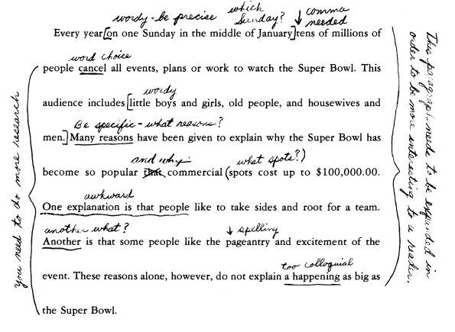

In this example, the instructor has included so much detailed commentary that it is difficult for the student to identify major problems and patterns of error. The marginal comments suggest cutting this paragraph. If the student takes this advice, the time the instructor spent line editing will have been wasted.

Supportive Responding

• Ask questions • Use any color ink or pencil…except red

• Write in legible and complete sentences • Vary and prioritize feedback

Example: Supporting Responding
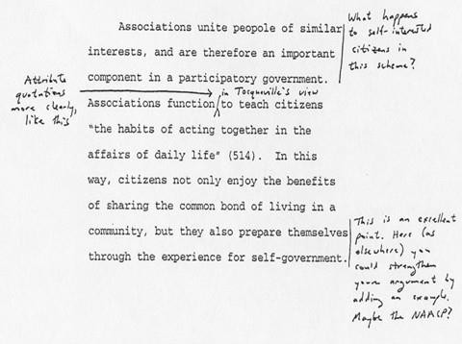

In this example, the instructor is using questions, modeling good citation, and providing suggestions for further development of the paper. These can be used singly or together as part of a supportive marking strategy.
Types of Feedback

Supportive Feedback

“You have done a great job at finding facts and quotes to support your argument”

“You have a strong thesis statement that remains convincing throughout your paper”

Revision-Oriented Feedback

“Your supporting arguments need some development, but your thesis statement is clear and strong.”

Informational Feedback

“Most states do allow a waiting period before an adoption is final—Do you feel that all such laws are wrong? How does this change what you have written so far?”

Editorial Feedback

“Your use of verb tenses is often confused. Please review paragraphs 1 and 2 on page 4 where those errors were corrected for you.”

Further Resources

Sample Draft Comments – A Three-Pronged Approach to Student Feedback

- Begin your end comments by telling the student what they are doing in their paper/assignment, or what you believe they are trying to do (as you, the instructor, see it).

  - Telling a student what you think they are doing is the hardest part, but it is the most constructive, as it gets to the heart of the paper and any issues or limitations.

- Then say one thing the student is doing successfully in their paper.

  - Providing positive feedback is crucial as it reinforces your students’ confidence and allows them to take pride in the work done so far.

- End by offering THREE suggestions for improvements. (Only ONE of these should be mechanics/ a lower order concern. The other two should be higher order concerns that address organization, evidence, thesis etc.)

  - Highlighting 3 specific aspects of the paper/assignment to improve on narrows the focus of your students and gives them a better chance of correcting these mistakes

Sample Peer Review Assignment 1 – Thesis Statements

Reviewer’s Name:
Writer’s Name:

Answer the following question to the best of your ability in the time you are allotted. *How hard you work to offer your peers constructive, useful advice will affect your participation grade for this class.

- Do you find that the thesis is specific, makes an argument, and gestures towards a “so what?”?
- What suggestions do you have for improving it?

*At home or in-class exercise, low stakes, can be adapted for any higher or lower order concern!

Sample Peer Review Assignment 2 – Organization

Reviewer’s Name:
Writer’s Name:

Instructions: Read the draft silently. Then spend 15 minutes outlining the author’s arguments below, using the format we discussed in class.

Reminder: your outline should list the thesis, each supporting argument, and the evidence used to prove each supporting argument.

Sample Peer Review Assignment 3 – Introductory Paragraphs

Reviewer’s Name:
Writer’s Name:

At home, read over the introduction to your peer’s paper. Respond to the following questions, keeping in mind the type and quality of feedback you would like to receive from a classmate:

- Write one sentence that could be added to the introduction that would convince a reader that the topic is worth reading.

- Is there a research question? If so, draw stars (*) around the research question on your hard copy.

- Is there a thesis? If so, underline the thesis on your hard copy.

- List the concepts used to support the thesis and indicate whether the author defined each one.

- How does the author plan to address the research question? Explain in your own words.

Sample Peer Review Assignment 4 – First Draft Questionnaire and Essay Response

Final Research Paper: Student Questionnaire
Please take a few minutes to answer the following questions. Your answers should be brief but informative and specific. Be sure to write legibly. You will share this questionnaire with your peer review partner when you email them your first draft, as well as with me, your instructor.

Name:
Which prompt are you answering?

- What do you consider to be the main strength(s) of this paper?

- What were your main difficulties in completing this draft?

- What would you like your reviewer to focus on when they read this draft (argument, evidence, analysis of story themes and/or secondary readings, organization, style, grammar, etc.)?

- Which aspects of this paper are most in need of improvement? Be specific, citing page numbers and sections if possible.

- How much more time do you plan to spend on this essay before handing in the final draft on _(insert date)_? Which additional sections may you plan to write?

Sample Peer Review Questions – First Draft Questionnaire and Essay Response

Final Research Paper: Student Essay Response
Read your partner’s first draft questionnaire and pay attention to the specific feedback they want. Then read the draft, making comments in the margins if you wish. Please type up a written response for your partner (1-2 pages) and bring TWO copies to class on _(insert date)_. Please write your name and the writer’s name at the top of your response. Be as specific as possible in your response, keeping in mind the kind of responses that would be most helpful to you as a writer. When referring to a particular passage be sure to indicate the page number and the paragraph (eg. p.3, #2). You will swap responses with your partner in class and hand the second copy in to me. *This is a required assignment and it will count towards your final grade.

The following questions should guide your reading and response:

Argument:
- What main argument is your partner making? Are the argument’s claims specific enough? Can they be supported using the chosen examples from the stories and critical readings?
- Summarize the writer’s main argument in two or three sentences. Be as specific as possible.
- How closely are the stories and critical readings explored in the essay?

Organization:
- Does each paragraph have a clear opening argument claim, textual evidence (a quotation that is correctly cited), analysis, and mini-conclusion? Is the overall structure of the paper effective? If not, how might the writer structure it differently?

Use of evidence/texts:
- Is the argument of the essay supported with evidence from the stories and critical readings? Where are some places where the essay needs more support?
- Does the writer use quotations clearly and effectively? Are they relevant to the argument? Do they move beyond just summary? If, not, identify which ones are not effective/related.
- Does the writer use critical sources effectively to extend, deepen, challenge, and/or support the argument?

Strengths and Weaknesses
- What do you consider to be this draft’s greatest (and best-supported) insight?
- Which ideas in this essay need to be thought through more critically?
- Where might your partner start their revision?
References

Bean, J.C. (2011). Engaging ideas: The professor's guide to integrating writing, critical thinking, and active learning in the classroom. San Francisco: Jossey-Bass, 2011.

Elbow, P. (1997). High Stakes and Low Stakes in Assigning and Responding to Writing. In Writing to Learn: Strategies for Assigning and Responding to Writing in the Disciplines, ed. Sorcinelli, M.D. and Elbow, San Francisco: Jossey-Bass. p. 5-14.

Ferris, D. (2006). Preparing Teachers to Respond to Student Writing. Journal of Second Language Writing. p. 165-193.

Harris, M. (1979). The Overgraded Paper: Another Case of More is Less. In How to Handle the

Paper Load, ed. Stanford, G. Urbana, IL: National Council of Teachers of English. p. 91 - 94.

Sommers, N. (1982). Responding to Student Writing. College. Composition and Communication, (33) (2), p.148-156.

Walk, K. (2007). Teaching with Writing: A Guide for Faculty and Graduate Students. Princeton Writing Program, p. 30-40.

