New York City College of Technology

Writing Across the Curriculum

Effective Grading Strategies Faculty Workshop
October 14, 2014

Presentation Slides

- Learn more about the Atrium Learning Center: http://www.citytech.cuny.edu/students/learningcenter/

- Minimal Marking

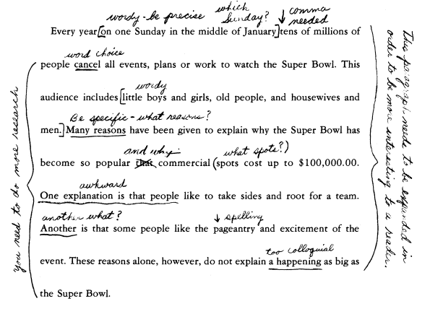

- Supportive Responding
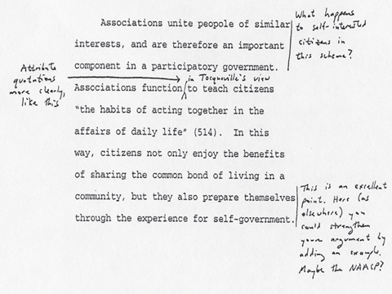

Group Exercise

Protocol: With your pens down, silently read the paper without making any marks or comments. Once completed work with your group to:

1. Read the piece out loud (one paragraph per person, for example).

2. Description of text: Make one non-judgmental, descriptive observation. It should be something we would all agree on (e.g., “the writer uses a quote”; “there are five paragraphs,” etc.)

3. Note one thing the writer does well.

4. Identify an idea you found provocative or interesting that you would like the writer to think about further.

5. Identify one or two patterns of error.

6. Drawing on previous observations, compose a comment for the student that will promote revision and move the paper forward.

Original Assignment:

Background: “Tong” wrote the attached essay on the topic “lies,” based upon a brief newspaper article the class had read the day before, during a 50-minute class period during the first week of the semester.

Prompt: Goodrich points out that there are many reasons why people lie and that there may be appropriate times to lie as well as times when lying may be harmful.
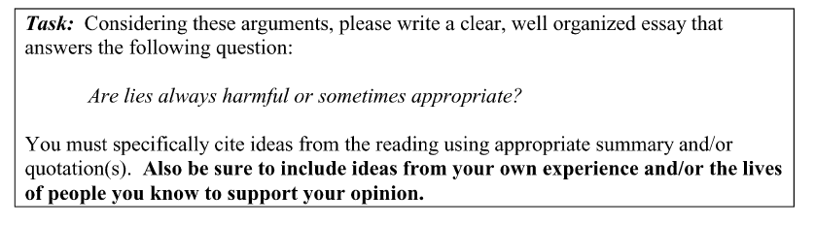

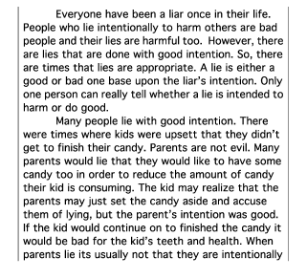

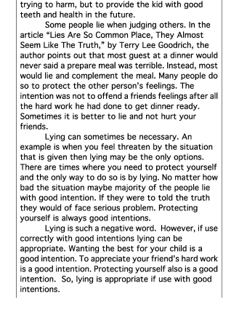

RESOURCES

- Sample of Completed Feedback

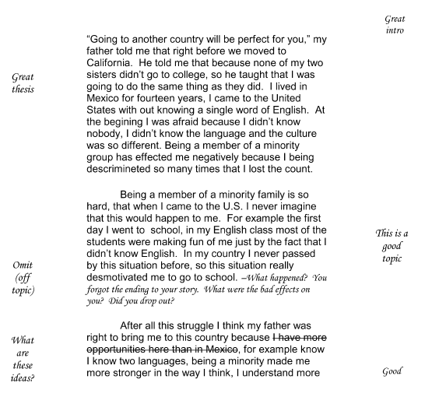

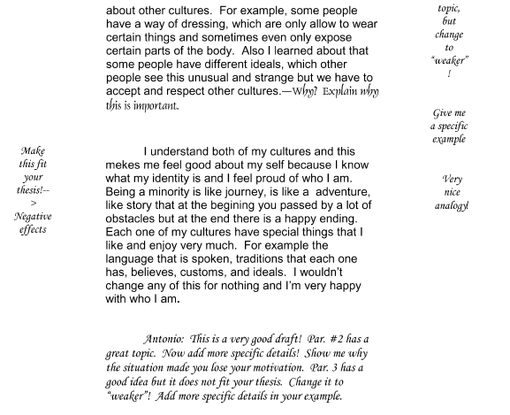

- Sample End Comments

Insert Contact Information Here:

Comments on Draft
Date:

Dear: ________________________

Nice job on getting a draft done! Your next steps are to revise your paper—take another look at it and don’t forget to use the original paper guidelines to make sure your revised paper meets the requirements of the assignment.
Here are some specific thoughts/ideas/suggestions to help you revise this draft.

1.

2.

3.

Also:
___ There was a higher than average number of grammar/technical errors. Please do your best to proofread your paper to work on these after you’ve revised your paper for content and ideas.
___ Please see the "Writing Resources" in our class Blackboard for additional tips/assistance/help with structure/writing conventions/formatting/citations, etc.

____Please make an appointment at the Writing Center for additional help—and bring your original assignment and these comments so they can give you better feedback.

As always, please see me during office hours or make an appointment if you need more detailed help with drafts.

Sincerely,
Prof. ---

- Sample Draft Comments

Date:
To: Student X

From: Prof. ---
Re: Draft of Cross-Cultural Interview Paper
This is a really great draft. You have a lot of rich details from your interviews and a lot to analyze. Here are some specific thoughts and suggestions for revising your paper:

- As you review and revise your paper, look at the themes that emerged especially as you compared and contrasted your two interviewees. These themes could be incorporated into your introduction and become part of the thesis or guiding statement which tells your reader what is to come.

- I like the details you give about your two interviewees and now you need to further develop the compare/contrast between the two respondents. What do they have in common/what do they not? Are there racial/ethnic backgrounds significant, etc.—what determines how their experiences turned out?

- Your paper still needs a “true” conclusion. A good strong conclusion does not give brand new information, but it doesn’t just “wrap up.” It should give the reader with a sense of a “takeaway.” What was interesting? What did you learn from this process? You can make connections to “real life” situations, etc.

- Your interviews sound really interesting and I think you could expand and include more information from your discussions. Go back to your interview notes to fill out some more detail.

- I did notice a lot of little errors in spelling and grammar and pointed them in out in a sample paragraph on page 2. Please try to make a note of the errors and work on them when you are proofreading. You can find strategies for grammar issues on Blackboard in the “Writing Resources” section.

You may want to go to the Writing Center for additional feedback (don’t forget to bring your paper guidelines and these comments along with your draft) and of course, you can always see more for more feedback.

As you refine and revise, don’t forget to go back to the original assignment to make sure your paper meets the goals and requirements of the assignment. Check out the Blackboard folder “Writing Resources” for helpful tips for the revision process in general. Good luck with the revisions!
REFERENCES

Bean, J.C. (2011). Engaging ideas: The professor's guide to integrating writing, critical thinking, and active
learning in the classroom. San Francisco: Jossey-Bass, 2011.

Elbow, P. (1997). High Stakes and Low Stakes in Assigning and Responding to Writing. In Writing to Learn:
Strategies for Assigning and Responding to Writing in the Disciplines, ed. Sorcinelli, M.D. and
Elbow, p. 5-14. San Francisco: Jossey-Bass.

Ferris, D. (2006). Preparing Teachers to Respond to Student Writing. Journal of Second Language Writing. p.
165-193.

Harris, M. (1979). The Overgraded Paper: Another Case of More is Less. In How to Handle the Paper Load,
ed. Stanford, G. p. 91-94. Urbana, IL: National Council of Teachers of English.

Sommers, N. (1982). Responding to Student Writing. College. Composition and Communication, (33)(2), p.
148-156.

Walk, K. (2007). Teaching with Writing: A Guide for Faculty and Graduate Students. Princeton Writing
Program, p. 30-40.

CONTACT INFORMATION

Louis Lipani
LLipani@citytech.cuny.edu

Bisola Neil
BNeil@citytech.cuny.edu

