GRA 1111
Graphic Communications Workshop
Prof Goetz
Wilbert Perez
February 2, 2012
In my opinion one of the most effective and most recognizable logos in human history may very well be the New York Yankees baseball team logo. The logo has evolved along with the team and its success. Easily the most seen logo throughout the entire city of New York, people of all ages and places can recognize New York by the famous interlocking lettering of NY found on the baseball cap. The logo is a prestigious icon throughout the game of baseball and associated to one of the best teams in sports history across the globe.
The logo first appeared alongside the New York Highlanders in 1909. Created by Louis B. Tiffany of the famous jeweler Tiffany & Co. in 1877, the original logo was used to honor a policeman shot during duty, which was then adopted for the team by a former police chief. The logo was then picked up and made its official debut in 1915 with the original Yankees team. It did not find its way onto the jersey until some 20 years later, removing the old monogram and matching the new logo with the pinstripe uniform. The overall cap has switched on and off from a pinstripe or base color, but has retained its classic navy color look for many decades now. (intertstateofmind.com) (omg-facts.com)
Although the logo hasn’t changed much at all, there are three different variations of the logo used across the team. They vary for purpose, standard for the cap, another more outstanding logo for the uniform and a simpler clean version for marketing use. New Yorkers take big pride in their sports and the best representation of their love are found surely in Yankees baseball caps. With a logo with such impression it’s hard to ever miss it. (newyorkyankees.mlb.com)
Cap logo. Pinstripe logo. Modernized logo. Up to date.
Interstateofmind.com
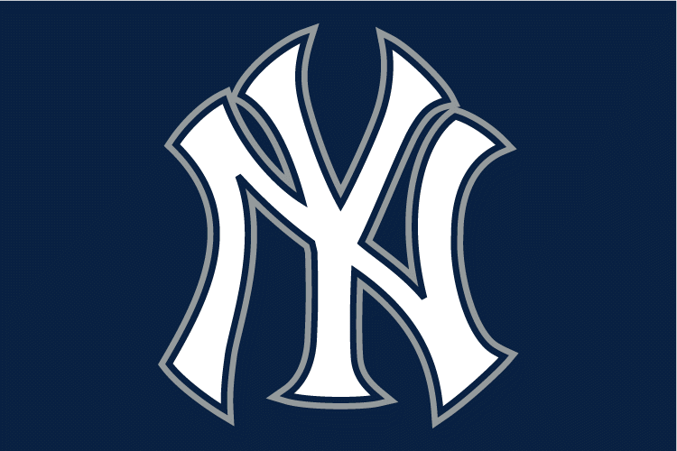
Specialized logo often used to honor special moments. (World Series 09’, Jeter 3000k hits, etc.)
Sportslogo.com
Sources :
http://www.interstateofmind.com/the-story-behind-the-yankees%e2%80%99-logo/
http://sportslogos.net/logo.php?id=nirgwflc2lcmgjh02u4m
http://newyork.yankees.mlb.com/nyy/history/uniforms_logos.jsp
http://sportslogos.net/logo.php?id=1258
http://www.omg-facts.com/view/Facts/32790

