COMD 2313 Illustration 1 New York City College of Technology
Department of Communication Design
Professor Sara Woolley Gómez
Office: N1126
Email: SJWoolley@citytech.cuny.edu
Phone extension:

Week 4
Topic: Concept Generation Techniques

- Review Project 1 – 3 minutes per student (1/2 to explain idea and ½ for feedback)

Lecture Topics:

- Sterling Hundley on Ideation
- SF Fillmore Concert Posters – design inspiration
- Is It Done Yet? Appropriate Level of Finish for Final Sketches

DEMOS & Media:
  - Sterling Hundley Ideation video
  - SF Fillmore Concert Posters PDF
  - Simple techniques to improve a pencil sketch in Adobe PS
  - Value Scales

Discussion TOPICS:
3.1 Discussion:
Share you’re your response to Yuko Shimizu’s post on VISUAL VOCABULARY.

DUE NEXT WEEK:

- Required Reading with blog post:

Composition Basics: Value Structure -By Dan dos Santos

http://muddycolors.blogspot.com/2012/08/composition-basics-value-structure.html

2 - Sketchbook Exercise: Timed Sketchbook Pages: (ongoing exercise)

Value Studies:

As this week’s sketchbook pages using a soft graphite pencil, create a value scale as pictured below, then try rendering a simple form to represent lighting and dimensionality using only value. YES this is just ONE PAGE.

In your sketchbook create a simple value scale such as the one at the bottom of the study below. Find a cube and a sphere to light and draw. Do a value study from observation. Set up a simple form and a light source. Try to "turn the form" or create volume by using the values in the scale you created.

- You only need to create one value scale and one drawing.
- Be sure to use the full range of values.
- Allow 30 minutes for the drawing and 30 minutes for the value scale. Take your time.

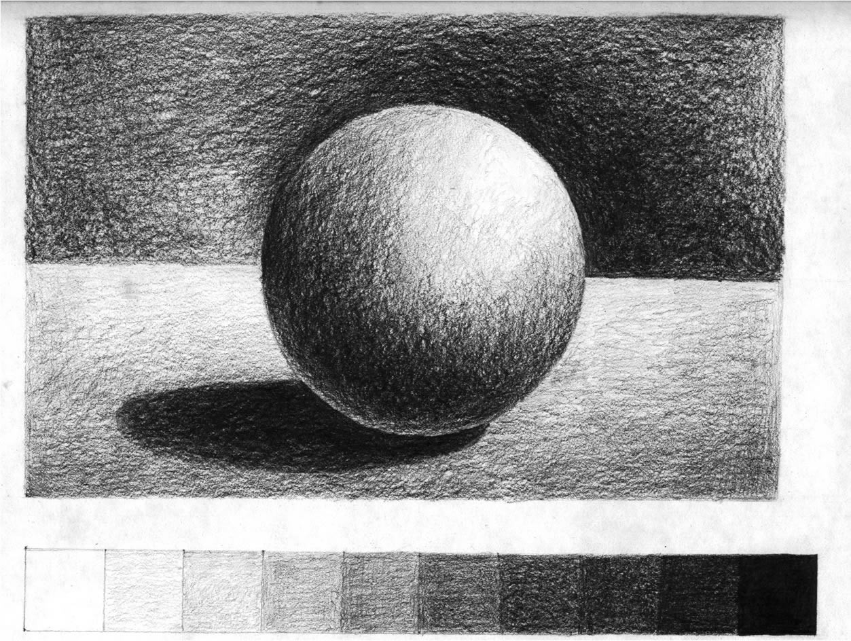

For the other required pages, study visual elements you may use for your poster designs from a variety of angles and in a variety of lighting conditions.

3 - Poster Illustration:

Part 3 FINAL Pencil Sketch DUE 2/27 2pm (Late work will be docked a full grade point)

Project 2: Poster Design Illustration

- Part 2 Ideation & Thumbanils - Generate MULTIPLE solutions for one client.

- Identify an event or cause you would like to design a poster illustration for.
- Brainstorm in your sketchbooks based on research to help you identify possible solutions for your illustration.
- From your brainstorm identify at least 4 different directions their final illustration could go.
- Explore these 4 different concepts through sketches related to their brainstorms in your sketchbooks. You may also begin collecting visual imagery related to your concepts as well as inspirational images and reference images – these can be collaged into your sketch books or compiled into a PDF.
- Refine these 4 different concepts through multiple thumbnail sketches of each idea.
Draw 5 at least thumbnails per idea, for a total of 20 thumbnails minimum.

*Be sure to use a ruler to draw the frames for your thumbnails BEFORE you begin them.

*Be sure they are in proportion to the poster you are designing.

* Final Art will be 11 x 14

* Final art should be DRAWN at approx 2X the size of final PRINTED WORK.

HELPFUL HINTS:

- Seek advice on your design EARLY on!

- Scan your visual elements, then use Adobe PS to try out different compositions and different proportions. See how this effects image hierarchy and the overall look BEFORE beginning your final art.

- Transfer Paper or a LIGHTBOX can be very helpful at this stage to allow you to recreate the larger shapes in a design without using a grid.

- You may NOT draw digitally. Final drawing must be entirely in pencil and entirely done by hand.

- Presentation MATTERS. If the work is presented poorly, it will be graded accordingly.

TO Submit your work:

Carefully Scan and Upload your drawing to OPENLAB. Tag your drawing Project 2.
Name your POST: LastName, FirstName_Project One

Comment with the name of the product.

* BRING YOUR WEEK 4 SUPPLIES TO CLASS ON 2/27

