COMD 1103 Foundations Drawing New York City College of Technology
Department of Communication Design
Professor Sara Woolley Gómez
Office: N1126
Email: SJWoolley@citytech.cuny.edu

Week 12
Topic: Introduction to two point Perspective

The Plan for Today:

- Warm Ups!
(15 min) – Working in groups, set up a still life. (Keep in mind you’ll need to draw this still life using one point perspective.) Using Charcoal on Newsprint, do the following exercises.

(5 min) Draw a blind contour: (5 min) Now, create a blind contour drawing of an object from the still life. Focus on careful and accurate observation of edges.

(5 min) Now, create cross contour drawing of one object from the still life. Focus on observing those ellipses, GO slowly. Observe every angle and see the volume of the shape. Try to use the full 5 minutes on just one object.

(5 min) Draw a blind contour: (5 min) Now, create a blind contour drawing of an object from the still life. Focus on careful and accurate observation of edges.

- Group Critique : 1 Point Perspective Assignment Drawings
How successful were we? Did we create the Illusion of Depth?
What strategies to create depth did we combine with 1 point perspective?

- One Point Perspective Review(15 min)

Planes Foreground
Vanishing Point Middle Ground
Horizon Line Background

- Drawing from life in one point perspective
How do we turn an ellipse into a 3-d form effectively? : Using the Rectangluar Prism as a base form.

- In class Practice: Drawing Still life objects in one point perspective

- Introduction to two point perspective

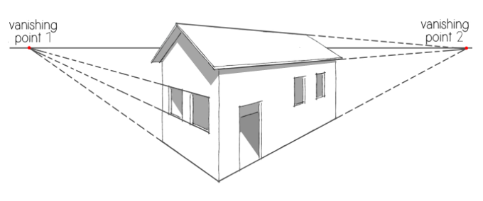
- Frame your picture plane.
- Draw your Horizon Line.
- Choose 2 vanishing points.
- Rule lines to that vanishing point.
- Draw parallel vertical lines to form objects.

- Draw a Building from Two Point Perspective. (15 min)

Beginning with a rectangular prism as a base shape, draw a unique and detailed building. Give the building an identity. Is this your dream home? A futuristic university? A castle or fort? Use realistic shapes and forms, and objects you can study in the room to create a sense of realism. Avoid drawing characters. Stick to objects, landscapes, and architecture.

DUE 5/11:

1- Required Video: WATCH videos on perspective on Open Lab (post: Creative Perspective Chapter 5)

2– Required Reading: Creative Layout: Perspective for Artists Chapters 5 (PDF on OPEN LAB)

3- Sketchbook Exercise: Timed Sketchbook Pages: (ongoing exercise)

Use your 2 pages to sketch Thumbnail Sketches of scenes drawn from two point perspective.

Also continue to illustrate your vocabulary terms and new concepts we learn to help commit them to memory.

4 - Assignment 10 – Two Point Perspective (One drawing… 2x as good!)
Time machine assignment! FORMAL DRAWING

Using the methods we learned in class, draw a city scene of the PAST or the FUTURE in two-point perspective. Use reference images from the internet to help you fill in architectural details or inspire your ideas.

Be sure to have a full range of value in your drawing. Be to use ALL the skills you’ve learned to lend a sense of realism and create depth.

- USE Your RULER, PENCIL, CHARCOAL PENCILS, and your 18 x 24 DRAWING PAPER for this Assignment.
- Lightly TONE your drawing paper before beginning drawing to a middle value.
- Draw this composition at your highest level of skill!

Tip: SPRAY the drawing with Aerosol Hairspray or Workable Fixatiff Spray when complete so they don’t smudge!

