COMG 1111 -Digital Media

Professor Maya Koenig

December 10, 2017

Annmarie Taylor-Myers

Logo Research

**The Successful Evolution of the Chase Logo**

Chase National Bank was formed by John Thompson and named after Chief Justice Solomon P. Chase a former United States Treasury Secrectary and who had no association with the Bank in 1877. Chermayeff & Geismar a leading graphic design firm in the fields of corporate identity, brand development and logo design. The octagon logo was designed for Chase Manhattan Bank in 1961 to represent the primitive water pipes laid by the Manhattan Company in New York, which were made by nailing together wooden planks. The logo representing the brand has evolved overtime to illustrate the expansion of the organization and the transition from age of analog to digital technology. My paper will prove that Chase logo has successfully evolved over time in its color, scope, messaging, progression and artistic design. It is timeless in its essence but its evolution has made it edgy and relevant to the technological age. My paper will outline in details the stage and the progression of the amazing evolution of the Chase logo that identifies their brand globally.

Chase has made a number of changes to its logo’s style and color; this in part is due to its multiple mergers and expansion of the organization over the years. I will focus on a few of the logos to make my point starting with one of the earliest logo that was originally red, white and blue, shape that is not so easy to describe, the word “chasebank” was in large san serif typeface with the word “chase” in bold and the word “bank” in regular type (fig.1). The first logo was designed in the 1950s, and it was deemed too bulky and therefore ineffective shortly after the introduction. (1000logos.net). Since the octagon logo was designed in the 1960’s there has been slight variations in color typography and layout but the octagon remain the one constant keeping their brand consistent, while they transition from one level to the next always growing and expanding. The next logo I will analyze is the white octagon against a royal blue background using the design element of contrast to make it stand out. Then there is the blue octagon, three dimensional and slightly angles with a white stylized san serif typeface that is designed horizontally across the octagon.

The final Chase logo I will analyze is the current one which composition includes the company’s name followed by the octagon, it uses the chase signature san sarif typeface with the word chase in black, while their tag line “so you can” and the octagon is in blue. Even though the composition has changed the brand is consistent, the three dimensional logo is edgy and a technological savvy move that has captured a younger demographical audience while staying true to their brand and staying relevant to current trends. The new composition expresses a stronger more success message by add a tag line to strengthen their brand. “The company name is written in black, and the octagon is blue. These colors express excellence and optimism.” (1000logos.net).

Chase bank consistency in their branding and messaging has won elite status in the court of public opinion. Chase has a long outstanding reputation of Excellency and consistency through their mergers and the diverse services they provide to their customers which has earned the public’s trust and propelled them into even greater success. “Chase launches identity campaign at 25 branches located in the Oklahoma City area. (Shottenkirk). Chase bank has become a giant in the banking industries and there is no doubt that this is a direct result of their branding and messaging that screams success and excellence. With the Chase mergers, J.P. Morgan Chase became the second-largest banking franchise in the United States, based on core deposits. The combine company has assets of more than $1.1 trillion. (Shottenkirk).

I was not able to find any empirical data that proves Chase logo directly influence other logos, but chase’s dominance in the banking industry is sure evidence of how effective branding and messaging can influence the success of a company.“Chase offers more than 5,100 branches and 16,000 ATMs nationwide. JPMorgan Chase & Co. has250,355 employees (as of 2016) and operates in more than 100 countries.” (Chase Bank – Wikipedia).

The Chase logo can be seen on their building across the nation (fig. 5 & 6) and in more than one hundred countries globally. It also seen on their products (fig.7) and banners (fig. 8) all correspondence and printed material and all other product and services that they provide. Chase continues to introduce products and services as they continue to expand their reach in the banking industry. “Chase today is rolling out a useful new feature for jot, the mobile banking app it provides for small business customers.”(Crosman). Pursuant to evidence carefully and meticulously presented above, it is safe to conclude that my hypothesis has been proven that there has been a successful evolution of the Chase logo.

**Figure Reference**

Fig.1

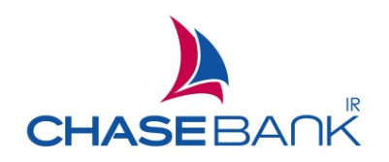

Chase Logo 1950’s

Fig.2

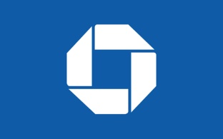

Chase Logo 2000

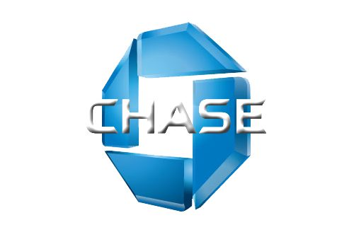Fig.3

Chase logo 3D edgy design

Fig.4

Chase logo since 2006

Fig. 5

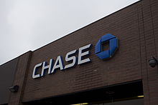

Chase Bank on Rye, New York

Fig. 6

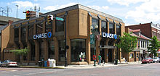

Chase branch located in Athens, Ohio

Fig.7

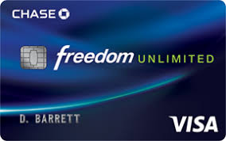

Chase product, Visa Credit Card

Fig. 8

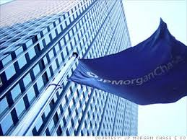

Chase building in Oklahoma City

**Works Cited**

1000 logos, The Famous Brands and Company Logos of the World,

The choice of color can say a lot about a brand… Here’s the list of the most popular logo colors..

<http://1000logos.net>

Chase Bank – Wikipedia, JPMorgan Chase Bank, N.A. doing Business as chase bank that

contitute consumer...

Https://en.wikipedia.org/wiki/Chase_Bank

Crossman, Penny. “Chase Adds Receipt Imaging to Small Business Mobile App.” *American*

*Banker*, 7 May 2013. Academic OneFile, <Http://link.galegroup.com/apps/doc/A328854248/AONE>? u=cuny_nytc&sid=AONE&xid=018a16da

Shottenkirk, Jerry. “Chase launches identity campaign at 25 branches located in the Okla.

City-area Journal Record. [Oklahoma City, OK], 26 Apr. 2005. General OneFile,

<Http://link.galegroup.com/apps/doc/A131917267/ITOF>? u=cuny_nytc&sid=ITOF&xid=94d66c79