Central Giant Cell Granuloma
Victoria Protopopova
Oral Pathology
11/30/20
Central giant cell granuloma (CGCG) is an intraosseous benign bony lesion that consists of fibroblast containing multinucleated giant cells. CGCG generally happens on the mandible however can likewise happen on the maxilla. CGCG can be moderate developing and fast developing. Slow-developing CGCG is asymptomatic and is non-forceful. Quick becoming CGCG is painful, excruciating, can cause teeth displacement and root resorption. CGCG represents absolute of 7% of all considerate tumors of the jaw. Although CGCG generally happens in the jaw and facial bones, instances of central giant cell granuloma were likewise been accounted for in the cranial vault and little bones of hands and feet
Etiology:
Central giant cell granuloma etiology is unknown but two theories of its etiology exist: Benign neoplasm and Reactive lesion.
Clinical Presentation:
Clinically CGCG can be present as firm non-tender, non-mobile and hard to palpation nodule. Surface changes can be none or blue-to-purple in shading. CGCG can cause recognizable facial deviation.
Demographic:
CGCG generally occurs at the initial thirty years of life and influences females more than male, 65% of cases were reported in a female. At 65-75%, CGCG has commonness to mandible than the maxilla. No particular preference to race had been reported
Histology/ Biopsy / Radiographs:
Intra oral biopsy is taken for CGCG that uncovers: multinucleated giant cells. With the presence of drain, hemosiderin, osteoid and woven bone.
Histological highlights of CGCG include exceptionally cell multinucleated giant cells with fusiform and round cells
Radiographic highlights of CGCG are Radiolucent multilocular or unilocular lesion, with well-demarcated sclerotic borders. The fringe of the CGCG may have a scalloped appearance on the radiographs. Loss of alveolar bone may be present. As CGCG gets more aggressive preformation of cortical bone is recognizable. The primary radiographic indication of CGCG can be the loss of lamina dura.
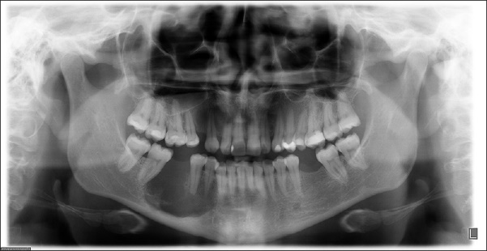
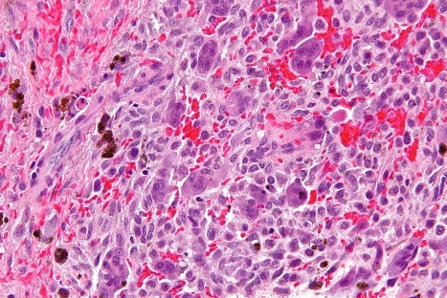
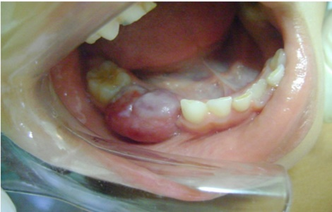

Differential Diagnosis:
CGCG can be mistaken for:
- Ameloblastoma
- Aneurysmal bone cysts
- Cherubism
- Hyperparathyroidism (brown tumor)
- Odontogenic keratocyst
- Odontogenic myxoma
- Paget disease

Treatment:
The most common treatment of CGCG is curettage. Extraction by an Oral Surgeon may likewise be a decision in treating CGCG, removal of the peripheral bony margins to improve the outcome. Intralesional infusions of corticosteroid have been discovered to be a decent decision of treatment, because of inhibition of osteoclasts action. Treatment with interferon-alpha shows great results in treating CGCG. Treating CGCG with bisphosphonates is viewed as an option in contrast to careful treatment. Aggressive phases of CGCG requires surgical treatment that should be possible through resection of the affected region. Non treated CGCG can become more aggressive and increase in size.

Prognosis:
Guess of CGCG is acceptable if the lesion was completely removed. Treatment that performed at the beginning phases have been indicated better results and diminished level of reoccurrence rate.
Professional Relevance:
Central giant cell granuloma and some other neurotic lesions generally apply to the profession of dental hygienist. Although dental hygienist is not permitted to diagnose, dental hygienist should to be knowledgeable, recognize the lesion and give a referral to the patient.
Another purpose why this applies to the dental hygienist is because patient general come for cleaning and dental specialist visit generally happens when there is actual pain or something has broken. White dental hygienist doing intro oral exam is easy to find out some abnormal lesion. General doctor or oral pathologist has to be informed if there is any lesion has been found. It’s our responsibility to give the referral and educate the patient.

Reference:
Jadu, F. M., Pharoah, M. J., Lee, L., Baker, G. I., & Allidina, A. (2011). Central giant cell granuloma of the mandibular condyle: a case report and review of the literature. Dento maxillo facial radiology, 40(1), 60–64. https://doi.org/10.1259/dmfr/85668294

Gulati, D., Bansal, V., Dubey, P., Pandey, S., & Agrawal, A. (2015). Central giant cell granuloma of posterior maxilla: first expression of primary hyperparathyroidism. Case reports in endocrinology, 2015, 170412. https://doi.org/10.1155/2015/170412

Recurrent Peripheral Giant Cell Granuloma: A Case Report. (n.d.). Retrieved November 30,
2020, from https://opendentistryjournal.com/VOLUME/12/PAGE/1043/FULLTEXT/

Pictures:
https://opendentistryjournal.com/VOLUME/12/PAGE/1043/FULLTEXT/
http://www.ijcasereportsandimages.com/archive/2012/008-2012-ijcri/014-08-2012-aswath/ijcri-016082013116-aswath-full-text.php
http://jultika.oulu.fi/files/nbnfi-fe201901021135.pdf

