TO: Professor Viviana Vladutescu
FROM: Marcellus Vilardel
DATE: July 10, 2015
SUBJECT: Field Trip to Optical Remote Sensing Laboratory of the City College of New York

On April 30, 2015, we, the EET 3120 students of CITYTECH, accompanied with Professor Viviana Vladutescue went to The Optical Remote Sensing Laboratory of The City College of New York on a trip to see different kind of sensors and learn about the functionality of all kind of them. The purpose of this trip was to explore the development of new technologies for remote sensing, and on the improvement of algorithms for the retrieval of geophysical parameters from the environmental monitoring of land, atmosphere and ocean, using remote-sensing and ground-based data. There are different kind of sensors, on the City College laboratory we came cross some of them, such as: CIMEL Sun Photometer, Backscatter Lidar, MFSRS Shadow-band, and the Microwave Radiometer sensor.

The CIMEL Sun Photometer CE318 is #237 in the NASA AERONET (Aerosol Robotic Network.) is located on the roof of Grove School of Engineering. It composes with two components, the optical head containing the sun collimator without lens, and the sky collimator with lenses and filter wheel. This Photometer detects radiation in six different wavelengths. Light is absorbed and scattered by atmospheric gasses, water vapor and aerosols. The concentration of different atmospheric components can be determined by the attenuation at wavelengths which are strongly absorbed or scattered. Total Optical Depth (TOD) is the sum of the Rayleigh Optical Depth (from atmospheric gasses, e.g. Nitrogen, Oxygen, Argon), the Ozone Optical. The Sun tracking is controlled with a 4-quadrant detector. Data is temporarily stored in memory and once every hour uploaded to NASA via a GOES-E (geosynchronous) satellite uplink.

CIMEL Sun Photometer
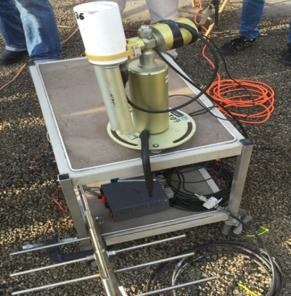

The Microwave Radiometer sensor is installed on a tripod, like the CIMEL Sun Photometer, on the roof of Grove School of Engineering, so that the instrument has clear view of the sky. The MWR has two radio frequency (RF) subsystems in the same cabinet. The RF subsystems both share same antenna pointing system. The temperature profiling subsystem utilizes sky brightness temperature observations at selected frequencies between 51 and 59 GHz and the water vapor profiling subsystem utilizes sky brightness temperature observations at selected frequencies between 22 and 30 GHz. It produces vertical profiles from the surface to 10 km, producing high-resolution temperature, relative humidity and water vapor profiles, and low-resolution liquid profiles.

Microwave Radiometer sensor
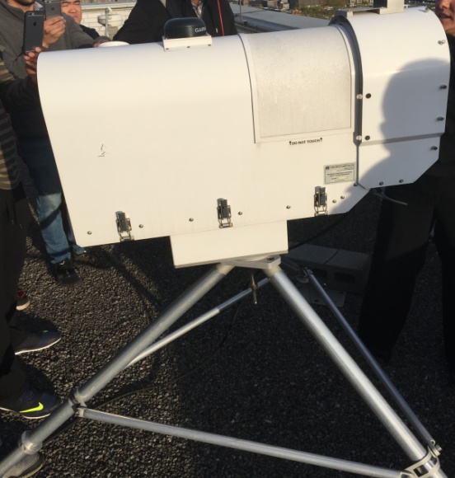

The MFR-7 Shadow band Radiometer (MFRSR) sensor is installed on outdoors on the roof of the Grove School of Engineering to measures total diffuse and direct irradiance at six wavelengths (415, 500, 615, 673, 870, and 940 nm, each 10 nm FWHM) in the visible/NIR spectrum. The MFRSR makes measurements across the seven channels simultaneously and displayed in near-real time updated every 15 minutes. All the data are used for atmospheric turbidity measurements.
Shadow band Radiometer

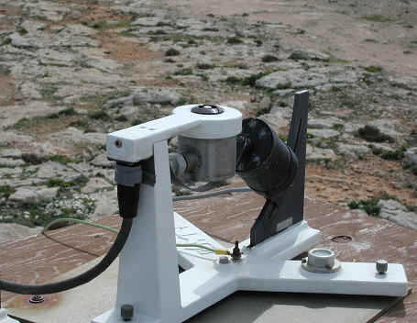

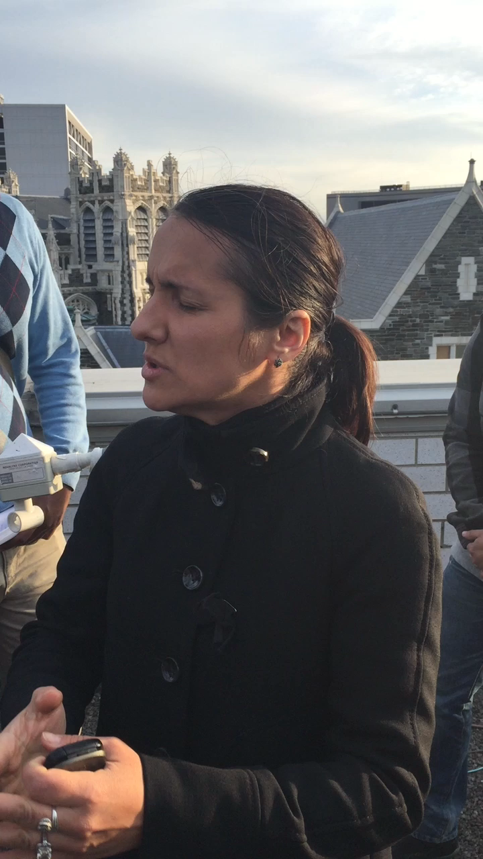
Professor Viviana Explanation on some of the Sensors
(double click on the picture to watch it)

This is some of the pictures we took during the field trip:
