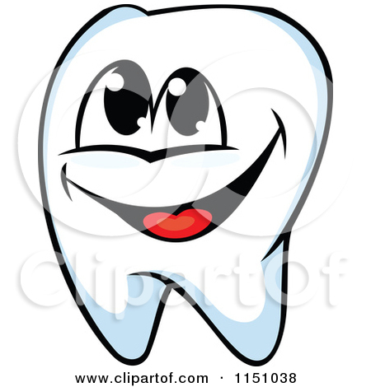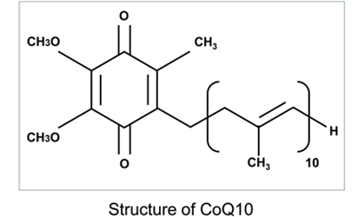 

### References:

-It’s the dental hygienist duty to educate the patient on what’s causing him/her to suffer from periodontitis, in this case being from deficiency of Coenzyme Q10. Thus the dental hygienist has to educate the patient on CoQ10 and aid the patient in understanding how this treatment is going to benefit them.

-The dental hygienist demonstrates the procedure so that the patient can incorporate it into their daily home care for maximum efficacy.

-It is important to help the patient understand that it is essential to routinely use both topical CoQ10 and CoQ10 supplements for patients with periodontal disease in every dental cleaning appointment they have.

-Diseased gingival tissue has significant lower levels of Coenzyme Q10 than a healthy gingiva in the same patient; therefore, a dental hygienists can implement Coenzyme Q10 into patient therapy plan to help treat, prevent and promote healing of periodontal disease.

-Helping the patient restructure their oral hygiene routine to ensure the patient regains maximum oral health.

http://www.ruwikmann.com/blog/forever-young-with-coq10[Web Address]

**Coenzyme Q10**

**An antioxidant to treat periodontal disease**

Pavone, Kristina, RDH and Nguyen, Paula, RDH (November 2008)

The Coenzyme Q10 periodontal therapy Retrieved from <http://www.thefreelibrary.com/The+coenzyme+Q10+periodontal+therapy.-a0190051882>

Sawyers, Melissa

How to Topically Apply CoQ10 to the Gums

Retrieved from

http://www.ehow.com/how_7848093_topically-apply-coq10-gums.html

http://www.ncbi.nlm.nih.gov/pubmed/7752836

Drs. Versman, Heller, and Beckman. (August 2012). CoQ10 for Stronger Gums

Retrieved from <http://periodontalhealth.blogspot.com/2012/08/supplement-to-improve-gum-disease.html>.

Dr. Sarah Brewer. Coenzyme Q10

Retrieved from

<http://nutritionexpert.healthspan.co.uk/coenzyme-q10>

### Role of the Dental Hygienist

#### Jessica Machado, Chitra Sukhraj & Vladlen Berlin

Presented by:

What is coenzyme Q10?

-Coenzyme Q10 (CoQ10) is a compound found in the cell's mitochondria.

-It's function is mitochondrial metabolism.

- CoQ10 has antioxidant properties.

-CoQ10 can reduce free radicals, which are damaging compounds that contribute to many health problems.

-Although the body makes CoQ10, deficiencies occur. Deficiency of CoQ10 has been reported in the gingival tissue of patients with periodontal disease.

http://www.meschinohealth.com/ArticleDirectory/Coenzyme_Q10_And_Hawthorn_After_Age_45

http://www.vidavibrante.com/2013/05/28/can-coenzyme-q10-reduce-heart-failure-deaths-by-half/

## **Treatment**

-California Pacific Medical Center recommends taking between 50 and 60 mg daily for the use of [gum disease](http://www.periodontalhealth.com/GumDisease.aspx) prevention.

-Look for dental care products containing CoQ10. Some commercial toothpastes list CoQ10 as an ingredient can be used such as toothpaste.

- Mouthwashes containing CoQ10 may also be effective

-CoQ10 can be found naturally in foods like oily fish, vegetable oils, organ meats, eggs and whole grains.

-It is also available as a supplement. CoQ10 can be found in local food or vitamin store and does not always require a doctor's prescription.

**Note-People taking blood thinners and thyroid medications should check with their doctors before using CoQ10 supplements

Simply put, gum disease is caused by harmful bacteria that irritate the gums. This then causes inflammation and discomfort. Left untreated, early stages of gum disease can progress into more advanced stages which can even lead to tooth loss. Brushing and flossing your teeth daily with regular visits to a dental hygienist for cleaning and a dentist for oral health checkups can help keep gum disease at bay.  Antioxidants are also beneficial in keeping gums healthy by boosting immunity of the gums and also fighting off free radical damage caused by any harmful bacteria.

“According to the University of Maryland Medical Center (UMMC), research shows that people who have gum disease also have low levels of coenzyme Q10 (CoQ10) in their gums. Diseased gums have a deficiency of CoQ10 led to faster healing and tissue repair in patients with periodontal disease”. Applying CoQ10 to the gums might control periodontitis because when antioxidants scavenge reactive oxygen atoms, it can reduce collagen destruction. Topical CoQ10 has been known to reduce the depths of pockets that have developed around the teeth and improve gum attachment to teeth. Several clinical studies have shown that CoQ10 supplements led to faster healing and tissue repair in patients with periodontal disease.

### **Connection between Coenzyme Q10 and periodontal disease**