MetKounthida Phansourivong (Mei)
Urban Tourism
HMGT 4987
June 25, 2018

The Metropolitan Museum of Art
On June 19th, 2018 our class went on a field trip to “The Metropolitan Museum of Art” (The Met Museum) as part of our museum visit. I knew about the Met museum through “Met Gala”; which is a fashion party that’s held once a year with fashion design that is inspired by a certain theme, it is hosted by Anna Wintour the editor in chief of Vogue magazine. The Met gala fashion was one of the reason why I wanted to go visit the museum.
The Met museum use to have the “contribute as much as you want” policy, which is you can pay however you like you can pay $1 or more. However, due to the museum low revenue they change the policy for non New Yorker.
- General Admission (including exhibition at the Met museum, the Met Cloisters and the Met Breuer, it is valid for three days)
  - Adult - $25
  - Senior - $17
  - Student - $12
  - Free for members/patrons of the museum and children under the age of 12
This policy is aim for non New Yorkers resident only; for New York State residents, New York, New Jersey and Connecticut students they can contribute as much as they want.

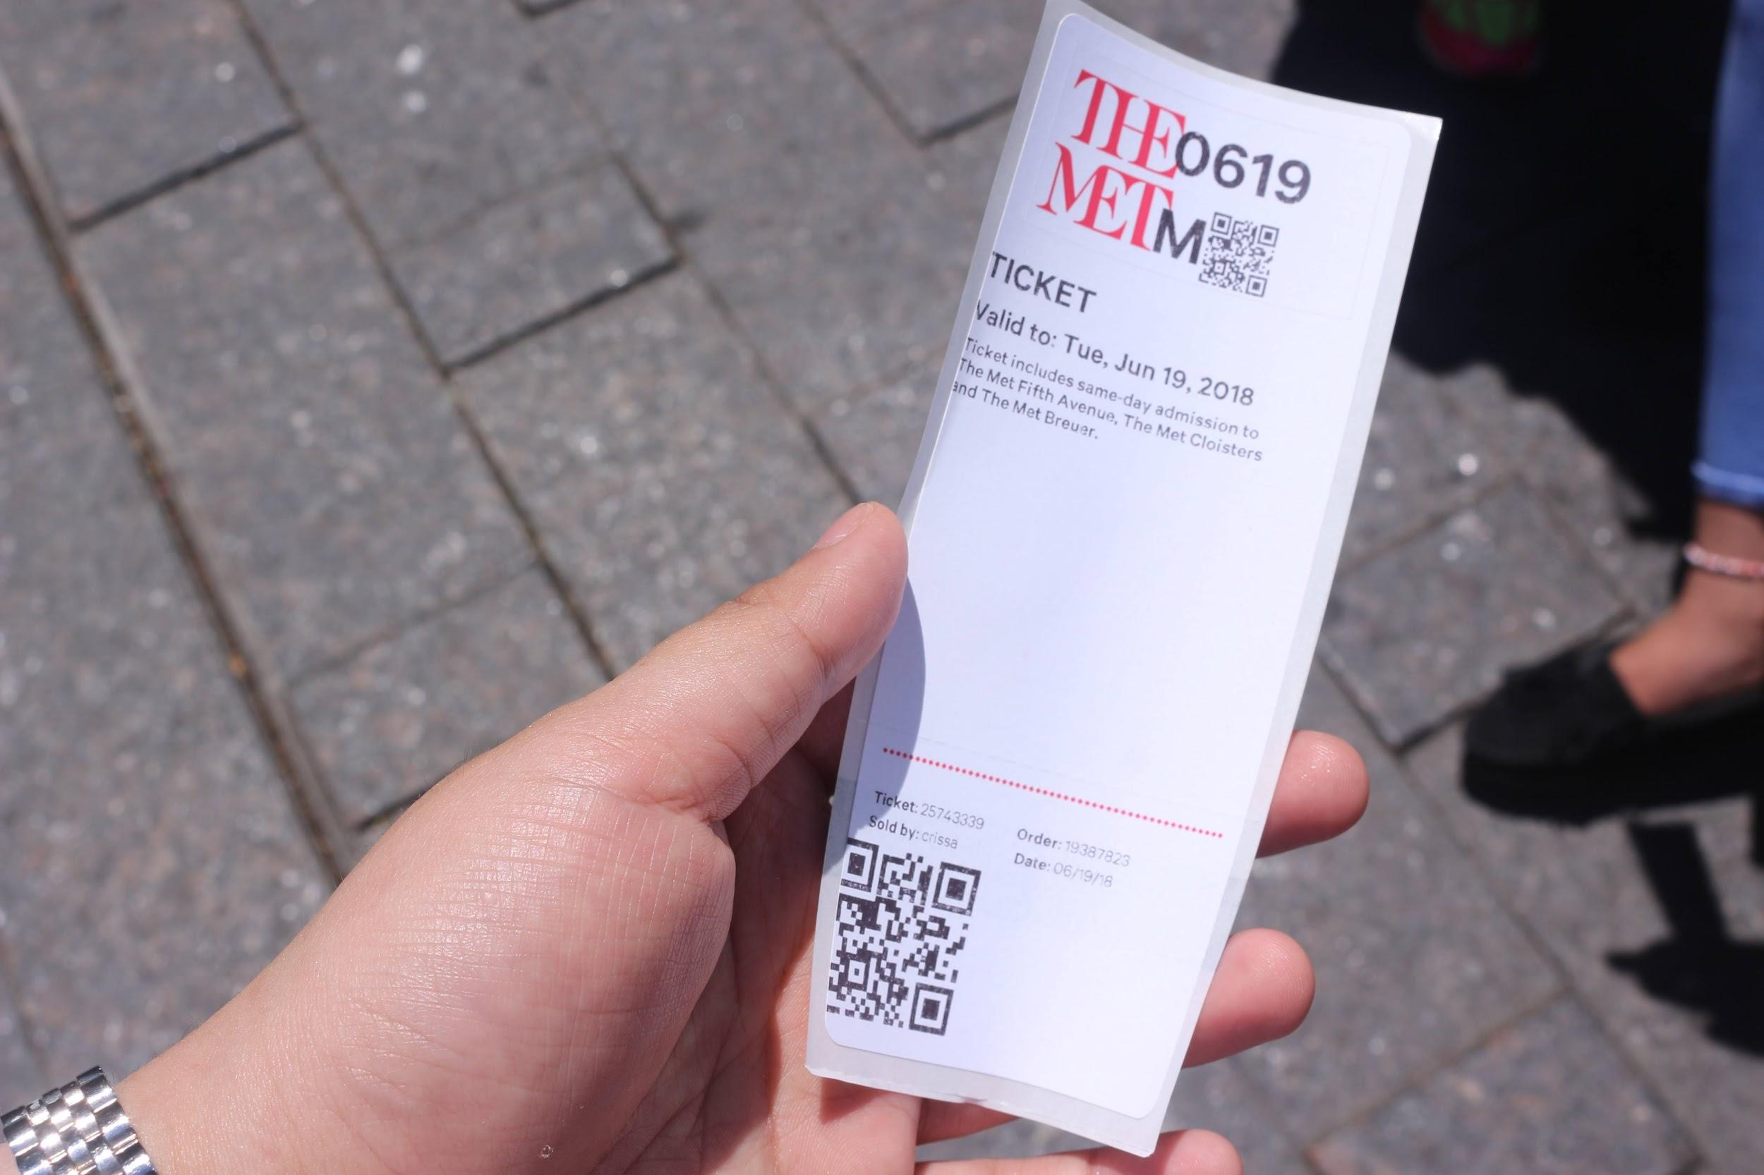

The ticket to the Met Museum

In terms of accessibility for public transportation you can take the 4, 5 or 6 subway train to 86th street Fifth or Lexington avenue and walk from the train to the museum, or take the M1, M2, M3 or M4 bus along Fifth avenue (from uptown to the museum) of Madison avenue (from downtown to the museum). The museum also have special events that can cater to people with disability so that they can come and enjoy the museum.
As of 2017 the Met museum have a total of 7 million visitors throughout the three locations (the Met museum, the Met Cloisters and the Met Breuer). When we got into the museum the staff were very nice to us and they were willing to help guide the way if we were lost in the museum or need direction to go see an exhibition.
The Met museum website was a very friendly user website, in the website they provided every information that you need to know including the exhibitions duration date, accessibility, exhibition information, events, arts and more. It is also very easy to use the website as most information is already provided, if not we can just use the search engine on the website and it will directly take us to information that we want to know.
During our visit to the Met museum we were given “the museum highlight tour” which focuses on different selected artwork from different cultures and time period. The museum highlight that we were shown to was “Greek and Roman Art” which focus mainly on sculptors that are made from 4500 B.C to A.D 312. “Arts of Africa, Oceania and the Americas” which is a collection of arts from sub-Saharan Africa, the Pacific Island and North, central and South America from early 3000 B.C.E to the present. Lastly, the “Modern and Contemporary Art” which are the collection of arts from living artists since 1870 to the present.
The tour was very helpful to me as I learn many new informations and facts about history and arts that I have never know about before such as;
- The “Marble Statue of a Kouros” which is one of the first statue that was made without any support to balance the sculptor.

- A painting method called “egg tempera with oil glazing” which is one of the first method method to make and paint art. The egg tempera is a paint that artist created by mixing color powder and eggs. By using this method they have to paint as fast as they can as the paint dries quickly.

We can clearly see the brush stroke on the skirt due to the paint drying so quickly

- Jackson Pollock painting “Number 28” first started off with a subject there was a pencil sketch of three people on the canvas, he then paint them over with abstract art as an expression of freedom thinking. The tour guide mention that if we were to see the back of the canvas we can still see the sketch that he made before painting over them.
Jackson Pollock painting “Number 28”, 1951

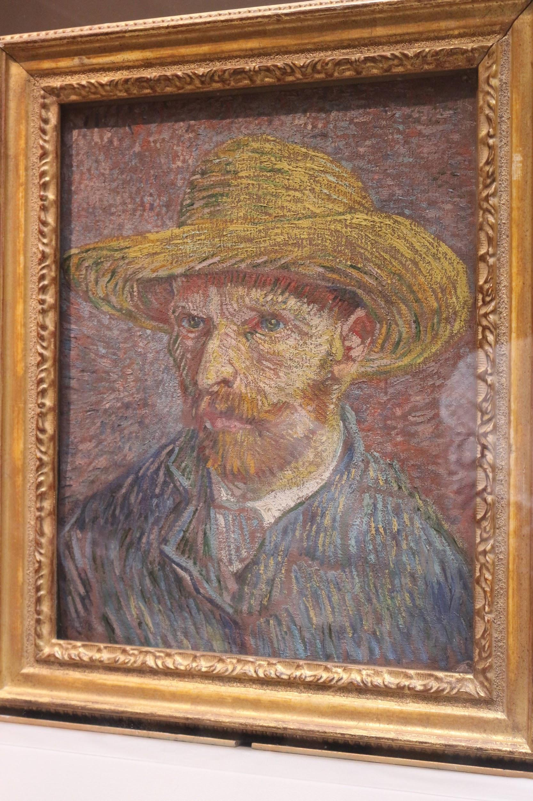
- Vincent Van Gogh would use one canvas frame for two of his painting due to his financial state.
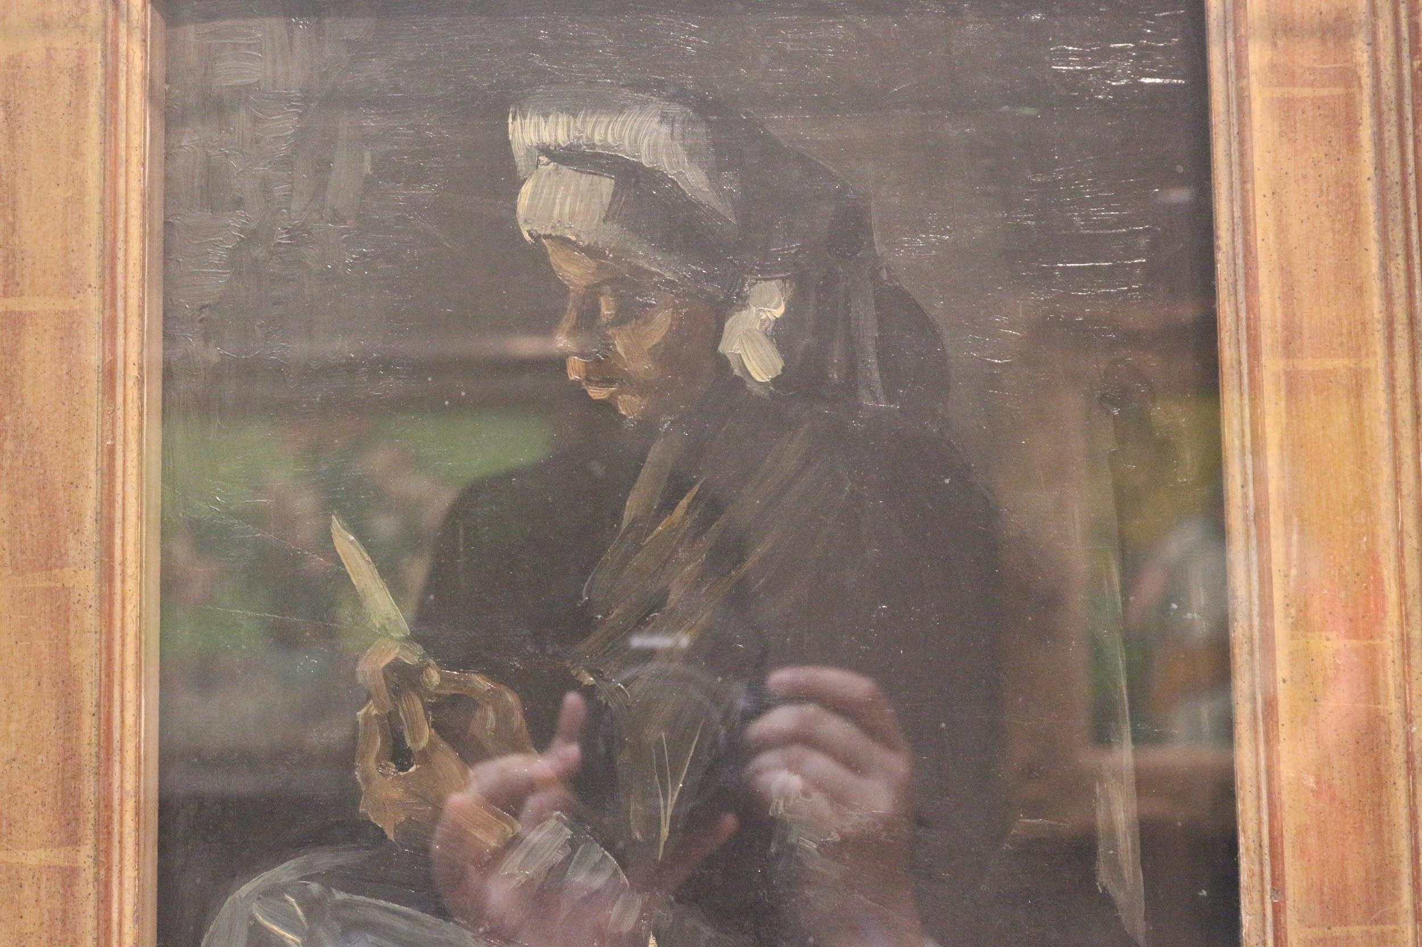
Both the painting were put onto the same canvas frame

References

Pogrebin, R. (2018, March 01). Prepared for Bumps, the Met Starts Charging Non-New Yorkers. Retrieved June 20, 2018, from https://www.nytimes.com/2018/03/01/arts/design/metropolitan-museum-of-art-starts-charging-non-new-yorkers.html
The Met Museum. (n.d.). Retrieved June 20, 2018, from https://www.metmuseum.org/

