On June 12th, our Urban Tourism class went on a field trip to Domino Park in Williamsburg, Brooklyn. It was a perfect sunny day to go out for a field trip. First, we walk down to Dumbo and walk pass some historical building such as an old newspaper warehouse called “The Eagle Warehouse”. Then, we arrived at the waterfront in Dumbo where we took the ferry to South Williamsburg. The cost of the transportation was $2.75 for one way ticket.
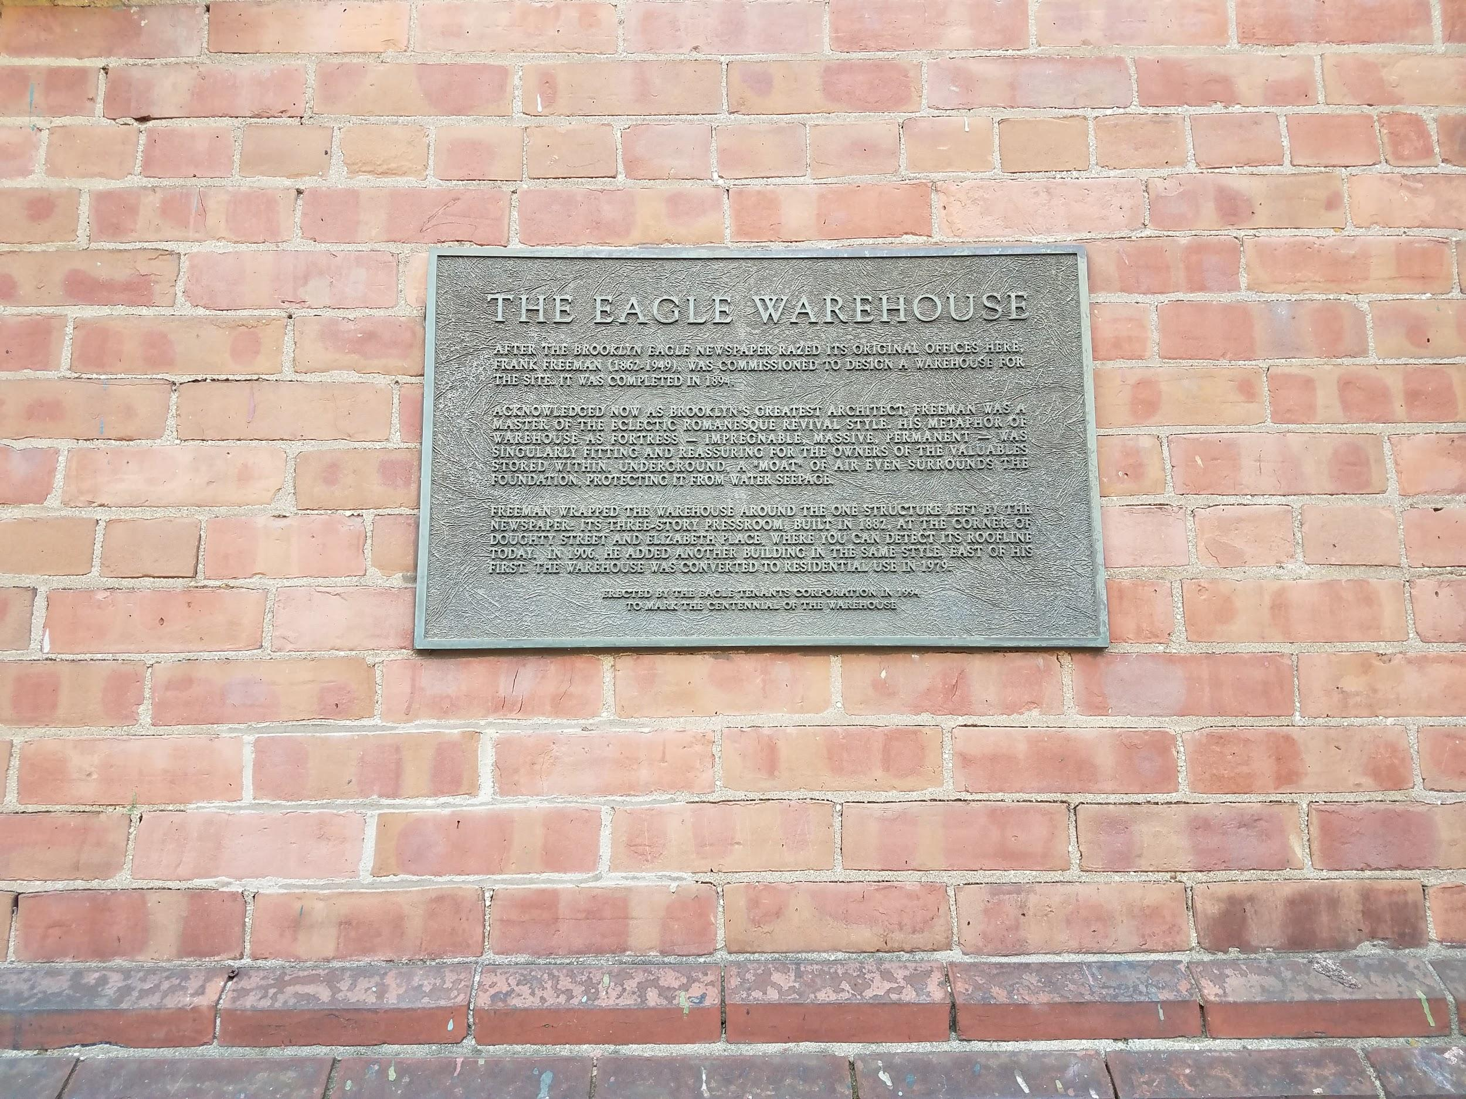
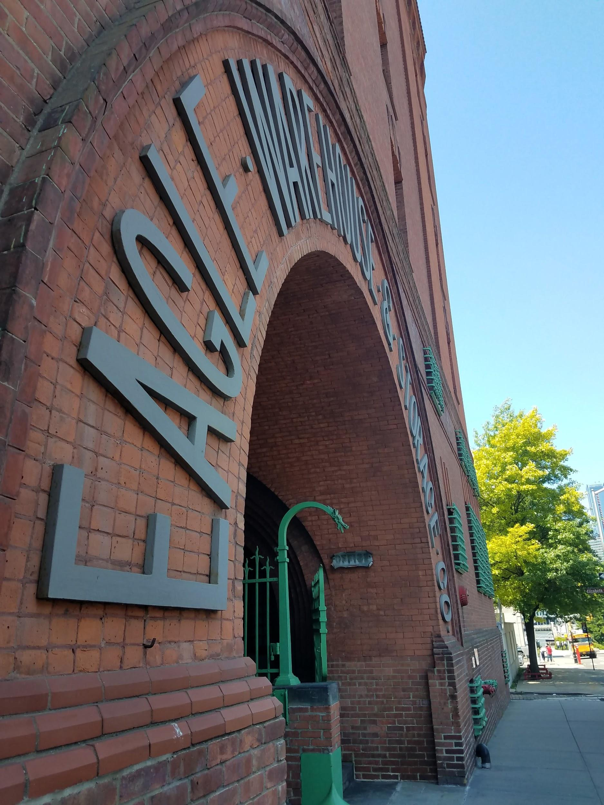

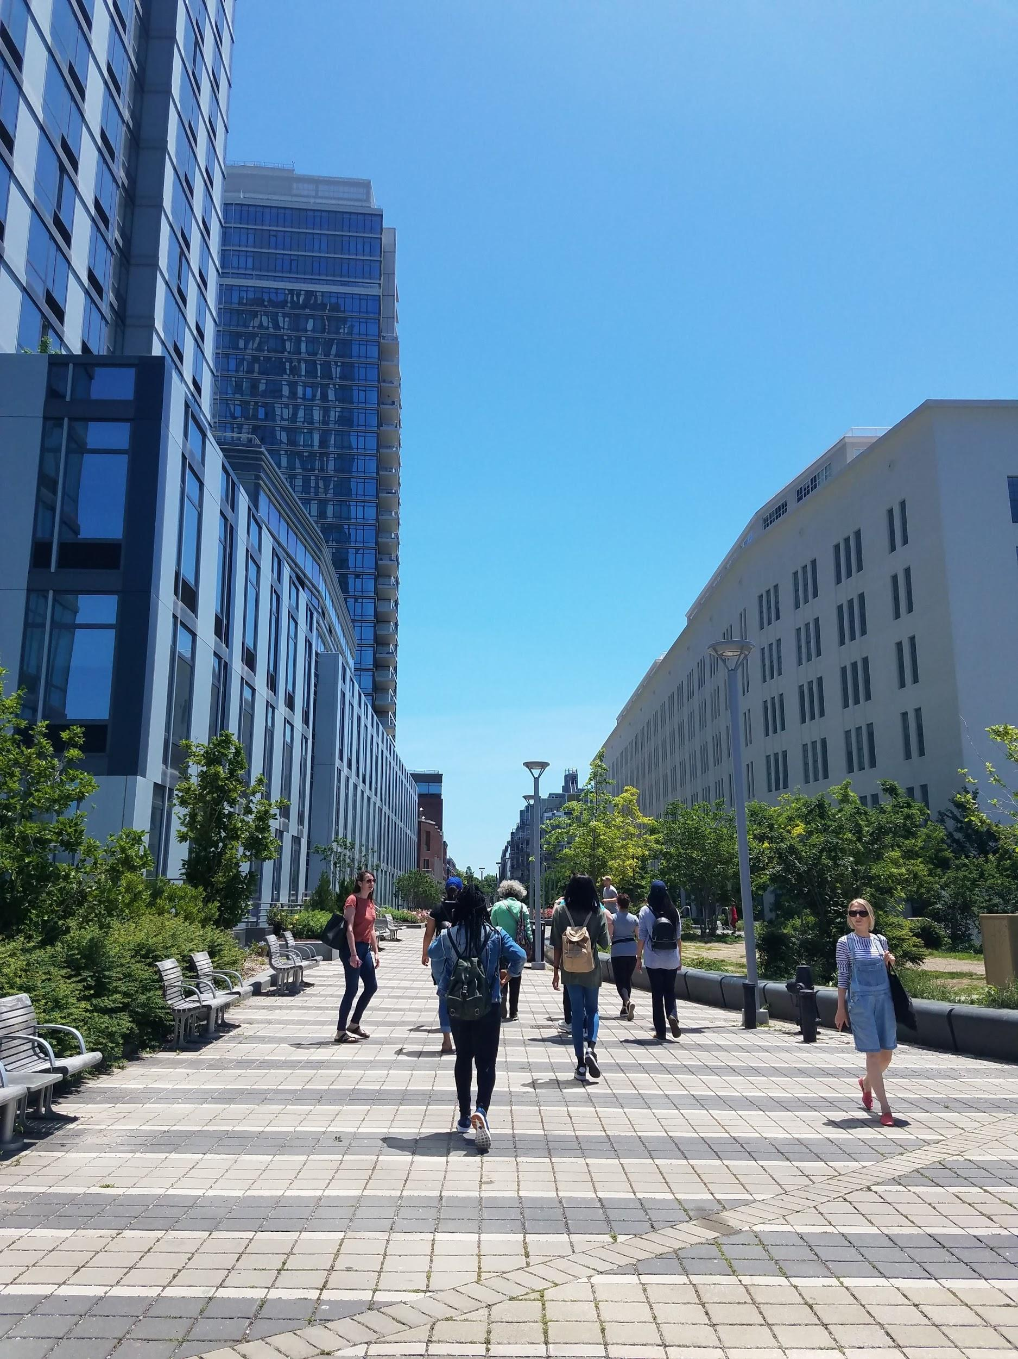
After we arrived at Williamsburg we walked our way to Domino Park, on our way I can see a few street art work similar to the ones in Bushwick. There are also many construction going on in the neighborhood as it is growing, there are a lots of condominium buildings, people moving into the neighborhood, and people are starting to open businesses (such as cafes, restaurants, laundry, small retail shops, etc…) around the area.
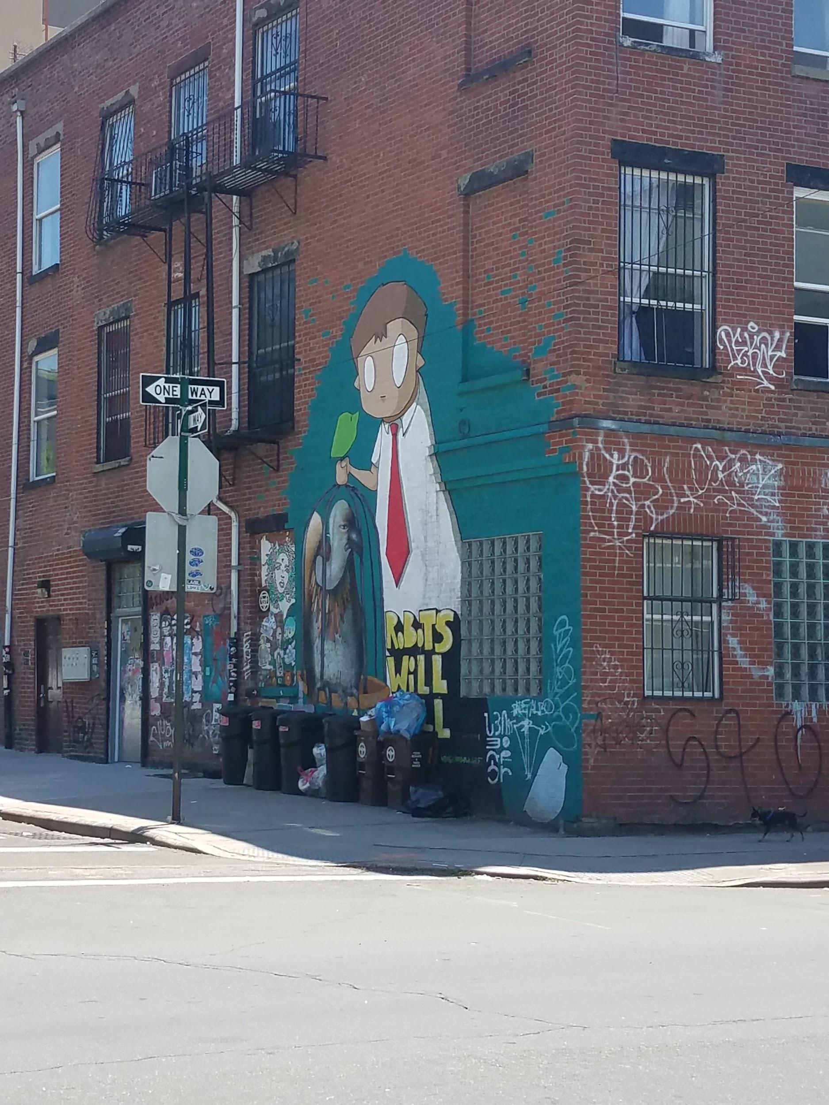
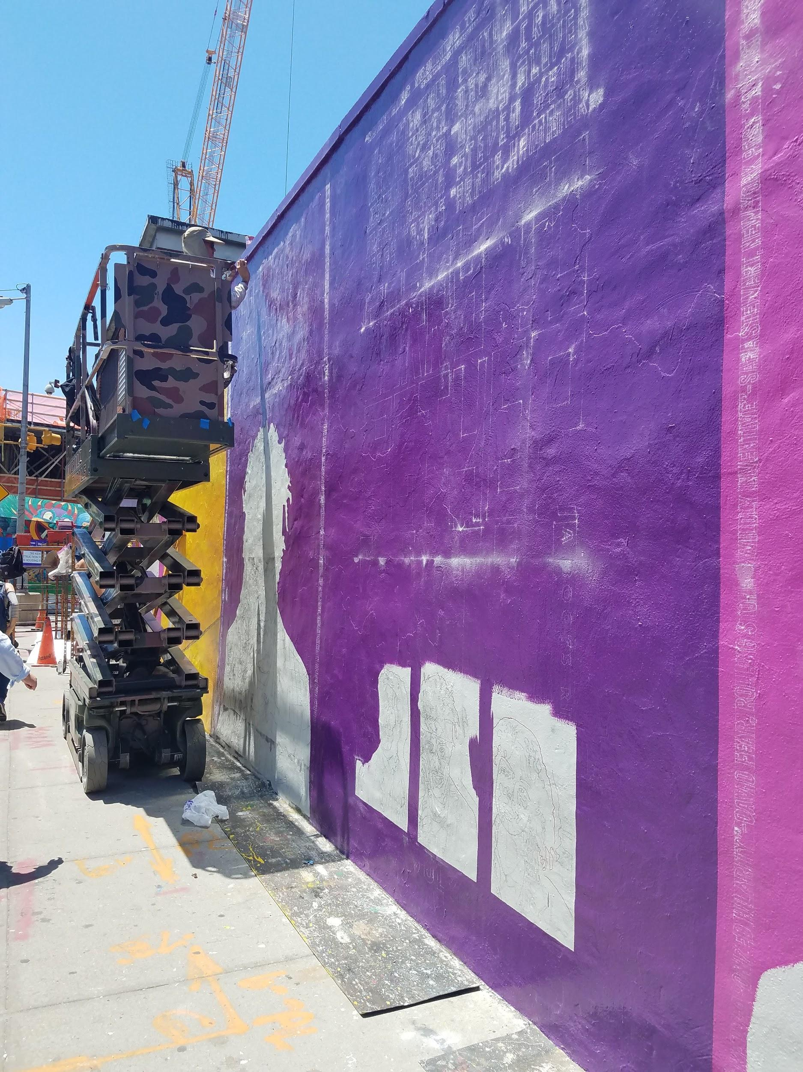

It was a 10 to 15 min walk from the ferry to Domino Park, as we were walking I notice the neighborhood was very clean and have a very beautiful view of the waterfront. Soon enough we arrived at the Domino park. The park was very clean, even though some people don’t throw away their trash properly there are some park staff to clean and pick up the trash. The park is family friendly there were a lot of families who took their kids to the park to play with their friends. Currently the food and beverage department is lacking in the park as there was only one shop called “Taco Cina”, personally I didn’t try the food since it was a little on the pricey side and didn’t think the what they offer was worth the price. There is also a lack of signage that could explain the history to the Domino sugar factory, and because of the construction cars are not able to pass through some roads. However, since this is a growing neighborhood I hope that there will be an easier access to the park whether it’s foods and beverages, public toilet or transportations.
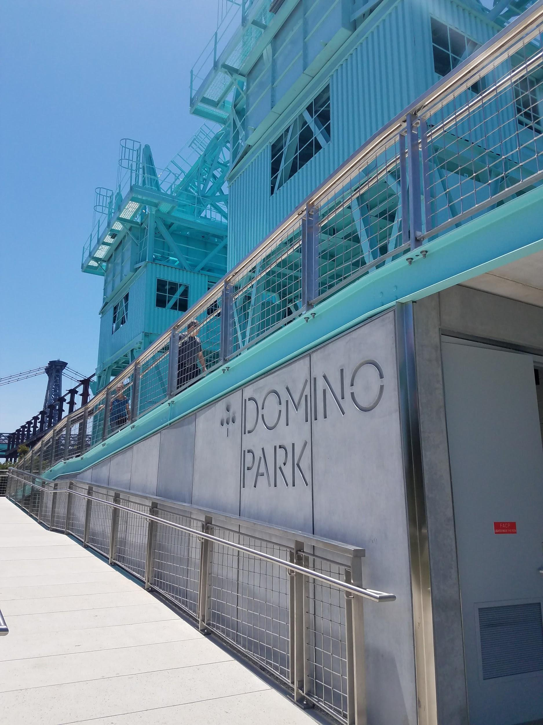
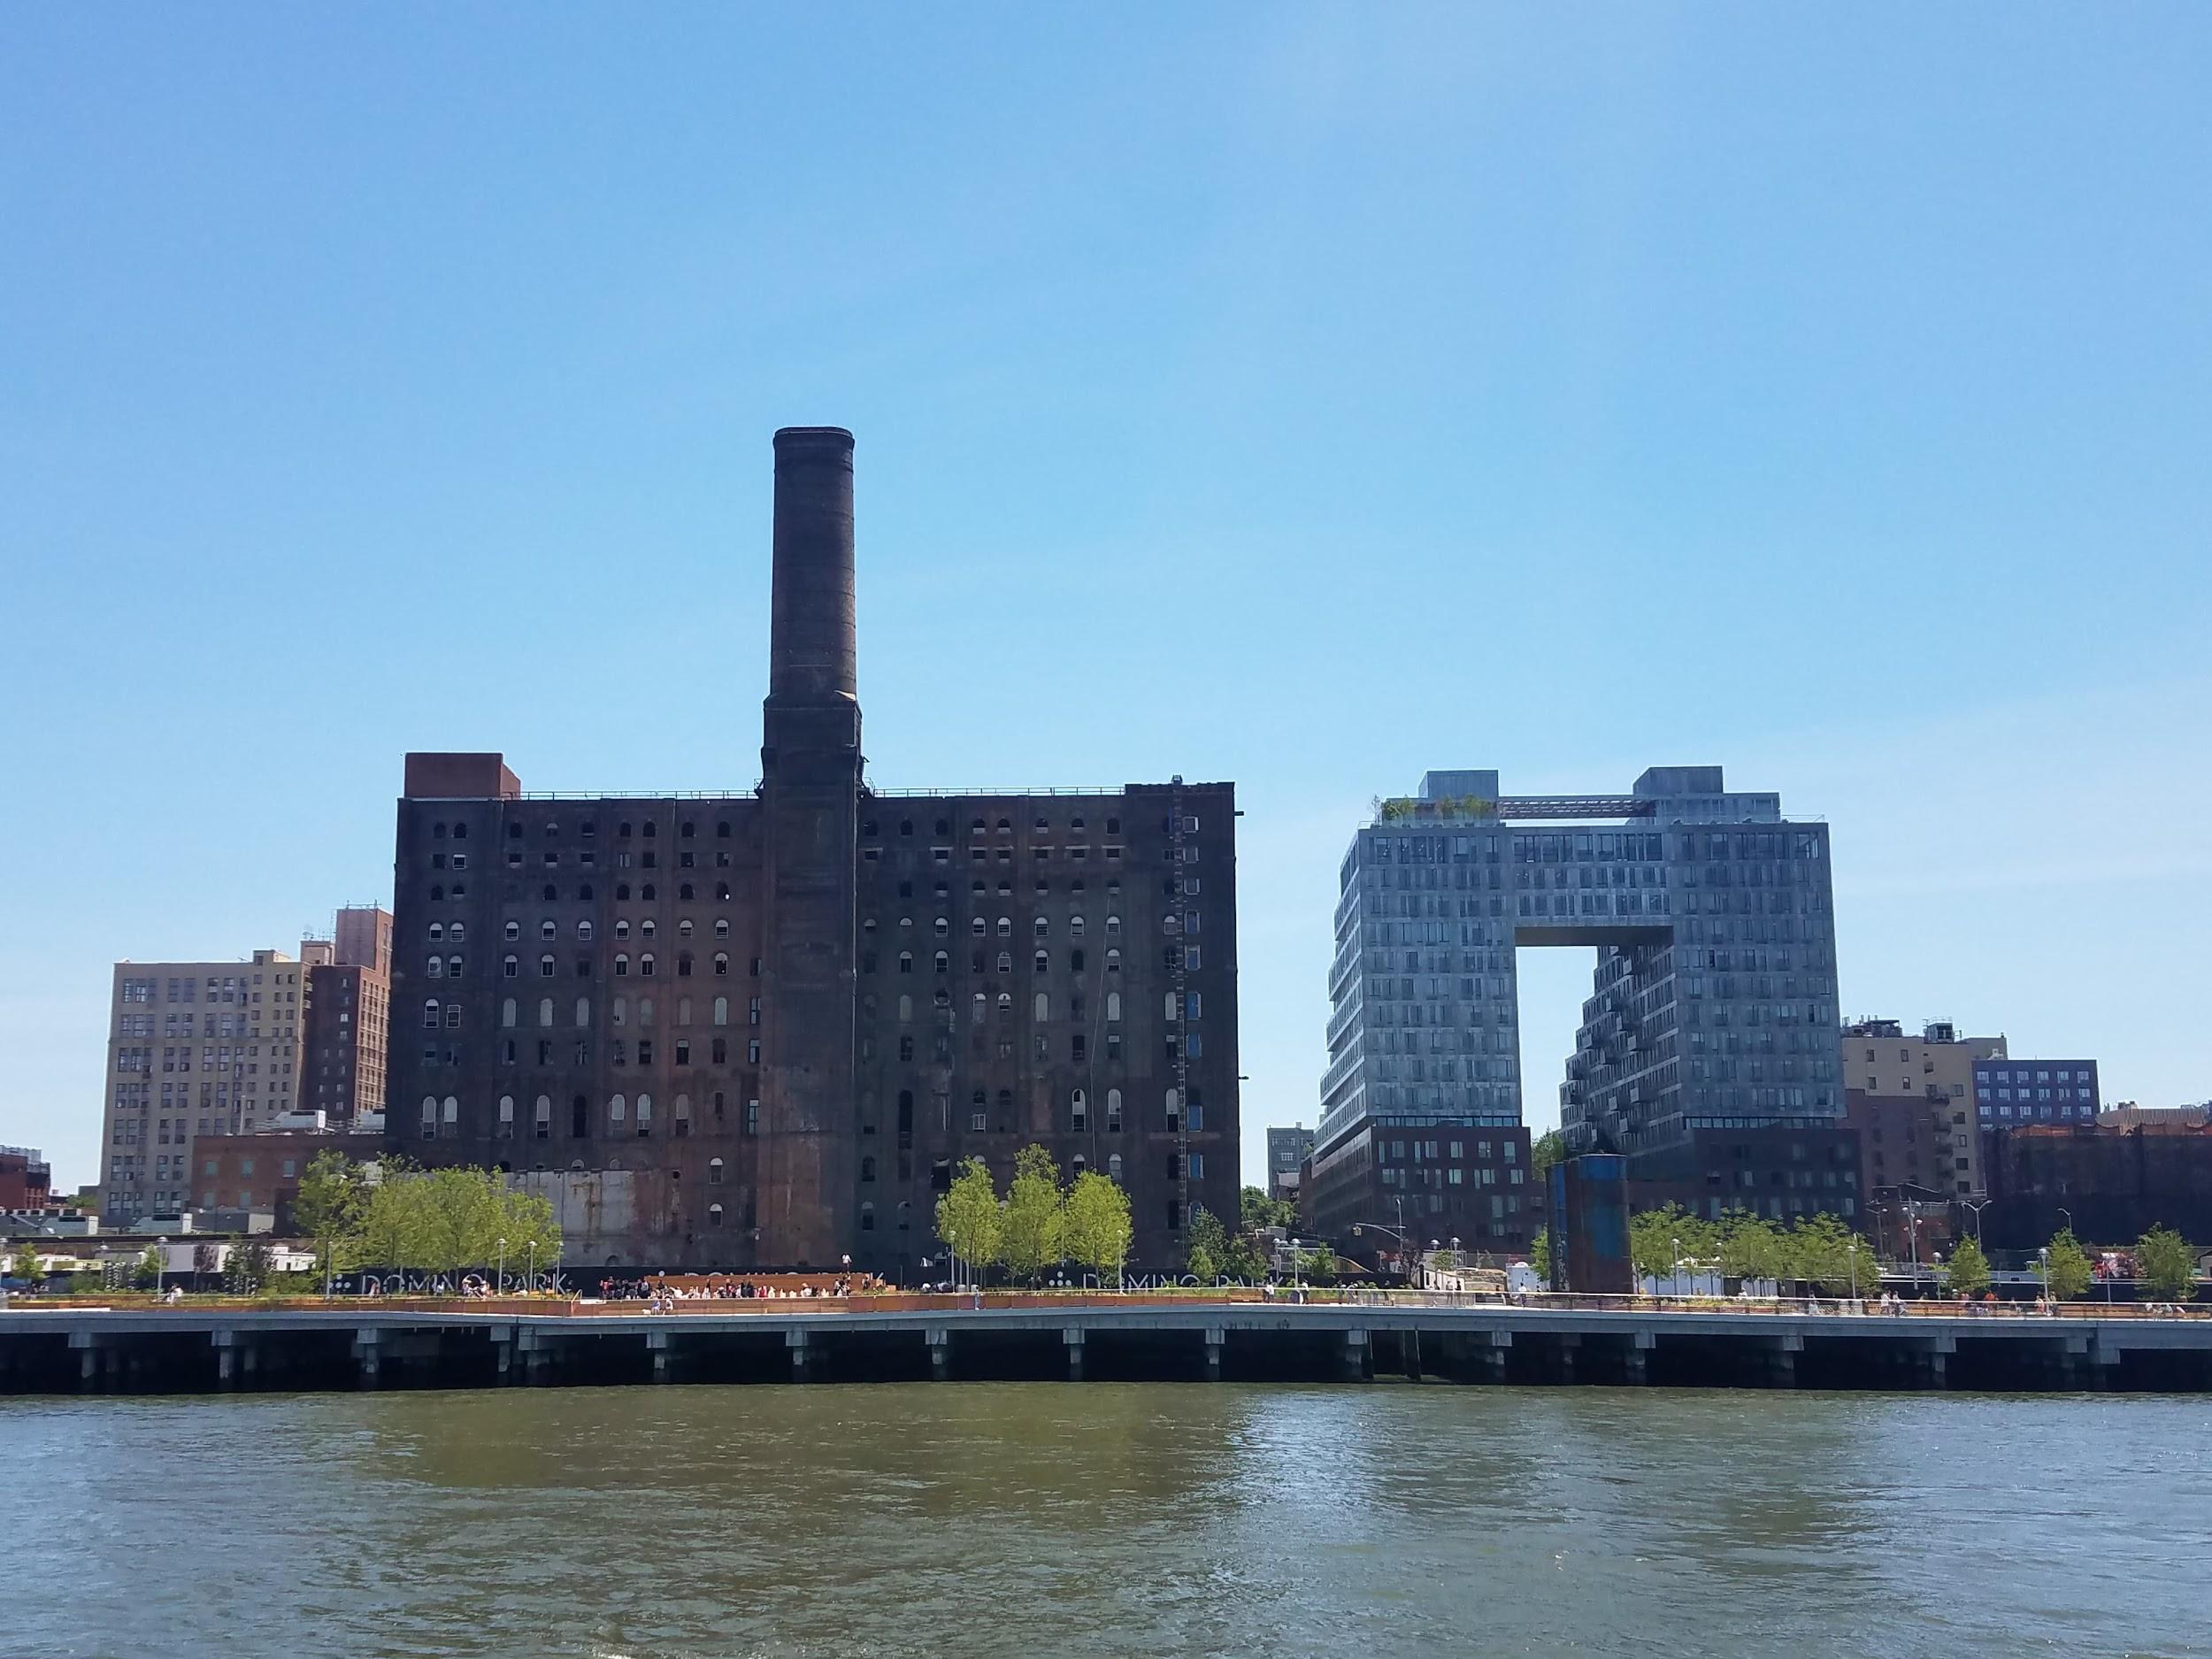

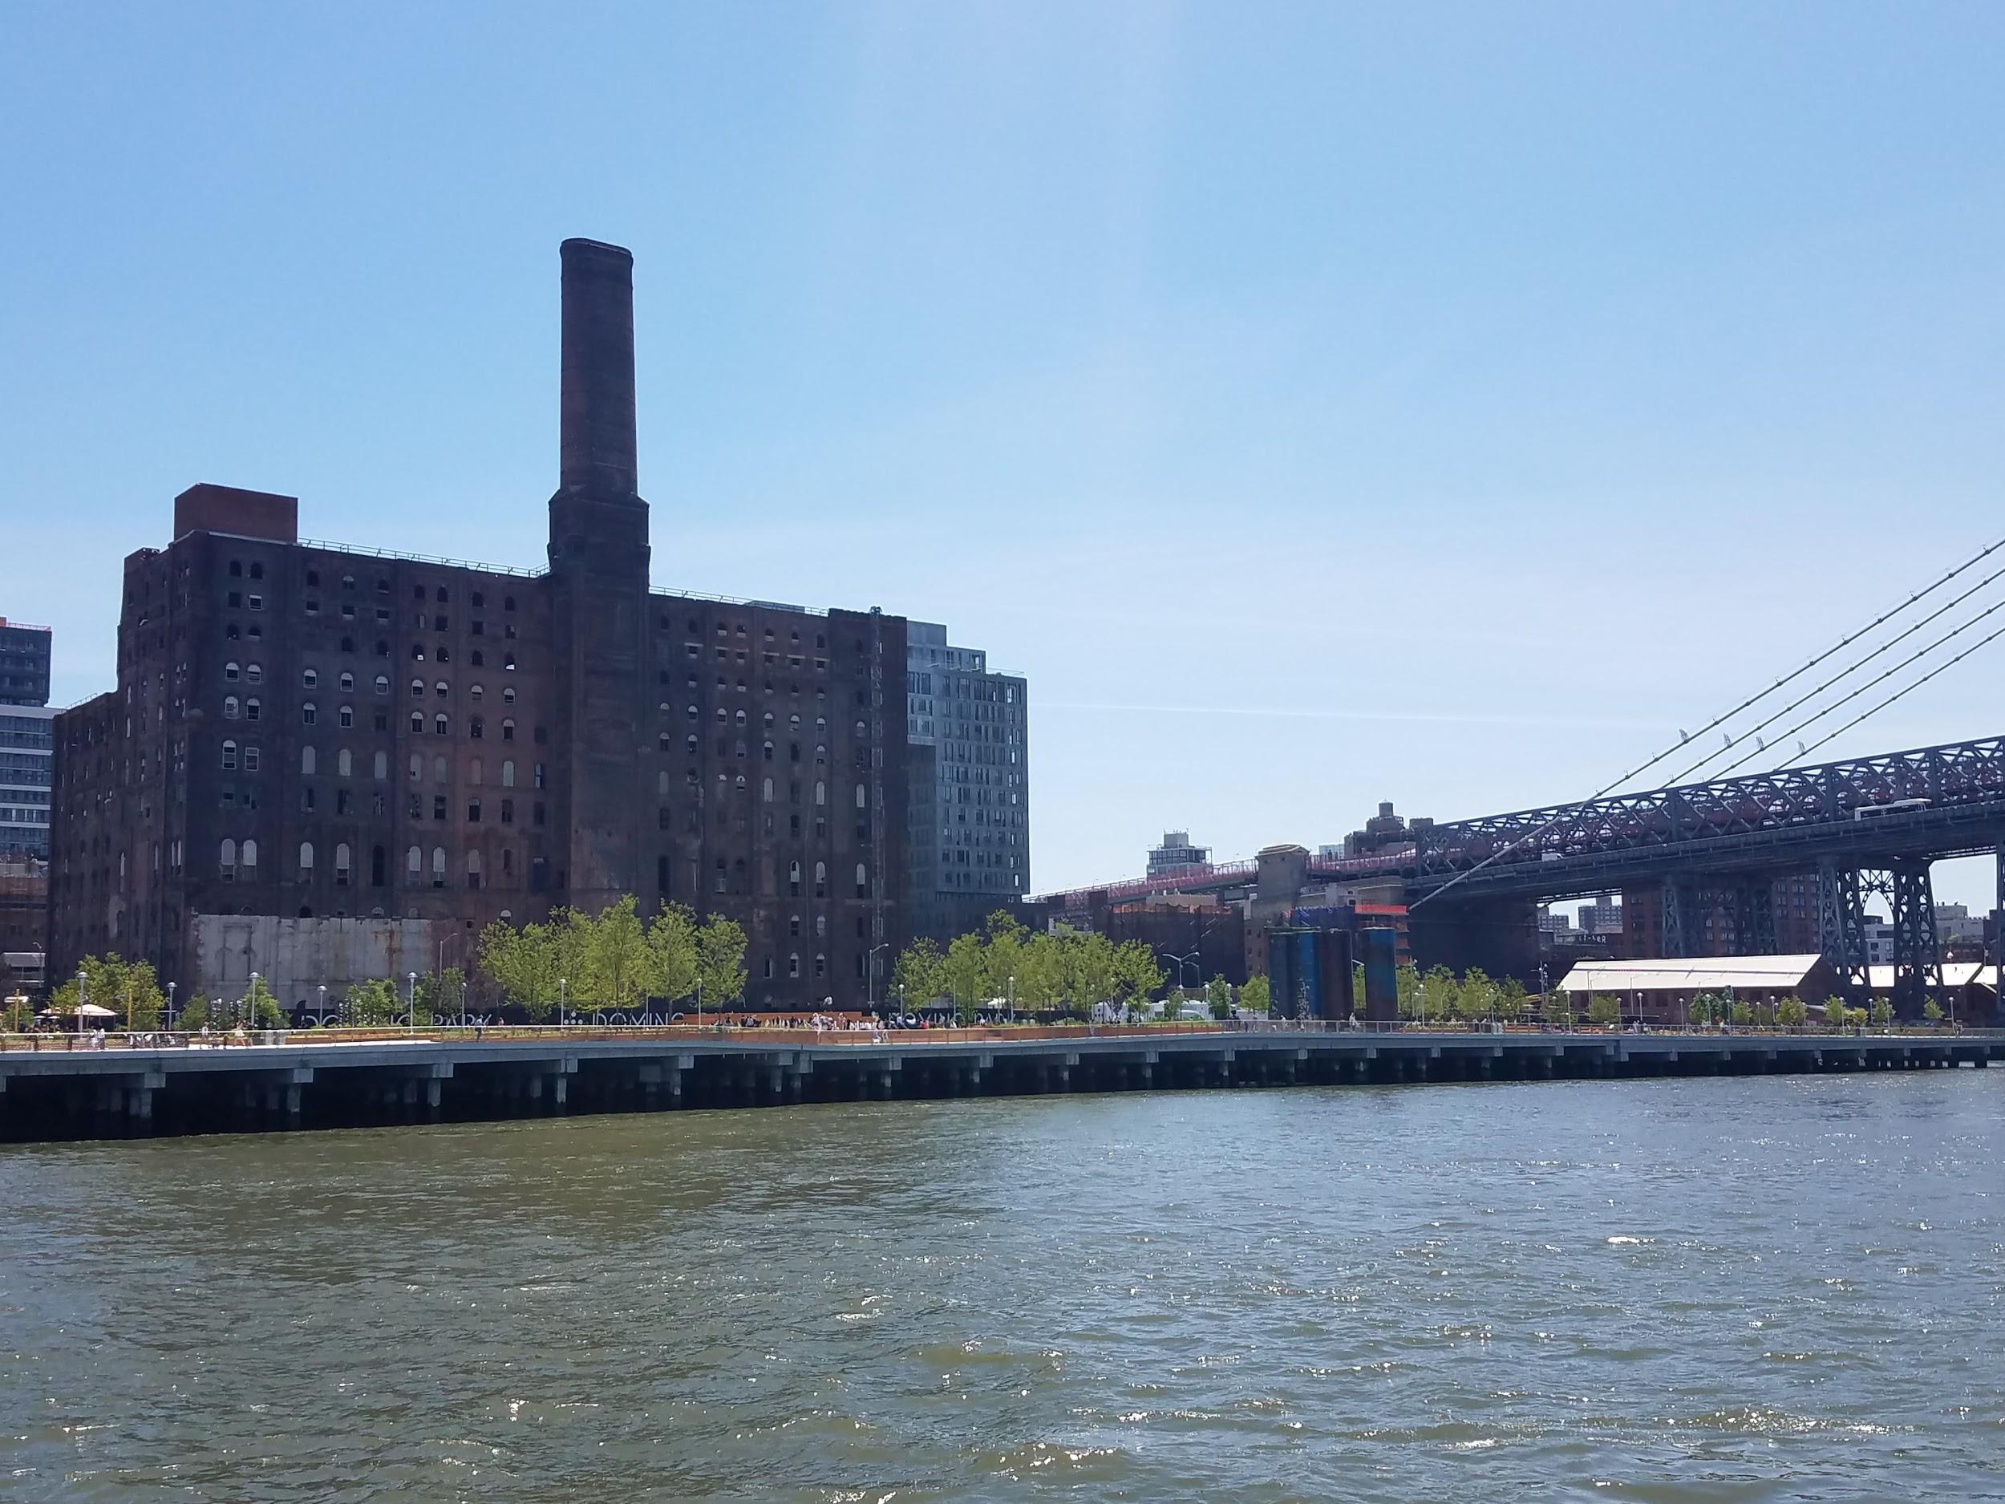

This is a vision of what the neighborhood will look like once it is complete.

