Ms. Singh Name: _________________________
10th grade Pre-Engineering Date: __________________________

Schematic Worksheet
- Draw a schematic of the pictorial circuit.
Pictorial  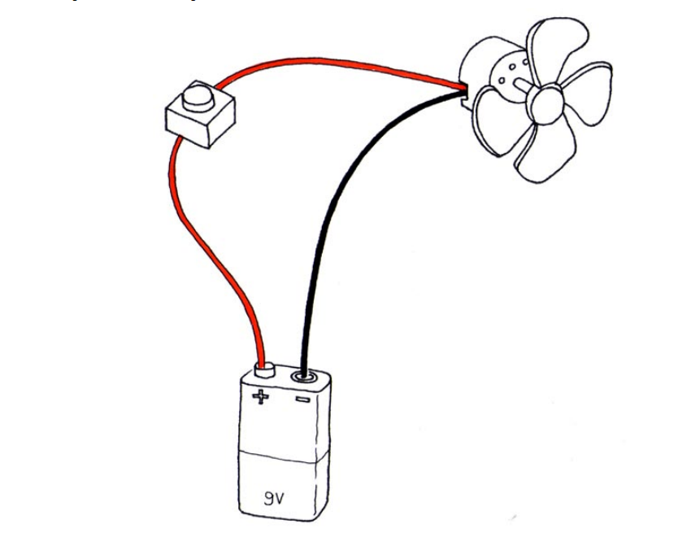  Battery(B1)  Push Button Switch(S2)  Motor(M1) | Schematic

- You have been hired to design a circuit for a flashlight. The flashlight needs to be as simple as possible and contain a battery, lamp and on/off slide switch. Design and draw the circuit so your drawing can be sent to the factory to be created.
- Build a circuit that turns on a light and fan using a slide switch. Draw the schematic of your circuit below, then build your circuit.

- Explain the process of designing a circuit, drawing a schematic and building the circuit. In your explanation answer the following questions in complete sentences:
  - What did you do first in the process?
  - Did your circuit work correctly the first time that you built it?
  - What were some challenges that you faced?
________________________________________________________________________________________________________________________________________________________________________________________________________________________________________________________________________________________________________________________
____________________________________________________________________________________________________________________________________________________________________________________________________________________________________________________________________________________________________________________________________________________________________________________________________________________________________________________________________________________________________________________________________________________________________________________________________________________________________________________________________________________________________________________________________________________________________________________________________________

