Serena Mincey
Art Nouveau
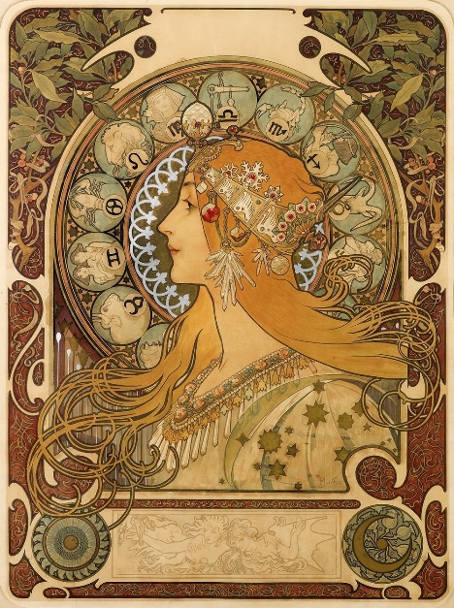

The artwork that I have chosen is an art nouveau piece called Zodiac by Alphonse Mucha. This artwork is one of Muchas more popular designs and was made in 1896, it was his first work when under a contract with the printers Champenois. The original concept of the piece was for it to be made as an in-house calender for printers Champenois, however it was not due to the chief editor Leon Deschamps of La Plume magazine taking notice of the piece. In the artwork Alphonse Mucha puts together zodiac signs and puts them in a circle behind a woman which is common in his other works.
Art nouveau is an ornamental, decorative art style that was popularized in the United States and Europe between 1890-1920. It is most associated by its organic lines and its earth like color palette. Art nouveau commonly uses women as their focal point and natural forms such as vines or flowers in the piece.
Taking a glance at the artwork it seems that the design elements used emphasis. Since emphasis in design is used to look at a certain focal point it is no surprise to see it be used in art nouveau. Zodiac captures the viewers’ attention by having the lady be the main focal point of the piece especially with the jewelry on her head.

