Project 1
Guidelines: Please type all the solutions! For the Smith Chart use Tools/ Typewriter to inset symbols or text. Email and UPLOAD your project 1 on your ePortfolio. In addition to this poject you also need to upload Project 2 and the reflections on the seminars/workshops/field trips, and email them to me.
Team 1: Mamadou Bah, Arie Meiman, Daniel Edwards
- A 690λ- long lossless Z₀=75Ω T-line is terminated in in a load Z_{L}=15+j67 Ω. Calculate and use the Smith Chart to find:
- Γ_{L}; b)VSWR; c)Z_{in}
- The input impedance for a 100Ω lossless T-line of length 1.162λ is measured as 12+j42 Ω. Determine the load impedance.
- a) Design an open ended shunt-stub matching network to match a load Z_{L} =70+j110 Ω to a 50 Ω impedance T-line. Chose the solution that minimizes the length of the through line.
- Now suppose the load turns out to be Z_{L} =40+j100 Ω. Determine the reflection coefficient seen looking into the matching network.
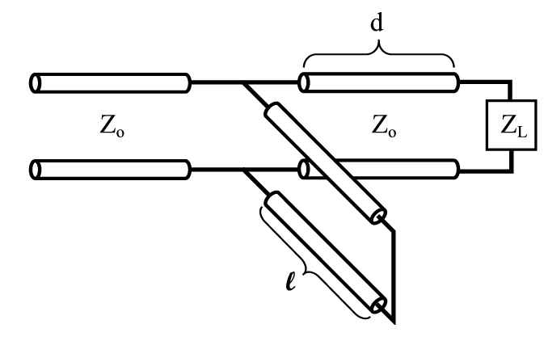
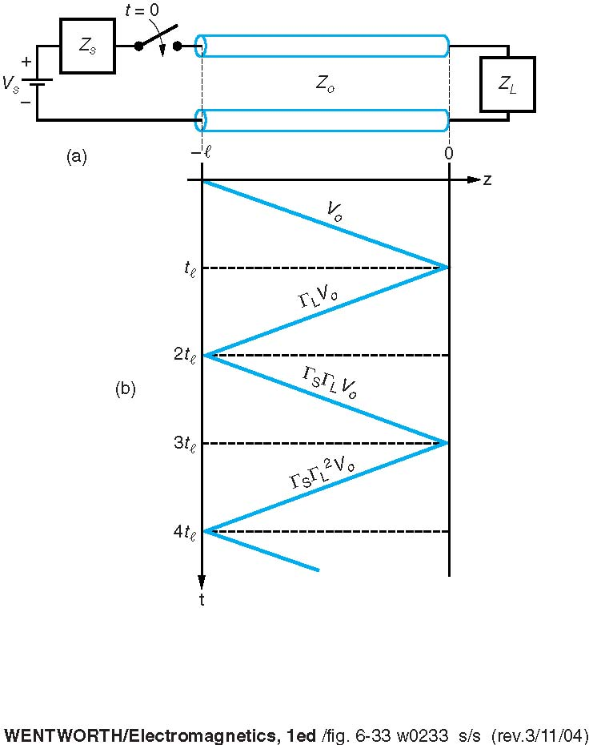
- A load impedance Z_{L}=25+j90 Ω is to be matched to a 50 Ω line using a shorted shunt stub tuner. Find the solution that minimizes the length of the shorted stub
- A 50 Ω line is terminated in a pair of parallel load impedances of 50+j100 Ω and 50 –j100 Ω. Determine the total load admittance and impedance seen by the line.
- Consider the figure with the following values V_{S}=10V, R_{S}=30Ω, R₀=50Ω, up=0.666c, R_{L}=150Ω, and l=10cm. Plot out to 2ns
- the voltage at the source end,
- b) the voltage at the middle,
- c) the voltage at the load end of the T-line.

Project 1
Guidelines: Please type all the solutions! For the Smith Chart use Tools/ Typewriter to inset symbols or text. Email and UPLOAD your project 1 on your ePortfolio. In addition to this poject you also need to upload Project 2 and the reflections on the seminars/workshops/field trips, and email them to me.
Team 2: Yevgeniy Morozov, Rupan Hossain, Esnan Ambeau
- A source with 50 Ω source impedance drives a 50 Ω T-Line that is 1/8 of a wavelength long, terminated in a load Z_{L}=50-j25 Ω. Calculate and use the Smith Chart to find:
a)Γ_{L}; b)VSWR; c)Z_{in} seen by the source.
- A 1m long T-line has the following distributed parameters: R’=0.10 Ω/m, L’=1.0 µH/m, G’=10.0 µS/m, and C=10nF/m. If the line is terminated in a 25 Ω resistor in series with a 1.0nH inductor, calculate at 200MHz, Γ_{L} and Z_{in.}
- The input impedance for a 30cm length of lossless 100 Ω impedance T-line operating at 2.0 GHz is Z_{in}=92.3-j67.5 Ω. The propagation velocity is 0.7c. Determine the load impedance.
- A matching network, using a reactive element in series with a length d of T-Line, is to be used to match a 35 – j50 Ω load to a 100 Ω T-Line. Find the through line length d and the value of the reactive element if (a) a series capacitor is used, and (b) a series inductor is used.
- You would like to match a 170 Ω load to a 50 Ω T-Line. (a) Determine the characteristic impedance required for a quarter-wave transformer. (b) What through-line length and stub length are required for a shorted shunt stub matching network?
- Consider the circuit in the figure with the following values: V_{s} = 10 V, Z_{s} = 30 Ω, Z_{o} = 50 Ω, u_{p} = 0.666c, Z_{L} = 150 Ω, l = 10 cm for a 10 V pulse of duration 0.4 ns. Plot, out to 2 ns, (a) the voltage at the source end, (b) the voltage at the middle, and (c) the voltage at the load end of the T-Line.

Project 1
Guidelines: Please type all the solutions! For the Smith Chart use Tools/ Typewriter to inset symbols or text. Email and UPLOAD your project 1 on your ePortfolio. In addition to this poject you also need to upload Project 2 and the reflections on the seminars/workshops/field trips, and email them to me.
Team 3: Mohammed Alawlaqi, Salam Seck, Romuald Ilboudo
- A 0.334λ long Z₀=50 Ω T-line is terminated in a load Z_{L}=100-j100 Ω. Calculate and use the Smith Chart to find:
a)Γ_{L}; b)VSWR; c)Z_{in} seen by the source.
- Suppose a Z₀=50 Ω T-line is is terminated in a 100 Ω load. Determine the aquired impedance of a quarter-wave matching section of T-line.
- Suppose a 50 Ω coaxial cable made with a Teflon dielectric, that must operate at 800MHz T-line is terminated in a Z_{L}=10-j15 Ω. Use the Smith Chart to
a) Create a matching network by adding a reactive element at a suitable location along the T-line,
b) determine the length of the coaxial line between the load and the capacitor,
c) determine the value of the series capacitor added to provide an impedance match.
4. You would like to match a 170 Ω load to a 50
Ω T-Line. (a) Determine the characteristic
impedance required for a quarter-wave
transformer. (b) What through-line length and
stub length are required for a shorted shunt
stub matching network?

- Consider a 6 cm long 75 Ω transmission line terminated in a 125 Ω load and having a matched source impedance (Z_{s} = 25 Ω). Propagation velocity on the T-Line is 0.1c. The source is a 0.4 ns square pulse of amplitude 4V. Determine
(a) the voltage at the source end, (b) the voltage at the middle, and (c) the voltage at the load end of the T-Line.

