Project 1
Guidelines: Please type all the solutions! For the Smith Chart use Tools/ Typewriter to inset symbols or text. Email and UPLOAD your project 1 on your ePortfolio. In addition to this poject you also need to upload Project 2 and the reflections on the seminars/workshops/field trips, and email them to me.
Team 1: Mamadou Bah, Arie Meiman, Daniel Edwards and Tyrell Miles
- A 690λ- long lossless Z₀=75Ω T-line is terminated in in a load Z_{L}=15+j67 Ω. Calculate and use the Smith Chart to find:
- Γ_{L}; b)VSWR; c)Z_{in}

- $ΓL=\frac{15+j67-75}{15+j67+75}=\frac{-60+j67}{90+j67}=\frac{89.9}{112.2}=0.8$
- $VSWR=\frac{1+0.8}{1-0.8}=\frac{1.8}{0.2}=9$

- The input impedance for a 100Ω lossless T-line of length 1.162λ is measured as 12+j42 Ω. Determine the load impedance.
Normalized input impedance$z_{in}=\frac{12+j42}{100}=0.12+j0.42$
Normalized load impedance $z2=0.32+j1.55$
Final Answer $Z2=100\left(0.32+j1.55\right)=32+j155$

- a) Design an open ended shunt-stub matching network to match a load Z_{L} =70+j110 Ω to a 50 Ω impedance T-line. Chose the solution that minimizes the length of the through line.
$$z_{L}=\frac{70+j110}{50}=1.4+j2.2$$
Admittance: 0.32+j0.2
1+j1.3
1-j1.4
Length: 0.324λ
Distance:0.324*2=0.648 meters
- Now suppose the load turns out to be Z_{L} =40+j100 Ω. Determine the reflection coefficient seen looking into the matching network.
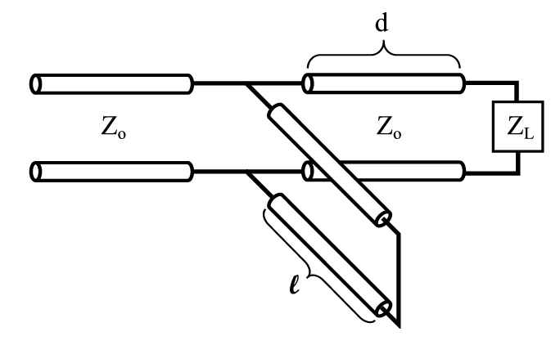
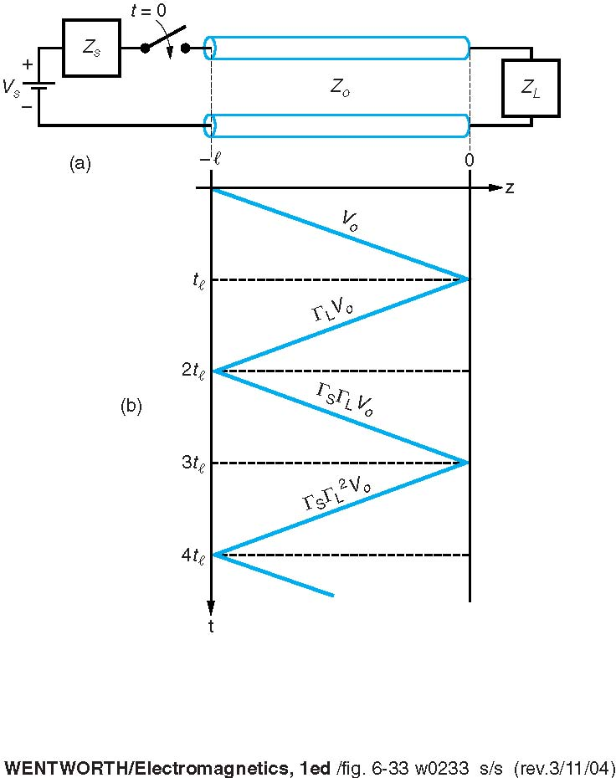
- A load impedance Z_{L}=25+j90 Ω is to be matched to a 50 Ω line using a shorted shunt stub tuner. Find the solution that minimizes the length of the shorted stub

Normalized load impedance:
$$Z_{L}=\frac{25+j90}{50}=0.5+j1.8$$
Admittance: YL=0.1+j0.5
1+jb=1+j2.6
1-jb=-j2.6
Wavelength from load: 5-0.422=0.078
Load λ + (1+jb) λ: 0.078 +0.172=0.25
Distance 1: 0.25*2=0.5m
Distance 2: 0.25-0.192=0.058
Minimized length: 0.058*2=0.116 m
Answer=0.116 meters

- A 50 Ω line is terminated in a pair of parallel load impedances of 50+j100 Ω and 50 –j100 Ω. Determine the total load admittance and impedance seen by the line.
- Consider the figure with the following values V_{S}=10V, R_{S}=30Ω, R₀=50Ω, up=0.666c, R_{L}=150Ω, and l=10cm. Plot out to 2ns
- the voltage at the source end,
$$reflection of source=\frac{Z_{S}-Z_{0}}{Z_{S}+Z_{0}}=\frac{30-50}{30+50}=\frac{-20}{80}=-0.25$$
$$reflection of load=\frac{Z_{L}-Z_{0}}{Z_{L}+Z_{0}}=\frac{150-50}{150+50}=\frac{100}{200}=0.5$$
$$v\left(0,0\right)=\frac{50}{50+30}*10=\frac{500}{80}=6.25 V$$
V⁺ =V⁻ *Γ
v+ = 3.125*-0.25= 1.5625
v+ =-0.25*0.7825=0.1953125
v+ =0.25*0.09765625=0.0244140625
v+ =0.25*0.01220703125=0.0030517578125
- b) the voltage at the middle,
$\frac{v1(1+rL)}{1-rSrL}=\frac{6.25(1+0.5)}{1-\left(-0.25\right)(0.5)}=\frac{6.25*1.5}{1+0.125}=\frac{9.375}{1.125}=8.33$ volts
- the voltage at the load end of the T-line.
$$v\left(x,∞\right)=\frac{150*10}{50+150}=\frac{1500}{200}=7.5 V$$
V⁻=V⁺ *Γ
v⁻ = (0.5)*6.25=3.125 volts
v- =0.5*1.5625=.7825
v- = 0.5*0.1953125=0.09765625
v- =0.5*0.0244140625=0.01220703125

