Tawsip Howlader
COMD 1112, D105
Thelma Bauer
Final Paper
Macy’s logo
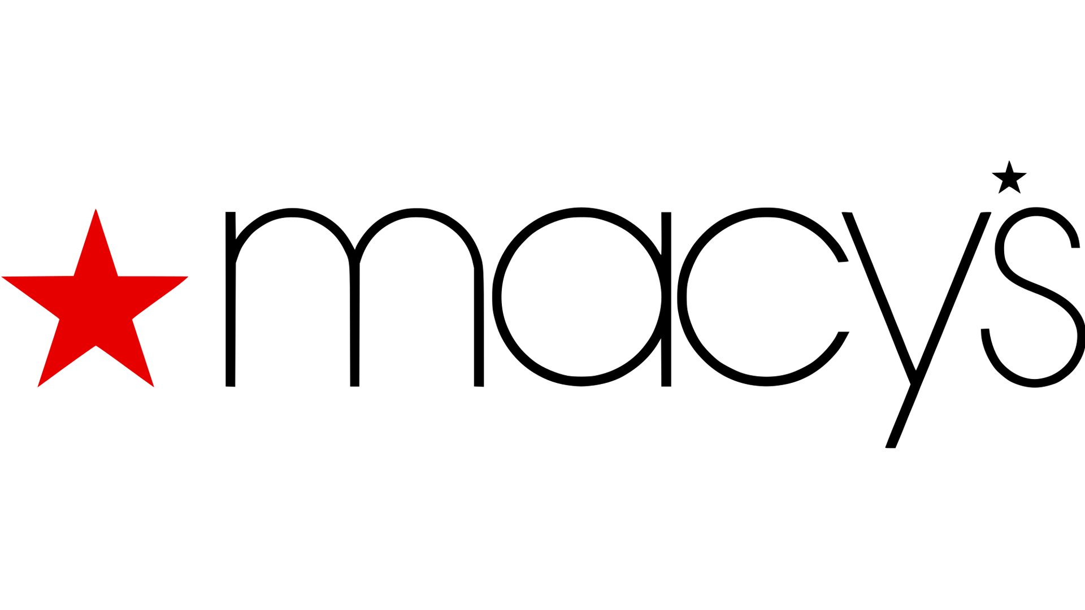
Macy’s is one of the biggest retail shops in the world. Macys was not same big and known always, it grew over time. Rowland Hussey Macy was fifteen when he left the home for sailing on the Whaling ship. After spending some years at the sea, he returns and started business. 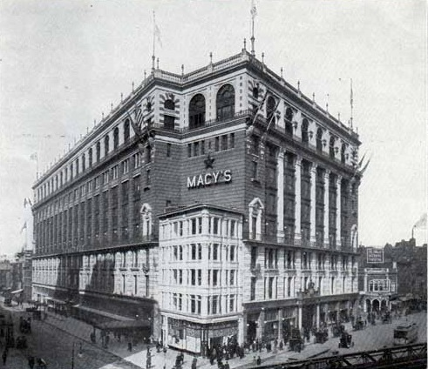First, he started working with his father then he opened his own needle- and- thread store, but that business didn’t work out very well. So, after some time he started another business and it was dry goods store, but he fails again. Then he starts another dry good store with his brother, the hometown for big city New York in 1858 to start again a dry goods store. This time he had some experience and some amount of money. He started a fancy dry goods store R. H. Macy & Co. on the corner of 14th street and 6th Avenue. On his first day of opening he did $11.06 business and grow at very fast pace. That year he had around $85,00 business.
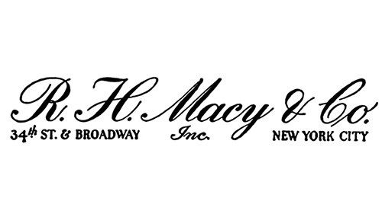
Macy’s first symbol was a rooster, but he replaced it with a red star. That red star was inspired by the tattoo in his forearm that he got it when he was sailing in the sea. That star guides him forward when he needs the way. Earlier the logo was just the full name of the owner and the full address of the store. Throughout the year the logo for Macy’s was the company name and red star. this logo stated 1920 to 1932. In 1932 to 1938 the macy’s logo was very simple and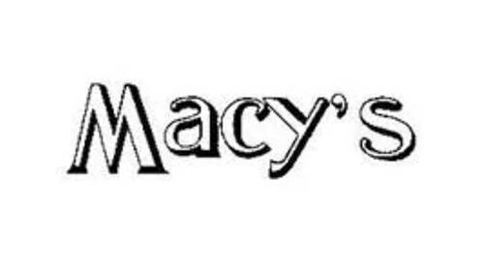 minimum. The logo was uppercase “M” with black outline in a white background. Then in 1938 logo style changed a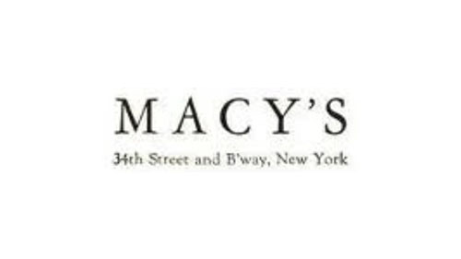 little bit. ￼The logo was all uppercase lettering but this time the font was different, and letters was all black and the address was back. This logo stays 1938 to 1948. New logo design came in 1948 and stay till 1986. This time logo was again mix of uppercase and lowercase letter and the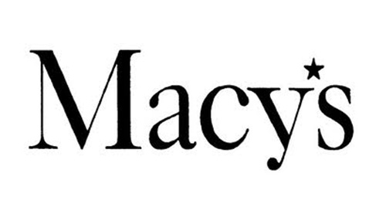 famous star appears. Letters has very high contrast and little space between the letters. Apostrophe replaced with the small black star before ”S”. 1961 to 1970 the typeface for the logo get changed but the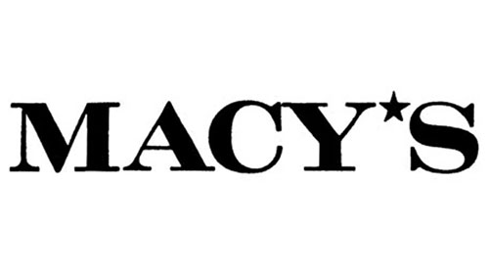 star stays the same. The lettering was much shorter bold and lot of contrast, also all capes. Then the period came when the Macy’s 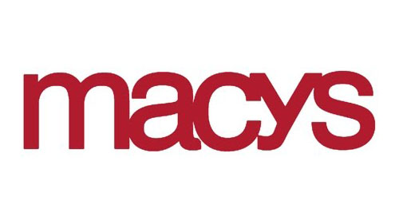logo found the right typeface and style that stay the same from 1970 to present. This time Macy’s logo start with lowercase ”m” and letter form stay round. Since that time the logo changed very saddle that so many people didn’t recognize the difference. In 1970 version of the logo color was red but this time the red star was absent. Couple of years designers just experiment with the shape, boldness, kerning.
In the present Macy’s logo is very similar to the 1970 version of logo but the wordmark is different, and these letters are thinner than previous logos. Now there is a big five points red star appear beginning of the logo and one small star is after “y”. Without the whole logo with red star and wordmarks the red star can be known as a Macy’s logo. It's only the star without wordmarks. Usually only red star use in the shopping bag and the tags. This star appears in two-way, one white background and big red star or red background with a big white star. Font style is unknown, but it is like the font Avant Garde Gothic but much lighter than it. The designer of this logo are Herb Lubalin and Tom Carnase.

Dwyer, Dialynn. “Macy’s famous red star has Nantucket roots.” Boston, Boston Globe Media Partners, September 23,2017, https://www.boston.com/news/history/2017/09/23/how-macys-famous-red-star-has-roots-in-nantucket
“Meaning and History logo.” 1000 logos, https://1000logos.net/macys-logo/
Wyatt, Rick. “Macy's (U.S.).” Flag of World, FOFW, December 27,2018, https://fotw.info/flags/us$macys.html
Youso, Karen. “Tattoo inspired Macy's star logo.” StarTribune, March 7, 2010, http://www.startribune.com/tattoo-inspired-macy-s-star-logo/86759367/?refresh=true
Hanson, Keri. “The History of Macy’s: From Humble Beginnings to Stunning Success.” Macy’s, December 06, 2017, https://www.visitmacysusa.com/article/history-macys-humble-beginnings-stunning-success

