Tawsip Howlader
New York City College of Technology
COMD 1112, D105
Thelma Bauer
Designer Research Paper
Jan Tschichold
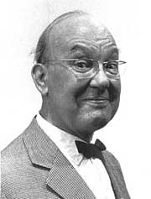
In the history there has been so many great designers. Jan Tschichold is one of them. He gave a very different prospective about the graphic design. Jan Tschichold was a German typographer and book designer and author. He also played very important role to played very important role to developing the 20th century graphic design and typography. He born on April 2, 1902 in Leipzig, Germany. He is best known as writer of “Die Neue Typography” and “Typographisch Gestaltung”. These two books are the standard textbook for the next generation typographers. His father was a sign painter and he was trained in calligraphy. Jan Tschichold practice his artistic ability with his father and start his training from watching. Calligraphic made some distance from his contemporary typographies. He did not have any formal education on fine art and Typography.
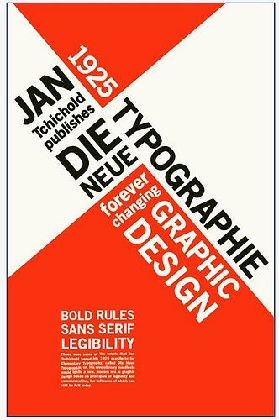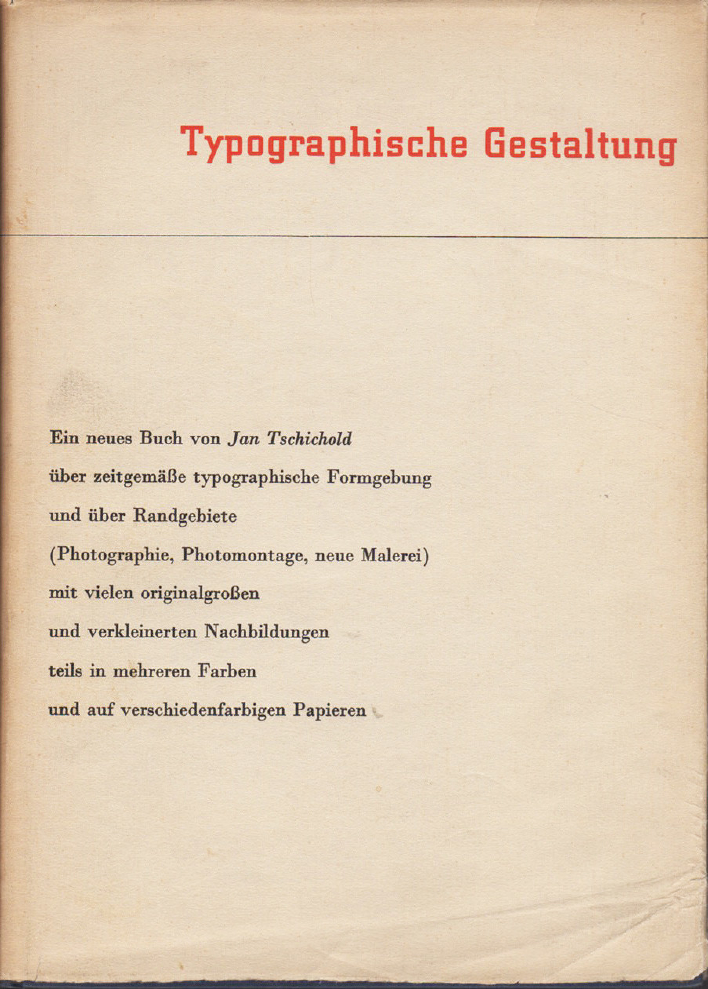

Jan Tschichold was the one of the most powerful and talented typographer and designer. This day designer still follows his design book. He is one of the designers who influenced the 20th century typographers.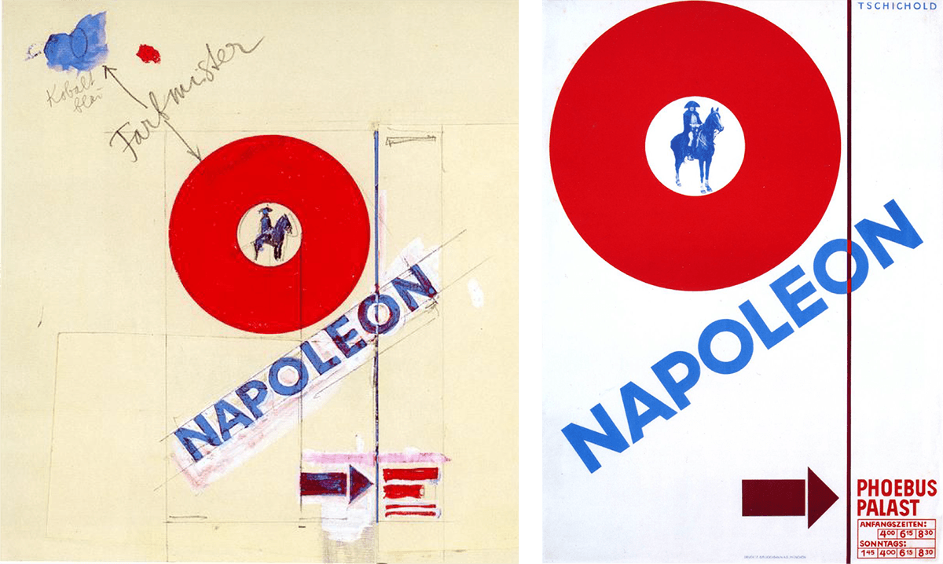 Jan Tschichold worked very closely with Paul Renner. Paul Renner designed Futura font. Jan Tschichold’s new typography and sans- serif typeface was very different. He didn’t believe the 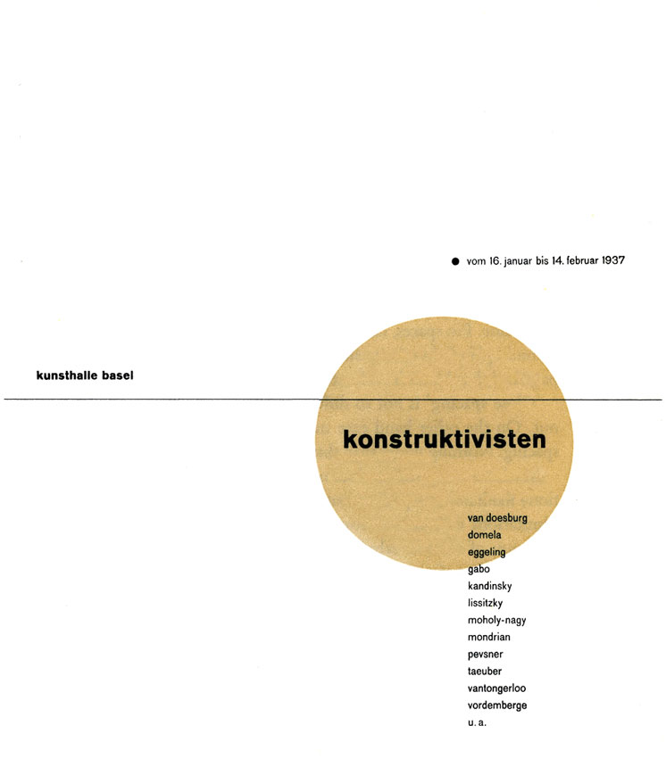symmetry and stander rules for the designs. He takes the stander size paper then set the fourth guidelines for set a typographic history as a type is a design. His text still has been using relatively. His new kind of typeface and design was very modern. He rejects the traditional fonts and symmetries composition. He gave a new look of san- serif typeface, geometrical construction, and asymmetrical composition. His design was functional, oddly satisfying and he designed for modern machine – type composition and printing machine. In Germany black letter or gothic script was used that time. But Jan Tschichold’s writing and design help to spread the modernism throughout the world.
The time of Hitlar’s election in Germany it was required all designers to registry themselves with the ministry. Also, all kind of teaching post was band that time. Help with Paul Renner, Jan Tschichold gather a teaching post in Munich. 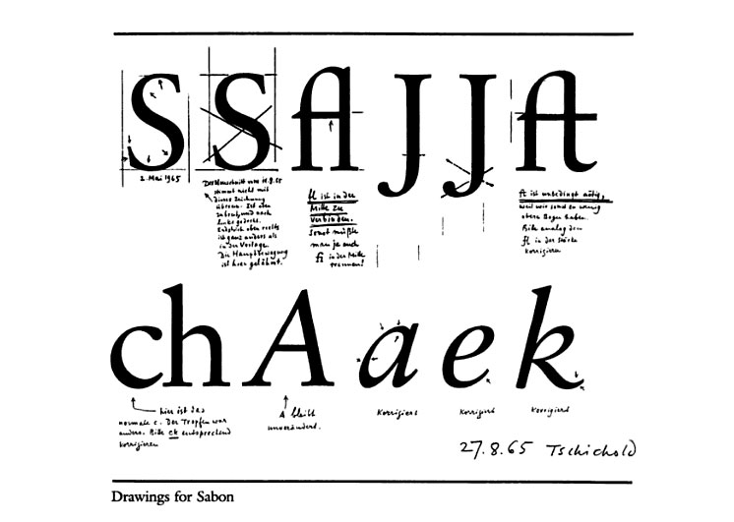Also, they both attend to Bolshevlets. But in 1933 Hitlar win the election so Jan Tschichold and his wife got arrested. In his house police found poster and books that shows the secret involvement with communists. The police put him under critical observation and examination. Secret state police of Nazis seized all this designs and books from his house. In that procedure he got his lesson and got very scared. after bit of time he got lucky and a policeman helped Jan Tschichold and his whole to arranged tickets and escape from the jail. They leave the Germany and settled in Switzerland until he died. He never came back to Germany again.
Jan Tschichold wrote a serice of practical manual on principal of Modern Typography. Germanys printer and worker loved his work. His book “Die neue Typographie” was all about modern typography but after the German incident he lost faith in this own work. Jan Tschichold went back to the simple Roman typeface and he called his own book as too extreme. His modernist design theory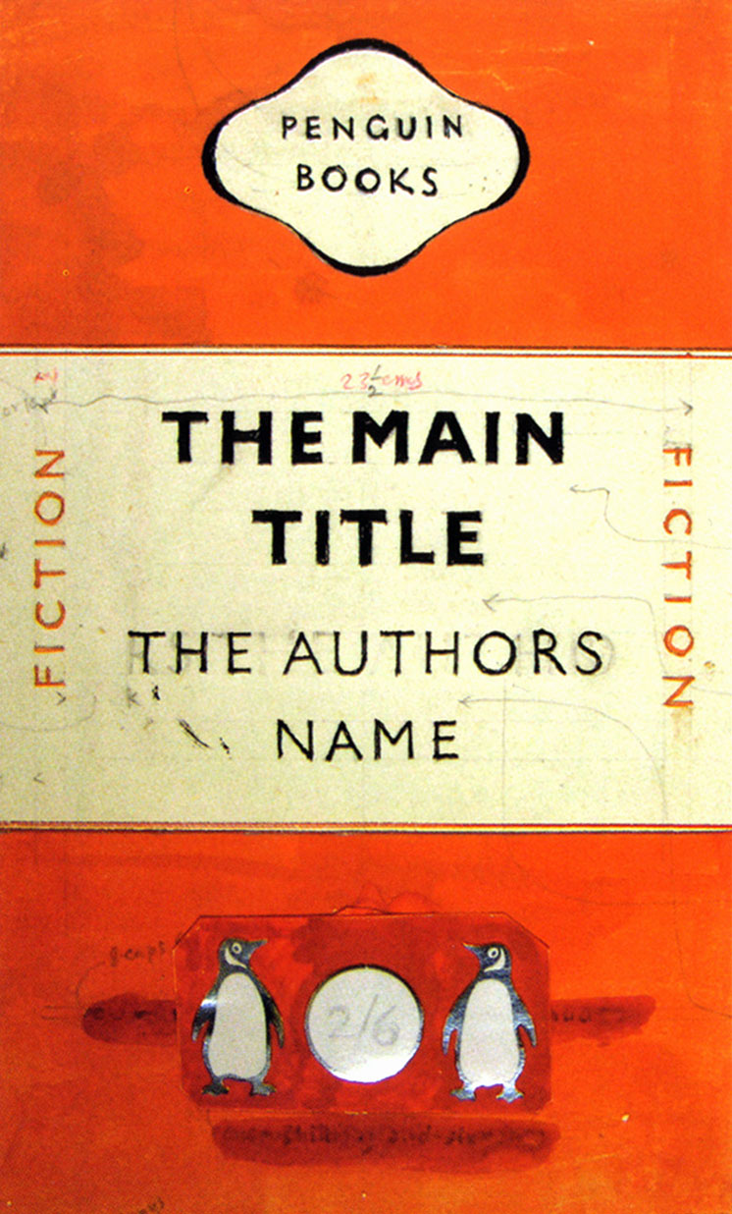 took 360-degree turn. When he was living in England, he got chance to redesign Penguin Books. He redesigns almost 500 books. Jan Tschichold wrote a guideline about typography and composition instruction for penguin editors. The name was “The Penguin Composition Rules.”
Without any doubt Jan Tschichold was a great book writer, designer, typographies and a great teacher for today's designer. Every chapter of his career he left a impressive impression. He passed away on August 11, 1974 in Locarno, Switzerland at age of 72.

  - Flask, Dominic. “Jan Tschichold.” Jan Tschichold : Design Is History,
http://www.designishistory.com/1920/jan-tschichold/

  - “Famous Graphic Designer.” FamousGraphicDesigner.org,
https://www.famousgraphicdesigners.org/jan-tschichold

  - The Editors of Encyclopaedia Britannica. “Jan Tschichold.” Encyclopedia Britannica, August 07, 2019,
https://www.britannica.com/biography/Jan-Tschichold

“Jan Tschichold (1902-1974).” identifont,
http://www.identifont.com/show?14O

  - Costin, Cristiana. “Jan Tschichold, Master Typographer of the 20th Century.” Creative Pro, October 9, 2018,
https://creativepro.com/jan-tschichold-master-typographer-of-the-20th-century/

