T’ahna Howard
Design Media Foundations
Logo History Paper

In February 2009 Nickelodeon unveiled a new look and logo for its company and began use of it on September 28th that same year.
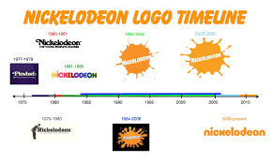
http://logos.wikia.com/wiki/File:NickelodeonLogoTimeline.jpg
The Nickelodeon logo was designed by Fred Seibert and Alan Goodman with help from Scott Nash and Tom Corey (owner of Corey & Co.). Fred Seibert is the owner Frederator Networks, Inc. and Frederator Studios. He also is an American television and film producer. Alan Goodman is an American advertising executive, businessman, consultant, writer and television producer. There was a very focused thought process that developed in the making of the logo. One was the decision to keep the name “Nickelodeon” even though at the time management wanted to change it to just “Nick” as it was easier to say and spell. Another decision was the decision to try and make it feel like something kids could enjoy. Seibert and Goodman, realizing they didn’t know anything about kids programing, enlisted the help of Scott Nash and Tom Corey. In the end the goal became trying to create a logo that would represent change similar to how kids go through changes growing up. This led them to lean towards a sketch of an orange splat.
There have been many changes of the logo over the years. The early Nickelodeon logos started off just being the word “Nickelodeon” in black coloring, then later came the addition of the rainbow coloring of the word in the Frankfurter typeface.
http://logos.wikia.com/wiki/Nickelodeon
During this time period a pinball theme was added that reflected the 80’s era use of computer generated graphics.
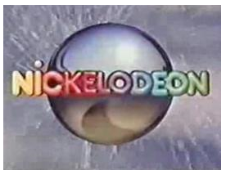
http://logos.wikia.com/wiki/Nickelodeon
Next comes the change from 1984 to 2009 which includes “Nickelodeon” in a new font, Balloon Extra Bold, and the start of the trademark orange lettering. Also the start of the continued use of the iconic “splat” design. Now in the present we have “Nickelodeon” in all lowercase in a custom font.
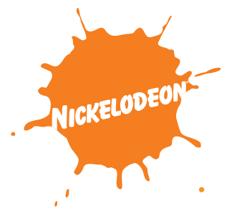
http://logos.wikia.com/wiki/Nickelodeon
The current logo was designed by Eric Zim. It was stated that reason for the change was in order to connect all of Nickelodeon’s sister networks under one logo. Nick Jr., Teen Nick (also known as The N), Nicktoons Network, and Nick at Nite are Nickelodeon’s sister networks.
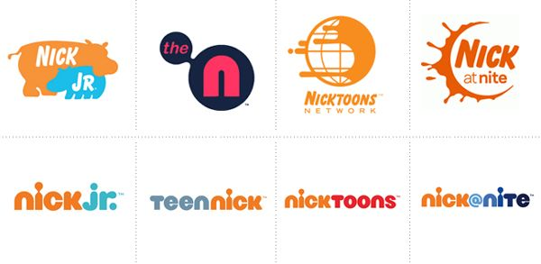
https://www.pinterest.com/pin/567242515537636382/

