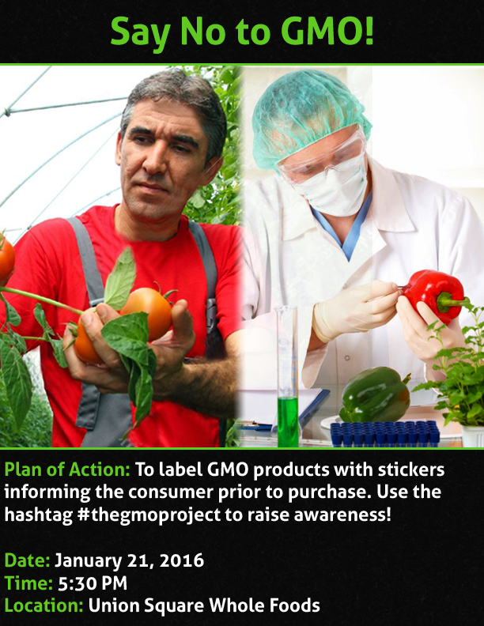

The GMO Project’s Declaration

i. Who Are We

We The GMO Project seek to reveal the truth surrounding GMOs. By uncovering Whole Foods participation in distribution and consumption of GMO sourced foods we aim to expose the misleading claims made by the chain. By continuously questioning their statements in conjunction with investigating the sources of their food we will not rest until the truth is out there. We believe consumers have a right to know where there food comes from and what is really in it and making the food market transparent is our mission.
ii. Creative Vision

Whole Foods proclaims to be all-organic, but is that really the case? Our intention is to expose the lies we have been told by Whole Foods and have the people innocently shopping for their daily groceries realize the lies they have been fed and be able fully comprehend what they are consuming with their friends and family and make educated choices.
Now, our focus will be mainly on produce. To this end, we will create stickers that will be used to re-label or cover falsified GMO products. There will be 4 different variations, each containing a different factoid and our hashtag, #THEGMOPROJECT, for those who seek more information. On our day of action we aim to enter the Union Square Whole Foods as a group and take action and launch our campaign.
For the long term, we can only speak idealistically. Of course we aim for the elimination of GMOs as a whole. However, we understand that the possibility of this is relatively low. We do intend to bring in other organizations, ones with experience and connections with this issue, to help spread our action and cause to a broader audience. Because, even if our small group can incite something to be done, big or small, that can be an achievement we can be proud of.
We intend to keep The GMO Project going as long as possible. With new students coming in, we can pass the torch onto them and they can spread our cause even more. Of course this doesn’t mean we plan to abandon our plight come the termination of our semester. If we can all continue to participate in this for years to come, then we intend to.
a. Spreading the Word & Gaining Support
There are many ways in which we will go about spreading the word for our cause. With two specific ways that we will focus on, the use of social media and speaking to people directly! Continuously promoting #TheGMOProject on Twitter and Facebook addressing concerns regarding the health risks of GMOs. It will also inform our audience and garner support for our cause. We will share several links containing current information and we will try to connect with other organizations that share our views on GMOs. Likewise, we will also try to offer alternatives for a healthy diet that is free of chemicals and pesticides. LIKE US AND FOLLOW US!!!

Speaking to people directly will almost always be a more effective way to gain supporters for our cause. For this aspect, we have chosen to talk to people in person beforehand and spread the message of the action. These days would be Tuesday, January 5th, and Friday, January 15th. We will also be connecting our cause to other well-established causes to bring in more people.

A constant flow of information is what keeps people engaged. The actions that we must take are creating social media accounts, arming ourselves with knowledge, and simply talking to people. We want this to have an impact and we need the voices of the many to do so.

b. Reaching Out to Other Organizations
There are a plethora of huge organizations that could potentially take interest in our cause. These people already believe what we believe; they just have a much larger reach than we do. We can try our best to spread the word on our own, but the best outlet is through people who already have a following.

One that comes to mind is the popular and ever growing YouTube channel “Tek Syndicate”. At the time of writing they have over 552,000 subscribers, a forum with over 60,000 active members, and a twitter following upwards of 200,000 users. We will be contacting them directly in order to ensure our campaign can reach past the lines we would be able to reach by ourselves.

In order to have people join the cause is to let people know about the evils of the GMO’s, their collaboration with multinational corporations, and the way in which it affects both people domestically and internationally in a negative way. And the best way to do this is by appealing to the public’s emotions. That is how we get people’s attention.

c. Where will it occur?
Our action will take place at the Union Square Whole Foods in New York City, (4 Union Square Street, New York, NY 10003) on Thursday, January 21st, 2015.

iv. When will it occur during the day?
Our action will occur during the afternoon, more specifically, around rush hour. We can capitalize on the amount of people outside during that time as many of them will be going home, doing their shopping, or going to other important places. With all of our members participating in the action, we hope to reach a significant amount of people.

Of course, due to the nature of rush hour, we know that a portion of these people will either be too busy or in a rush to pay attention to us. This would be added on top of those who will naturally ignore or disregard our action. We understand this and aim to, at the very least, get these people to notice our action. Even if they ignore us, we hope our poster, stickers, or action will stick in their mind and perhaps mention it to somebody else or acknowledge it at later time.

d. Are these choices strategic?
Yes, very much so. We chose rush hour on a weekday due to the sheer amount of people who would be outside at that point in time. This would allow us to reach a much larger audience both inside and outside our target location, Whole Foods, than say at 9 A.M on a Sunday.
We choose Whole Foods because, this is a store that tells its customers that they are buying fresh and organic. Our idea is to have people realize how much of what they consume is GMO and bring awareness to these facts. As well as, exposing how Whole Foods has been built on a foundation of deceit and valuing profit over its integrity and customers.
We had discussed how if Whole Foods actually wanted to sell real organic and fresh produce, they have the means to do it. All they need to do is to demand that such produce should be available for them. Whole Foods is also capable of preventing the sales of produce that is widely known to be GMO, such as corn, yet, they continue to sell it anyway.

iii. Map The Terrain
- DID YOU KNOW?

- Whole Foods has knowingly been selling GMO products for years, hiding them under the “natural” label.
- GMO products can be found in Whole Foods salad bar, packaged foods, meats, dairy products and some of the Whole Foods branded vitamin line.
- Whole Foods knowingly trains its employees to say they do not carry any GMO food.
- Whole Foods has makes an estimated $2-$3 billion a year in sales of GMO products.
- Whole Foods financially supports Monsanto through the GMO sourcing supply chain, selling all sorts of products made with Monsanto’s GM corn.
- Two-thirds of Whole Foods products are labeled “natural” instead of certified organic.
Whole Foods seeks a “coexistence” with Monsanto, making deals with the USDA for genetically modified alfalfa and commercialized engineered crops.

Over 90% of Americans have said they want labels on GMO products and yet, the House passes a bill to prevent mandatory GMO food labeling. Our fight against GMO is never-ending but we, The GMO Project are motivated to implement a day of action specifically targeting Whole Foods. Whole Foods Corporation proudly depicts their business as a supermarket chain specializing in organic food.

Whole foods is not the only perpetrator behind the problem of GMOs but politicians as well play a part in the interest of only making a profit without knowing the facts of whether GMOs are truly harmful or beneficial to the human body. Representatives Collin Peterson of Minnesota, Frank Lucas of Oklahoma, Mike Conaway of Texas, and Kurt Schradler of Oregon are all cosponsors of the legislation; who also sit on the House of Agricultural Committee. They all attain six-figure salaries from providers of agricultural services and products during the 2014 election cycle. Politicians are not limited to the names above, there are countless others who all have the same motive in mind; keep pumping GMOs into food so money can continue to fill their already fat pockets.

Many countries have strict rules and regulations about GMO’s and are adamant about their exposure. Those who haven’t banned or modified the way GMOs are sold and consumed are taking active measures to do so. Sixteen countries ban the sale or growth of seeds and other GMO related products. See the chart below to find out more.

Italy: | The four regions Tuscany, Molise, Lazio, and Marche and around 25 provinces, cities, and communes including Rome, Milan, Turin, Brescia and Genoa banned GE crops.
Austria: | Bans on three GE maize (Novartis, Monsanto, and AgroEvo), the federal institution for Less­Favoured and Mountainous Areas is pressing for GM free legislation and published and published a study on GE­free zones, initiatives in the States of Vorarlberg and Salzburg to ban GE trials.
France: | Ban of PGS and AGROEVO HR rapeseed.
Germany | Bans of Novartis Bt maize. The initiative “No GE on communal land” of Friends of the Earth Germany launched activities in several German communities to discuss and vote on GE­free resolutions.
Luxembourg | Ban of Norvatis Bt maize.
Portugal | Ban of Norvatis Bt maize.
Greece | Ban of AgroEvo HR rapeseed, moratorium of GE crop trials.
Spain | The three provinces of Castilla­La Mancha and Baleares banned GE food.
Norway | Banned the import of several GE crops and products that contain antibiotic resistant genes.
Australia | The state of Tasmania banned GE rapeseed as weed; Western Australia has banned commercial GE planting.
Thailand: | Banned imports of 40 GE crops for commercial planting, but not for research purposes.
Saudi Arabia | Banned foods that are made from GMOs and declared not to import GE wheat.
Egypt | Declared not to import GE wheat.
Algeria | Banned the import, distribution, commercializations and utilization of GE plants except for research purposes.
Brazil | Planting of GE seeds in prohibited by federal law in Brazil for the time being.
Paraguay | The Ministry of Agriculture plans to ban GE crops from commercial planting.

iv. Explore Tactics
- To change the labels on certain foods in either a Whole Foods store or a known supermarket such as Stop & Shop, or a warehouse chain such as Costco.
- To place a sticker on the board displaying the price, which would show which foods contain GMO`s and which ones don’t. We want to show the public exactly what they are ingesting.
- To change restaurant sanitation scores into GMO scores, to show that an A is equivalent to a restaurant that does not use any GMO`s in the food served to customers. Members of the group would create their own scores and place it over the original scores of certain restaurants to get the point across that the food served should not have any GMO substances within it. Preferably over chain restaurants, since these are the ones who can afford to use quality ingredients but choose not to for business reasons.
- To have a list of ingredients displayed in the major Pizza stores in the country such as Papa John`s, Dominoes, and Pizza Hut, to show the extensive amount of GMO`s located in their pizza through the ingredients they call natural.
- Will get a big pack of tomatoes from the store that we will be exposing, to show how they use GMO products in the food that they sell to the consumers, potentially harming our health and our way of life. We will hand these tomatoes out on the sidewalk in front of the store and each tomato will contain a toothpick with a little piece of paper attached to the top. On one side of the paper, a question will be displayed: “Are you sure you know what you’re eating?” This is in order to catch the consumer`s attention. Then, on the other side of the paper, there will be hashtags linked to a Twitter and/or Facebook page (that was created by us) which shows information about GMO`s and the harmful effects it can have on the human population.

v. Plan For Action

We have cultivated a strategy around bringing awareness to the mistruths Whole Foods has been selling its consumers. From this was birthed the idea of relabeling items for what they’re “missing”.

a. We will go into a Whole Foods Store located at Union Square on Thursday, January 21, 2016 and place stickers on products that contain GMOs. We will have 4 different stickers simultaneously arranged on different fruits and packaging throughout the store:
- “Did you know that I am not supposed to look like this?”
- “I am a GMO product, don`t eat me!”
- “I am only ONE of the GMO products sold in this store.”
- “Did you know that the associates around you are trained to say
That they do not sell GMO products?”
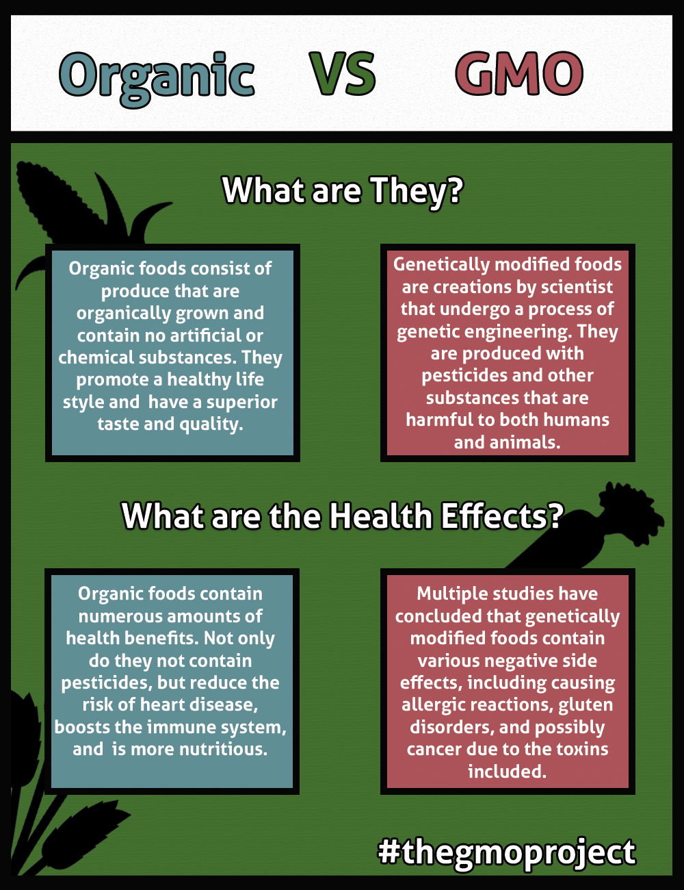
b. We will be buying stickers in bulk at Vistaprint.com. We will buy 5 sheets of 10 matte small rectangular stickers at a cost of $13.99 (as of December 14, 2015). $4.99 will be charged for Economy Shipping, which will take approximately a week to two weeks to ship. $18.98 will be the total cost with tax and shipping included. 9 members make up the GMO Project therefore each person will pay $2.11. Samantha will collect all the money and pay back the person who paid for the total cost at the time of ordering.
c. On January 21, all group members will wear a lime green top with black pants and black shoes along with any color cap with the purpose of identifying each member while we are in the store.
We as an organization plan to then further apply this strategy in other NYC whole foods in hopes that other organizations will join our movement and carry out our plan in other major cities.
