[BAMBO]
The research tool we would create would be a specialized federated search system that includes an add-on application, which attaches to a web browser. A federated search is an intended search that is spread through numerous databases at the same time that turns up a compiled list of results.
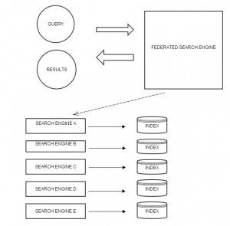
[ABOVE IMAGE: Illustration of a federated search.]

An add-on is an accessory device or piece of software designed to increase the capability of a computer or hi-fi system (Webopedia). In other words, it is a small portion of software that adds new features to your installed browser (i.e. Google Chrome, Explorer, Safari, Firefox, etc.) The name of it would be INSPECTIO, which is Latin for investigation or inquiry.
[ALL IMAGES BELOW MUST BE EXPLAINED]

The image below is a prototype of a fresh web page. This web browser could be any of the commonly used browsers like Internet explorer, Google Chrome, fire fox, Safari.
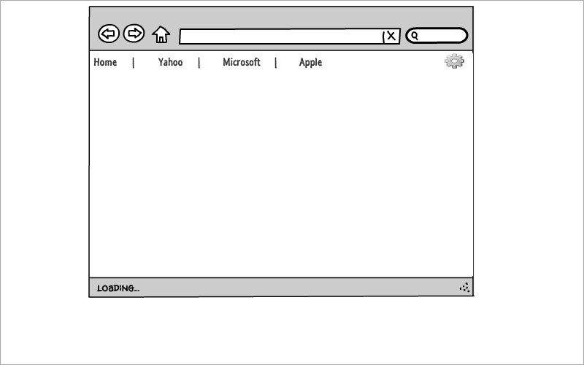

Here is a browser page of inspecto when installed on the browser. It’s just going to look like one of those extensions like the addblock on Google chrome- inspecto will probably be found on market like chrome store and apple store. And once installed, the icon will appear each time you open up your browser.
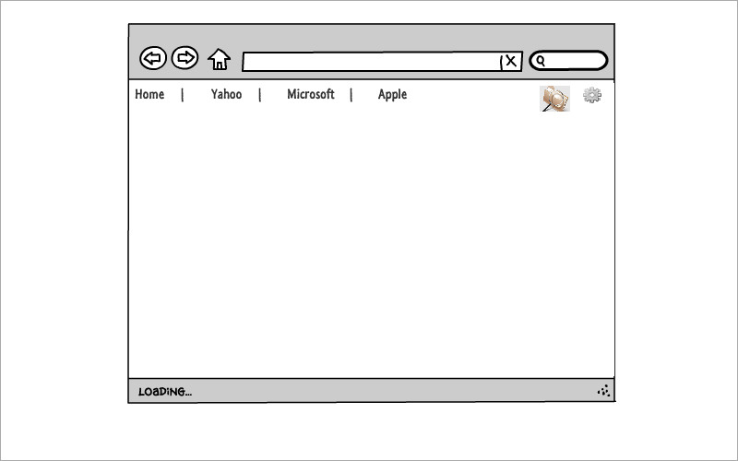

User then click on the inspecto icon which will instantly provide a search box with drop down menu for research to choose category or categories. Making a single choice, returned result will be narrowed to just the selected class while choosing two or more categories broadening search field and bringing other related results.
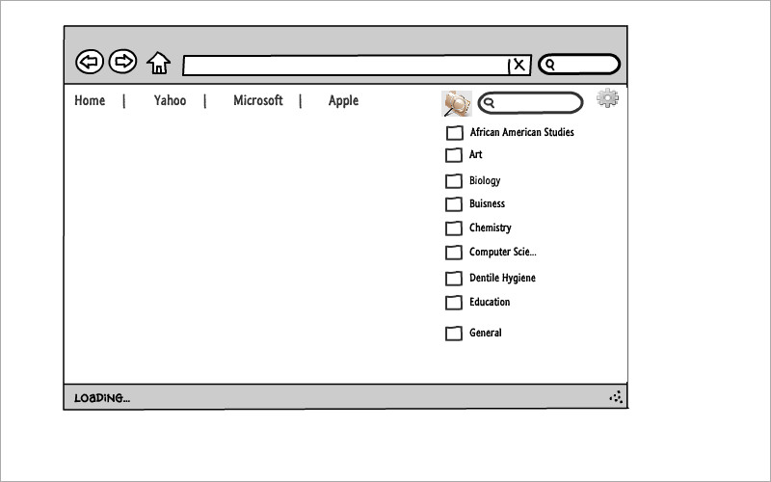

A page showing returned results with links for data/ file to be accessed by researcher.
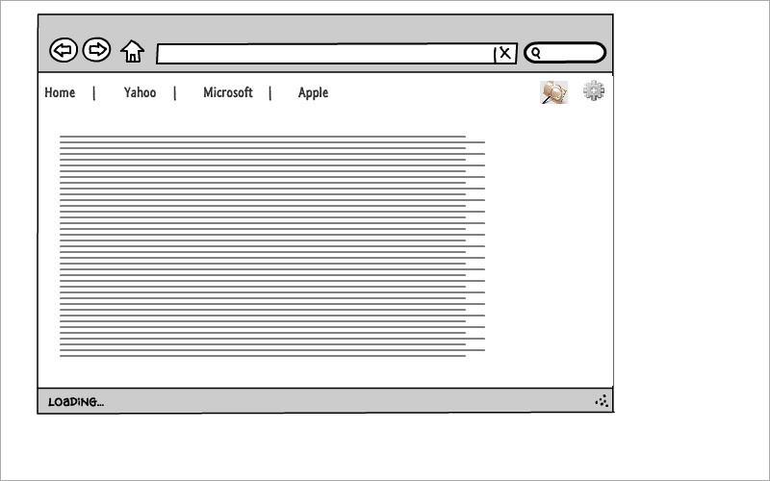

The last page here shows one of the links after user already clicked from the list provided. The page then pop ups comment bar and a simple yes or no answer type of a question. Basically asking the user if the link was help or was it just a deceptive link. If answered, this will enhance the performance of inspecto helping writer to fix bugs and improve its functionality.
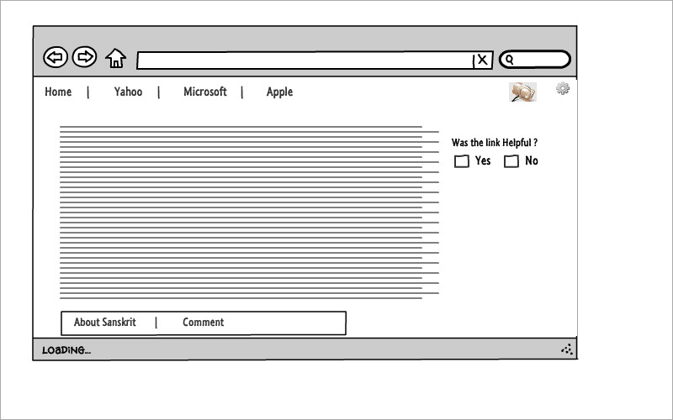

[EMILIO]
Another function that further differentiates “Inspectio” from pre-existing federated search tools, is the incorporated ability to perform auto Boolean, and truncated searches. As opposed to writing out the search terms multiple times, in multiple search engines and having to add the “AND”,”OR”,”NOT”, and truncation syntax to every individual search you do. (As you would have to with the conventional method of searching with Booleans and truncation. **Shown Below**)

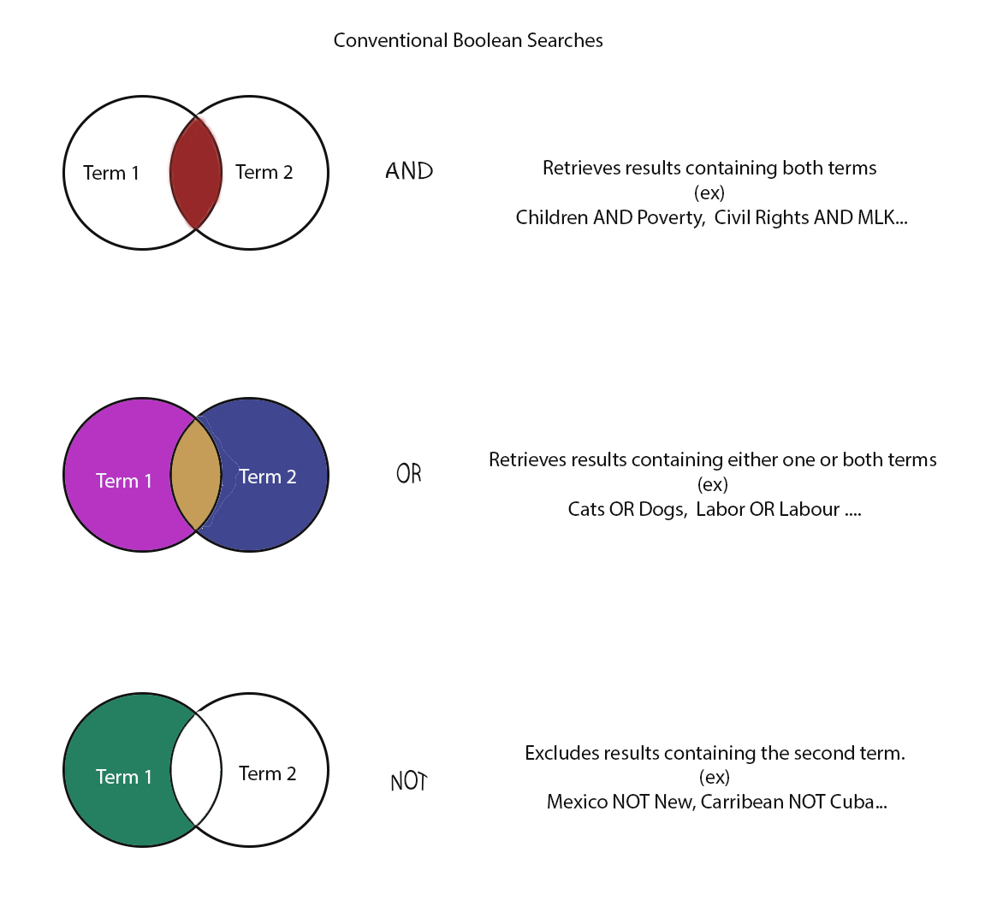
Inspectios granular search settings give you the option to incorporate or omit any of the Boolean or truncated searches directly to your search query. Without the need to rewrite or re-search the same terms in different search engines or databases, and it then returns multiple result pools simultaneously, each with their own individual search settings/options As seen in following illustration.

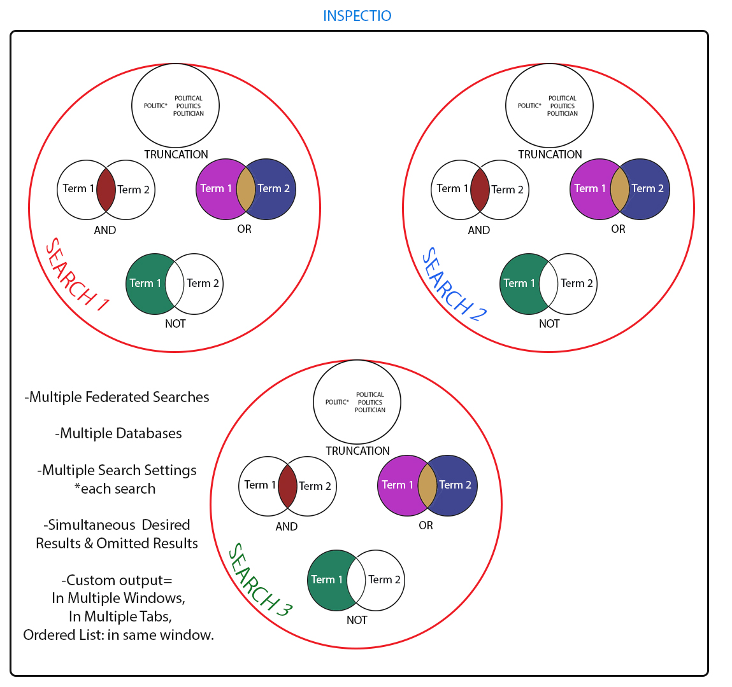Furthermore, Inspectio can then take the search results received and present it to the user in a concise, organized and customizable form, such as to open the results in separate windows, to present the results in an ordered list, or to open the received results in multiple tabs within the same browser window. However, if any of the Boolean or truncated search options are undesired they can be turned off and go unused.

The intended audience for this research tool would be college/university students looking for an alternate route to traditional database searching. Users “have stopped using resources because they are frustrated by the number of dissimilar search interfaces they must use to access database content (Warren, 262)”
[LENA]
How would it be different from the research tools we’ve worked with this semester?
In comparison to the CUNY CityTech library database system, and Google, this search program would produce the same results in less time than the traditional route.

In choosing which search tool (Google or Federated) is the best, student opinion is equally divided (Georgas, page number needed). In short, student preference for Google is due to familiarity and ease of use, and student preference for Federated is due to more scholarly results, and citations provided. Additionally, some other search tools of possible merit have been omitted from the research of student preferences surveyed.
Certainly both tools have their advantages and disadvantages. Perhaps combining the best features of both into one tool might be worthwhile. A feature that could potentially be added would be the ability to “vote down” a search result which is deceptive or fraudulent. At present, a researcher might click on a Google result, only to find that the page which loads has nothing to do with the subject desired. But the site has gained the “click” or hit on the page, and while the researcher may be angry that her time was wasted, there is nothing that she can do to remove the click and vote the site down in the search engine results. A similar situation is found where the click results in the loading of a page which offers the results only if paid for, usually at an exorbitant price. Again, the researcher’s time has been wasted, and the “payware” site has its click. I would like to see Google having a little pop-up window which would ask the user, “Was this site helpful? Yes, or No.” The researcher could then vote “no” on the fraudulent or payware site, and vote its search engine ranking down, until it no longer appears high in search engine rankings to waste the time of busy researchers.
[DOMINIQUE]
How would it make doing research easier, faster, or more enjoyable?
This add-on tool “will allow users to search a range of databases simultaneously” (Warren, 259). And “it will present results to the end user sorted by relevance, with duplicate records merged and independent of the sources they are drawn from” (Warren, 263). Users would be able to make searches across a wide range of databases that would be categorized by subject/category. “Metasearching removes the need for the user to spend additional time choosing databases that seem relevant and searching them individually” (Herrera, 45).

How would it help solve commonly encountered difficulties with research?
A user would be able to do an academic search by categories listed in the system. “Categories contain subcategories, and subcategories contain resources” (Xu, 236). The category labels would match academic disciplines found in traditional college/university settings. The distribution of information by category could help users sort through sources faster. Some databases would fall under more than one category increasing the probability of reliable information being sought out.
What would the tool look like? [IMAGES BELOW NEED EXPLANATIONS]
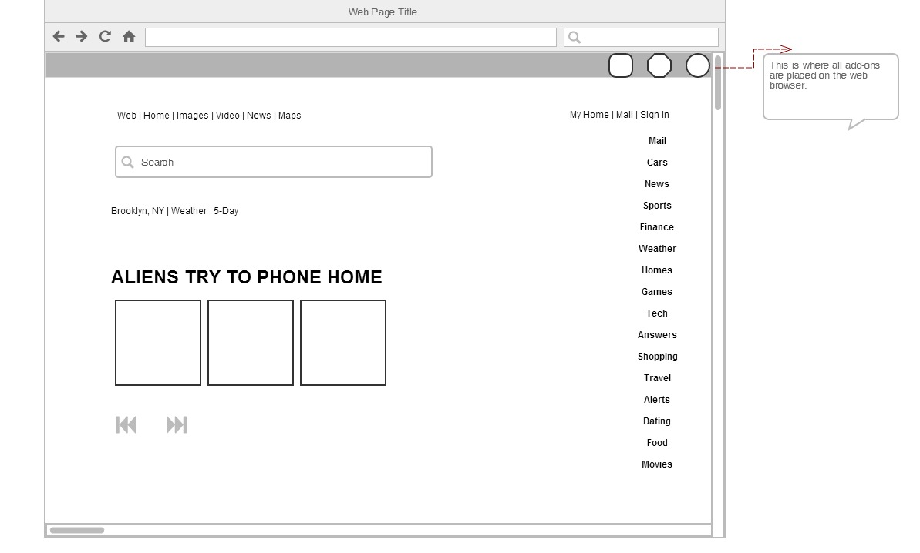
Another similar proto type browser with inspectio installed on it.
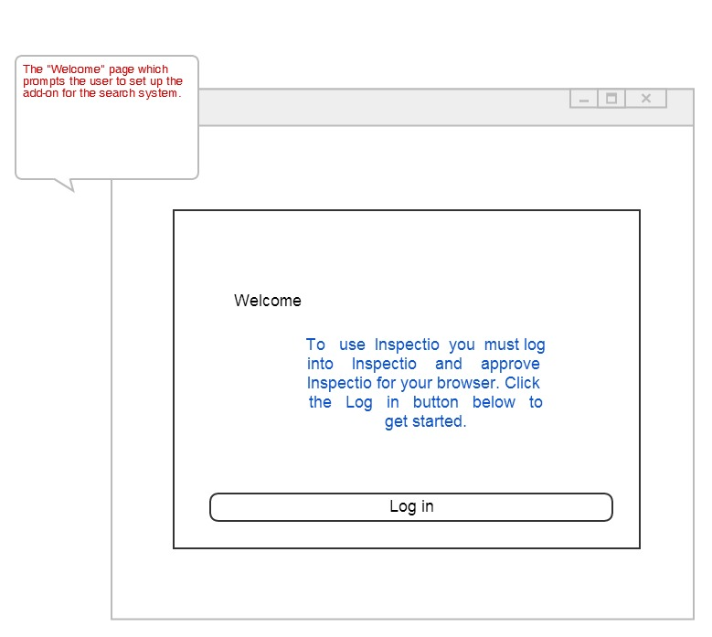
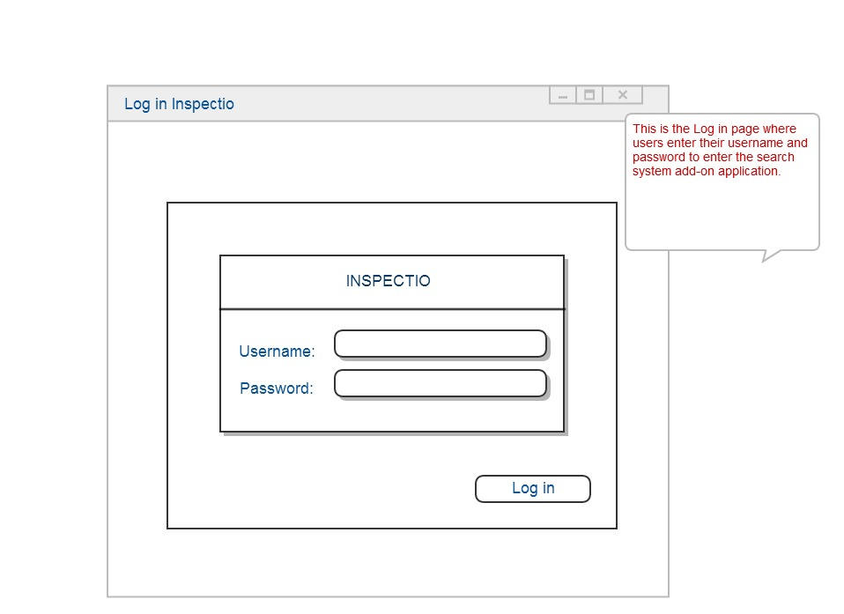
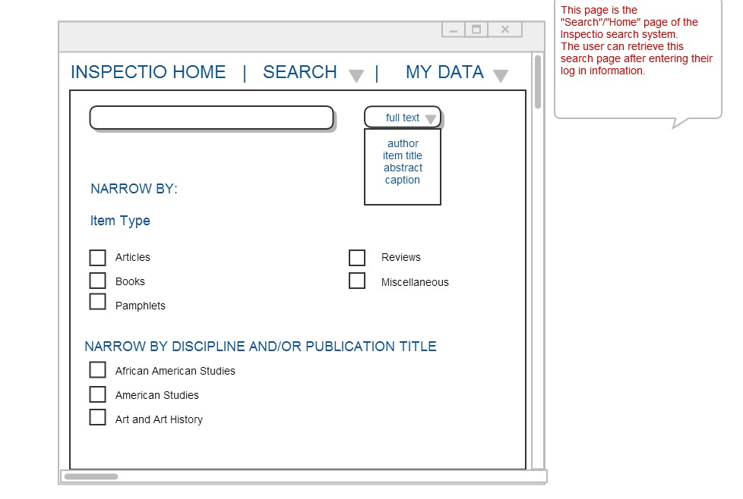

Could it be a mobile application?
Yes and no. A mobile application is meant to be a condensed version of a website, which runs on smart phones, tablets and other electronic devices that have internet capabilities. If there are too many features to work through then the application becomes instantly forgotten and/or deleted. This type of search system could work if the interface is seamless and user friendly.

