Tsering Samdup Gurung
09/6/15
Ramsey Dabby
Arch 1110

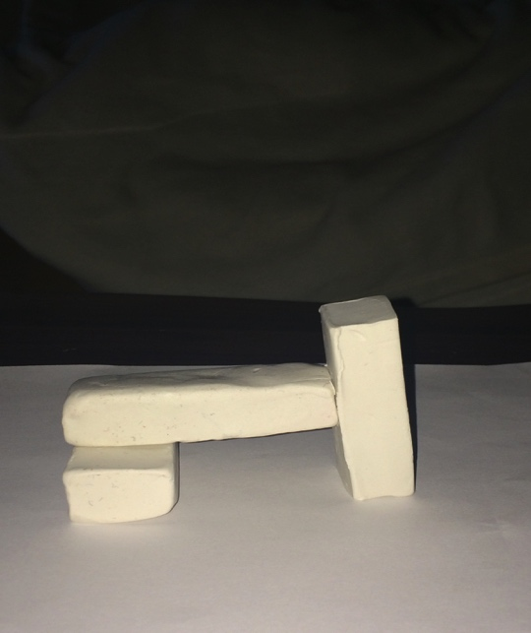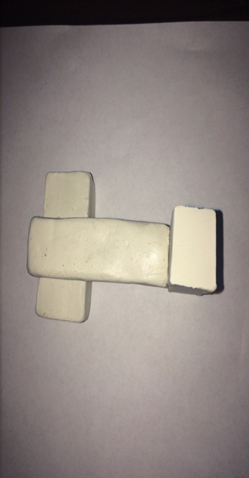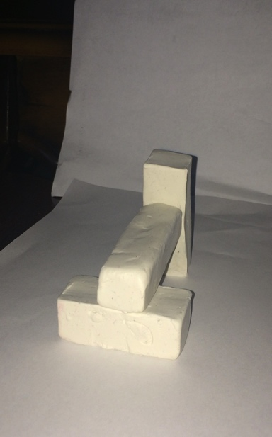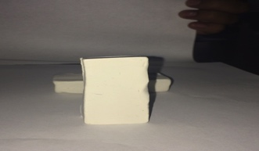

This is my first clay model that I ever made in my life and I am starting to like it more and more when I keep on making different kinds designs. The three clay models that I made have different structure and so far I like this design model the best because it shows the real architect by having a deeper meanings on each style. For example; it has a shape of shelter that protects us from anything and also we can walk by it or around it, which makes this clay model, stand out the best.

