Periodontal disease and osteoporosis are important issues in public health and clinical management. Both diseases characterized by bone resorption.

**What is Osteoporosis?**

* Osteoporosis is a systemic bone disease in which the density and quality of the bone is reduced.
* Cortical bone becomes more porous and thinner.
* Bones become more fragile, increasing the risk of fracture.
* Cause: imbalance between new bone formation and old bone resorption, relating in imbalance in calcium and phosphate ratio which is controlled by parathyroid gland.

**What is periodontitis?**

* Periodontal disease is local pathological inflammatory condition of gingiva and bone support surrounding the teeth,
* Periodontitis may progress and cause chronic periodontal destruction leading infectious breach of the alveolar cortical bone, cause teeth to loosen or lead to tooth loss.
* Cause: dental biofilm is the primary risk factor for periodontitis.
* Dental biofilm is a layer of soft film contain bacteria trigger inflammation of periodontium.
* Periodontal disease is mostly seen in adults.

**Positive Association**

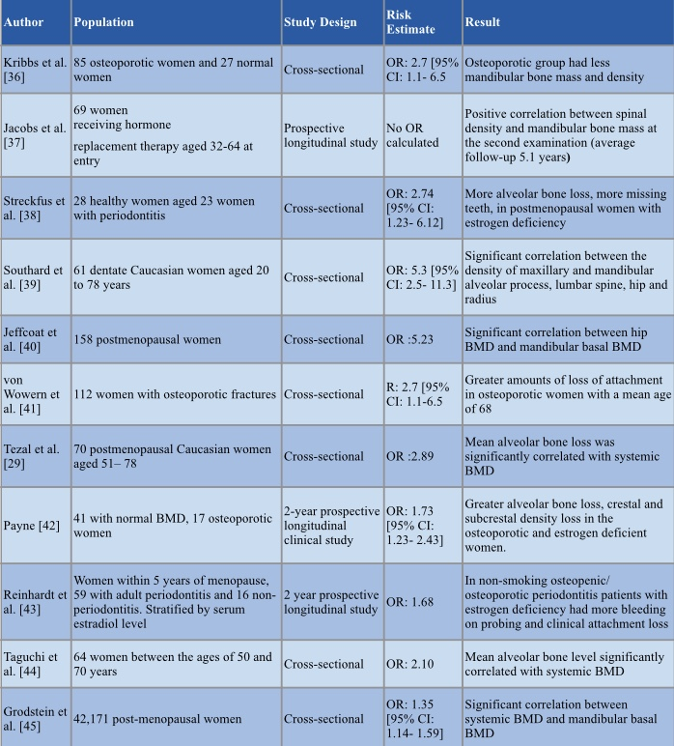

* Significant correlation between the density of maxillary and mandibular alveolar process, lumbar spine, hip and radius
* Greater alveolar bone loss, crestal and subcrestal density loss in the osteoporotic and deficient women.
* Significant correlation between systemic BMD and mandibular basal BMD

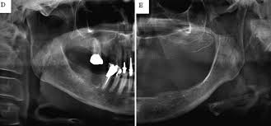

Dental radiograph showing a patient with osteoporosis and periodontitis

**Negative Associations**

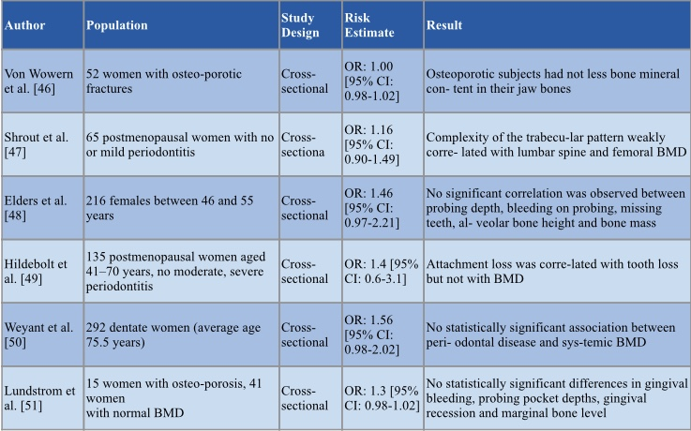

* Attachment loss was correlated with tooth loss but not with BMD.
* No statistically significant association between periodontal disease and systemic BMD.
* The MO (morphologic operator) measurements were weakly correlated with lumbar spine and femoral BMDs, with no clear trends discernible in this population of postmenopausal women with no or mild periodontal disease.
* No association was found between number of remaining teeth and BMD of the spine in both sexes.

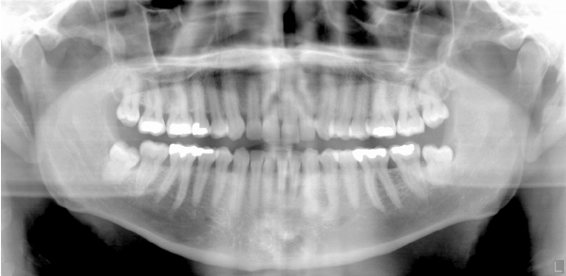

Dental radiograph with osteoporosis but no periodontitis



OSTEOPOROSIS?

PERIODONTAL DISEASE?

THE JURY IS STILL OUT!

PRESENTED BY:

Yanling Feng

Parvina Axmadalieva

Tamar Gamreklidze

04/10/2019



#### References

* Savić Pavičin, I., Dumančić, J., Jukić, T., Badel, T., Savić Pavičin, I., Dumančić, J., & Jukić, T. (2017). The relationship between periodontal disease, tooth loss and decreased skeletal bone mineral density in ageing women. *Gerodontology*, *34*(4), 441–445. <https://doi-org.citytech.ezproxy.cuny.edu/10.1111/ger.12290>
* Shrout MK, Hildebolt CF, Potter BJ, Brunsden TK, Pilgram TK, Dotson M, et al. Comparison of morphological measurements extracted from digitized dental radiographs with lumbar and femoral bone mineral density measurements in postmenopausal women. J Periodontol. 2000 Mar;71(3):335–40.
* Haerian-Ardakani A, Dehghan A, Ezzodini-Ardakani F, Ahmadi L. Relationship between Osteoporosis and Periodontitis in the Females over 40 Years. *Journal of Shaheed Sadoughi University of Medical Sciences & Health Services*. 2014;22(3):1274-1284. http://citytech.ezproxy.cuny.edu:2048/login?url=http://search.ebscohost.com/login.aspx?direct=true&db=ccm&AN=103987881&site=ehost-live&scope=site. Accessed April 1, 2019.
* Iofbonehealth.org. (2019). *What is Osteoporosis? | International Osteoporosis Foundation*. [online] Available at: http://www.iofbonehealth.org/what-is-osteoporosis [Accessed 4 Apr. 2019].
* Chohayeb AA. Influence of osteoporosis on the oral health of menopausal women. *General Dentistry*. 2004;52(3):258-262. http://citytech.ezproxy.cuny.edu:2048/login?url=http://search.ebscohost.com/login.aspx?direct=true&db=ccm&AN=106641301&site=ehost-live&scope=site. Accessed April 1, 2019.

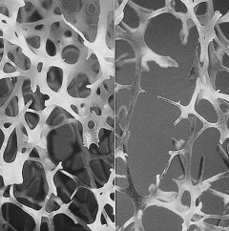

Left: normal bone, right: osteoporotic bone

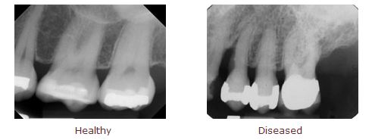

Periapical radiograph showing healthy and disease alveolar bone.