Tara Gallo
Pharmacology-DEN2315
December 8, 2015
Valerian
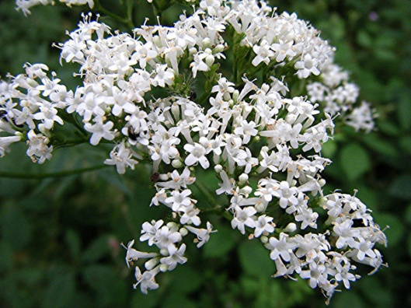
Valerian is an herb sold as a dietary supplement in the United States. Common names for Valerian include all-heal and garden heliotrope, and it is scientifically known as Valeriana Officinalis. The Food and Drug Administration (FDA) regulates dietary supplements under a different set of regulations than those covering other drug products. According to the FDA, if the dietary supplement contains a new ingredient, that ingredient will be reviewed by the FDA prior to marketing, for safety but not effectiveness. According to the University of Maryland Medical Center, Germany’s Commission E approved valerian as an effective mild sedative and the United States FDA listed valerian as “Generally Recognized As Safe” (GRAS). The supplements are made from the roots of valerian into many forms including capsules, tablets, liquid extracts and teas. Valerian root is known to have a very distinctive sharp odor. For this reason, it is often combined with other calming herbs, including passionflower, hops, lemon balm, skullcap, and kava to mask the scent.
Valerian is a common ingredient in products promoted as mild sedatives and sleep aids for nervous tension and insomnia. According to the National Institutes of Health, evidence from clinical studies of the efficacy of valerian in treating sleep disorders, such as insomnia, is inconclusive. Constituents of valerian have been shown to have sedative effects in animals, but there is no scientific agreement on valerian’s mechanisms of action. Some researchers believe that valerian may need to be taken for a few weeks before it begins to work. However, in one study, valerian was effective almost immediately. Other studies show that valerian reduces the times it takes to fall asleep and improves the quality of sleep. Therefore, the evidence remains contradictory. Although there is not enough scientific evidence to determine whether valerian works for other conditions, valerian is also used as a traditional remedy for headaches, depression, irregular heartbeat and trembling.
Valerian is native to Western Europe and grows up to 2 feet tall. Valerian grows best with constant light moisture. The best time to harvest valerian roots are in the spring and fall because the medicinal compounds are at their peak potency. This plant is found throughout Britain and Ireland as well as most of mainland Europe and parts of Asia. Common Valerian can be found in both dry grassland and damp grassland habitats, but it does not tolerate permanently waterlogged conditions. Valerian has been used in Unani, Ayurvedic, and traditional Chinese health systems. The tincture has been used for its sedative properties for centuries and it is still widely used in France, Gernany, and Switzerland as a sleep aid.
Unlike many prescription sleeping pills, valerian may have fewer side effects. Headaches, dizziness, pruritus, and gastrointestinal disturbances are the most common reported in clinical trials. Women who are pregnant or nursing and children under 3 years old, should not take valerian because the possible risks to the fetus, infant, or child has not been evaluated. Individuals taking valerian should also be aware of theoretical possibility of additive sedative effects from alcohol or sedative drugs, such as barbiturates and benzodiazepines. No oral manifestations are known to occur while taking this dietary supplement which minimizes the dental hygienists’ role for patients taking valerian. However, since consumers may be attracted to using valerian or other herbal supplements that are believed to promote a calming effect on the central nervous system, it is essential for a dental hygienist to familiarize with some of the oral manifestations that may present due to their intake.

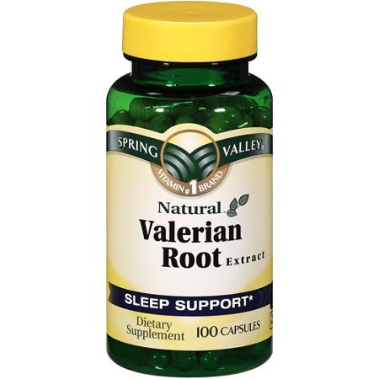

Sources:
1. "Valerian." NCCIH. Web. 10 Dec. 2015. https://nccih.nih.gov/health/valerian
2. "Valerian." — Health Professional Fact Sheet. Web. 10 Dec. 2015. https://ods.od.nih.gov/factsheets/Valerian-HealthProfessional/
3. "Valerian." University of Maryland Medical Center. Web. 10 Dec. 2015. http://umm.edu/health/medical/altmed/herb/valerian
4. "Valerian Uses, Benefits & Dosage - Drugs.com Herbal Database." Valerian Uses, Benefits & Dosage - Drugs.com Herbal Database. Web. 10 Dec. 2015.

