Tarique Blue

Prof. Vladutescu

EET 3132

May 16, 2016

Research Paper Summary

Armen, G. Bradley, "Phase sensitive Detection: The Lock-in Amplifier

In this Article, Dr. Armen talks about the method of Phase-Sensitive Detection and how the instrument known as the Lock-in Amplifier makes the method possible by describing how the amplifier works and what they are good for. Dr. Armen defines Phase-Sensitive Detection; otherwise known as a "Lock-In" as a fancy AC voltmeter that is supplied with a periodic reference signal. The PSD then responds only to the portion of the input signal that occurs at the reference frequency with a fixed phase relationship. Dr. Armen adds on to this by stating that creating this type of design would also one to measure quantities that would otherwise be overwhelmed with plenty of noise.

Dr. Armen then goes on to elaborate on how the lock-in amplifier works. The process goes as follows: 1) The input signal V (t) passes through a capacitor, blocking any pre-existing DC offset and then amplified in stages; before and/or after the multiplier. 2) The reference signal VR (t) passes through an adjustable phase-shifter (φ). And finally, 3) These two results are then multiplied, and any resulting DC component is extracted by the low-pass (L.P.) filter. Below is a block diagram provided from Dr. Armen's theory that illustrates how the lock-in amplifier works:

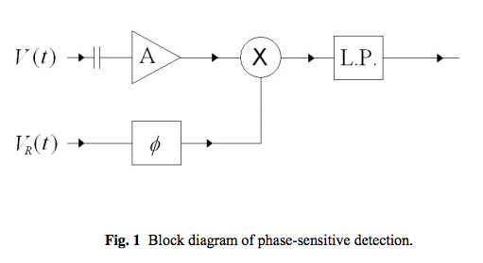

Moreover, Dr. Armen then discusses & demonstrates how the Lock-in Amplifier is applied in various situations which includes:

- Real World Applications: To test the Lock-in's behavior in the real world, Dr. Armen used a simulator box that would provide several synthetic and well-controlled signals that ranges from pure sine wave, signal w/ no noise, noise w/ no signal, and finally signal w/noise together towards the amplifier. Once he applied signal & noise together, Dr. Armen's results showed that at frequencies relatively close to the reference signal, the noise would be superimposed atop the DC signal level

- Performance & Power: To test the power of Lock-in detection, Dr. Armen experimented with the amplifier by using a flashlight and rotating mask; which would chop the light given by the flashlight and in effect allow the lock-in amplifier to exhibit it’s amazing capability of measuring the small signal given by the flashlight even in the presence of lighting with higher intensity (i.e. Hall lights) and other obstructions such as large distances and objects as coke machines in his case.

- Applying The Faraday Effect: Finally, Dr. Armen moves to a much more serious application for the Lock-in, which is the capability of finding the Verdat Coefficient, which is a constant of proportionality needed to apply the Faraday Effect. The Faraday effect is when a beam of polarized light traverses a material in the direction of an external magnetic field; causing the angle of polarization to rotate slightly. The angle of rotation θ is then found to be proportional to the strength of the magnetic field and to the distance traveled through the sample. Dr. Armen proves this theory by having an experimental sample placed in the center of a Helmholtz coil pair so that a magnetic field lies along the sample axis. As a result, the magnitude is modulated by driving the coils with an AC current, so that B (t) B sinωt = 0. A linearly polarized laser beam is then passed through the sample axis & through a sheet polarizer then detected with a photodiode. The Faraday effect rotates the angle of polarization by θ as the beam passes through the sample.

