Tarique Blue

Prof. Vladutescu

EET 3132

5/24/16 ***RS Final Pt. 2***

1)

|  |  |  |
| --- | --- | --- |
| Planet | Period (Hrs) | Semi-Major Axis (Meters) |
| Mercury | 2781 | 0.3871 |
| Venus | 5392.824 | 0.7233 |
| Earth | 8760 | 1 |
| Mars | 16487.304 | 1.5273 |
| Jupiter | 9571.20 | 5.2028 |
| Saturn | 258221.28 | 9.5388 |
| Uranus | 8871.84 | 19.1914 |
| Neptune | 1444368 | 30.0611 |
| Pluto | 2173944 | 39.5294 |

% Tarique Blue

% Submitted To: Prof. Viviana Vladutescu

%EET-3132 Remote Sensing, Spring 2016

% RS Final Part 2, Problem 1

p=[2781.12,5392.824,8760,16487.304,9571.2,258221.28,8871.84,1444368,2173944];

%Orbital Period (Hrs)

s=[0.387098,0.72332,1,1.5273,5.2028,9.5388,19.1914,30.0611,39.5294];

%SemiMajor Axis (Astronomical Unit, 1 AU= 149,597,871 km)

figure(1)

loglog(p,s,'*-');

title('loglog(p,s)')

xlabel('Period(Hrs)')

ylabel('SemiMajor Axis(AU)')



Based off the graph above, Kepler’s 3rd Law ( $τ^{2}∝r^{3})$ is obeyed.



2)

|  |  |  |  |
| --- | --- | --- | --- |
|  | Red (DN) | Green (DN) | Blue (DN) |
| 1 | 40 | 50 | 60 |
| 2 | 20 | 25 | 28 |
| 3 | 30 | 30 | 30 |
| 4 | 15 | 16 | 14 |

% Tarique Blue

% Submitted To: Prof. Viviana Vladutescu

%EET-3132 Remote Sensing, Spring 2016

% RS Final Part 2, Problem 2

T=[40,50,60;20,25,28;30,30,30;15,16,14;];

Correlation = corrcoef(T)

Covariance = cov(T)

[V,D]= eig(Covariance)

>> RSProblem2Blue

Correlation =

1.0000 0.9693 0.9397

0.9693 1.0000 0.9949

0.9397 0.9949 1.0000

Covariance =

122.9167 154.5833 201.6667

154.5833 206.9167 277.0000

201.6667 277.0000 374.6667

V =

-0.3193 -0.8559 0.4069

0.8360 -0.0523 0.5462

-0.4462 0.5146 0.7322

D =

0.0203 0 0

0 11.1085 0

0 0 693.3712

3)

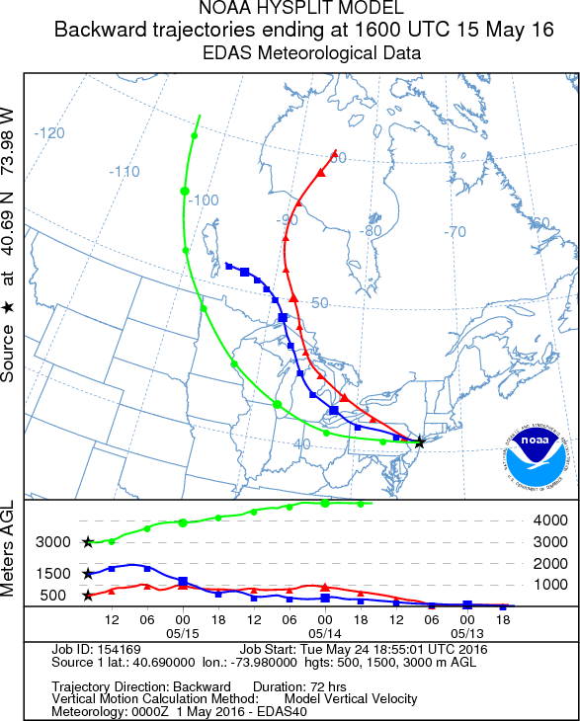

Based off of the graph above, we can conclude that the higher the altitude, the less pollution contained in the air. For the plots at 500 m, you can tell it is taken near bodies of water, which shows that the winds were affected possibly by industrial buildings and the likes and their fumes that they output in the atmosphere, as the altitude reached 3000 m, the winds began to remain high, and even reaching higher heights due to the absence or very small values of pollution in that range.

4) % Tarique Blue

% Submitted To: Prof. Viviana Vladutescu

%EET-3132 Remote Sensing, Spring 2016

% RS Final Part 2, Problem 4

load ('Cloud_FractionBlue.txt')

figure(1)

imagesc(Cloud_FractionBlue)

colorbar

title('Cloud Fraction', 'Fontsize',15)

ylabel('latitude', 'Fontsize',12)

xlabel('longitude', 'Fontsize',12)

figure(2)

histogram(Cloud_FractionBlue)

